IEEE P802.11
Wireless LANs
Specification Framework for TGbk
Date: 2023-03-06
Author(s):
Name | Affiliation | Address | Phone | email
Roy Want | Google Inc | 1600 Amphitheatre Drive, Moutain View, CA 94043 | +1-650-691-3600 | roywant@google.com

Abstract
This document provides the framework from which sections of the draft TGbk amendment.

The document provides an outline of each the functional blocks that will be a part of the final amendment. The document is intended to reflect the working consensus of the group on the broad outline for the draft specification and is derived from the set of functional requirements. As such it is expected to begin with minimal detail reflecting agreement on specific techniques and highlighting areas on which agreement is still required (<TBD> in the document). It may also begin with an incomplete feature list with additional features added as they are justified. The document will evolve over time until it includes sufficient detail on all the functional blocks and their inter-dependencies so that work can begin on the draft amendment itself.

Revision history
Revision | Date | Changes
0 | Feb 27, 2023 | Initial Version
0.1 | Mar 3rd, 2023 | Better classification of PHY and MAC requirements in 248/r1

Contents
1 Definitions 4
2 Abbreviations and acronyms 5
3 MAC 5
3.1 Frame Formats 5
3.2 Negotiation 5
3.3 Measurement exchange 5
3.3.1 Trigger Based measurement exchange 5
3.4 Termination 5
4 PHY 5
4.1 Frame structure 6
4.1.1 Common section 6
4.1.2 EHT Ranging NDP 6
4.1.3 EHT TB Ranging NDP 6
5 Security 6
5.1 Common section 6

Definitions

FTM Initiator – the STA initiating the FTM procedure.

FTM Responder – the STA responding to the FTM Procedure establishment request

Abbreviations and acronyms

EHT Extremely High Throughput
FTM Fine Timing Measurement
IFTM Initial FTM
FTMR FTM Request

MAC

Frame Formats
The Ranging NDP Announcement frame of 802.11bk will use the existing Ranging NDP Announcement variant encoding of 802.11az, and the existing 320MHz indication of 802.11be:
- There is no change to the 802.11az Ranging NDP Announcement MAC content
(11-23-48: 202301-12)

Negotiation

Extends the IFTMR and IFTM frames with a new subelement to indicate information on the transmit power envelope of the BSS.
(11-23-48: 202301-15)

Measurement exchange

Trigger Based measurement exchange
The EHT Ranging Trigger frame sets the Trigger Type subfield in the Common Info field to 8 as in the 802.11az and includes the Special User Info field immediately after the Common Info field as defined in 802.11be. (11-23-48: 202301-13)

Termination

PHY

4.1 Frame structure

4.1.1 Common section
The new types of NDP frames for ranging are called: EHT Ranging NDP and EHT TB Ranging NDP.

Both the EHT Ranging NDP and the EHT TB Ranging NDP shall use the 2x LTF with 1.6 µs GI. (11-23-40: 202301-06)

Both the EHT Ranging NDP and the EHT TB Ranging NDP will support up to eight EHT-LTF Repetition Blocks, and will not support extra EHT LTFs
(11-23-08: 202301-08)

Both the EHT Ranging NDP and the EHT TB Ranging NDP use only the 2x LTF with 1.6 µs GI. (11-23-08: 202301-11)

4.1.2 EHT Ranging NDP

The EHT Ranging NDP shall use the EHT MU PPDU preamble (11-23-40/202301-05)

The Ranging NDP Announcement frame of 802.11bk will use the existing 320MHz indication of 802.11be:
- For a non-HT dup PPDU: set B7 in SERVICE field to 1 to indicate 320 MHz
- For an EHT MU PPDU: use the Bandwidth field in the U-SIG field to indicate 320 MHz
(11-23-48: 202301-12)

4.1.3 EHT TB Ranging NDP

EHT TB Ranging NDP uses the EHT TB PPDU preamble. (11-23-40: 202301-07)

Security

Common section

Secure LTF ranging will use AES-128 for pseudo random octet generation and use 64-QAM modulation. (11-23-40:202301-09)

Secure LTF ranging will use a 4-way octet parser to parse the pseudorandom octets between the four 80-MHz segments, and when a subchannel is punctured, then the pseudorandom octets which would have been sent to the punctured subchannel, will be dropped at both the transmitter and the receiver. (11-23-40: 202301-10)

The figures below are included from slides 10-13 (doc 11-23/40r1)
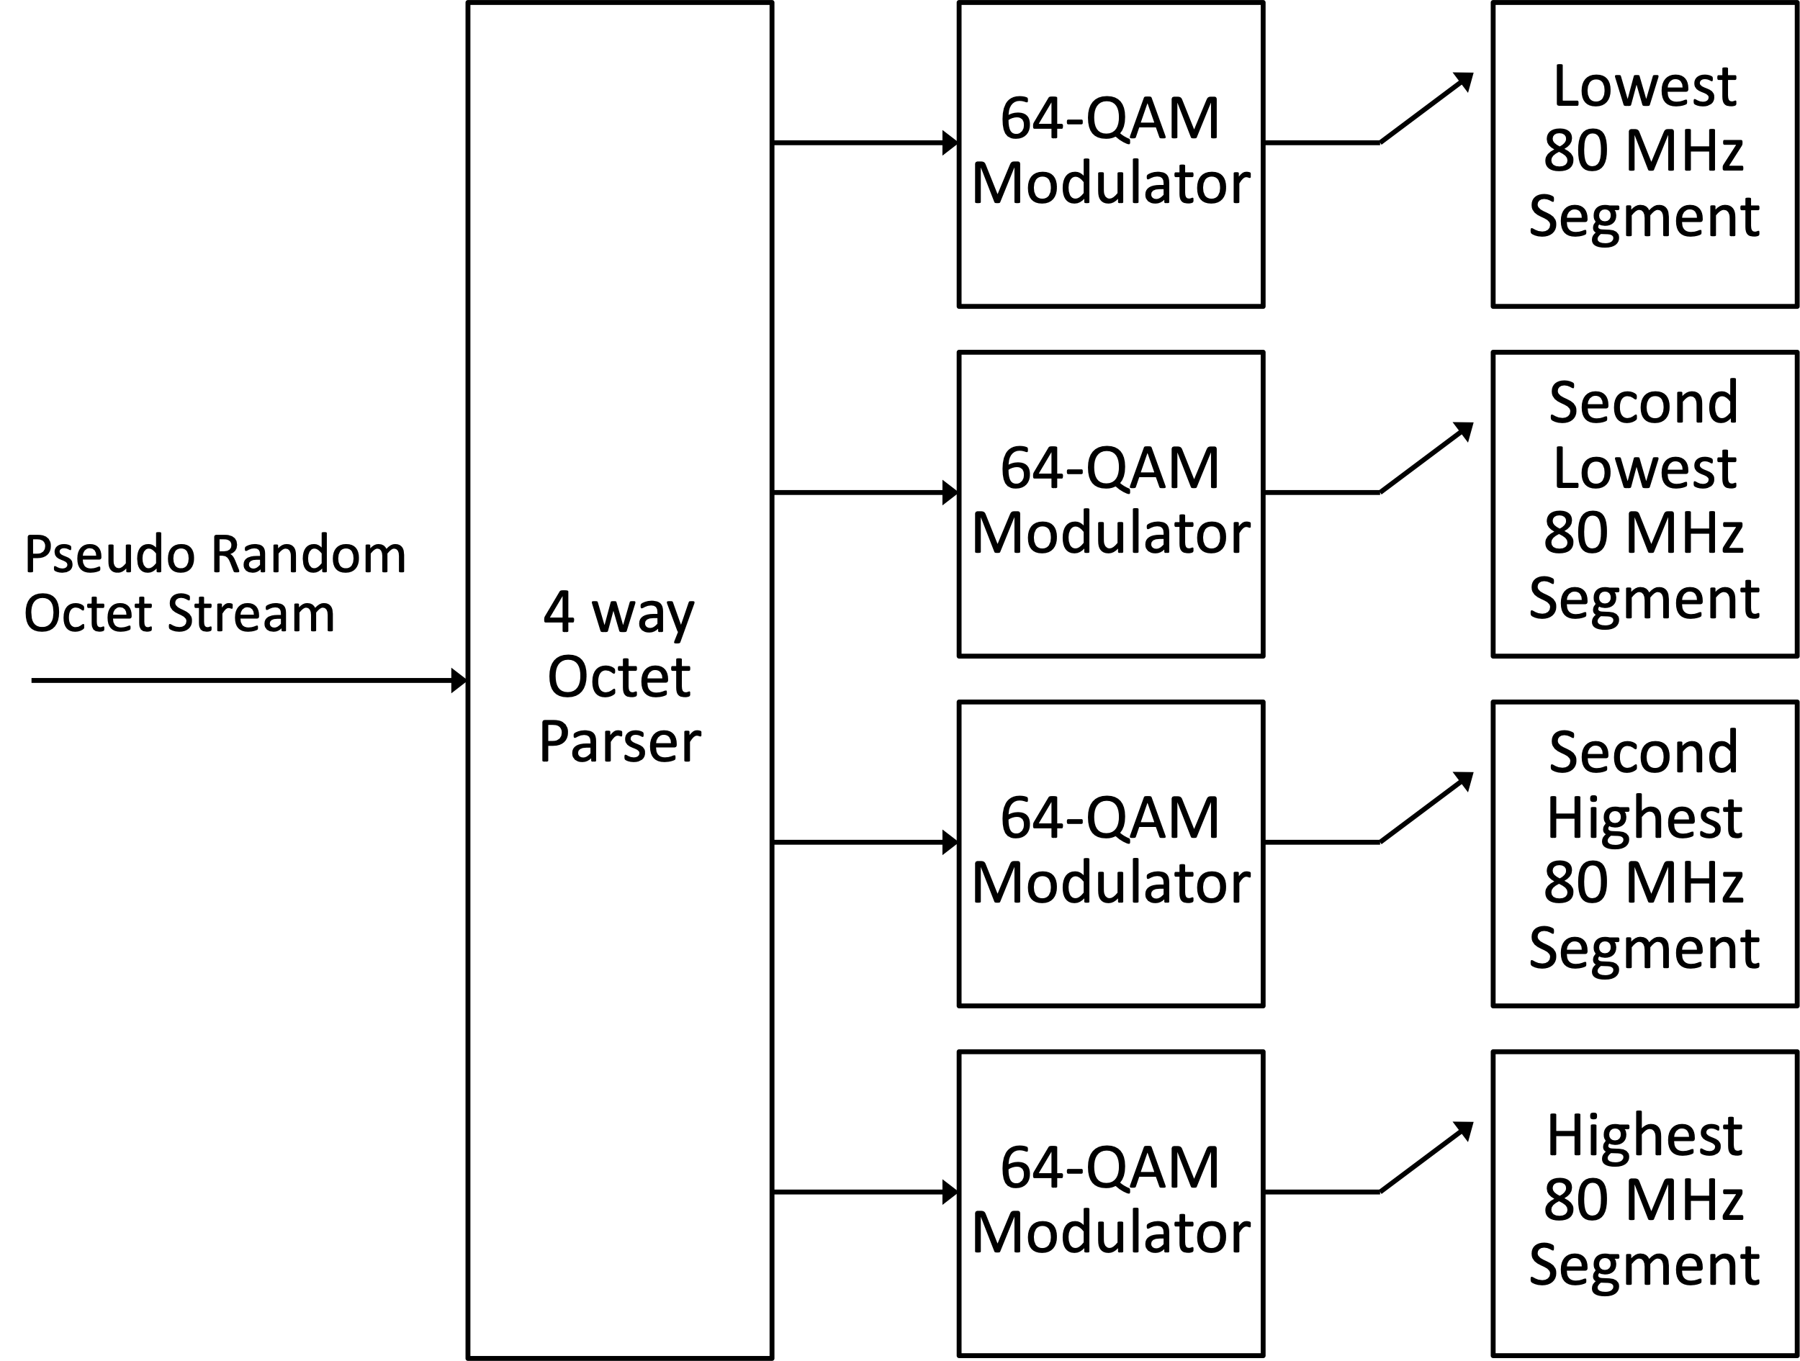
Figure 1: 320 MHz Secure LTF showing 4-way parser and no puncturing.

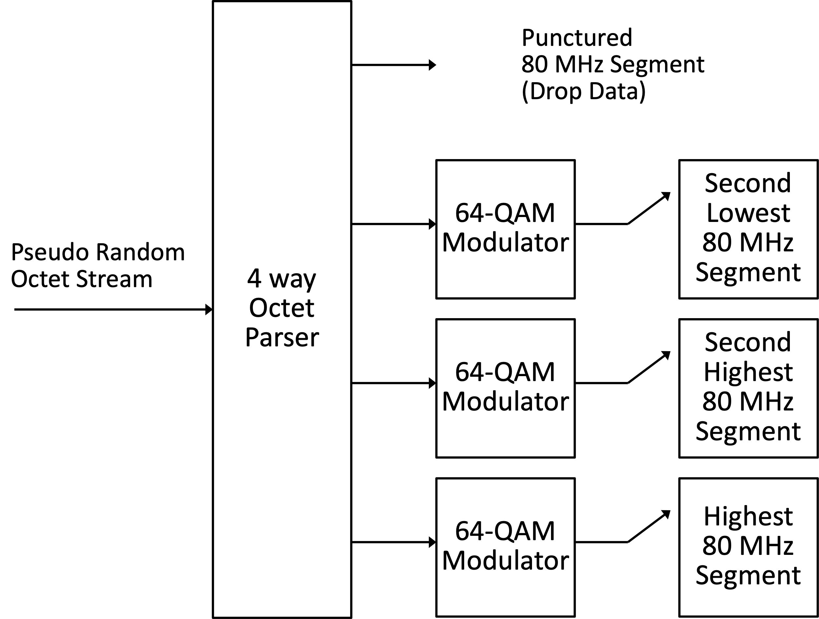

Figure 2: 320 MHz Secure LTF showing 4-way parser and 80 MHz puncturing

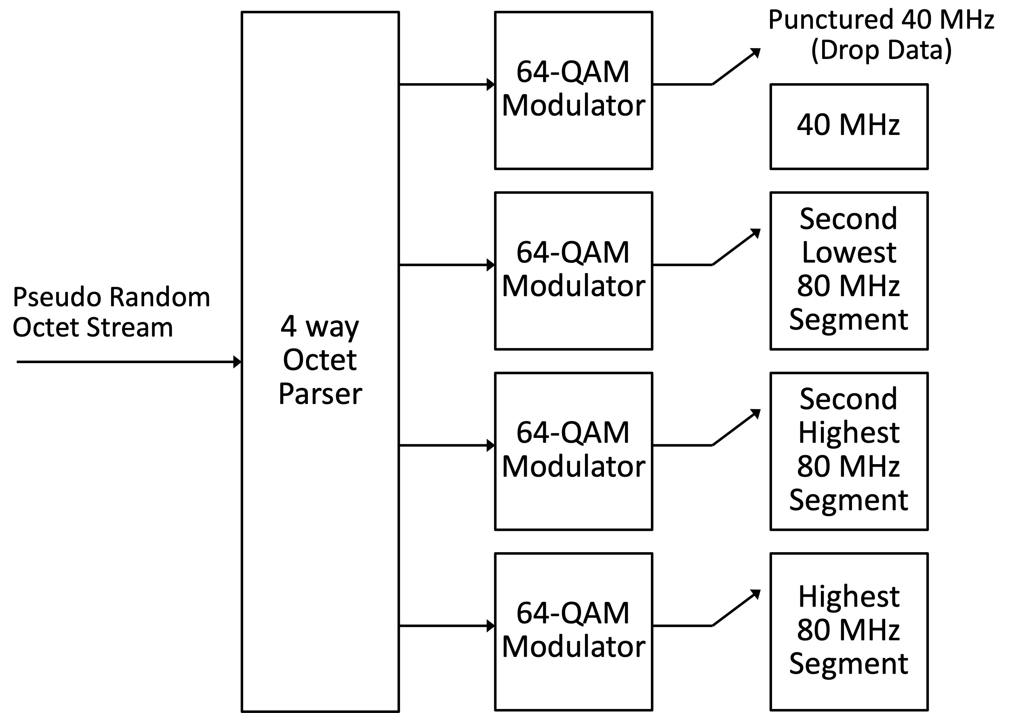
Figure 3: 320 MHz Secure LTF showing 4-way parser and 40MHz puncturing.
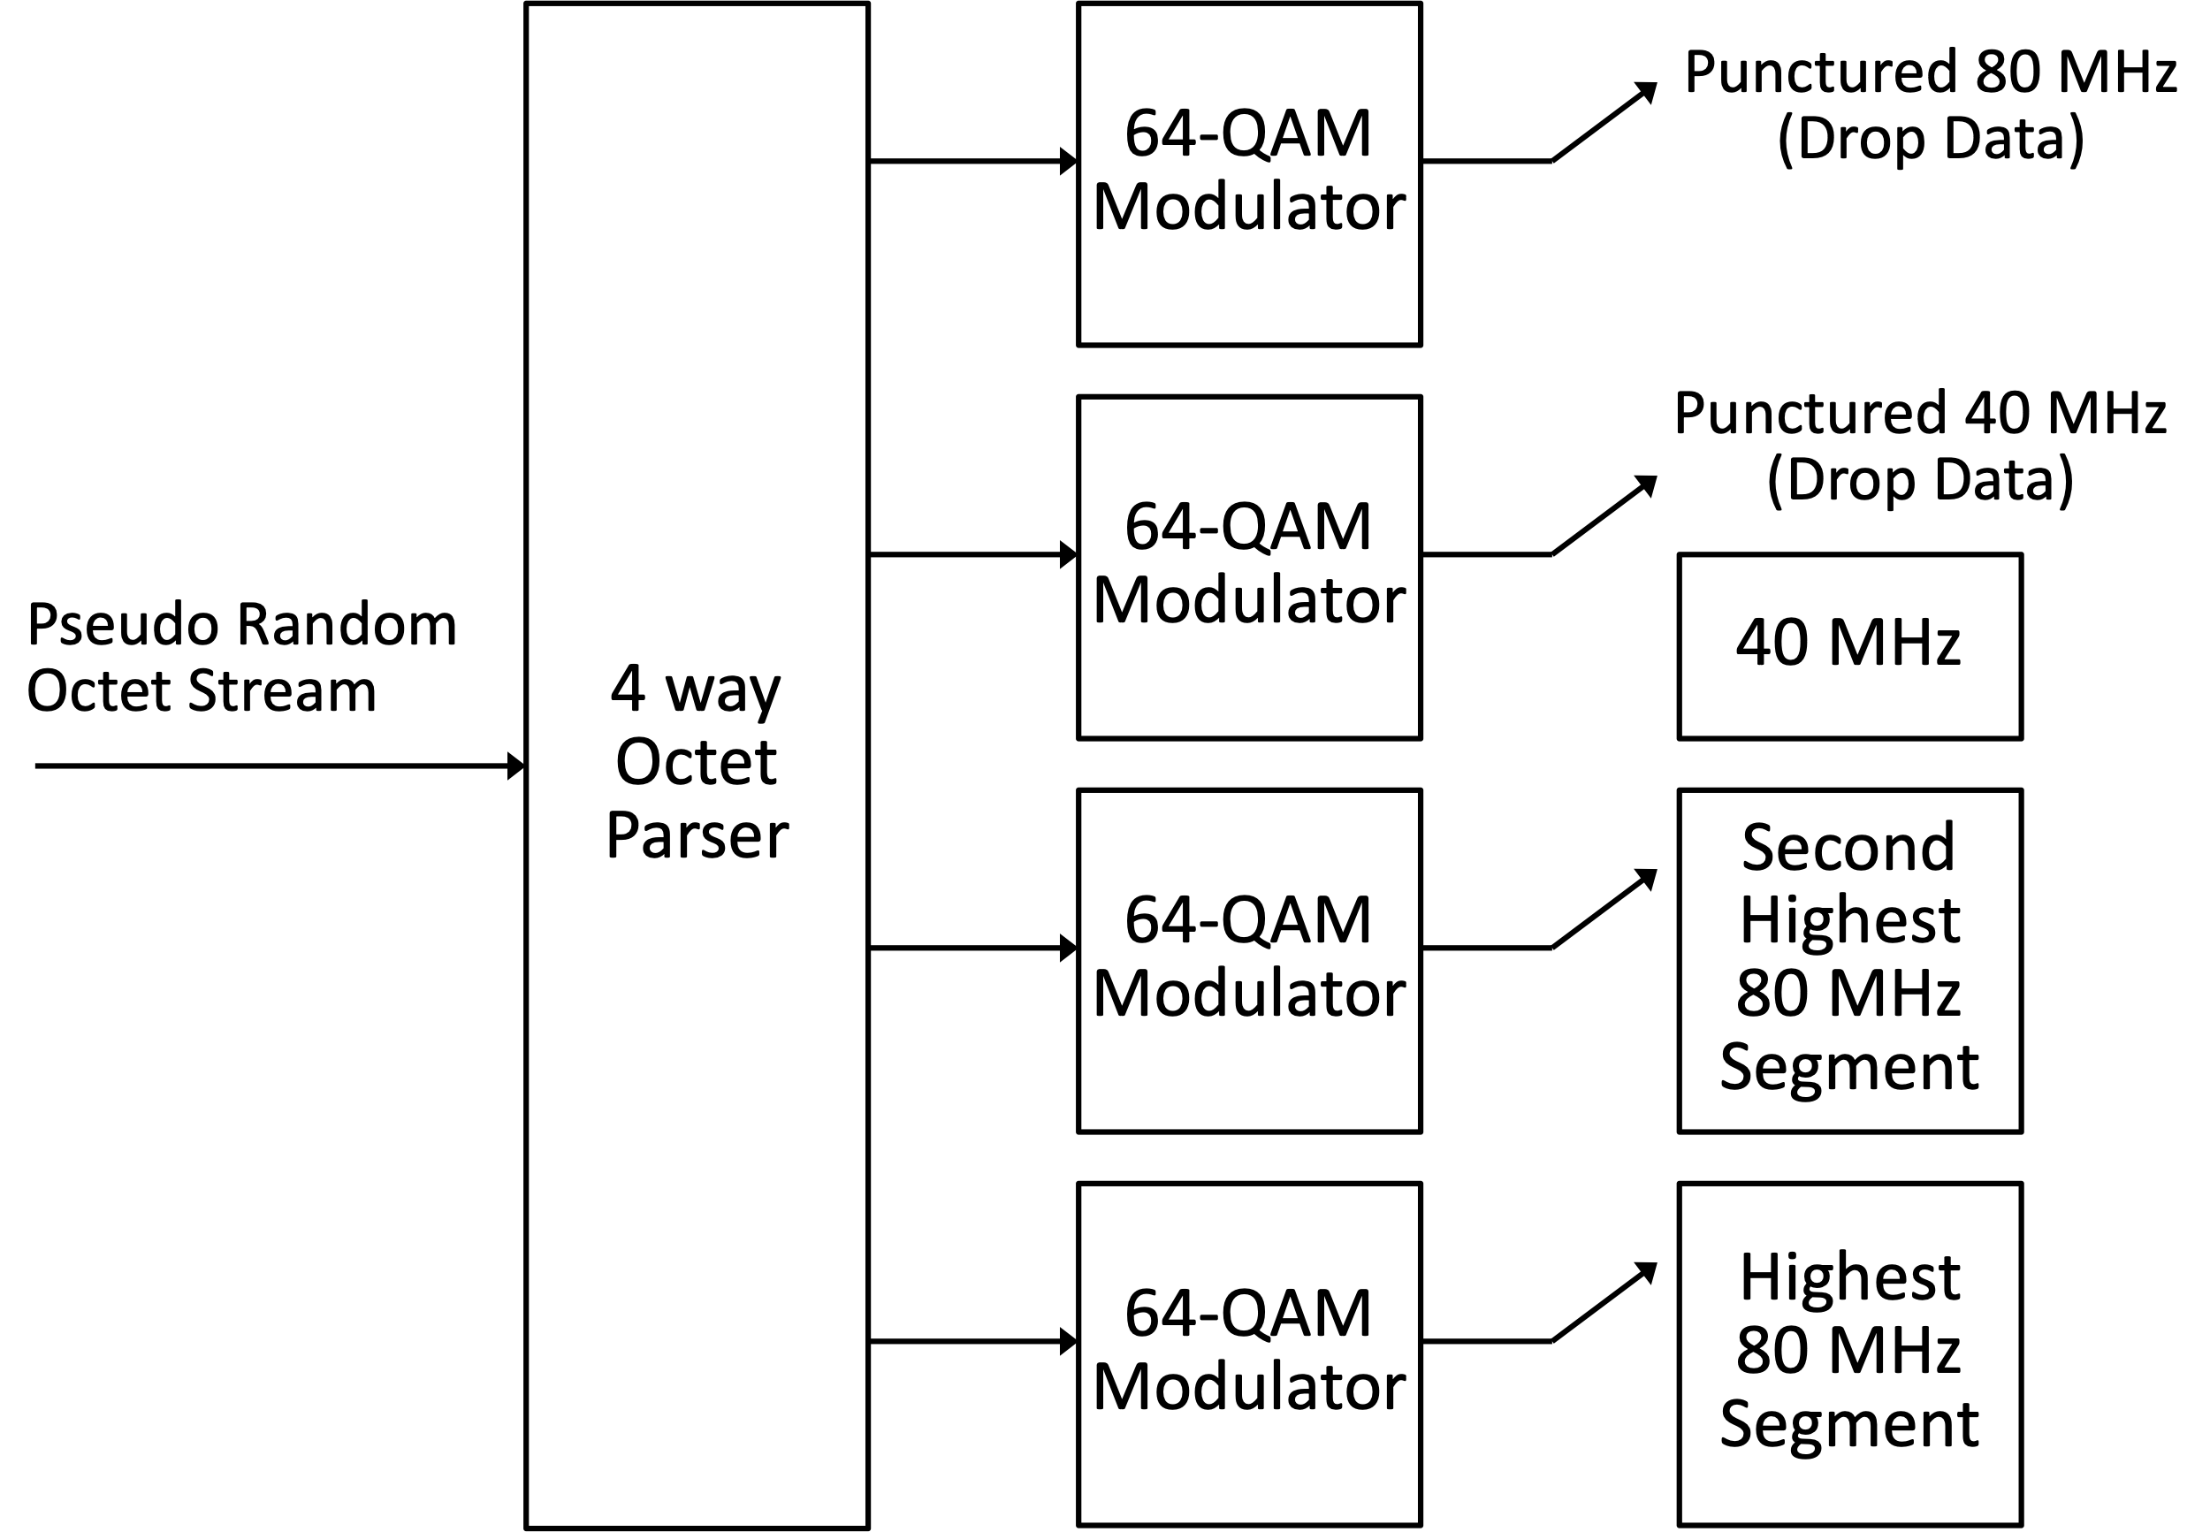
Figure 4: 320 MHz Secure LTF showing 4-way parser and 40MHz & 80MHz puncturing.

