Minutes IEEE P802.11
Wireless LANs
IEEE 802.11 TGbh Meeting Minutes, February 21, 2023
Randomized and Changing MAC addresses (RCM)
Date: 2023-02-21
Author(s):
Name | Affiliation | Address | Phone | email
Stephen Orr | Cisco | Wallkill, NY |  | sorr@cisco.com
Abstract
This document contains the minutes of the IEEE 802.11bh telecon meeting of February 21, 2023.

Note: Highlighted text are action items.
Q- proceeds a question asked at the meeting
A- proceeds an answer
C- proceeds a comment

Meeting February 21th, 2023 9:30 a.m. to 11:30 a.m. ET

Chair: Mark Hamilton (Ruckus/CommScope)
Vice Chair: Peter Yee (NSA-CSD/AKAYLA)
Vice Chair: Stephen Orr (Cisco)
Secretary: Peter Yee
Editor: Carol Ansley (Cox)

The teleconference was called to order by the Chair at 9:33 a.m. EST.

Agenda slide deck 11-23/0229r00

- Policies and procedures were presented by the Vice Chair Peter Yee. (Slides 4 to 14)
There were no Patent declarations.
Copyright policy slides were presented (Slides 10 and 11)

- Agenda:
- Attendance, noises/recording, meeting protocol reminders
- Policies, duty to inform, participation rules
- Organization topics (see Backup slides)
  - Timeline reminder (slide 24)
  - Teleconference plan, going forward (slide 17)
- Issues Tracking: 11-21/0332r37
- Results of Comment Collection on D0.2: 11-22/0973r13
- Motions record: 11-22/0651r9
- Discussion on Way Forward
  - Final down-select Straw Poll
  - Technical Comments/corrections on final solution?
- Contributions
- WBA liaison response
Any comments?
C: Two additional contributions to be worked on (1329 and 0083)
Any objections to agenda? [None] – approved

- Discussions on Way forward
Chair presented a summary of strawpolls from last meeting

Chair ran the following strawpoll
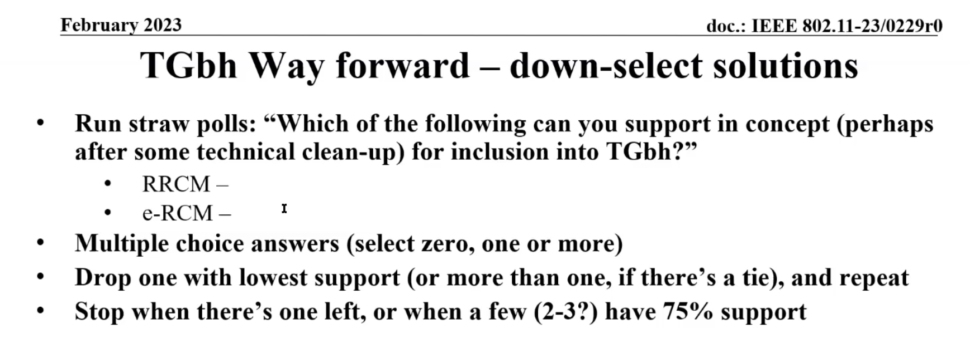
Results: RRCM (12), e-RCM (11), No Answer (7)
C: How do we identify how many people voted for neither? 21 people on the call (Chair does not vote)
C: None of the options have 75% support
Chair – this is just for downselect (strawpoll)
Chair – downselect process is finished. However if someone else wants to run another strawpoll we can.
C – Yes downselect is complete, but not clear that we have one left. No clear winner. Cannot get behind a mechanism that uses a MAC address as an identifier.
C – Run poll again with adding None as an option
C – run a strawpoll “do you support including RRCM in the Draft”
Next Strawpoll
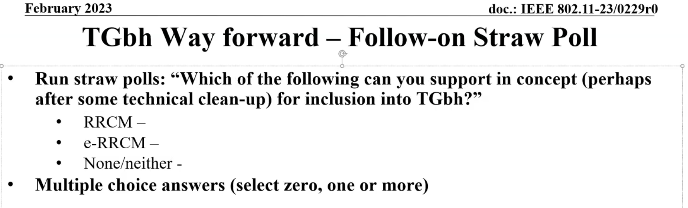
Results: RRCM (10), e-RCM (6), None/Neither (11), No Answer (2)

Next Straw Poll
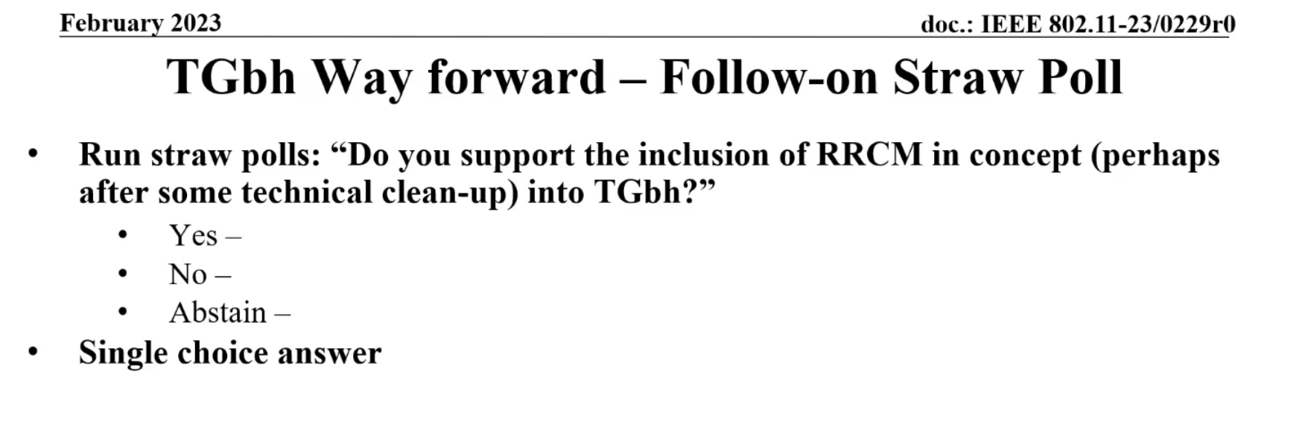
Results: Yes (11), No (8), Abstain (4), No Answer (1)

Q – If we are dealing with a pre-assoc situation with no expected security just privacy. What is the big objection to a MAC address not tied to an identity? The MAC is the only ID for the transmission coming out of the STA. In order for the pre-assoc use case to be saitified it must be shared between the network and the STA so some sort of tracking can be done on that non-random ID.
C – The MAC is a STA property. Getting the network to assign a STA property is not valid. Every device on the network gets to decide its own properties. In the pre-assoc case we need to have an explicit mechanism to convey to the user what kind of ID is being assigned and what the content mechanism and what it will be used for. Without that this would be a violation of the device rights (privacy). It is better for any ID to be communicated by an IE, opaque and dynamic enough where the STA can easily discard it.
C – The MAC coming out of the STA is its choice always. However, if the STA is aware of the network it is trying to assoc with and it has previously assoc with, using a MAC that it has previously used may have some advantages.
C – All issues brought up for pre-assoc cases are done in the cellular space
C – We did define a MIB that allows the device to be identified.
C – Pre-assoc privacy the problem is potentially with “other” networks in the area and how to use which MAC address when.
C – We need to understand how MAC addresses are used today and figure out how RCM breaks it – and how the identifier will be used.
C – Need to continue these discussions on the reflector
C – If we want to go to letter ballot at the next plenary – this may be rushed and we might not have the right design for the constraints we need to get to. We should take the time and define a solution that does honor user privacy before hand.
Chair – we are not here to solve the privacy issues…we are here to not create new issues (because of RCM).
C – Four key areas for identifiers:
1.Consent
2. Unauthenticated environment
3. Malicious 3rd party protection
4. What is the identifier used for?
C – How does the STA know when to use which Identifier and when? It is very difficult for the STA if it is trying to connect to the network prompting “this network may track you” and then what do I tell them the information will be used for? This will lead to a bad user experience.
Chair – this is a good discussion, possibly make progress offline on the reflector.
C – The use of these techniques is similar to how a STA chooses what network to assoc. We may be moving outside the .11 spec if we start speculating on how things are being used.
C – What is the ID used for – that may be outside the scope of .11 as well.
- Contributions
0083r5 – Kurt Lumbatis (CommScope)
Reviewed Document
1329r14 – Kurt Lumbatis (CommScope)
Reviewed Document and discussed
Q – Not convinced of stating that the ID is recognized openly or not?
A – This is in a secure state – you already have the keys
C – having a difficult time with #1 and #2
Chair – we have run strawpolls on these topics and they lean in this direction as the preferred solution.
Q – “Shared Identity State” – 12.2.10
A – 12.2.10 does not have a defined state. It is a common ID that is shared between AP and Non-AP STA for state.
C – need to clarify 12.2.10
Strawpolls
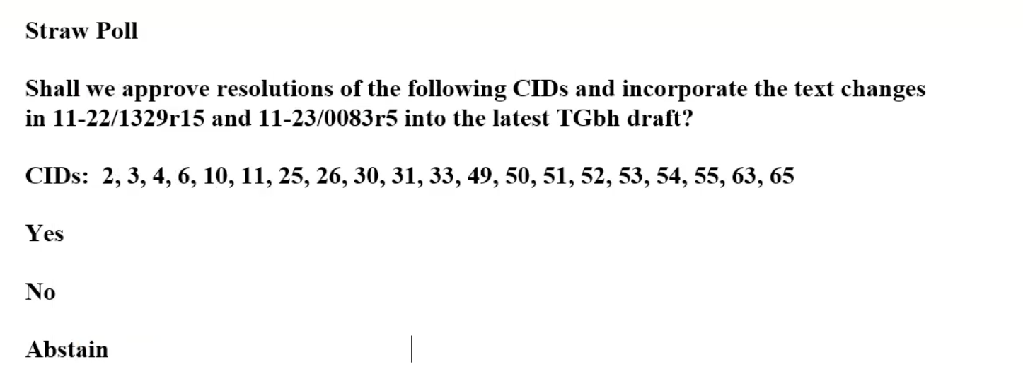
Results – no objection

C – Question on RRCM, suggestion to bring up on reflector and have a presentation for next call

Meeting adjoined at 11:26 a.m. EST.

Attendance
Breakout | Timestamp | Name | Affiliation
TGbh | 2/21 | Ansley, Carol | Cox Communications Inc.
TGbh | 2/21 | baron, stephane | Canon Research Centre France
TGbh | 2/21 | Bredewoud, Albert | Broadcom Corporation
TGbh | 2/21 | DeLaOlivaDelgado, Antonio | InterDigital, Inc.
TGbh | 2/21 | Hamilton, Mark | Ruckus/CommScope
TGbh | 2/21 | Harkins, Daniel | Hewlett Packard Enterprise (Aruba Networks)
TGbh | 2/21 | Levy, Joseph | InterDigital, Inc.
TGbh | 2/21 | Lumbatis, Kurt | CommScope, Inc.
TGbh | 2/21 | Montemurro, Michael | Huawei Technologies Co., Ltd
TGbh | 2/21 | Mutgan, Okan | Nokia
TGbh | 2/21 | Orr, Stephen | Cisco Systems, Inc.
TGbh | 2/21 | Riegel, Maximilian | Nokia
TGbh | 2/21 | RISON, Mark | Samsung Cambridge Solution Centre
TGbh | 2/21 | Sam, Harvey | Broadcom Corporation
TGbh | 2/21 | Sevin, Julien | Canon Research Centre France
TGbh | 2/21 | Smith, Luther | Cable Television Laboratories Inc. (CableLabs)
TGbh | 2/21 | Sun, Bo | Sanechips
TGbh | 2/21 | Yang, Jay | Nokia

