Minutes IEEE P802.11
Wireless LANs
IEEE 802.11 TGbh Meeting Minutes, February 14, 2023
Randomized and Changing MAC addresses (RCM)
Date: 2023-02-14
Author(s):
Name | Affiliation | Address | Phone | email
Stephen Orr | Cisco | Wallkill, NY |  | sorr@cisco.com
Abstract
This document contains the minutes of the IEEE 802.11bh telecon meeting of February 14, 2023.

Note: Highlighted text are action items.
Q- proceeds a question asked at the meeting
A- proceeds an answer
C- proceeds a comment

Meeting February 14th, 2023 9:30 a.m. to 11:30 a.m. ET

Chair: Mark Hamilton (Ruckus/CommScope)
Vice Chair: Peter Yee (NSA-CSD/AKAYLA)
Vice Chair: Stephen Orr (Cisco)
Secretary: Peter Yee
Editor: Carol Ansley (Cox)

The teleconference was called to order by the Chair at 9:33 a.m. EST.

Agenda slide deck 11-23/0220r00

- Policies and procedures were presented by the Vice Chair Peter Yee. (Slides 4 to 14)
There were no Patent declarations.
Copyright policy slides were presented (Slides 10 and 11)

- Agenda:
- Attendance, noises/recording, meeting protocol reminders
- Policies, duty to inform, participation rules
- Organization topics (see Backup slides)
  - Timeline reminder (slide 24)
  - Teleconference plan, going forward (slide 17)
- Issues Tracking: 11-21/0332r37
- Results of Comment Collection on D0.2: 11-22/0973r13
- Motions record: 11-22/0651r9
- Discussion on Way Forward
- Contributions
- WBA liaison response
Any comments? [None]
Any objections to agenda? [None] - approved
- Discussions on Way forward
PAR update – propose a motion on Feb 28th 2023 if the group wants to updated the PAR.
- Chair discussed the proposed text changes (clarifications) on slide 16
- Chair opened the floor for comments.
Q – Never been in a group where they change their PAR – what does this mean.
A – (Chair) What we are hoping to do is clarify the PAR not change it. This type of clarification has happened before.
Q – Does it make sense to go through this.
A – Trying to find consensus at the WG level – and peel back the issue and find out why we are going in circles within this group.
Q – Seems to add a lot of pre-assoc use cases. Does this mean that pre-assoc use cases are out of scope of the current PAR?
A – We can work on wording to make this clear (pre and post assoc). Intent was to expand on “customer support”
C – Viewpoint that this is adding pre-assoc use cases. Diag and troubleshooting is only for associated devices. No need for PAR change for pre-assoc use cases.
C – second the previous comment regarding pre-assoc identification of the STA. Did we really understand the process of customer support (how did they work pre-RCM). We didn’t take the time to understand that – and probably should take the time to do that.
C – If you are updating the PAR – the clarifying statements in parenthesis. These would be added in section 8.1 if you are updating the PAR.
C – Pre-assoc is really not clear where the client has not joined or selected a network, and then there is the point where it selects the network. This has not been clearly defined in .11 – when going down the route of privacy, we may need to define this intermediate state. If we did – some of these issues may be easier to solve.
C – This does an excellent job of clarifying the original intent of what the group should do. However, we do need something to address pre-assoc and this change does that. Why do we need to change the PAR if we can’t arrive at a pre-assoc scheme are we really addressing the current PAR?
C – If a device is not associated and you haven’t dealt with it before, that is the only pre-assoc case we agreed to. Maybe after “troubleshooting” parenthetical needs to be cleared up.
C – Suggest including “returned devices”
C- Issues tracking doc does not do a good job. We need a presentation on how RCM has wrecked things like troubleshooting.
C – RCM may not have wrecked things…if STAs wanted to maintain privacy they could have just used passive scanning. Need to differentiate discovering a network vs interacting/joining the network.
C – In the past clients may not have been trying to get around things.
C – You can’t make a claim that it was always helpful – in some cases it may be.
C – Suggestion around Active Scanning prior to assoc.
C – Disagree with mandating Active Scanning
C – These are not new use cases – they are old use cases. Maybe we just don’t understand them. Need a presentation/contribution on how it is done. There should be no doubt about these use cases.
C – Whether we address all of these use cases via 802.11 is the sticking point.
C – the problem we are having right now is we have a bunch of pre-schemes that can address the use cases, the issue is we can’t agree on one.
C – (Chair) Where are we stuck and not sure what to propose to get us un-stuck.
C – We have been over all the use cases, lets go through the down-select and take whatever comes out.
C- (Chair) if we don’t come to consensus soon we will not make the March timeline. Maybe we go back to the reflector and get some additional input for pre-assoc.
C – There is a difference on the client side regarding pre-assoc when a client hasn’t selected a network vs when it has selected a network (decided to set up state). Two real states – Network Discovery and Network Selection.
C – Maybe we should rephrase to use Network Discovery and Network Selection.
C – We could do a strawpoll to go with draft 0.2
C – (Chair) we have run strawpolls multiple times
C – If we can’t reach a conclusion on the pre-assoc case can we move to letter ballot? We may need to modify the PAR because we will not meet the scope of the current PAR.
Chair – run through the down-select or accept D0.2
Chair constructed the following straw poll:
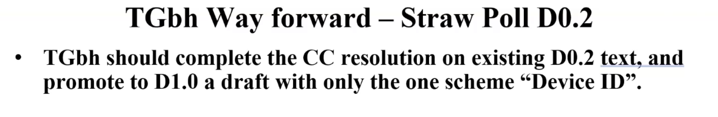
Yes (13)
No (10)
Abstain (4)
No Answer (2)

Chair constructed the following straw poll:
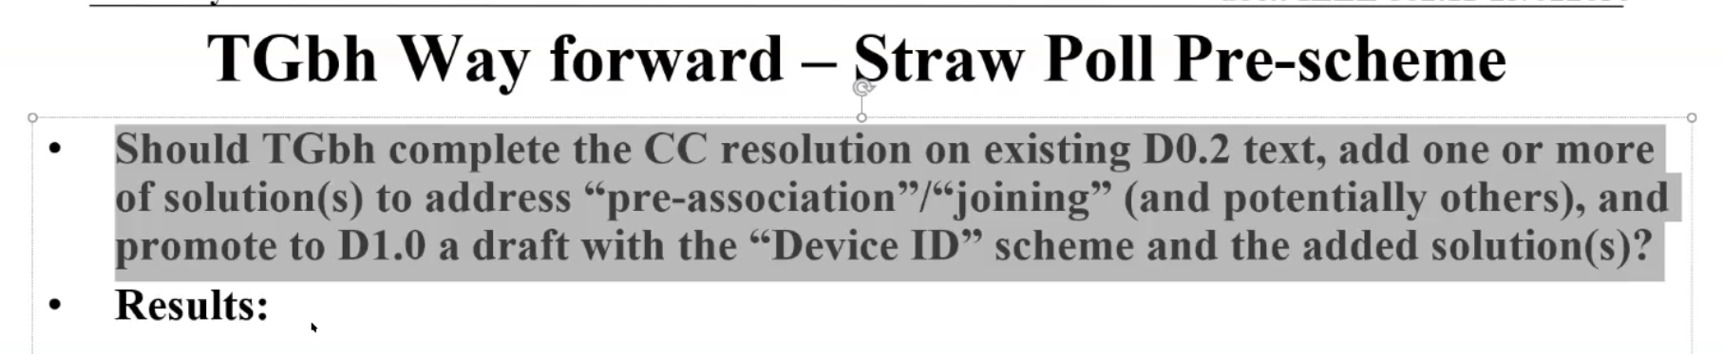

Yes (15)
No (10)
Abstain (2)
No Answer (1)

C: Covering adding one or more solutions to address “pre-association” cases.

Discussion on what to do next:

C: One proposal was to move the content over to TGbi
C: Other commentors spoke against moving the content to TGbi
C: Suggest changing the PAR to move the “pre-Assoc” content out of TGbh, with TGbi free to pick it up or not
C: Another comment that the joint TGbi/TGbh meeting did not move toward collapsing the groups’ respective scopes

Chair proposed to begin the down-selection vote, allowing votes for as many schemes as a person is willing to support

First poll was run (Chair has results). Choices with 3 or fewer votes were eliminated. Poll was run again on the reduced selection set.
Chair has results.
Only one option was eliminated with 3 or fewer votes on this round.
Some discussion of whether or not the meeting could be extended, but most spoke against extending the meeting.
Results of third round eliminated 3 more choices. Chair decided to run one more round with the last 3 surviving choices.
Chair has results. One of the 3 (IRMA) was lower than the other 2 and was a candidate for elimination, but time ran out at that point.

Meeting adjoined at 11:30 a.m. EST.
Attendance
Breakout | Timestamp | Name | Affiliation

TGbh | 2/14 | Ansley, Carol | Cox Communications Inc.
TGbh | 2/14 | baron, stephane | Canon Research Centre France
TGbh | 2/14 | Hamilton, Mark | Ruckus/CommScope
TGbh | 2/14 | Hedayat, Ahmadreza | Apple Inc.
TGbh | 2/14 | Henry, Jerome | Cisco Systems, Inc.
TGbh | 2/14 | Kneckt, Jarkko | Apple, Inc.
TGbh | 2/14 | McCann, Stephen | Huawei Technologies Co., Ltd
TGbh | 2/14 | Montemurro, Michael | Huawei Technologies Co., Ltd
TGbh | 2/14 | Mutgan, Okan | Nokia
TGbh | 2/14 | Nezou, Patrice | Canon Research Centre France
TGbh | 2/14 | Orr, Stephen | Cisco Systems, Inc.
TGbh | 2/14 | Petrick, Albert | InterDigital
TGbh | 2/14 | Riegel, Maximilian | Nokia
TGbh | 2/14 | RISON, Mark | Samsung Cambridge Solution Centre
TGbh | 2/14 | Sam, Harvey | Broadcom Corporation
TGbh | 2/14 | Smith, Graham | SRT Wireless
TGbh | 2/14 | Smith, Luther | Cable Television Laboratories Inc. (CableLabs)
TGbh | 2/14 | Sun, Bo | Sanechips
TGbh | 2/14 | VIGER, Pascal | Canon Research Centre France
TGbh | 2/14 | Yang, Jay | Nokia
TGbh | 2/14 | Zhou, Lei | H3C Technologies Co., Limited

