IEEE P802.11
Wireless LANs
Proposed IEEE 802.11 AIML TIG Technical Report Text for the Multi-AP Coordination Use Case
Date: 2023-02-27
Author(s):
Name | Affiliation | Address | Phone | email
Szymon Szott | AGH University of Science and Technology | al. Mickiewicza 30, 30-059 Kraków, Poland |  | szott@agh.edu.pl
Katarzyna Kosek-Szott |  |  |  | kks@agh.edu.pl
Boris Bellalta | UPF Barcelona | Plaça de la Mercè, 10-12, 08002 Barcelona, Spain |  | boris.bellalta@upf.edu
Abstract
This document contains the proposed text for the multi-AP coordination grouping use case to be included in the IEEE 802.11 AIML TIG technical report.

Revision history:
r0: initial version
r1: add Figure 2
r2: updated based on comments from Peng Liu
r3: update after comments from March plenary
r4: accept previous changes, improve description of state-of-the-art, move to new document structure
r5: update Figure 2 and minor edits based on received comments
r6: editorial updates, mostly from Steven McCann

- Introduction
  - Terminologies
  - Background information

- AIML Use cases for IEEE 802.11
  - Use case N: Multi-AP Coordination
    - Use case description

In dense multi-AP networks, co-channel interference becomes a problem. Hence, methods for multi-AP coordination (MAPC) become necessary to improve the utilisation of the limited radio resources, typically measured as an increase of the overall network throughput [4]. An example method is to create groups of APs, able to leverage spatial reuse opportunities, and have stations transmit in parallel during transmission opportunities (TXOPs) shared among coordinated APs [5, 12]. Several coordination methods (sometimes called coordination subtypes), which are referred to as MAPC transmission strategies, have been proposed in the literature and discussed in the 802.11 WG including coordinated TDMA [11], coordinated OFDMA, coordinated spatial reuse, coordinated beamforming, and joint transmissions [3]. In addition to the strategies used for transmissions, strategies for MAPC coordination level (centralised, distributed, etc.) also need to be studied. Various coordination levels have been proposed, e.g., two levels (loose/light coordination and tight coordination) [1] or even three levels (centralised, directly between APs and between APs through a common non-AP STA) [2]. The Ultra High Reliability (UHR) SG will be “considering scenarios with multiple overlapping networks” [10] and, based on discussions in the group, MAPC may be included as one of the features in UHR [3]; at this stage specifics of the MAPC features (transmission strategies and coordination levels) are still left open.

Analysing the state of the art, MAPC is clearly a novel functionality with as yet few ML-based solutions [6]. A related method was studied in [7], where distributed MIMO (D-MIMO) for WLANs was proposed under the assumption that APs are replaced in a multi-AP network by radio heads (RHs). Deep reinforcement learning (DRL) agents were able to learn which groups of RHs to select to perform D-MIMO, following dynamic client distribution, leading to a 20% overall throughput improvement. The authors of [8] propose a centralised channel allocation architecture which supports federated learning of channel access. The method is shown to outperform TXOP sharing, but is not strictly an MAPC transmission strategy as considered by UHR. However, coordinated OFDMA is a considered MAPC transmission strategy and its performance is closely related to regular (uncoordinated) OFDMA. The difference between coordinated and uncoordinated OFDMA is that in the latter, resource units (RUs) are allocated among stations within a single BSS, while in the former – within multiple BSSs. There has been much research done on optimizing RU allocation in OFDMA networks [13-15]. In particular, deep reinforcement learning is used in [16] to improve RU selection in IEEE 802.11ax OFDMA networks: average throughput is increased by over 100%, while latency is reduced by over 70%. In our opinion, the same ML methods proposed for single-BSS OFDMA can be applied to the coordinated OFDMA case and therefore, similar performance gains will be obtained. Furthermore, for the case of coexistence between coordinated TDMA APs with legacy APs, the authors of [17] propose a reinforcement learning method to avoid interference from disruptive, uncoordinated MAPC transmissions and thus improve the aggregate network throughput. In summary, even though a literature review has revealed few AIML solutions to MAPC so far, further research in this area is expected, as evidenced by the “Machine Learning for Throughput Prediction in Coordinated Wi-Fi Networks” problem statement of the ITU AI Challenge [9] and the recently released survey [18].

To illustrate AIML-enhanced MAPC operation, Figure 1 shows a simple scenario with 2 BSSs. AP 1 of BSS 1 is able to execute AIML models, which may be trained in AP 1, in other APs such as AP 2, or outside the 802.11 network. It collects channel state information (CSI), buffer state reports (BSRs) and any other suitable information from AP 2 of BSS 2 and all stations (STAs 1, 2, and 3), either directly or through AP 2. Using the collected information as the input for the AIML model, AP 1 is then able to a) determine if AP 1 and AP 2 can form an MAPC group, and b) select the most adequate transmission strategy depending on which AP-STA pairs are scheduled (including SU or MU, DL or UL). For example, while STA 1 and STA 3 can transmit simultaneously by leveraging coordinated spatial reuse, transmissions from STA 1 and STA 2 require coordinated OFDMA.

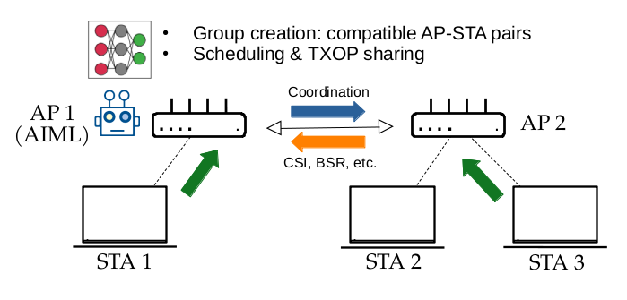
Figure 1. MAPC example scenario

The MAPC use case proposes to apply AIML methods to MAPC with the goal of improving utilisation of available resources while maintaining minimum inter-BSS interference. In particular, AIML can be used to learn and make decisions for the following subtasks of MAPC:
- Select which devices (APs/STAs) to involve (e.g., find the AP-STA pairs that can leverage coordinated transmissions).
- Configure the selected transmission strategies and the associated parameters.
- Perform prediction-based scheduling decisions following traffic patterns and channel conditions.
- Reduce the overhead of statistical information exchange required for MAPC.
Since UHR will define a subset of all possible coordination levels and transmission strategies, we note that AIML can choose the best strategies among the available options given the state of the environment. The AIML model selection and training will need to consider the specifics of the available transmission strategies (e.g., coordinated beamforming may require different training than coordinated OFDMA).

Figure 2 presents an example message exchange for an AIML-enhanced multi-AP coordinated transmission. (This is an illustrative example only, the exact exchange of MAPC messages will be determined by UHR.) The MAPC exchange is triggered by a sharing AP (AP 1) with an MAPC-RTS/MAPC-CTS exchange between all APs involved in the upcoming coordinated transmission. This RTS/CTS may be optional. Then, in an initial phase —indicated by (1) in Figure 2— each AP collects information from its associated stations. Note that this data collection and report phase may not be required if AIML can predict measurement reports, or in the case that some measurements are quasi-static. Moreover, principal component analysis (PCA) can be used to reduce the amount of data to exchange (i.e., exchanging only a fraction of the total data, and reconstructing the missing data at the destination). However, since the reconstructed data may incur information loss, the accuracy-overhead trade-off needs to be considered. In the second phase —indicated by (2) in Figure 2— these reports are communicated to the sharing AP which uses AIML to select and configure the MAPC transmission strategy to be used in the final phase of transmission. It is expected that the pre-trained AIML model provides either a near-instantaneous response for immediately scheduling the coordinated transmission or schedules coordinated transmissions in the near future.

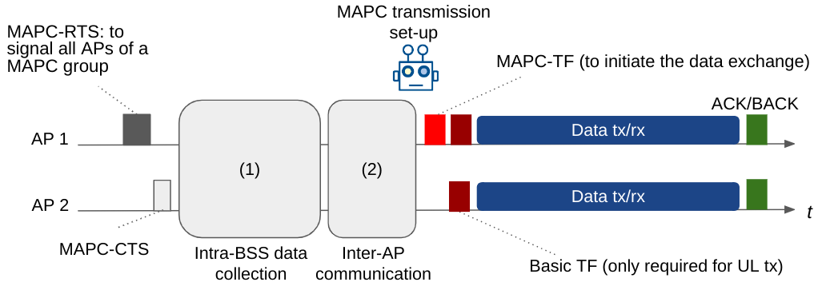
Figure 2. Example of AIML-enhanced MAPC message exchange.

    - KPIs

The KPIs considered in this use case are proposed as follows:
- Network performance metrics (throughput, latency and jitter, power efficiency) measured at the BSS level but also aggregated over the whole multi-AP network.
- Fairness – to ensure that all users are fairly served.
- AIML overhead – additional signalling, computational complexity, and learning latency, i.e., any additional delay which is introduced by AIML exploration.

    - Requirements

The requirements of this use case are the following:
- Compatibility with UHR amendment (as it becomes drafted).
- Performance evaluation proving the gain from AIML (improved network performance metrics, high fairness, low overhead).

    - Potential features analysis
The following potential features can be analysed within the scope of this use case. First, applying AIML in scenarios where the MAPC transmission strategy must be selected and configured. The set of transmission strategies will be defined in the UHR amendment and may include TXOP sharing (coordinated TDMA), coordinated OFDMA, coordinated spatial reuse, coordinated beamforming and joint transmissions. Second, applying AIML to predict measurement reports to limit the MAPC signalling overhead.

    - Technical feasibility analysis

      - Standard impact
The signalling and protocols related to parameter exchange between APs as well as between APs and non-AP STAs may be impacted. Signalling may be required to facilitate AIML model training, e.g., an AP may request additional data reports (the same format as standardized but requested more frequently). Additionally, trained AIML models may be shared between APs (according to Use case #X Model Sharing) so that any AP can be the sharing AP in case they are the TXOP holders. Conversely, signalling can also be reduced if an AIML model is able to predict network and traffic conditions so that the exchange of reports, indicated as (1) and (2) in Figure 2, is not required.

      - Technical feasibility
Hardware/software capability: The APs that support AIML-based multi-AP coordination shall have the hardware and software capability to support AIML algorithm(s). The APs that support model training may require higher computation capabilities.

- Summary
The reported use case of applying AIML for multi-AP coordination is important because MAPC is a strong candidate for adoption in UHR and can benefit from extensions with AIML support.

References:
[1] 11-22/1899 "Multi-AP Operation for Low Latency Traffic Delivery - Follow up"
[2] 11-22/1512 "Multi AP Coordination and Residential Wi-Fi"
[3] 11-22/1516 "Considerations on Multi-AP Coordination"
[4] C. Deng et al., "IEEE 802.11be Wi-Fi 7: New Challenges and Opportunities," in IEEE Communications Surveys & Tutorials, vol. 22, no. 4, pp. 2136-2166, Fourthquarter 2020, doi: 10.1109/COMST.2020.3012715.
[5] D. Nunez, F. Wilhelmi, S. Avallone, M. Smith and B. Bellalta, "TXOP sharing with Coordinated Spatial Reuse in Multi-AP Cooperative IEEE 802.11be WLANs," 2022 IEEE 19th Annual Consumer Communications & Networking Conference (CCNC), Las Vegas, NV, USA, 2022, pp. 864-870.
[6] S. Szott et al., "Wi-Fi Meets ML: A Survey on Improving IEEE 802.11 Performance With Machine Learning," in IEEE Communications Surveys & Tutorials, vol. 24, no. 3, pp. 1843-1893, thirdquarter 2022.
[7] N. Nurani Krishnan, E. Torkildson, N. B. Mandayam, D. Raychaudhuri, E. -H. Rantala and K. Doppler, "Optimizing Throughput Performance in Distributed MIMO Wi-Fi Networks Using Deep Reinforcement Learning," in IEEE Transactions on Cognitive Communications and Networking, vol. 6, no. 1, pp. 135-150, March 2020.
[8] L. Zhang, H. Yin, S. Roy and L. Cao, "Multiaccess Point Coordination for Next-Gen Wi-Fi Networks Aided by Deep Reinforcement Learning," in IEEE Systems Journal, 2022.
[9] UPF/ITU-T AI Challenge 2022 edition, https://www.upf.edu/web/wnrg/2022-edition (accessed on 2023-02-21).
[10] 802.11 UHR Draft Proposed PAR, doc.: IEEE 802.11-22/0078r3.
[11] P. Imputato, S. Avallone and D. Magrin, "Multi-AP coordination in Wi-Fi 7 exploiting time resources sharing," 2022 IEEE International Mediterranean Conference on Communications and Networking (MeditCom), Athens, Greece, 2022, pp. 166-171, doi: 10.1109/MeditCom55741.2022.9928663.
[12] Nunez, David, Malcom Smith, and Boris Bellalta. "Multi-AP Coordinated Spatial Reuse for Wi-Fi 8: Group Creation and Scheduling." MedComNet 2023. arXiv preprint arXiv:2305.04846 (2023).
[13] I. -S. Comşa, S. Zhang, M. Aydin, P. Kuonen, R. Trestian and G. Ghinea, "Enhancing User Fairness in OFDMA Radio Access Networks Through Machine Learning," 2019 Wireless Days (WD), Manchester, UK, 2019, pp. 1-8, doi: 10.1109/WD.2019.8734262.
[14] I.-S. Comsa, S. Zhang, M. Aydin, P. Kuonen, R. Trestian, and G. Ghinea, “A Comparison of Reinforcement Learning Algorithms in Fairness-Oriented OFDMA Schedulers,” Information, vol. 10, no. 10, p. 315, Oct. 2019, doi: 10.3390/info10100315.
[15] M. K. Tefera, S. Zhang, and Z. Jin, “Deep Reinforcement Learning-Assisted Optimization for Resource Allocation in Downlink OFDMA Cooperative Systems,” Entropy, vol. 25, no. 3, p. 413, Feb. 2023, doi: 10.3390/e25030413.
[16] D. Kotagiri, K. Nihei and T. Li, "Distributed Convolutional Deep Reinforcement Learning based OFDMA MAC for 802.11ax," ICC 2021 - IEEE International Conference on Communications, Montreal, QC, Canada, 2021, pp. 1-6, doi: 10.1109/ICC42927.2021.9500628.
[17] Y. Kihira, Y. Koda, K. Yamamoto, T. Nishio and M. Morikura, "Adversarial Reinforcement Learning-based Robust Access Point Coordination Against Uncoordinated Interference," 2020 IEEE 92nd Vehicular Technology Conference (VTC2020-Fall), Victoria, BC, Canada, 2020, pp. 1-5, doi: 10.1109/VTC2020-Fall49728.2020.9348462.
[18] S. Verma, T. K. Rodrigues, Y. Kawamoto, and N. Kato. "A Survey on Multi-AP Coordination Approaches over Emerging WLANs: Future Directions and Open Challenges." arXiv preprint arXiv:2306.04164 (2023).

