IEEE P802.11
Wireless LANs
Proposed IEEE 802.11 AIML TIG Technical Report Text for the Multi-AP Coordination Use Case
Date: 2023-02-27
Author(s):
Name | Affiliation | Address | Phone | email
Szymon Szott | AGH University of Science and Technology | al. Mickiewicza 30, 30-059 Kraków, Poland |  | szott@agh.edu.pl
Katarzyna Kosek-Szott |  |  |  | kks@agh.edu.pl
Boris Bellalta | UPF Barcelona | Plaça de la Mercè, 10-12, 08002 Barcelona, Spain |  | boris.bellalta@upf.edu
Abstract
This document contains the proposed text for the multi-AP coordination grouping use case to be included in the IEEE 802.11 AIML TIG technical report.

Revision history:
r0: initial version
r1: add Figure 2
r2: updated based on comments from Peng Liu

- Introduction
  - Terminologies
  - Background information

- AIML Use cases for IEEE 802.11
  - Use case N: Multi-AP Coordination

In dense multi-AP networks, co-channel interference becomes a problem. Hence, methods for multi-AP coordination (MAPC) become necessary to improve the utilisation of the limited radio resources, typically measured as an increase of the overall network throughput [4]. An example method is to create groups of APs, able to leverage spatial reuse opportunities, and have stations transmit in parallel during transmission opportunities (TXOPs) shared among coordinated APs [5]. Several coordination methods (sometimes called coordination subtypes), which we refer to as MAPC transmission strategies, have been proposed in the literature and discussed in the 802.11 WG including coordinated OFDMA, coordinated spatial reuse, coordinated beamforming, and joint transmissions [3]. In addition to the transmission strategies used in the data plane, there is also the control plane issue of MAPC coordination level (centralised, distributed, etc.). Various coordination levels have been proposed, e.g., two levels (loose/light coordination and tight coordination) [1] or even three levels (centralised, direct peer-to-peer between APs, peer-to-peer between APs through a common non-AP STA) [2]. The Ultra High Reliability (UHR) SG will be “considering scenarios with multiple overlapping networks” [10] and discussions in the group confirm that MAPC is expected to be a key feature [3], although specifics regarding MAPC implementation (transmission strategies and coordination levels) are still left open.

Analysing the state of the art, MAPC is clearly a novel functionality with as yet few ML-based solutions [6]. A related method was studied in [7], where distributed MIMO (D-MIMO) for WLANs was proposed under the assumption that APs are replaced in a multi-AP network by radio heads (RHs). DRL agents were able to learn which groups of RHs to select to perform D-MIMO following dynamic client distribution, leading to a 20% overall throughput improvement. The authors of [8] propose a centralised channel allocation architecture which supports federated learning of channel access. The method is shown to outperform TXOP sharing, but is not strictly an MAPC transmission strategy as considered by UHR. In summary, even though a literature review reveals few AIML solutions to MAPC so far, research in this area is expected, as evidenced by the “Machine Learning for Throughput Prediction in Coordinated Wi-Fi Networks” problem statement of the ITU AI Challenge [9].

To illustrate AIML-enhanced MAPC operation, Figure 1 shows a simple scenario with 2 BSSs. AP 1 (BSS 1) is able to execute AIML models, which may be trained outside the 802.11 network, in AP 1, or in other APs such as AP 2. It collects CSI, BSR and any other suitable information from AP 2 (BSS 2) and all associated stations (STAs 1, 2, and 3), either directly or through AP 2. Using the collected information as the input for the AIML model, AP 1 is then able to a) determine if BSS 1 and BSS 2 can form an MAPC group, and b) select the most adequate transmission strategy depending on which AP-STA pairs are scheduled. For example, while STA 1 and STA 3 can transmit simultaneously by leveraging coordinated spatial reuse, transmissions from STA 1 and STA 2 require coordinated OFDMA.

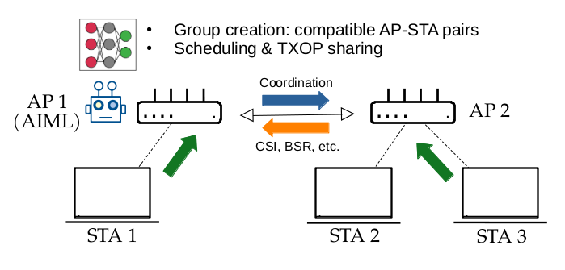
Figure 1. MAPC example scenario

The MAPC use case proposes to apply AIML methods to MAPC with the goal of improving utilisation of available resources while maintaining minimum inter-cell interference. In particular, AIML can be used to learn and make decisions for the following subtasks of MAPC:
- Select which devices (APs/STAs) to involve (e.g., find the AP-STA pairs that can leverage coordinated transmissions).

- Configure the selected transmission strategies and the associated parameters.
- Perform prediction-based scheduling decisions following traffic and channel patterns.
AIML may also reduce the overhead of statistical information exchange required for MAPC.
Since UHR will define a subset of all possible coordination levels and transmission strategies, we note that AIML can choose the best strategies among the available options given the state of the environment.

Figure 2 presents an example message exchange for an AIML-enhanced multi-AP coordinated uplink transmission. (This is an illustrative example only, the exact exchange of MAPC messages will be determined by UHR.) The MAPC exchange is triggered by a sharing AP (AP 1) with an MAPC-RTS/MAPC-CTS exchange between all APs involved in the upcoming coordinated transmission. Then, the first phase of the exchange (gathering information) is initiated by the sharing AP, which sends an info trigger frame (TF) to the other APs, which in turn send TFs to their associated stations. These stations reply with reports. Note that this data collection and report phase may not be required if AIML can predict measurement reports, or in the case that some measurements are quasi-static. For example, principal component analysis (PCA) can be used to reduce the amount of data to exchange (i.e., exchanging only a fraction of the total data, and reconstructing the missing data at the destination). In the second phase, these reports are communicated to the sharing AP which uses AIML to select and configure the MAPC transmission strategy to be used in the final phase for transmission.

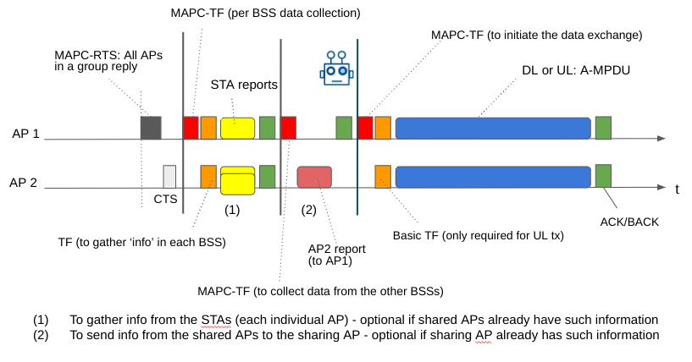
Figure 2. Example of AIML-enhanced MAPC message exchange.

The KPIs considered in this use case are proposed as follows:
- Network performance metrics (throughput, latency and jitter, reliability of data delivery, power efficiency) measured at the BSS level but also aggregated over the whole multi-AP network.
- Fairness – to ensure that all users are fairly served.
- Energy efficiency – the additional energy required for learning and coordination needs to be offset by the network performance gains.
- AIML overhead – additional signalling, computational complexity, and learning latency, i.e., any additional delay which is introduced by AIML exploration.

- Requirements and Potential features analysis (high level)
  - Requirements
The requirements of this use case are the following:
- Compatibility with UHR standard (as it becomes drafted).
- A set of reference scenarios for demonstrating performance improvement over non-AIML MAPC.
- Performance evaluation targeting the mentioned KPIs: improving the network performance metrics, while maintaining high fairness and a low overhead.

  - Potential features analysis
The following potential features can be analysed in this use case:
- MAPC coordination level
  - Centralised
  - Distributed
- MAPC transmission strategy
  - TXOP sharing / coordinated TDMA
  - Coordinated OFDMA
  - Coordinated spatial Reuse
  - Coordinated beamforming
  - Joint transmissions

- Technical feasibility analysis
  - Standards impact
Signalling and protocols related to parameter exchange between APs as well as between APs and non-AP STAs, e.g., capability indication, data report to facilitate AIML model training (exchange state info: buffer state, CSI info, etc.), management information (to set up joint transmissions). Additionally, distributing the AI/ML model between APs (according to Use case #X Model Sharing) so that any can be the sharing AP in case they are the TXOP holders.

  - Technical feasibility
Hardware/software capability: The APs that support AIML-based multi-AP coordination shall have the hardware and software capability to support AIML algorithm(s). The APs that support model training may require higher computation capabilities.

- Summary
The reported use case of applying AIML for multi-AP coordination is important because MAPC is a strong candidate for adoption in UHR and can benefit from extending with AIML support.

References:
[1] 11-22/1899 "Multi-AP Operation for Low Latency Traffic Delivery - Follow up"
[2] 11-22/1512 "Multi AP Coordination and Residential Wi-Fi"
[3] 11-22/1516 "Considerations on Multi-AP Coordination"
[4] C. Deng et al., "IEEE 802.11be Wi-Fi 7: New Challenges and Opportunities," in IEEE Communications Surveys & Tutorials, vol. 22, no. 4, pp. 2136-2166, Fourthquarter 2020, doi: 10.1109/COMST.2020.3012715.
[5] D. Nunez, F. Wilhelmi, S. Avallone, M. Smith and B. Bellalta, "TXOP sharing with Coordinated Spatial Reuse in Multi-AP Cooperative IEEE 802.11be WLANs," 2022 IEEE 19th Annual Consumer Communications & Networking Conference (CCNC), Las Vegas, NV, USA, 2022, pp. 864-870.
[6] S. Szott et al., "Wi-Fi Meets ML: A Survey on Improving IEEE 802.11 Performance With Machine Learning," in IEEE Communications Surveys & Tutorials, vol. 24, no. 3, pp. 1843-1893, thirdquarter 2022.
[7] N. Nurani Krishnan, E. Torkildson, N. B. Mandayam, D. Raychaudhuri, E. -H. Rantala and K. Doppler, "Optimizing Throughput Performance in Distributed MIMO Wi-Fi Networks Using Deep Reinforcement Learning," in IEEE Transactions on Cognitive Communications and Networking, vol. 6, no. 1, pp. 135-150, March 2020.
[8] L. Zhang, H. Yin, S. Roy and L. Cao, "Multiaccess Point Coordination for Next-Gen Wi-Fi Networks Aided by Deep Reinforcement Learning," in IEEE Systems Journal, 2022.
[9] UPF/ITU-T AI Challenge 2022 edition, https://www.upf.edu/web/wnrg/2022-edition (accessed on 2023-02-21).
[10] 802.11 UHR Draft Proposed PAR, doc.: IEEE 802.11-22/0078r3.

