IEEE P802.11
Wireless LANs
RESOLUTION OF CID 3316
Date: 2022-12-02
Author(s):
Name | Affiliation | Address | Phone | email
Graham SMITH | SR Technology | Sunrise, FL, USA. | 916 799 9563 | gsmith@srtrl.com
Abstract
This submission proposes resolution for CID 3316

Green indicates material agreed to in the group,
yellow material to be discussed, red material rejected by the group and
cyan material not to be overlooked.

The “Final” view should be selected in Word.

3316 Clause 6.5.9.2 MLME_DISASSOCIATE.confrim. The semantics of the service primitive are missing.

____________________________________________________________________________________
6.5.9.2 MLME-DISASSOCIATE.confirm
6.5.9.2.1 Function

This primitive reports the results of a disassociation procedure with a specific peer MAC entity.

6.5.9.2.2 Semantics of the service primitive

The primitive parameters are as follows:
MLME-DISASSOCIATE.confirm()

6.5.9.2.3 When generated
This primitive is generated by the MLME as a result of an MLME-DISASSOCIATE.request primitive to
(#2234)disassociate from a specified peer MAC entity.

6.5.9.2.4 Effect of receipt
The SME is notified of the results of the disassociation procedure.
_________________________________________________________________________________________
It appears that in 802.11 – 2020 and 802.11 -2016 this omission is also present (Clause was then 6.3.9.2)

In 802.11 – 2012 the clause is present:

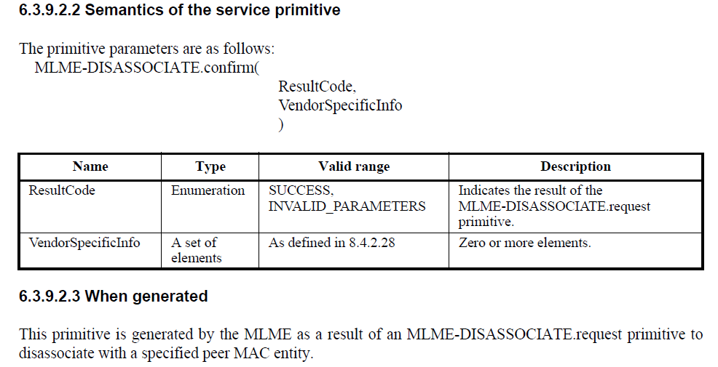:

The resolution is therefore to copy the text for 6.3.9.2.2. from 802.11 – 2012 Page 145 and insert as clause 6.5.9.2.2 at 476.43 in D2.0

RESOLUTION
REVISED

Clause 6.5.9.2.2 P476.43 to read as follows:

6.5.9.2.2 Semantics of the service primitive

The primitive parameters are as follows:
MLME-DISASSOCIATE.confirm(
ResultCode,
VendorSpecificInfo
)

