IEEE P802.11
Wireless LANs
CID 3097 and 3096 – LB258 802.11REVme
Date: 2022-08-23
Author(s):
Name | Affiliation | Address | Phone | email
Joseph LEVY | InterDigital, Inc. | 111 W 35th St., NY, New York | +1 631.622.4239 | joseph.levy@interdigital.com
Abstract
This document provides a proposed resolution for CID 3097 and 3096 from LB258.

This contribution addresses:

CID | Page | Line | Clause |  | Comment |  | Proposed Change
3097 | 3113 | 60 | 15.2.3 |  | The definition of RX_START_OF_Frame_OFFSET seems to only be located in the RXVECTOR parameter tables and the definition itself does not make sense. All timing parameters for measurements are provided by the PHY and exist in the PHY, the MAC only uses the PHY supplied values. Hence, "an estimate of the offset from the point in time at which the start of the preamble off the PPDU arrived at the received antenna connector to the point in time at which this primitive is issued to the MAC" does not make sense. In clause 8.3.5.6.3 there is a note stating that a more precise name for RX_START_OF_FRAME_OFFSET would be RX_START_OF_PPDU_TO_PHY_RXSTART_PRIMITIVE_OFFSET. In clause 15.2.3 RXVECTOR parameters all of the parameters are defined in subclauses except the RX_START_OF_FRAME_OFFSET parameter. However in clause 6.3.55.1 an offset is mention in Note 2 that describes an offset that can be used to correct the timestamp generated by the PHY by subtracting the delay between actual start of frame arrival at the antenna to when the timestamp is generated (this is an implementation specific value). I believe that this offset is the RX_START_OF_FRAME_OFFSET. Also note that previous versions of 802.11 (e.g. 2012) had two times shown Figure 6-16 t2 and t3, where t3 corresponded to the time stamp and t2 the time of arrival, which was "t3"-"the offset". Also it should be noted that the timing of when a frame is sent to the MAC has no meaning as the MAC does not measure arrival times only the PHY is capable of making such measurements. |  | Replace: "An estimate of the offset (in 10 ns units) from the point in time at which the start of the preamble of the PPDU arrived at the receive antenna connector to the point in time at which this primitive is issued to the MAC." With: "An estimate of the offset (in 10 ns units) from the point in time at which the start of the preamble of the PPDU arrived at the receive antenna to the point in time that the time stamp is generated." With: "An estimate of the offset (in 10 ns units) from the point in time at which the start of the preamble of the PPDU arrived at the receive antenna to the point in time that the time stamp is generated." Note this definition should also be corrected at the following additional locations: 3114.37, 3152.6, 3168.42, 3217.6, 3235.42, 3392.27, 3523.10, and 3578.20 (9 locations in all).
3098 | 3121 | 37 | 15.3.7 | The use of RX_START_OF_FRAME_OFFSET is said to be described in 6.3.55, based on notes in the draft at the following locations: 3426.37, 3451.55, 3513.16, 3622.53, 3680.58, 3793.62, and 4113.45. But "RX_START_OF_FRAME_OFFSET" is not present in the clause. The clause does refer to an "offset" in several notes, but it does not tie the RX_START_OF_FRAME_OFFSET to any of the offsets mentioned in the clause. It seems the offset mentioned in NOTE 2 - is the RX_START_OF_FRAME_OFFSET but there is no reference to the parameter. |  | Replace the NOTE with the following:  "The RX_START_OF_FRAME_OFFSET value is the offset used to compensate for the delay in generating the timestamp as described in 6.3.55 (Timing measurement). The estimated arrival time of the start of the preamble for the incoming PPDU is the value of the timestamp minus the value of RX_START_OF_FRAME_OFFSET."  Note this note should also be corrected at the following additional locations: 3146.55, 3207.18, 3316.56, 3374.57, 3489.17, 3691.14, and 3811.45 (8 locations in all).

Discussion:
This comment was discussed in the 802.11 TGme December Ad Hoc

From the minutes [1]:
    - CID 3097 (PHY)
      - Review Comment
      - Review the proposed change – note that the Proposed Change as a duplicate change included in it.
      - The 9 instances are different PHYs
      - There is a reference that was cleared up yesterday, it was removed.
      - Discussion on why we may remove the “connector” from Antenna.
      - It was discussed if this one was the connector or the start of the antenna.
      - The discussion is measurement of a received antenna, only one antenna is used to receive a specific signal and is what is used for measurement.
      - In a Multi-antenna system, we have had debate on where the point is.
      - For most of the antenna measurements, they are done at the antenna connector, but for this parameter, it is about when the signal hit the antenna, and when the measurement occurred.
      - Timestamp is one word.
      - Assign CID to Joseph Levy
      - Mark CID – More Work Required.
      - Schedule for the January Interim

    - CID 3098 (PHY)
      - Similar to CID 3097
      - Assign CID to Joseph Levy
      - Mark CID – More Work Required.
      - Schedule for the January Interim

Email was sent to the reflector to get feedback and comments from experts:
On 2022-12-14 an email was sent to the 802.11 WG and the 802.11 TGme reflectors: “TGme - PHY - discussion on RX_START_OF_Frame_OFFSET point of reference- CID 3097”
No response was received.

On 2022-12-16 the above e-mail was forwarded (resent) to some timing experts from TGaz: Jonathan Segev, Assar Kasher, Chaochun Wand, Roy Want, Dong Wei, Steve Shellhammer, Yan Junsunstd, and Christian Berger.
No response was received.

Resolution for CID 3097:
Revised (there is a cut and past error in the comment and the changes are provided twice)

Proposed CID 3097 text changes (redlined) for reference:

An estimate of the offset (in 10 ns units) from the point in time at which the start of the preamble of the PPDU arrived at the receive antenna to the point in time that the time stamp is generated."

Note this definition should also be corrected at the following additional locations: 3114.37, 3152.6, 3168.42, 3217.6, 3235.42, 3392.27, 3523.10, and 3578.20 (9 locations in all).

Resolution for CID 3098:
Accepted

Proposed CID 3098 text changes (redlined) for reference:

Edit the NOTE as shown:
NOTE—The RX_START_OF_FRAME_OFFSET value is the offset used to compensate for the delay in generating the timestamp as described in 6.3.55 (Timing measurement). The estimated arrival time of the start of the preamble for the incoming PPDU is the value of the timestamp minus the value of RX_START_OF_FRAME_OFFSET.

Note this note should also be corrected at the following additional locations: 3146.55, 3207.18, 3316.56, 3374.57, 3489.17, 3691.14, and 3811.45 (8 locations in all).

From P802.11REVme D1(highlighting added):
6.3.55.1 General
The following set of primitives supports triggering a Timing Measurement procedure or stopping an
ongoing Timing Measurement procedure, and exchange of timing measurement information from one SME
to another. Figure 6-16 (Timing measurement primitives and timestamps capture) shows the use of these
primitives and various points in time that are of interest to the timing measurement procedure.

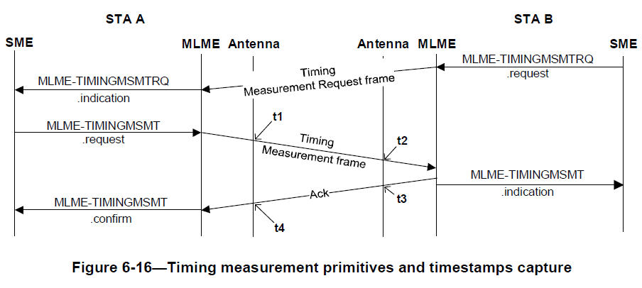

NOTE 1—In Figure 6-16 (Timing measurement primitives and timestamps capture), t1 and t3 correspond to the point in
time at which the start of the preamble for the (#14)PPDU containing the Timing Measurement of Ack frame appears at
the transmit antenna connector. An implementation may capture a timestamp during the transmit processing earlier or
later than the point at which it actually occurs and offset the value to compensate for the time difference.

NOTE 2—In Figure 6-16 (Timing measurement primitives and timestamps capture), t2 and t4 correspond to the point in
time at which the start of the preamble for the (#14)PPDU containing the Timing Measurement or Ack frame arrives at
the receive antenna connector. Because time is needed to detect the (#14)PPDU and synchronize with its logical
structure, an implementation determines when the start of the preamble for the (#14)PPDU arrived at the receive antenna
connector by capturing a timestamp some time after it occurred and compensating for the delay by subtracting an offset
from the captured value.

Note: this information seems to have been removed with the Clause 6 update. But there are still refences to it in D2.0 related to RX_START_OF_FRAME_OFFSET, so this may need to be put somewhere in the draft.
References:
1 11-22/2110r1 “Minutes for REVme 2022 December AdHoc – Piscataway”

