IEEE P802.11
Wireless LANs
RXVECTOR Parameter CSI_ESTIMATE
Date: 2022-01-13
Author(s):
Name | Affiliation | Address | Phone | email
Claudio da Silva | Meta Platforms |  |  | claudiodasilva@meta.com
Abstract
This submission proposes a possible definition for the RXVECTOR parameter CSI_ESTIMATE.

Discussion:
- It is necessary to define an RXVECTOR parameter that allows the MAC/SME to retrieve CSI measurements needed to support the WLAN sensing procedure.
- TGbf’s draft already assume the existence of such parameter. For example,
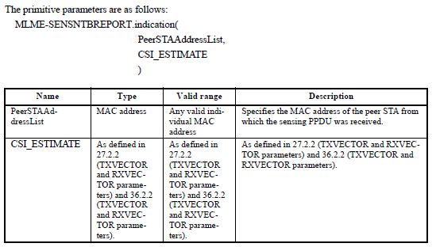

Modifications: Editor – Please add the following parameter to Table 27-1 (TXVECTOR and RXVECTOR parameters) under 27.2.2 (TXVECTOR and RXVECTOR parameters) and 27.2 (HE PHY service interface)

Parameter | Condition | Value | TXVECTOR | RXVECTOR
CSI_ESTIMATE | FORMAT is either HE_SU or HE_TB, and PSDU_LENGTH is 0 | Contains an array of CSI values based on the channel measured during the training symbols of the received HE Ranging NDP or HE TB Ranging NDP (see 11.55.1 (WLAN sensing procedure)). The number of complex elements is $N_{SC}×N_{TX}×N_{RX}$ where $N_{SC}$ is the total number of subcarriers, $N_{TX}$ is the number of transmit antennas, and $N_{RX}$ is the number of receive antennas. | N | Y
 | Otherwise | Not present | N | N

Editor – Please add the following parameter to Table 36-1 (TXVECTOR and RXVECTOR parameters) under 36.2.2 (TXVECTOR and RXVECTOR parameters) and 36.2 (EHT PHY service interface)

Parameter | Condition | Value | TXVECTOR | RXVECTOR
CSI_ESTIMATE | FORMAT is EHT_MU, PSDU_LENGTH is 0, and CH_BANDWIDTH is either CBW320-1 or CBW320-2 | Contains an array of CSI values based on the channel measured during the training symbols of the received EHT sounding NDP (see 11.55.1 (WLAN sensing procedure)). The number of complex elements is $N_{SC}×N_{TX}×N_{RX}$ where $N_{SC}$ is the total number of subcarriers, $N_{TX}$ is the number of transmit antennas, and $N_{RX}$ is the number of receive antennas. | N | Y
 | Otherwise | Not present | N | N

Notes (for HE text):
- PSDU Length
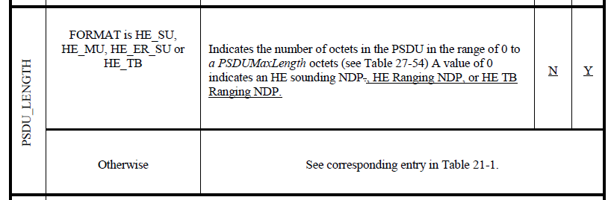
- Format
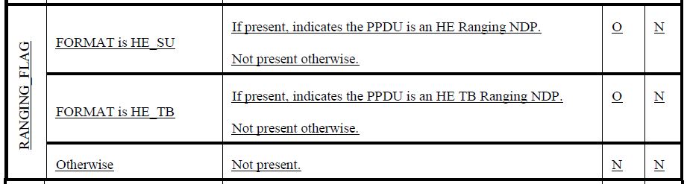
- Main reference:
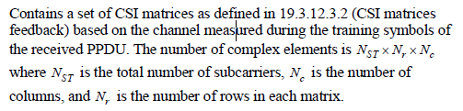

Notes (for EHT text):
