IEEE P802.11
Wireless LANs
RXVECTOR Parameter CSI_ESTIMATE
Date: 2022-01-13
Author(s):
Name | Affiliation | Address | Phone | email
Claudio da Silva | Meta Platforms |  |  | claudiodasilva@meta.com
Abstract
This submission proposes a possible definition for the RXVECTOR parameter CSI_ESTIMATE.

Discussion:
- It is necessary to define an RXVECTOR parameter that allows the MAC/SME to retrieve CSI measurements needed to support the WLAN sensing procedure.
- TGbf’s draft already assume the existence of such parameter. For example,
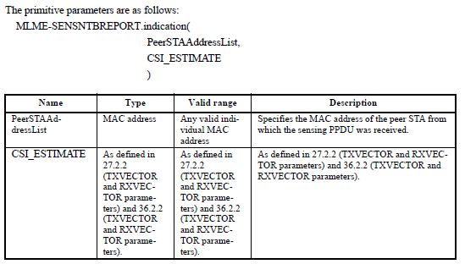

Modifications: Editor – Please add the following parameter to Table 27-1 (TXVECTOR and RXVECTOR parameters) under 27.2.2 (TXVECTOR and RXVECTOR parameters) and 27.2 (HE PHY service interface)

Parameter | Condition | Value | TXVECTOR | RXVECTOR
CSI_ESTIMATE | FORMAT is either HE_SU or HE_TB, and PSDU_LENGTH is 0 | Contains an array of CSI values as defined in 9.4.1.75.4 (Sensing Measurement Report field) based on the channel measured during the training symbols of the received HE Ranging NDP or HE TB Ranging NDP. | N | Y
 | Otherwise | Not present | N | N

Notes:
- PSDU Length
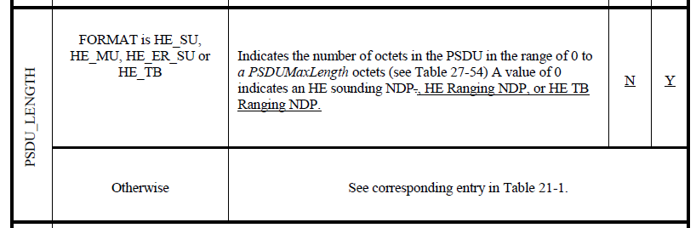
- Format
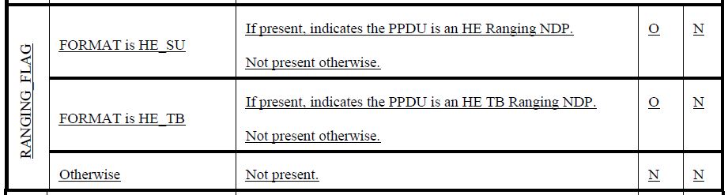
- Other references (Table 27-1—TXVECTOR and RXVECTOR parameters, IEEE P802.11-REVme/D2.0)
- CHAN_MAT “Contains a vector in the number of selected subcarriers containing feedback matrices as defined in 27.3.16.2 (Beamforming feedback matrix V) based on the channel measured during the training symbols of previous HE sounding NDP.”
- DELTA_SNR “Contains an array of delta SNR values as defined in 9.4.1.66 (HE MU Exclusive Beamforming Report field(11ax)) based on the channel measured during the training symbols of the received HE sounding NDP.”
- SNR “Contains an array of average values of received SNR measurements for each spatial stream. SNR indications of 8 bits are supported. Average value of SNR shall be the sum of the decibel values of SNR per subcarrier divided by the number of subcarriers represented in each stream as described in 9.4.1.65 (HE Compressed Beamforming Report field(11ax)).”

