IEEE P802.11
Wireless LANs
PDT for Sensing Measurement Report – Bug Fix
Date: 2023-01-11
Author(s):
Name | Affiliation | Address | Phone | email
Mahmoud Kamel | InterDigital |  |  | mahmoud.kamel@interdigital.com
Zinan Lin | InterDigital
Rui Yang | InterDigital

Abstract
This submission proposes changes to the Sensing Measurement report in P802.11bf D0.51:

NOTE – Set the Track Changes Viewing Option in the MS Word to “All Markup” to clearly see the proposed text edits.

Revision History:

R0: Initial version
R1: SPed several options of potential text changes and applied the changes according to option2.

DISCUSSION:
The support of reporting the Sensing Measurement Report to the initiator is optional in 11bf as stated in Motion 60, but the support of generating the Sensing Measurement Report should not be optional. In cases where sending the Sensing Measurement Report is not required, the Sensing Measurement Report should be generated and consumed locally at the responder. To keep the same interface between the case when the responder sends the Sensing Measurement Report to the initiator (Figure 1) and the case when it consumes it locally (Figure 2), the generation of the Sensing Measurement Report should be mandatory.

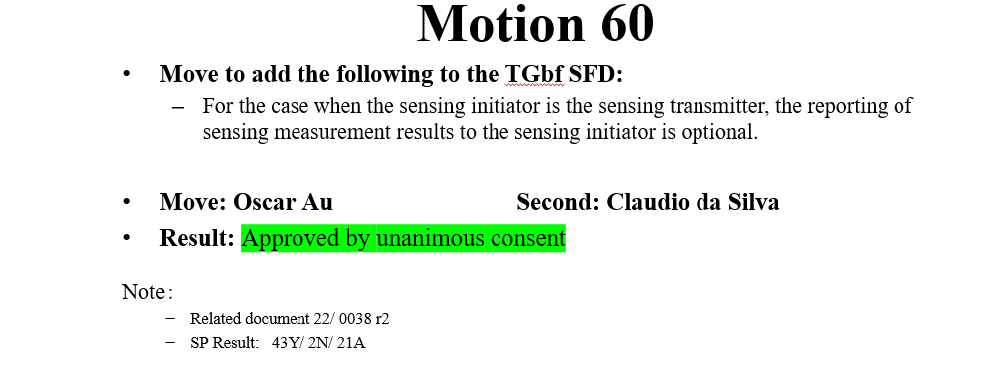

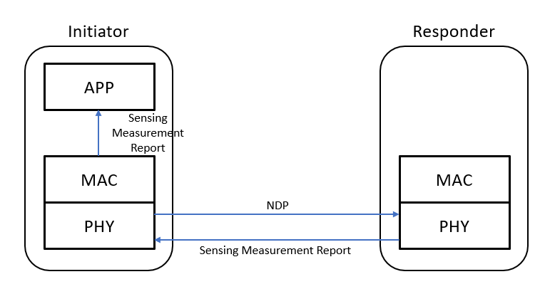
Figure 1: Responder Sends the Sensing Measurement Report to the Initiator

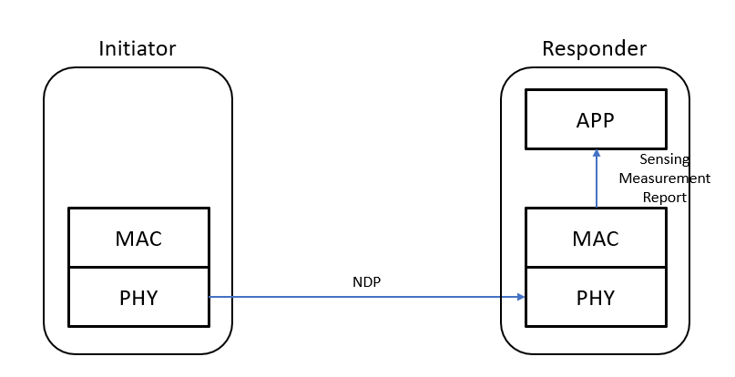
Figure 2: Responder Generates and Consumes the Sensing Measurement Report Locally

END OF DISCUSSION

SP1: Which option of the following options do you prefer to change the text in Subclause 11.55.1.2 Dependencies in 11bf D0.51 P156L9
- A STA that transmits a Sensing Measurement Report frame shall support $N_{b}$values of 8 and 10.

- A STA shall support $N_{b}$values of 8 and 10 in the Sensing Measurement Report frame.

- A STA shall support $N_{b}$values of 8 and 10 in the Sensing Measurement Report frame it transmits.

- When a STA transmits a Sensing Measurement Report frame, it shall support $N_{b}$values of 8 and 10.

- When a STA transmits or receives a Sensing Measurement Report frame, it shall support $N_{b}$values of 8 and 10.

Result: 1/2/3/4/5/abs: 1/16/0/9/1/4

The SP considered only one sentence in Subclause 11.55.1.2 Dependencies in 11bf D0.51, however, it applies to all the sentences in this Subclause.

TGbf Editor: Please modify Clause 11.55.1.2 Dependencies in 11bf D0.51 P156L9 based on the results of SP1 as follows

A STA shall support Nbvalues of 8 and 10 in the Sensing Measurement Report frame.

A STA with four or less transmit antennas shall support an $N_{g}$
value of 4 and may optionally support an Ng value of 16 in the Sensing Measurement Report frame.

A STA with five or more transmit antennas, and a bandwidth of 80 MHz
shall support an Ng value of 4 and may optionally support an Ng value of 16 in the Sensing Measurement Report frame.

A STA with five or more transmit antennas, and a bandwidth of 160 MHz
shall support an $N_{g}$value of 8 and may optionally support an Ng value of 16 in the Sensing Measurement Report frame.

