IEEE P802.11
Wireless LANs
DMG-Procedure-examples
Date: 2023-01-01
Author(s):
Name | Affiliation | Address | Phone | email
Assaf Kasher | Qualcomm |  |  | akasher@qti.qualcomm.com
Solomon Trainin | Qualcomm |  |  | strainin@qti.qualcomm.com
Abstract
This document proposes a clean-up of the examples of the DMG sensing procedure. The examples will be moved to the correct places in the subclauses discussing the procedure.
All changes are based on D0.5

443 | 11.21.20.1 | 76.54 | "Each DMG sensing instance contains a sounding phase. The first DMG sensing instance in each DMG sensing  burst contains sounding and reporting phases separated by the SIFS interval." - is this normative text (it sounds like that) or does it only describe an example | demote all the example text to a subcluase so examples are separted from normative text | Revise  TGbf Editor: perform changes specified in 11-22-2073r0.

TGbf Editor: change the text in P163L62-65, P164L1-2
Coordinated monostatic sensing is an extension of monostatic sensing to coordinate monostatic sensing. In the Coordinated monostatic sensing type, the transmissions by one or more devices that perform monostatic sensing are coordinated by a PCP/AP(#718).
Coordinated Bistatic sensing is an extension of bistatic type to coordinate multiple sensing responders by one sensing initiator.

TGbf Editor: change the text in P164L29-36
A sensing responder may participate in several DMG sensing measurement setups containing multiple and possibly overlapping DMG sensing bursts.
A sensing initiator may initiate several DMG sensing measurements containing multiple DMG sensing bursts with multiple, possibly overlapping sets of sensing responders(#207).

TGbf Editor: Replace the text (and figures) in P164L44 through P171L47 with the following figure and text

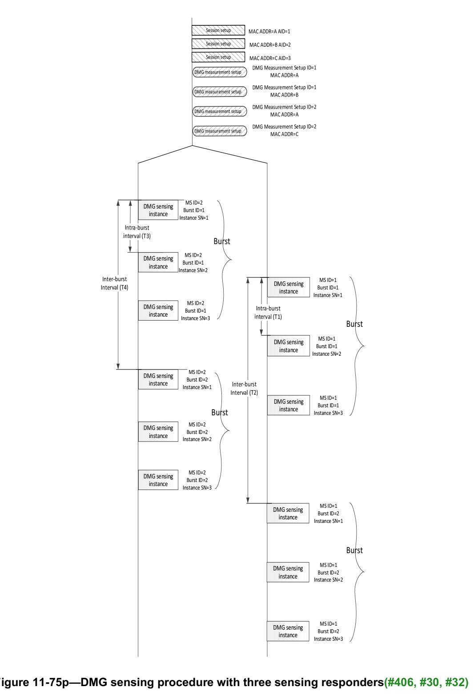
Figure 11-75p (DMG sensing procedure with three sensing responders(#406, #30, #32)) illustrates a DMG sensing procedure with an AP performing a DMG sensing measurements with three non-AP STAs, which are identified by their MAC addresses A, B, and C. The example starts with a DMG sensing session setup procedure performed between the AP and STAs A, B, and C that establishes a sensing session identified by the AID 1, AID 2, and AID 3, respectively.

DMG sensing measurement setup procedures are then performed, defining sets of operational parameters. The AP establishes with STA A and STA B a set that is assigned a DMG Measurement Setup ID equal to 1, and it establishes with STA A and STA C another set that is assigned a DMG Measurement Setup ID equal to 2. Operational parameters identified with the same DMG Measurement Setup ID may be different among the involved STAs, besides the intra-burst and inter-burst intervals. The intervals (inter-burst and intra-burst) for both STAs are equal as per the equal DMG Measurement Setup ID.

After the measurement setup, DMG sensing instances are performed. DMG sensing instances are grouped in DMG sensing bursts. Each DMG sensing burst is identified by the measurement Burst ID. It is unique per the DMG Measurement Setup ID. The figure presents two bursts (with Measurement Burst ID equals to 1, and Measurement Burst ID equals to 2) of the DMG Measurement Setup ID set to 1, and two bursts (with Measurement Burst ID equals to 1, and Measurement Burst ID equals to 2) of the DMG Measurement Setup ID set to 2.
Two DMG sensing bursts belonging to the DMG Measurement Setup ID set to 1 are performed with the
intra-burst interval equal to T1 and the inter-burst interval equal to T2. Another two DMG sensing bursts
belonging to the DMG Measurement Setup ID set to 2 are performed with different burst parameters:
intra-burst interval equal to T3 and the inter-burst interval equal to T4.
The Sensing Instance SNs uniquely identifies the DMG sensing instance per the Measurement Burst ID. There are 3 DMG sensing instances in each burst, which have Sensing Instance SNs equal to 1, 2, and 3.

TGbf Editor: insert the following text and figure at the end of 11.55.3.5 (P175L65)

Figure xyz - Example of a DMG sensing burst

Figure xyz (Example of a DMGsensing burst) illustrates a DMG sensing burst when an AP performs a DMG sensing procedure with two non-AP STAs, which are identified by their MAC addresses A and B. The example starts with a DMG sensing session setup procedure performed between the AP and STAs A and B that establishes a sensing session identified by the AID 1 and AID 2, respectively.

DMG sensing measurement setup procedures are then performed, defining sets of operational parameters. The AP establishes with STA A and STA B a set that is assigned a DMG Measurement Setup ID equal to 1. Operational parameters identified with the same DMG Measurement Setup ID may be different among the involved STAs, besides the intra-burst and inter-burst intervals. The intervals (inter-burst and intra-burst) for both STAs are equal as per the equal DMG Measurement Setup ID.

After the measurement setup, DMG sensing instances are performed. DMG sensing instances are grouped in DMG sensing bursts. Each DMG sensing burst is identified by the Measurement Burst ID. It is unique per the DMG Measurement Setup ID. The figure presents two bursts (with Measurement Burst ID equals to 1, and Measurement Burst ID equals to 2 per DMG Measurement Setup ID equals to 1. Two DMG sensing bursts are performed with the intra-burst interval equal to T1 and the inter-burst interval equal to T2.

The Sensing Instance SNs uniquely identifies the DMG sensing instance per the Measurement Burst ID. There are 3 DMG sensing instances in each burst, which have Sensing Instance SNs equal to 1, 2, and 3. The sensing instances include the initiation and sounding phases and do not include the reporting phase. DMG sensing results are aggregated and reported for each burst.

The report phase is delayed by the time it takes for the responder to calculate the reported result. During the reporting phase, the AP separately polls the responder STA and obtains the report. Each DMG sensing report is identified with responder’s MAC Address and AID and with the DMG Measurement Setup ID and Measurement Burst ID.

TGbf Editor: insert the following text and figure at the end of 11.55.3.6.3 (P178L34)
Figure 1 - Example of a bistatic DMG sensing measurement
Figure 1 shows an example of a bistatic DMG sensing burst. The example shows three instances within the burst identified by their Sensing instance SNs. In each instance the initiator transmits a BRP frame within a BRP PPDU (with TRN field). The responder responds in each instance with a BRP frame. In this case the responder is not ready with immediate report so in each instance after the first one the report is on the previous instance (Report Delay=2). In the first instance there is no report (Report Delay=1).

TGbf Editor: insert the following figure and text after 11.55.3.6.5.3 Reporting (P179L65)
Figure 2 - Example of an EMDG multistaic sensing instance with two sensing responders
Figure 2 shows an example of an EDMG Multistatic sensing instance. The instance starts with the initiator sending a DMG Sensing Request frame to each of the responder to initiate the burst and indicate the parameters that will be used in the TRN fields of the EDMG multistaic sensing PPDUs in the instance. The responders respond with DMG Sensing Response frames indicating they are ready to participate in the instance. After receiving the response from the last responder, the initiator sends an EDMG Multistatic sensing PPDU. Responding STA A uses Sync subfield 1 for synchronization and responding STA B uses Sync subfield 2 for synchronization. They then use the TRN field for sensing. After the EDMG Multistatic sensing PPDU, the initiator uses DMG Sensing Poll frame to solicit reports from the responder.

References:

