IEEE P802.11 Wireless LANs
LB270 SEC Adhoc Comment Resolutions Part 2
Date: 2023-03-03
Author(s):
Name | Affiliation | Address | Phone | email
Michael Montemurro | Huawei |  |  | montemurro.michael@gmail.com
Dan Harkins | HPE
Background
This contribution proposes comment resolutions to selected REVme SEC adhoc comments from LB270.

R0 – Initial version.
R1 – TG Review on Jan 18
R2 – TG Review on Jan 19
R3 – Incorporate changes based on offline comments received from Mark Rison; also added additional resolutions
R4 – TG Review on Feb 10
R5 – TG Review on Mar 3
R6 –

Comment
CID | Page | Clause | Duplicate of CID | Resn Status | Comment | Proposed Change
3469 |  | 12 |  |  | We refer to 802.1X-2010 but there's an 802.1X-2020 | Update references to be to the current standard

Discussion:
- There are 40 occurrences of 802.1X-2010 in the draft. After review, all occurrences could be replaced without affecting the context of their usage.
- There are no changes to 802.1X in IEEE Std 802.1X-2020 that would affect IEEE 802.11.

Proposed Resolution: (3469)
ACCEPTED
Note to Editor: There are 40 occurrences throughout the draft.

Comment
CID | Page | Clause | Duplicate of CID | Resn Status | Comment | Proposed Change
3468 | 2899.00 | 12.7.2 |  |  | It is not clear whether the Packet Body Length field in EAPOL-Key frames can indicate that there are some octets after the packet body | Say "The Packet Body Length field is specified in IEEE Std 802.1X. This field may indicate the presence of octets beyond the end of the Key Data field, and may imply the presence of octets after the EAPOL PDU."
3467 | 2899.00 | 12.7.2 |  |  | It is not clear whether the Packet Body Length field in EAPOL-Key frames can indicate an EAPOL PDU size that extends beyond the end of the Key Data field (but still within the packet body) | At 2899.65 add a para "The Packet Body Length field is specified in IEEE Std 802.1X. This field may indicate the presence of octets beyond the end of the Key Data field, and may imply the presence of octets after the EAPOL PDU."

Discussion:
- Two comments with the same proposed resolution:
- The text the comment is referencing is the following:
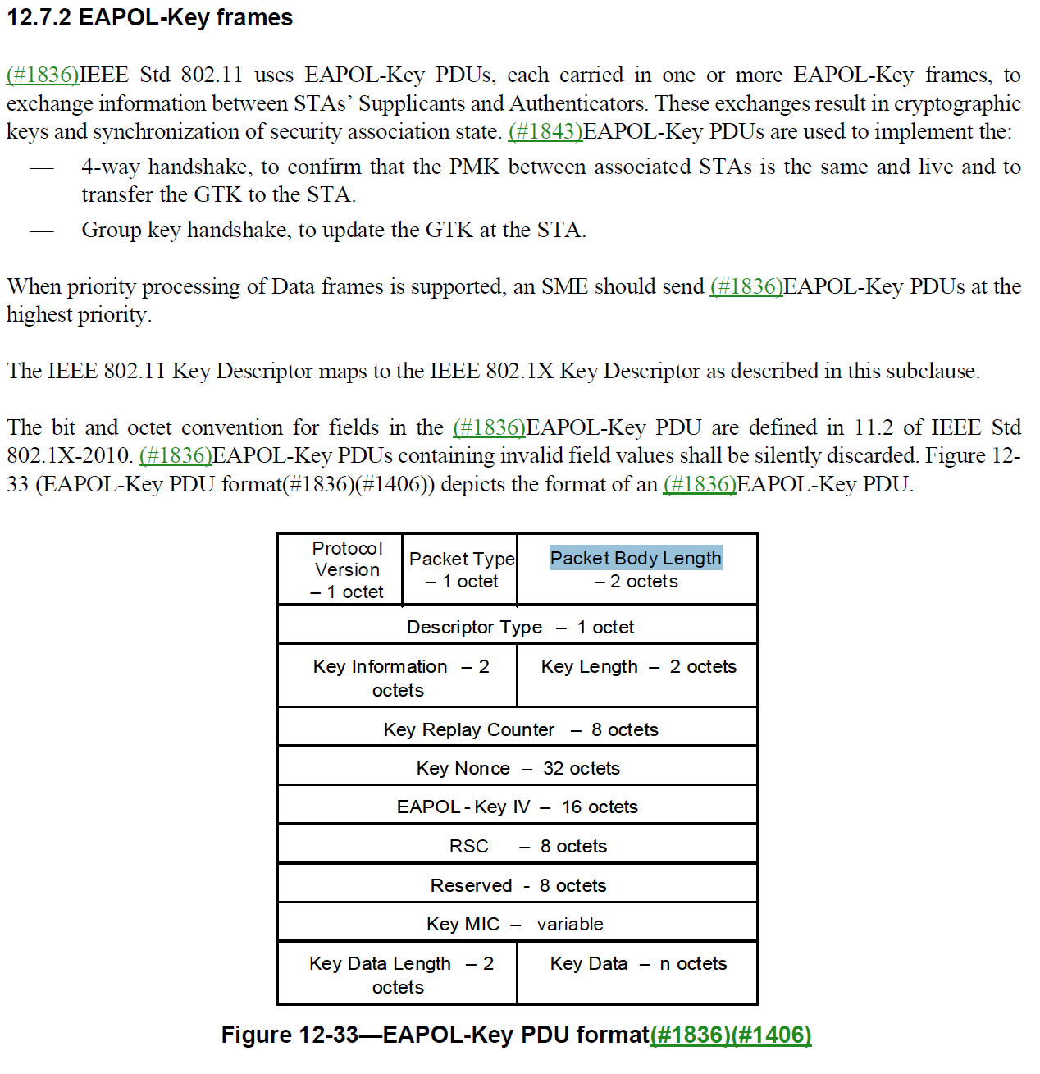

- The comment proposes adding this text after the figure:
“The Packet Body Length field is specified in IEEE Std 802.1X. This field may indicate the presence of octets beyond the end of the Key Data field, and may imply the presence of octets after the EAPOL PDU”
- The Packet Body Length field is clearly defined in IEEE Std 802.1X as “This two octet field encodes an unsigned binary number that defines the length in octets of the Packet Body field.”
- Furthermore in the requirements for receiving an EAPOL PDU, IEEE Std 802.1X states: “The Packet Body Length denotes a Packet Body that is contained within the octets of the received EAPOL MPDU.

Otherwise the received EAPOL PDU shall be discarded.

Any octets following the Packet Body field in the frame conveying the EAPOL PDU shall be ignored.”
- These requirements are clearly specified in IEEE Std 802.1X and do not need to be updated in this draft.
- However the description of the EAPOL-Key frame could be improved by moving the paragraph at 2899.36 to the end of paragraph starting at 2899.38. The editing instructions would be:
Delete the paragraph at 2899.36.
At the end of the paragraph starting at 2899.38, append the following sentences. “The Protocol Version, Packet Type, and Packet Body Length are specified in clause 11.3 of IEEE Std 802.1X. The IEEE 802.11 Key Descriptor maps to the IEEE 802.1X Descriptor as described in this subclause.”
At 2900.4, change “IEEE 802.11 Key Descriptor” to “IEEE 802.11 Key Descriptor Type”

Proposed Resolution: (3467, 3468)
(3467) REVISED. Clarify the mapping of IEEE 802.1X fields in the IEEE 802.11 EAPOL-Key frame, including the Packet Body Length.
Delete the paragraph at 2899.36.
At the end of the paragraph starting at 2899.38, append the following sentences.
“The Protocol Version, Packet Type, Packet Body Length, and Packet Body fields are specified in 11.3 of IEEE Std 802.1X-2020.

<new paragraph> The IEEE 802.11 Key Descriptor consists of the fields from and including the Descriptor Type field to and including the Key Data field in Figure 12-33. The IEEE 802.11 Key Descriptor maps to the IEEE 802.1X Key Descriptor as described in this subclause.

<new paragraph> There shall be no octets in the Packet Body field of the EAPOL-Key PDU after the Key Data field.”

(3468) REVISED. At 2899.65 add the following note:
“NOTE---There might be octets in the MSDU carrying the EAPOL-Key PDU after the Packet Body field (see 11.3 of IEEE Std 802.1X-2020)."

Comment
CID | Page | Clause | Duplicate of CID | Resn Status | Comment | Proposed Change
3394 | 2934.00 | 12.7.9.4 |  |  | "StaProcessEAPOL-Key (S, M, A, I, K, RSC, ANonce, RSC" -- it is confusing to have RSC twice and only differing by italicisation. Based on 12.7.4 it actually looks as if the second RSC is bogus | Delete the second ", RSC". Italicise RSC at 2934.60, 2935.7

Discussion:
- The cited text in context is:
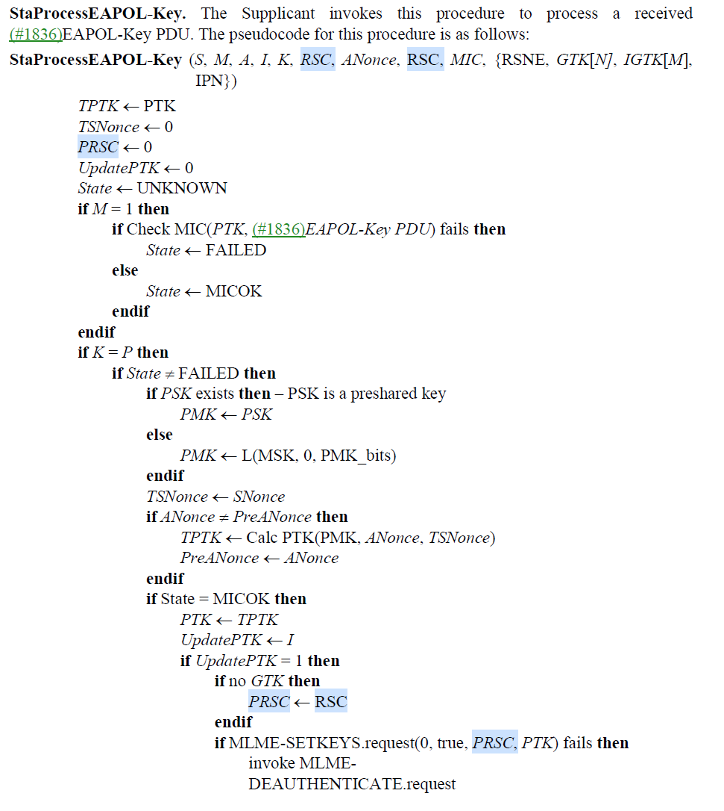

- Agree with the commenter that the second RSC is incorrect and it should be italicized in the pseudo code.

Proposed Resolution: (3394)
ACCEPTED.

Comment
CID | Page | Clause | Duplicate of CID | Resn Status | Comment | Proposed Change
3812 | 2850.00 | 12.5.4.3.1 |  |  | "NOTE--Retransmitted MPDUs are not modified on retransmission."  The MPDU includes the MAC header and the Retry subfield in the Frame Control field in the MAC header is modified during the retransmission.  This NOTE is wrong. | Change to "NOTE 1--The frame body of the reetransmitted MPDU is not modified on retransmission."

Discussion:
- The cited text in context is:
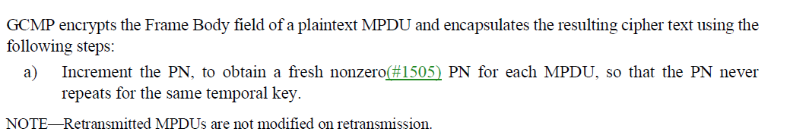
- The comment proposes changing the note text to “The frame body of the retransmitted MPDU is not modified on retransmission.”
- Agree with the commenter but there is a typo and NOTE-1 should be NOTE

Proposed Resolution: (3812)
ACCEPTED
Note to Editor. The changed text with typos corrected is: “NOTE—The frame body of the retransmitted MPDU is not modified on retransmission.”

Comment
CID | Page | Clause | Duplicate of CID | Resn Status | Comment | Proposed Change
3811 | 2836.00 | 12.5.2.3.1 |  |  | "NOTE 1--Retransmitted MPDUs are not modified on retransmission."  The MPDU includes the MAC header and the Retry subfield in the Frame Control field in the MAC header is modified during the retransmission.  This NOTE is wrong. | Change to "NOTE 1--The frame body of the reetransmitted MPDU is not modified on retransmission."

Discussion:
- The cited text in context is:
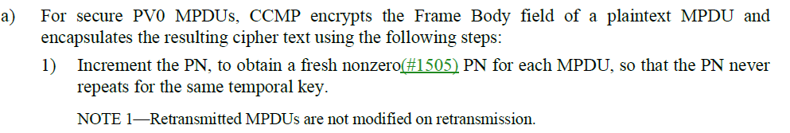
- The comment proposes changing the note text to “The frame body of the retransmitted MPDU is not modified on retransmission.”
- Agree with the commenter but there is a typo.

Proposed Resolution: (3811)
ACCEPTED

Comment
CID | Page | Clause | Duplicate of CID | Resn Status | Comment | Proposed Change
3131 | 250.00 | 3.4 |  |  | PWE is used both with ECC (see 12.4.4.2.2 P2812 L35) and FFC  (see12.4.4.3.2 P2817 L56) groups, so it should not be defined  with a constraint of "an ECC group". | At P250 L51, replace "password element of an ECC group" with "password  element".

Discussion:
- The cited text in context is:
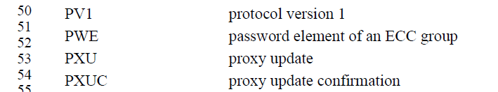
- For generating the PWE with ECC:
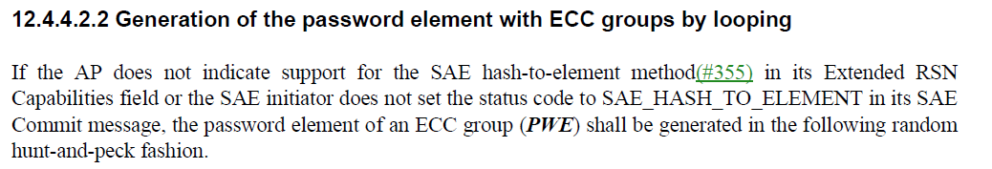
- For generating the PWE with FCC
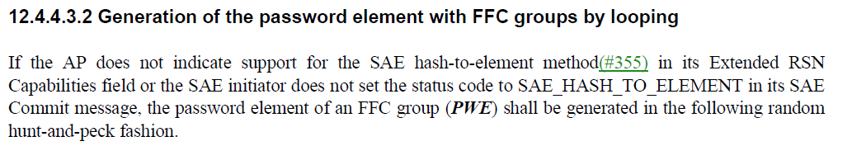
- Both ECC and FCC are finite cyclic groups so it would be better to change the acronym definition to address both cases.

Proposed Resolution: (3131)
REVISED. At P250.51, replace “password element of an ECC group” with “password element of a finite cyclic group”

Comment
CID | Page | Clause | Duplicate of CID | Resn Status | Comment | Proposed Change
3133 | 2963.00 | 12.12 |  |  | 12.12 was added as a generic location for covering various security  constraints. While this was added as a part of P802.11ax, the design and  intent of the subclause was such that it could be used as a placeholder  for collecting all similar requirements from the full standard into a  single location instead of maintaining them in various locations (e.g.,  see 5.1.2 and the end of 12.2.5). This would make it easier for the reader  to find the required constraints preventing use of various obsole and  deprecated mechanisms. | Delete P343 L50-59 (at the end of 5.1.2).  At P2963 L62, add the following subclauses:  12.12.3 Security constraints for HT STAs  An HT STA shall not use either of the pairwise cipher suite selectors:  "Use group cipher suite" or TKIP to communicate with another HT STA.  12.12.4 Security constraints for VHT STAs  A VHT STA shall not use either of the pairwise cipher suite selectors:  "Use group cipher suite" or TKIP to communicate with another HT STA or  VHT STA.  12.12.5 Security constraints for HE STAs  An HE STA shall not use either of the pairwise cipher suite selectors:  "Use group cipher suite" or TKIP to communicate with another HT STA, VHT  STA, or HE STA.  12.12.6 Security constraints for S1G STAs  An S1G STA shall not use the pairwise cipher suite selectors WEP-40,  WEP-104, TKIP, or "Use group cipher suite".  12.12.7 Security constraints for mesh STAs  A mesh STA shall not use the pairwise cipher suite selectors WEP-40,  WEP-104, or TKIP.  12.12.8 Security constraints for STAs that support nanagement frame  protection  A STA that has associated with management  frame protection enabled shall not use pairwise cipher suite selectors  WEP-40, WEP-104, TKIP, or "Use group cipher suite."

Discussion:
- The cited text in context is:
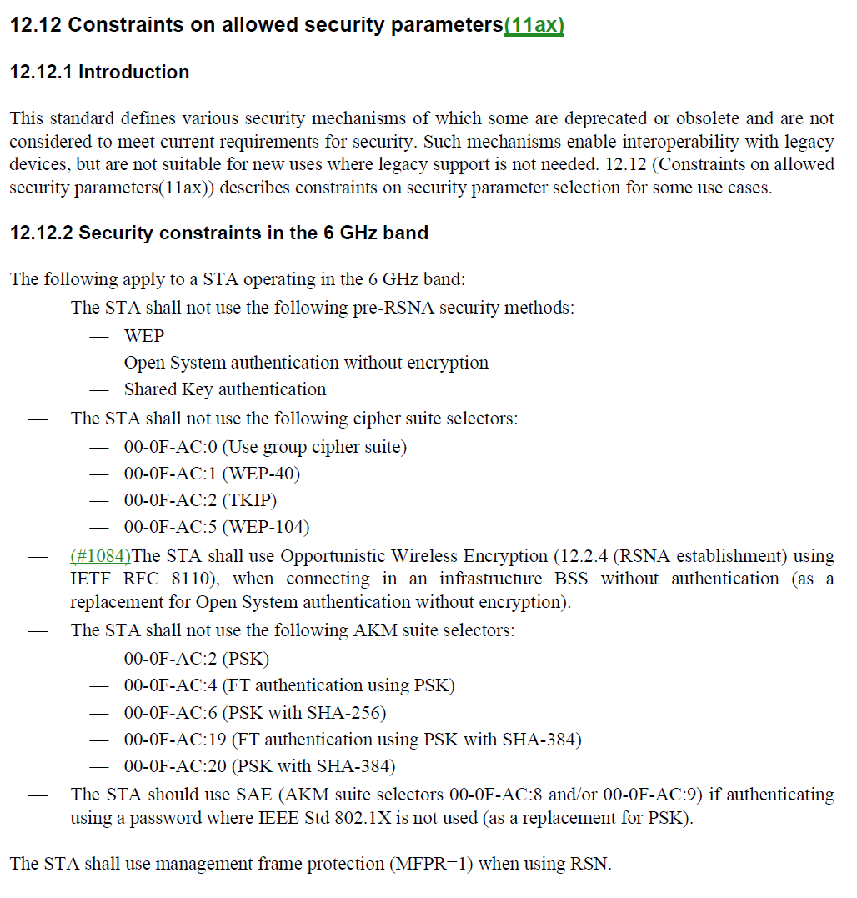
- Agree with the commenter that it would make sense to include the constraints in one place.

Delete P343 L50-59 (at the end of 5.1.2).
A STA that has associated with management frame protection enabled shall not use pairwise cipher suite selectors WEP-40, WEP-104, TKIP, or “Use group cipher suite.”

A mesh STA with dot11MeshSecurityActivated equal to true shall not use the pairwise cipher suite selectors WEP-40, WEP-104, or TKIP.
An S1G STA shall not use the pairwise cipher suite selectors WEP-40, WEP-104, TKIP, or “Use group cipher suite”.

At P2963 L62, add the following subclauses:

12.12.3 Security constraints for HT STAs

An HT STA shall not use either of the pairwise cipher suite selectors "Use group cipher suite" or TKIP to communicate with another HT STA.

12.12.4 Security constraints for VHT STAs

A VHT STA shall not use either of the pairwise cipher suite selectors:
"Use group cipher suite" or TKIP to communicate with another HT STA or
VHT STA.

12.12.5 Security constraints for HE STAs

An HE STA shall not use either of the pairwise cipher suite selectors:
"Use group cipher suite" or TKIP to communicate with another HT STA, VHT
STA, or HE STA.

12.12.6 Security constraints for S1G STAs

An S1G STA shall not use the pairwise cipher suite selectors WEP-40,
WEP-104, TKIP, or "Use group cipher suite".

12.12.7 Security constraints for mesh STAs

A mesh STA shall not use the pairwise cipher suite selectors WEP-40,
WEP-104, or TKIP.

12.12.8 Security constraints for STAs that support management frame
protection

A STA that has associated with management
frame protection enabled shall not use pairwise cipher suite selectors
WEP-40, WEP-104, TKIP, or "Use group cipher suite."

Proposed Resolution: (3133)
ACCEPTED.
Note to Editor. The changes are shown in the discussion of <this> document. Part of the text referring to WEP has been deleted as a result of the resolution of CID 3222 in document https://mentor.ieee.org/802.11/dcn/22/11-22-2003-04-000m-wep-removal.docx

Comment
CID | Page | Clause | Duplicate of CID | Resn Status | Comment | Proposed Change
3199 | 2880.00 | 12.6.20 |  |  | "the protected variant is used when management frame protection has been negotiated" -- needs to be "a non-protected variant shall be discarded when management frame protection has been negotiated" | As it says in the comment

Discussion:
- The cited text in context is:
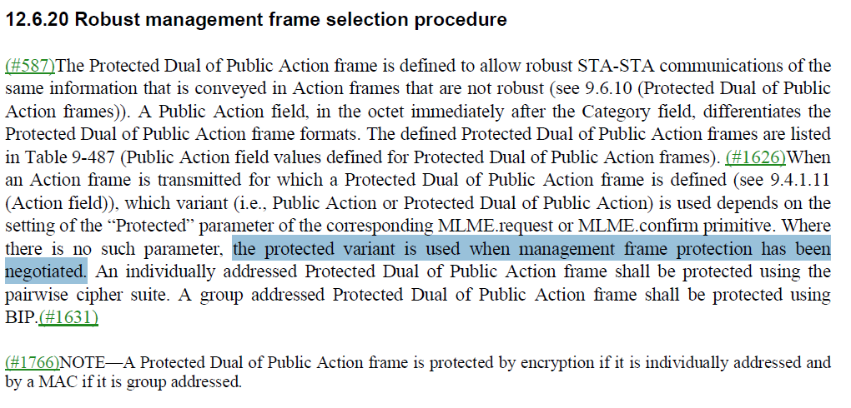

- The third sentence of the paragraph begins with “When an action frame is transmitted for which ….” and describes behavior in terms of the transmitter and relates to the “Protected” parameter in the MLME. As such the cited sentence “Where there is no such parameter, the protected variant ….” is correct.
- Mark Rison comment: “Well, OK, so where is the requirement on the receiving side specified? That’s the side that matters from a security perspective”. First of all, the comment is not in the context of the cited text. Secondly, the receiving side is specified later in the clause.

Proposed Resolution: (3199)
REJECTED. The cited paragraph describes requirements for behaviour associated with the transmission of Protected Dual of Public action frames. The cited text is correct and consistent with the other text in the paragraph.

Comment
CID | Page | Clause | Duplicate of CID | Resn Status | Comment | Proposed Change
3228 | 2871.00 | 12.6.10.1 |  |  | "SAE authentication is initiated when a STA's MLME-SCAN.confirm primitive finds another AP within the ESS of which the STA is a member that advertises support for SAE in its RSNE." -- not necessarily (maybe the AP also supports PSK) and the STA is not necessarily in an ESS (initial assoc). And maybe you don't want to connect to that AP at all? Ditto other auths | Change to "SAE authentication can be initiated when a STA's MLME-SCAN.confirm primitive identifies an AP that advertises support for SAE in its RSNE." Similarly change the next 3 lines to  FILS authentication can be initiated when a STA's MLME-SCAN.confirm primitive identifies an AP that advertises support for FILS authentication in its RSNE.  (#1084)OWE can be initiated when a STA's MLME-SCAN.confirm primitive identifies another AP within the ESS of which the STA is a member that advertises support for OWE in its RSNE.  IEEE 802.1X authentication can be initiated by any one of the following mechanisms:

Discussion:
- The cited text in the “RSNA assumptions and constraints” clause, in context is:
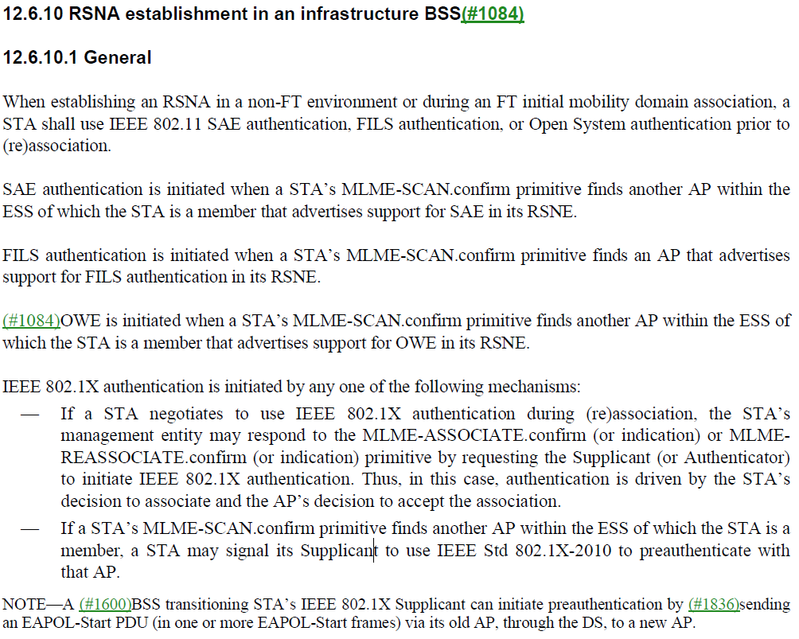
- The proposed change affects the 2nd, 3rd, 4th and the beginning of the 5th paragraph.
- The changes in general replace “is” with “can”, rewords the sentence, and removes the reference to the ESS.

Proposed Resolution: (3228)
ACCEPTED.
Note to Editor. The changes are <shown in <this> document>:
At 2871.40, change
“SAE authentication is initiated when a STA’s MLME-SCAN.confirm primitive finds another AP within the ESS of which the STA is a member that advertises support for SAE in its RSNE.”
To
“SAE authentication can be initiated when a STA's MLME-SCAN.confirm primitive identifies an AP that advertises support for SAE in its RSNE.”

At 2871.44, change
“FILS authentication is initiated when a STA’s MLME-SCAN.confirm primitive finds an AP that advertises support for FILS authentication in its RSNE.”
To
“FILS authentication can be initiated when a STA's MLME-SCAN.confirm primitive identifies an AP that advertises support for FILS in its RSNE.”

At 2871.48 change
“OWE is initiated when a STA’s MLME-SCAN.confirm primitive finds another AP within the ESS of which the STA is a member that advertises support for OWE in its RSNE.”
To
“OWE authentication can be initiated when a STA's MLME-SCAN.confirm primitive identifies an AP that advertises support for OWE in its RSNE.”

At 2871.51, change
“IEEE 802.1X authentication is initiated by any one of the following mechanisms:”
To
“IEEE 802.1X authentication can be initiated by any one of the following mechanisms:”

Comment
CID | Page | Clause | Duplicate of CID | Resn Status | Comment | Proposed Change
3230 | 2780.00 | 12.2.1 |  |  | "12.2.1 Classes of security algorithm  This standard defines two classes of security algorithms for IEEE 802.11 networks:  -- Algorithms for creating and using an RSNA, called RSNA algorithms  -- Pre-RSNA algorithms" -- also TSN algorithms, since non-RSNA includes pre-RSNA an TSN | Change the last bullet to "Pre-RSNA and TSN algorithms"

Discussion:
- The cited text in context is:
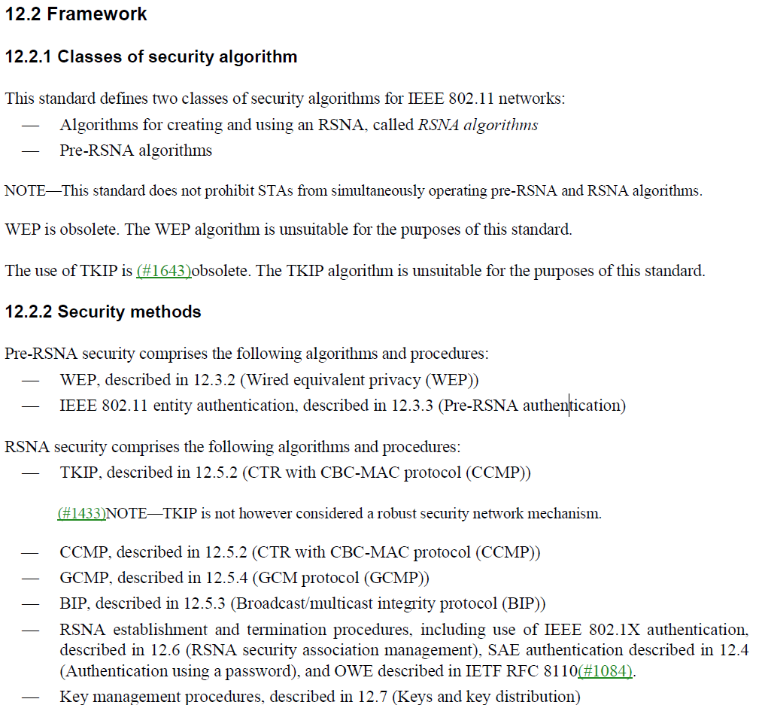

- TSN has been removed from the standard with the deletion of WEP.

Proposed Resolution: (3230)
REVISED. Remove WEP as a standalone cipher by incorporating changes under the “Changes to the draft” header in document https://mentor.ieee.org/802.11/dcn/22/11-22-2003-04-000m-wep-removal.docx. This removes the referenced text.
Note to Editor. The same resolution to CID 3222.

Comment
CID | Page | Clause | Duplicate of CID | Resn Status | Comment | Proposed Change
3257 |  | 12 |  |  | It is not clear what the difference between "PeerKey" (e.g. in MLME-SETKEYS.req) and "TPK" (in 12.7.8.2 TPK handshake) is. It might be that "TPK" is TDLS PeerKey as opposed to AP PeerKey, but if so, it's not clear what an unlabelled "PeerKey" means (12x in Clause 6, 3x in 9.4.2.24.4, 1x in 12.7.8.4.2, 1x in Figure 12-51, 1x in 12.10.2) | Change "PeerKey" to "AP PeerKey" at 2946.62. Change "PeerKeyInit" to "EAPOL-Key PDU" at 2932.53

Discussion:
- Relative to the proposed, change the context at 2946.62:
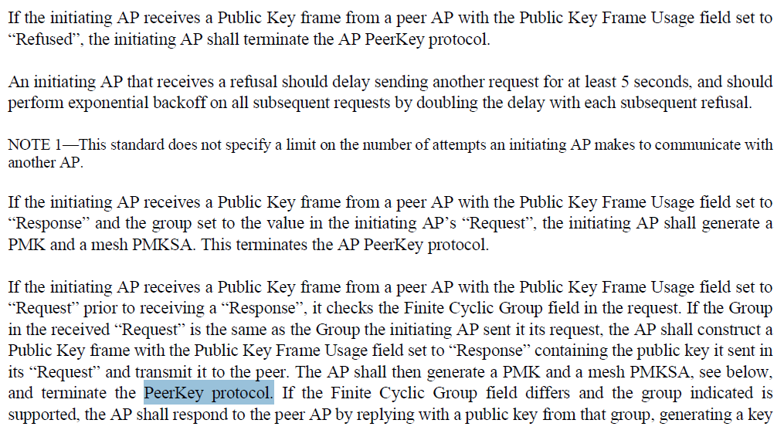

- Agree with the commenter that PeerKey should be AP PeerKey at that location.
- Relative to the proposed change, the context at 2932.53 is:
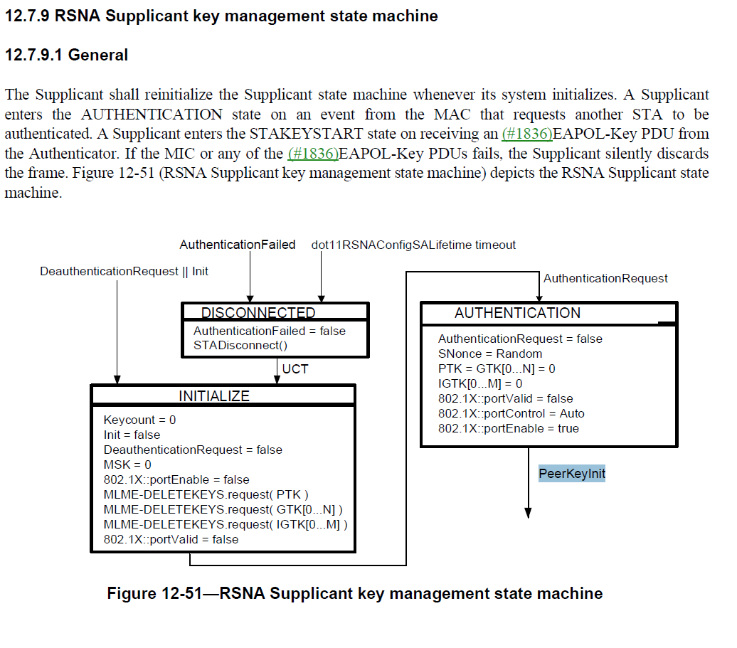
- The proposal is to change “PeerKeyInit” to “EAPOL-Key PDU”. The text above the figure says that the Supplicant enters the STAKEYSTART state on receiving the EAPOL-Key PDU”.

Proposed Resolution: (3257)
REVISED. Change "PeerKey" to "AP PeerKey" at 2946.62. Change "PeerKeyInit" to " EAPOLKeyReceived" at 2932.53

Comment
CID | Page | Clause | Duplicate of CID | Resn Status | Comment | Proposed Change
3269 | 2857.00 | 12.6.1.1.6 |  |  | "There shall be only one PTKSA per key ID per band (see 12.6.19 (Protection of robust Management frames)) with the same Supplicant and Authenticator MAC addresses." -- xref seems bogus | Identify the correct xref

Discussion:
- The cited text in context is:
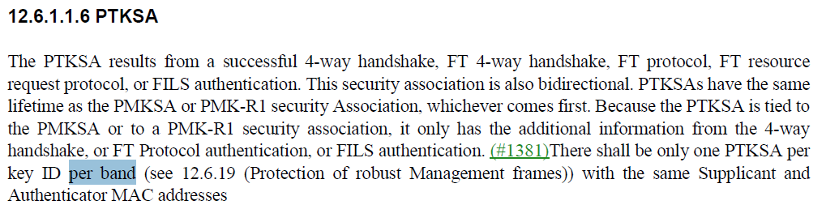

- The cited text refers to multi-band RSNA. The appropriate clause would be 12.6.22 (Multi-band RSNA)

Proposed Resolution: (3269)
REVISED. The cited text refers to multiband operation, change cross reference from 12.6.19 to 12.6.22 at cited location.

Note to Editor. Clause titles would be updated with the update in cross-reference.

Comment
CID | Page | Clause | Duplicate of CID | Resn Status | Comment | Proposed Change
3281 | 2402.00 | 12.7.7.1 |  |  | "If RSN is used without management frame protection and a valid PTK is configured for the  STA, the current GTK shall be sent to the STA using a group key handshake (see 12.7.7 (Group key  handshake)) immediately following the WNM Sleep Mode Response frame." -- can BIGTK be used without PMF? If so then BIGTK needs to be covered here | As it says in the comment

Discussion:
- The cited text in context in the Key Information description of the EAPOL-key frame is:
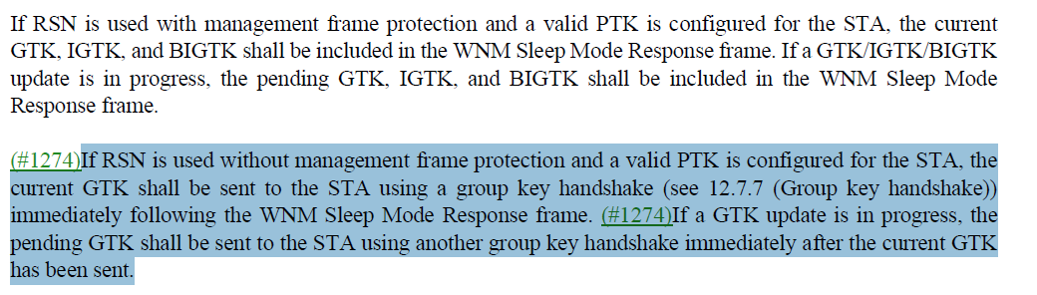

- The commenter is correct to point out that IGTK and BIGTK should be included.
- The updated text is shown below in the proposed resolution.

Proposed Resolution: (3281)
REJECTED. Beacon protection cannot be used without management frame protection.

Comment
CID | Page | Clause | Duplicate of CID | Resn Status | Comment | Proposed Change
3292 | 492.00 | 6.5.14.1.4 |  |  | "identify a new key to be set" (2x) is not clear. It would be safest to say that a new key is a new Key parameter value (the odds of a PTK and a GTK or whatever having the same temporal key are vanishingly small) | At 492.20 add a "NOTE---A new key is identified by virtue of having a different Key parameter than used so far during the membership of the current BSS."

Discussion:
- The cited text in context is:
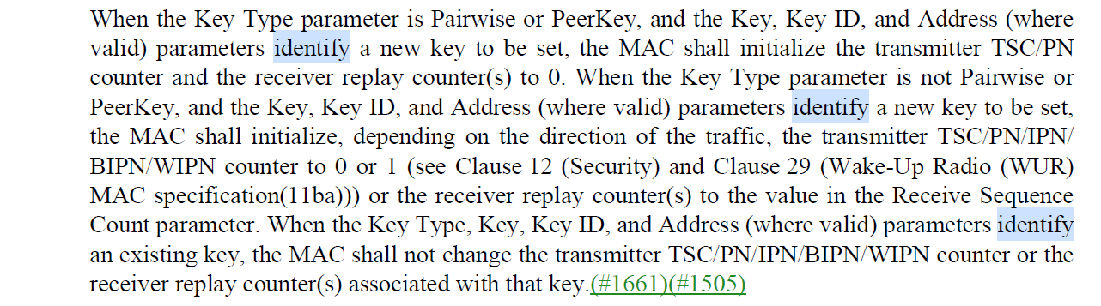

- The commenter suggests adding a note to clarify what constitutes a “new key”
- However, not sure what's so confusing and "…so far during the membership of the current BSS" implies that the MAC is going to keep track of key parameters for a period of time. The new key is the key included in the MLME-SETKeys primitive that differs from the current key.
- Mark Rison clarification on the confusing text: “Well, e.g. if the Key parameter is the same but the Key ID parameter is different, is that a “new key”?”
- Mark Rison comment on keeping track of key parameters: “Yes, indeed. The idea is that if key A was first used in the BSS, then key B, and then a request to use key A again comes along that’s suspect and should be denied”

Proposed Resolution: (3292)
REVISED. At 492.20 add a "NOTE---A new key is identified by virtue of having a different Key parameter than any of the currently configured keys used by the MAC."

Comment
CID | Page | Clause | Duplicate of CID | Resn Status | Comment | Proposed Change
3302 |  | 12.7.6 |  |  | The Secure bit might be 1 in M1 and M2 if rekeying | At 2913.23 change "Secure = 0" to "Secure = 0 or 1 (see 12.7.2)". At 2914.15 change "Secure = 0 -- same as message 1" to "Secure = 0 or 1 (see 12.7.2)"

Discussion:
- The cited text (at the first location) in context is:
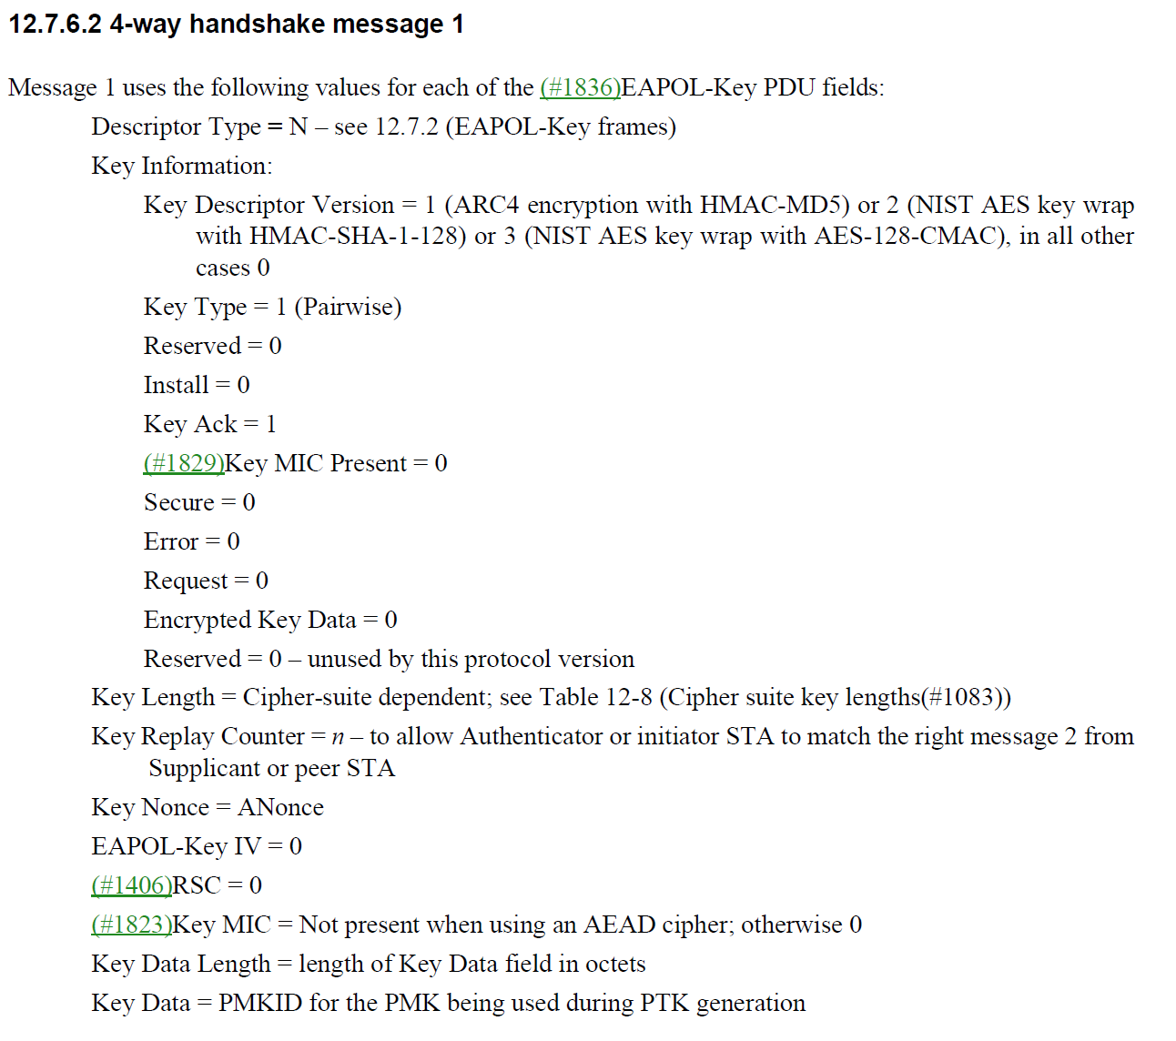

- The second location is 4-way handshake message 2.
- Agree with the commenter that in the re-keying case, the Secure bit can be set to 1.

Proposed Resolution: (3302)
ACCEPTED

Comment
CID | Page | Clause | Duplicate of CID | Resn Status | Comment | Proposed Change
3328 | 2831.00 | 12.4.8.6.3 |  |  | "Otherwise, the frame shall be processed by first checking whether  a password identifier is present. If so and there is no password associated with that identifier, BadID shall be set  and the protocol instance shall construct and transmit an Authentication frame with Status Code set to  UNKNOWN_PASSWORD_IDENTIFIER" -- should be an SAE Authentication frame, specifically? Or even an SAE Commit message? Ditto below | Change "Authentication frame" to "SAE Authentication frame" at 2831.46/51

Discussion:
- This is the cited text in context:
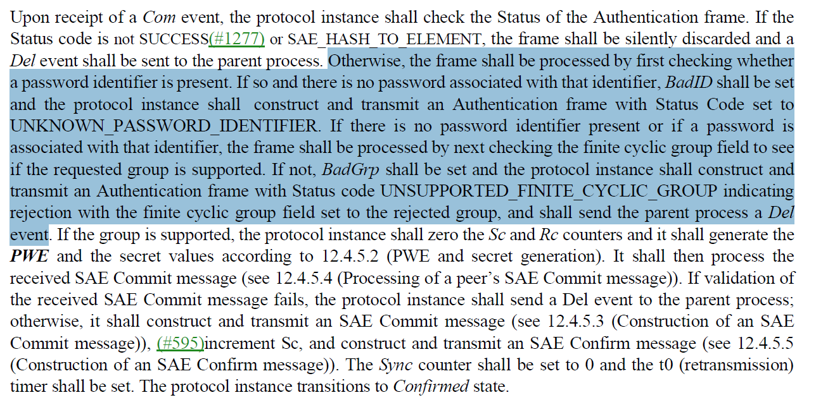

- Agree with the comment that calling it an “SAE Authentication frame” would be better in this context.

Proposed Resolution: (3328)
REVISED. Change "Authentication frame" to "SAE authentication frame" at 2831.42/46/51

Comment
CID | Page | Clause | Duplicate of CID | Resn Status | Comment | Proposed Change
3353 | 2876.00 | 12.6.18 |  |  | CID 1851 -- also need change "In the case of an IBSS, the SME shall delete the PTKSA and the receive GTKSA and any  IGTKSA." to allow for multiple PTKSAs etc. | Change to "... any PTKSA(s) ... any IGTKSA(s)"

Discussion:
- This is the cited text is actually on page 2878:
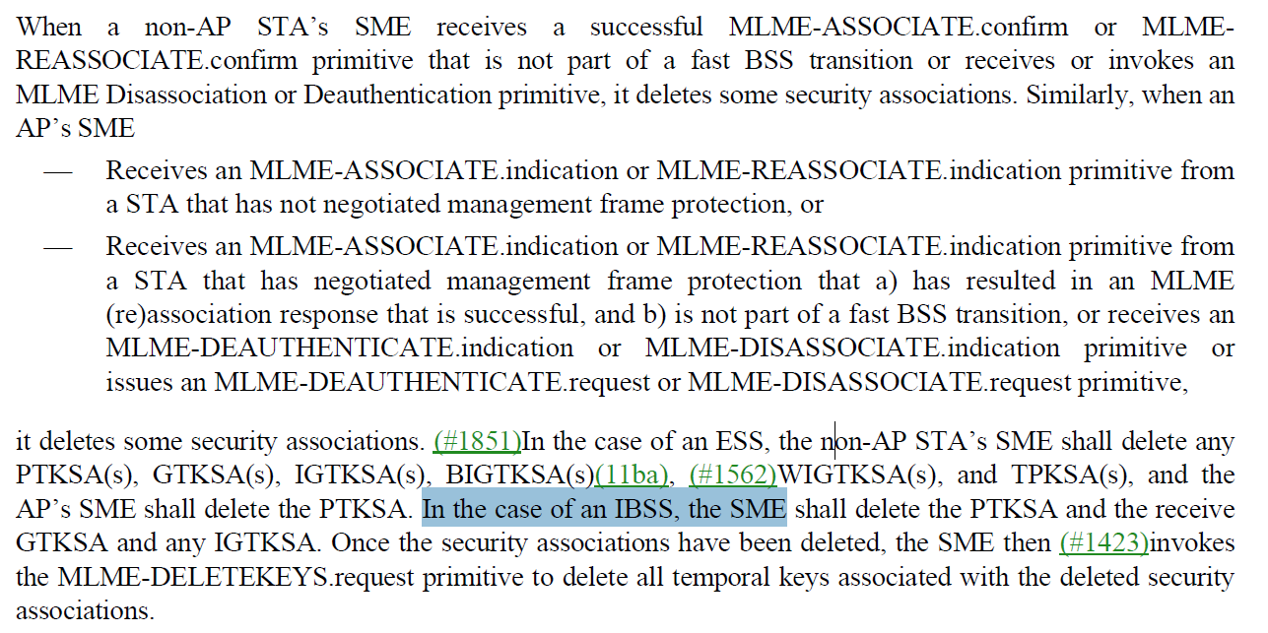

- The comment is asking for the IBSS requirement to be modified to acknowledge multiple PTKSAs, GTKSAs, and IGTKSAs. The change would be as shown in the proposed resolution (with the correct reference).
- Mark Rison comment: “Can we have multiple IGTKSAs?

Proposed Resolution: (3353)
REVISED. Make the following changes at the correct location in line with the proposed changes. At 2878.27, change
“In the case of an IBSS, the SME shall delete the PTKSA and the receive GTKSA and any IGTKSA.”
to
“In the case of an IBSS, the SME shall delete the PTKSA(s) and the GTKSA(s) and any IGTKSA(s)."

Comment
CID | Page | Clause | Duplicate of CID | Resn Status | Comment | Proposed Change
3685 |  | 12.6.1.1 |  |  | 12.6.1.1.8: "The GTKSA results from a successful 4-way handshake, FT 4-way handshake, FT protocol, FT resource  request protocol, (11ai)group key handshake, or FILS authentication(11ai)" but 12.6.1.1.1: "GTKSA: A result of a successful group key handshake, 4-way handshake, FT 4-way handshake,  (11ai)FT authentication sequence, or FILS authentication(11ai)." -- the two sets differ (" FT protocol, FT resource  request protocol" v. "FT authentication sequence" | Make the two sets identical, or even better avoid the duplication in the first place by only keeping one and xreffing to it from the other

Discussion:
- The cited text from 12.6.1.1.8:
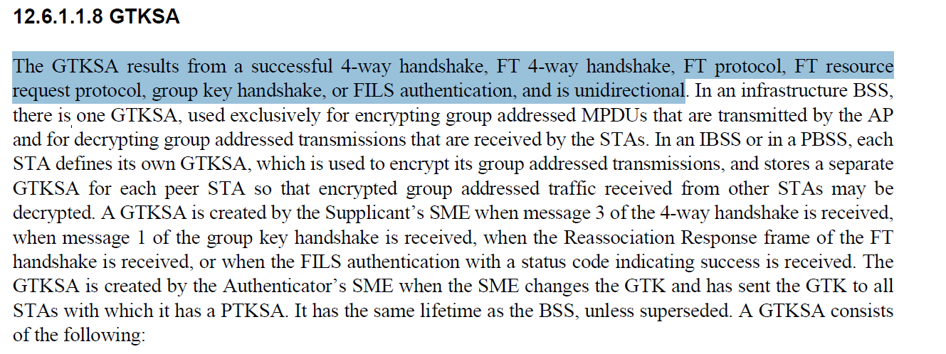

- The cited text from 12.6.1.1.1:
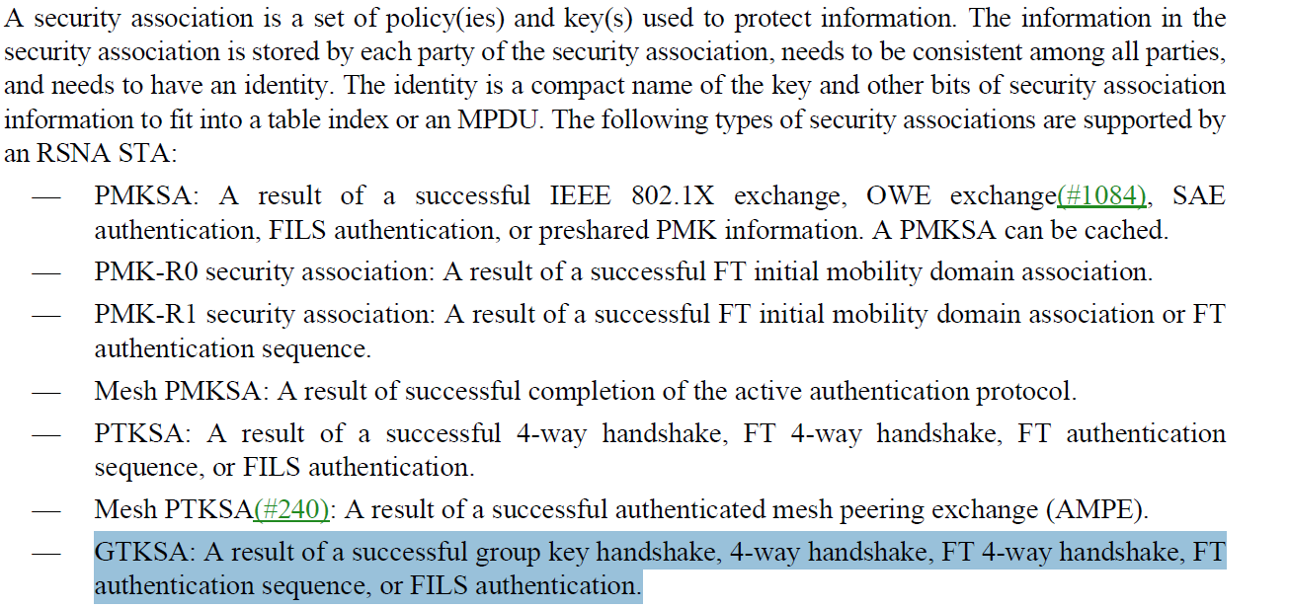
- The GTKSA statement in 12.6.1.1.1 is consistent with the other security associations described in the bulleted list. The list summarizes the types of security associations in 802.11.
- The description of FT protocols is different in the two lists. Note that the FT protocol and FT resource request protocol are FT authentication sequences. The description in 12.6.1.1.8 is more accurate so it would be better to align 12.6.1.1.1 with the description in 12.6.1.1.8. Update the list in 12.6.1.1.1 in Proposed Resolution

Proposed Resolution: (3685)
REVISED. Align the two cited sentences. At 2855.34, change:
“GTKSA: A result of a successful group key handshake, 4-way handshake, FT 4-way handshake, FT authentication sequence, or FILS authentication.”
to
“GTKSA: A result of a successful group key handshake, 4-way handshake, FT 4-way handshake, FT protocol, FT resource request protocol, or FILS authentication.”

Comment
CID | Page | Clause | Duplicate of CID | Resn Status | Comment | Proposed Change
3407 | 491.00 |  |  |  | If MLME-SETKEYS.req is passed the same Key, Key Type as an existing key, but a different Key ID, this is suspect (some kind of new KRACKy thing) and should probably be rejected | After the first sentence of the subclause insert the sentence "Otherwise, irrespective of the Key Type, when the Key is the same as a key installed as a result of EAPOL-Key PDUs or exiting WNM sleep mode, receipt of this primitive shall have no effect."

Discussion:
- This is the cited text in context:
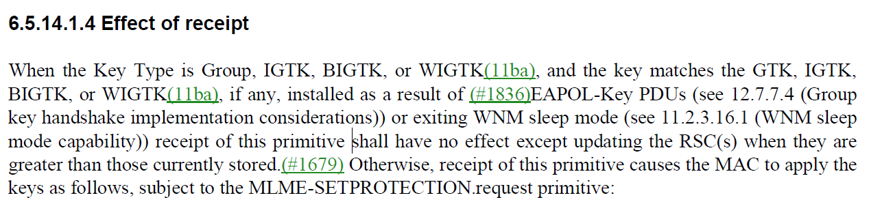

- The commenter is requesting that the following sentence is inserted after the first sentence, making the first two sentences read:
“When the Key Type is Group, IGTK, BIGTK, or WIGTK(11ba), and the key matches the GTK, IGTK, BIGTK, or WIGTK(11ba), if any, installed as a result of (#1836)EAPOL-Key PDUs (see 12.7.7.4 (Group key handshake implementation considerations)) or exiting WNM sleep mode (see 11.2.3.16.1 (WNM sleep mode capability)) receipt of this primitive shall have no effect except updating the RSC(s) when they are greater than those currently stored.(#1679). Otherwise, irrespective of the Key Type, when the Key is the same as a key installed as a result of EAPOL-Key PDUs or exiting WNM sleep mode, receipt of this primitive shall have no effect. Otherwise, receipt of this primitive causes the MAC to apply the keys as follows, subject to the MLME-SETPROTECTION.request primitive:”
- The “Otherwise,” in the Proposed Change is not required.
- The current sentence seems to cover the case where the same key is received with a different Key ID.
- You could add “irrespective of the Key ID,” before “receipt of this…”
- Mark Rison comment: ““the key matches” is too vague. It should be “the Key parameter matches” Also, the first sentences only applies to *GTK but the proposed new sentence also applies to PTK”

Proposed Resolution: (3407)
REVISED. After the first sentence of the subclause insert the sentence "Otherwise, irrespective of the Key Type parameter, when the Key parameter is the same as a key installed as a result of EAPOL-Key PDUs or exiting WNM sleep mode, receipt of this primitive shall have no effect."

Comment
CID | Page | Clause | Duplicate of CID | Resn Status | Comment | Proposed Change
3465 | 2899.00 | 12.7.2 |  |  | 802.1X-20q0 says that for EAPOL-Key frames "The first two fields in the Descriptor Body [i.e. after the Descriptor Type field] comprise a Subtype and a Version", but our EAPOL-Key frames have no subtype field | At 2899.65 add a "NOTE---IEEE Std 802.1X-2020 says that for EAPOL-Key frames "The first two fields in the Descriptor Body [i.e. after the Descriptor Type field] comprise a Subtype and a Version, but the 802.11 EAPOL-Key frames have a key type instead of the subtype."

Discussion:
- From IEEE 802.1X-2020:
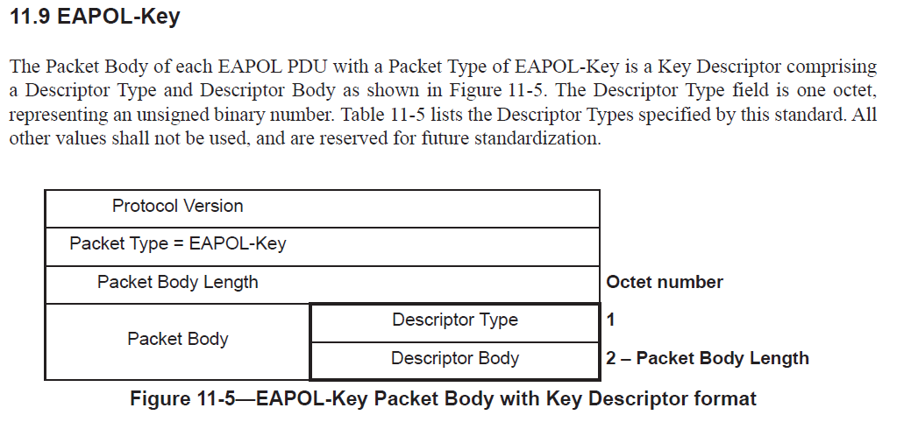
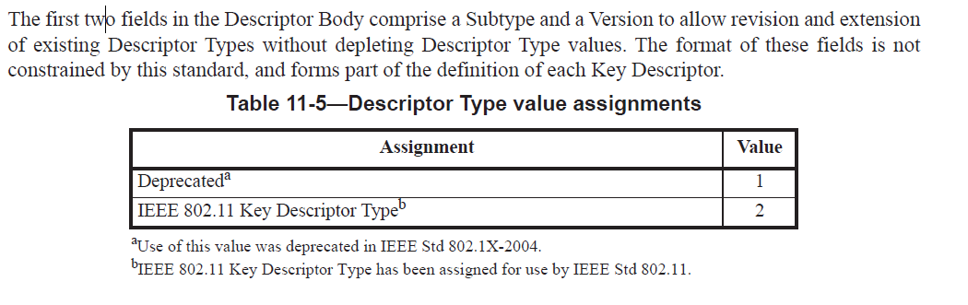

- From D2.0:
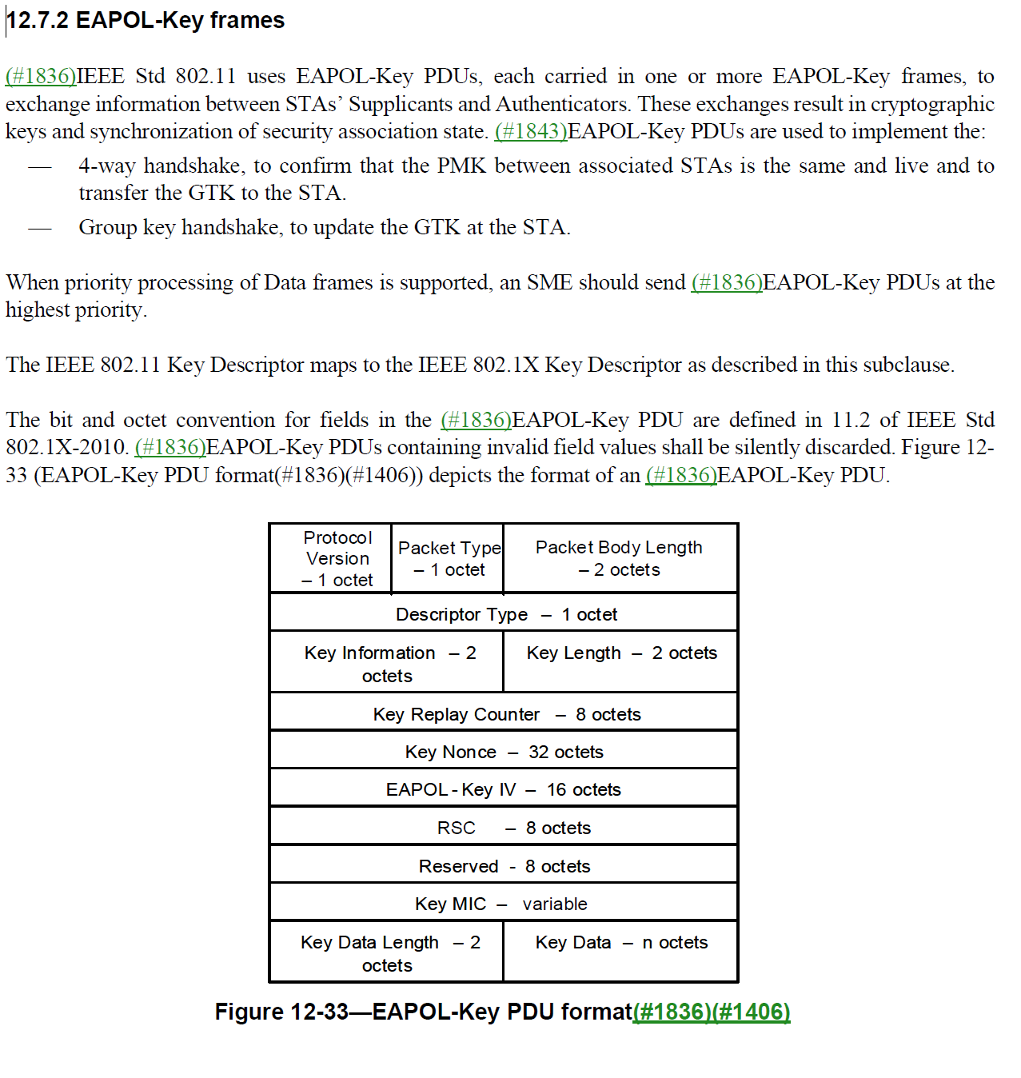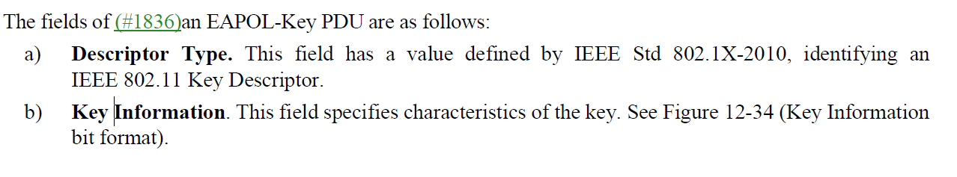
- Note that with respect to the Subtype and Version, the IEEE 802.1X standard states: “The format of these fields is not constrained by this standard, and forms part of the definition of each Key Descriptor.”
- Mark Rison comment: “I don’t think 1X says that. It says the format of the subtype and version fields (in the Descriptor Body) are not constrained by 1X.”
- In IEEE 802.11, the Key Information field addresses the extensibility of Descriptor Type described in IEEE 802.1X
- Given that the EAPOL-key frame is defined in the IEEE 802.11 standard, no note is required.

Proposed Resolution: (3465)
ACCEPTED

Comment
CID | Page | Clause | Duplicate of CID | Resn Status | Comment | Proposed Change
3466 | 2902.00 | 12.7.2 |  |  | "It may contain 0 if a nonce is not required to be sent." is confusing | Change to "It shall contain 0 if a nonce is not required to be sent."

Discussion:
- This is the cited text in context:

- "It may be zero" is a notice to a recipient that you might get something that has a zero value. Mandating it being sent as zero is very different.
- Mark Rison comment: “That’s not how I’m reading it. I think it’s trying to say that in those cases where a nonce is not required, it is set to 0.”

Proposed Resolution: (3466)
More Work Required. Assign to Mark Rison and schedule for March plenary.

Comment
CID | Page | Clause | Duplicate of CID | Resn Status | Comment | Proposed Change
3486 | 2904.00 | 12.7.2 |  |  | It's not clear whether KDEs are extensible (e.g. can the PMKID KDE have more than 16 octets in the Data field?) | At the end of the referenced para add "Unless stated otherwise, KDEs are not extensible."

Discussion:
- This is the cited text in context:
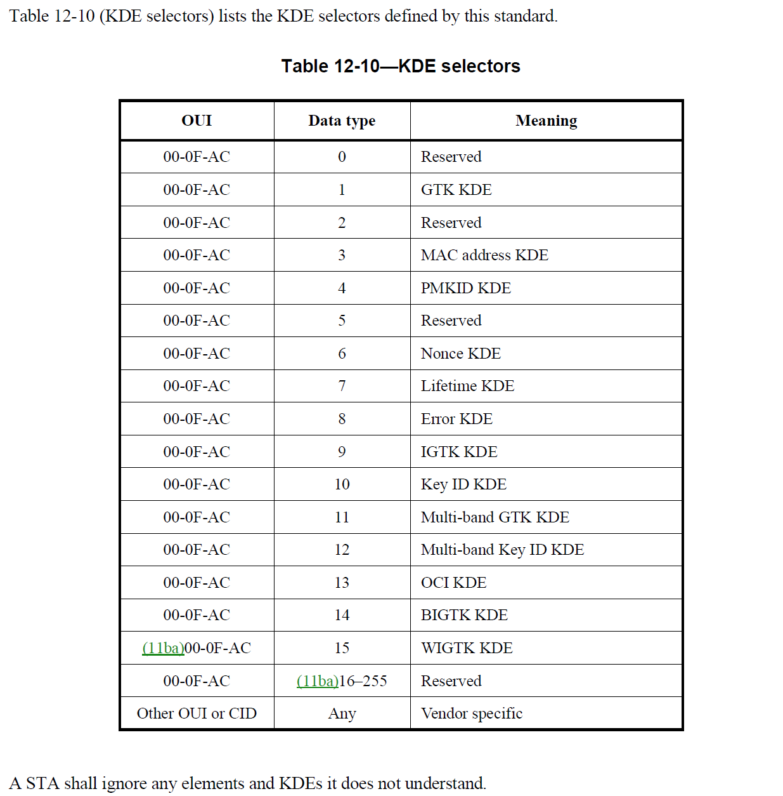

- Comment proposes adding an extensibility statement after sentence that introduces the table.

Proposed Resolution: (3486)
REVISED. Add the following text at the end of the referenced paragraph “Unless stated otherwise, KDEs defined in this standard are not extensible.”

Comment
CID | Page | Clause | Duplicate of CID | Resn Status | Comment | Proposed Change
3492 | 2905.00 | 12.7.2 |  |  | "If the value of the Tx field is 1, then the IEEE 802.1X component shall configure the temporal key derived  from this KDE into (#408)the IEEE 802.11 MAC for both transmission and reception.  If the value of the Tx field is 0, then the IEEE 802.1X component shall configure the temporal key derived  from this KDE into (#408)the IEEE 802.11 MAC for reception only." -- 1 is not used anywhere (0 is used in 12.11.2.6.3 (Re)Association Response for FILS key confirmation) | Delete the cited text and in Figure 12-36--GTK KDE format change Tx to Reserved and in 12.11.2.6.3 delete " with Tx subfield equal to 0" (2960.51)

Discussion:
- This is the cited text in 12.7.2 context:
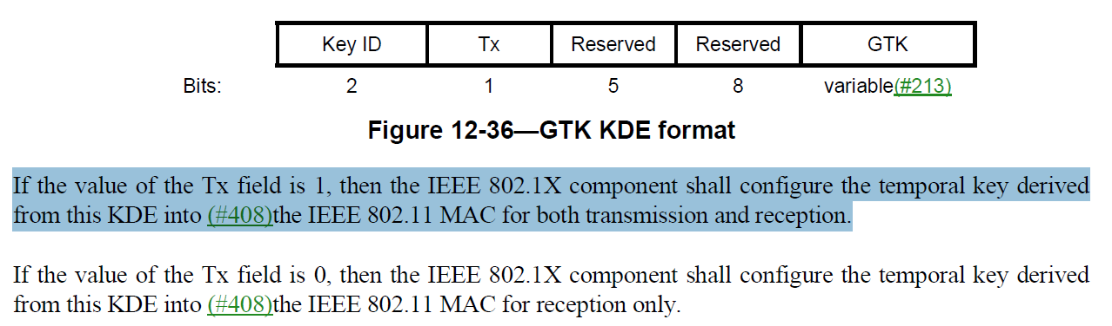
- The cited text in 12.11.2.6.3 is
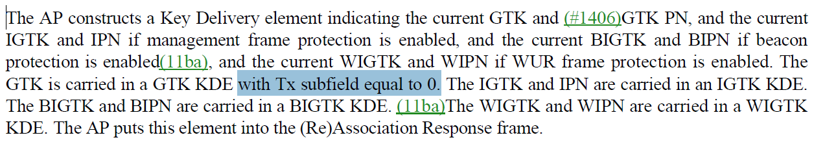
- The commenter is correct in pointing out that the Tx field is always set to 0 so we could remove the field and make it reserved.

Proposed Resolution: (3492)
ACCEPTED

Comment
CID | Page | Clause | Duplicate of CID | Resn Status | Comment | Proposed Change
3497 | 2929.00 | 12.7.8.4.2 |  |  | "The FTE shall be set as follows:  SNonce shall be set to a value chosen randomly by the TDLS initiator STA, see 12.7.5 (Nonce  generation) for a recommended procedure.  All other fields shall be set to 0." -- it is not clear what the last sentence means in terms of the optional subelements | Change to "The FTE shall be set as follows:  SNonce shall be set to a value chosen randomly by the TDLS initiator STA, see 12.7.5 (Nonce  generation) for a recommended procedure.  All other fields shall be set to 0. The Optional  Parameter(s) field shall not be present.", on the basis none of the subelements make sense for TDLS

Discussion:
- This is the cited text in context:
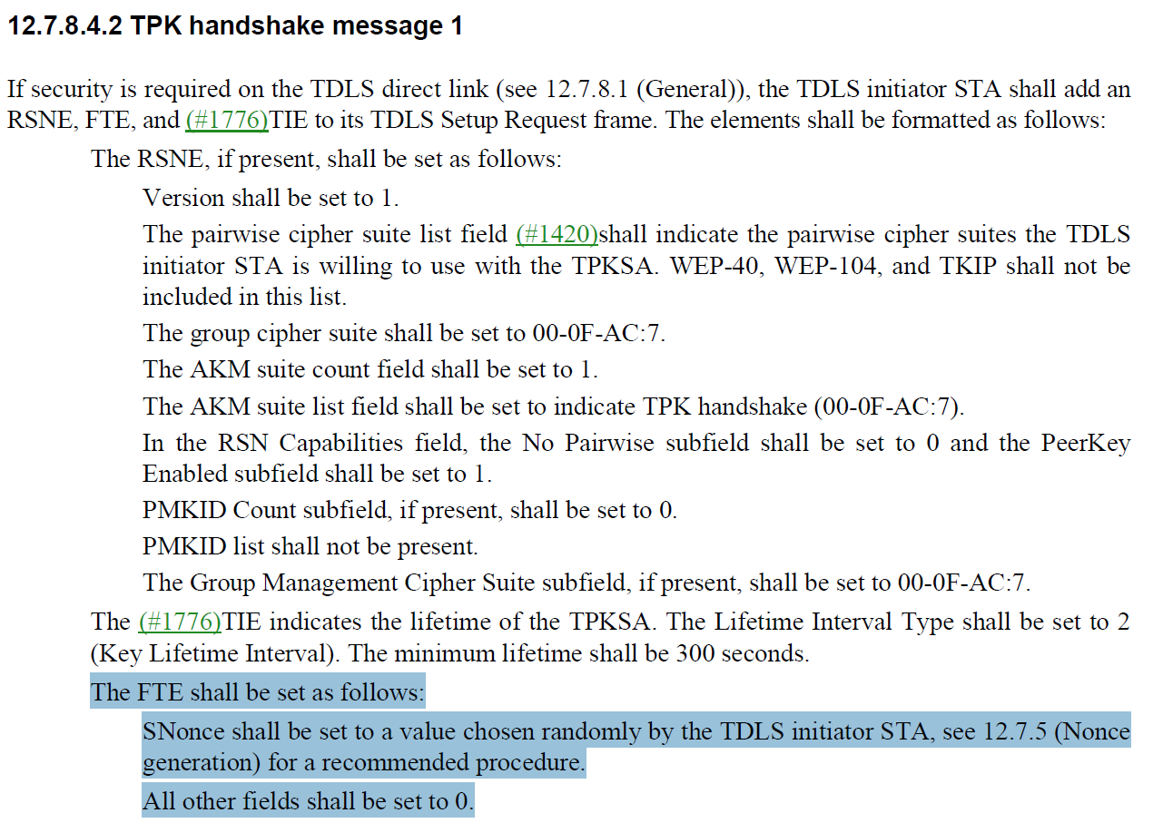
- The change is proposing to append “The Optional
Parameter(s) field shall not be present” at the end of the last highlighted sentence.
- From 2992.39 in the FT protocol description “When this message of the authentication sequence appears in a Reassociation Response frame, the Optional Parameter(s) field in the FTE may include the GTK, IGTK, BIGTK, and WIGTK(11ba) subelements. If a GTK, an IGTK, a BIGTK, or WIGTK(11ba) are included, …”

Proposed Resolution: (3497)
REVISED
At 2929.31, change
“All other fields shall be set to 0.”
to
“The Optional Parameter(s) field has zero length. All other fields shall be set to 0.”

Comment
CID | Page | Clause | Duplicate of CID | Resn Status | Comment | Proposed Change
3551 |  | 12.6.21 |  |  | Consider the following scenario:  - AP has set up the GTK with Key ID 3  - Evil STA leaves the BSS  - AP is the suspicious type and (rightly) does a GTK rekey, and sets up the GTK with Key ID 2  - The remaining STAs duly install the new GTK under Key ID 2  - Sadly, the old key is still there under Key ID 3  - So Evil STA can forge group frames with the old GTK, and get the remaining STAs to accept them  The old GTK needs to be disabled when the new one is set, even with a different Key ID | At the end of the referenced subclause add a para: "After performing GTK rekeying, to avoid attacks from STAs that have left the BSS, a Supplicant shall delete the old GTK when it receives a frame encrypted with the new key."

Discussion:
- This is the related text in context:
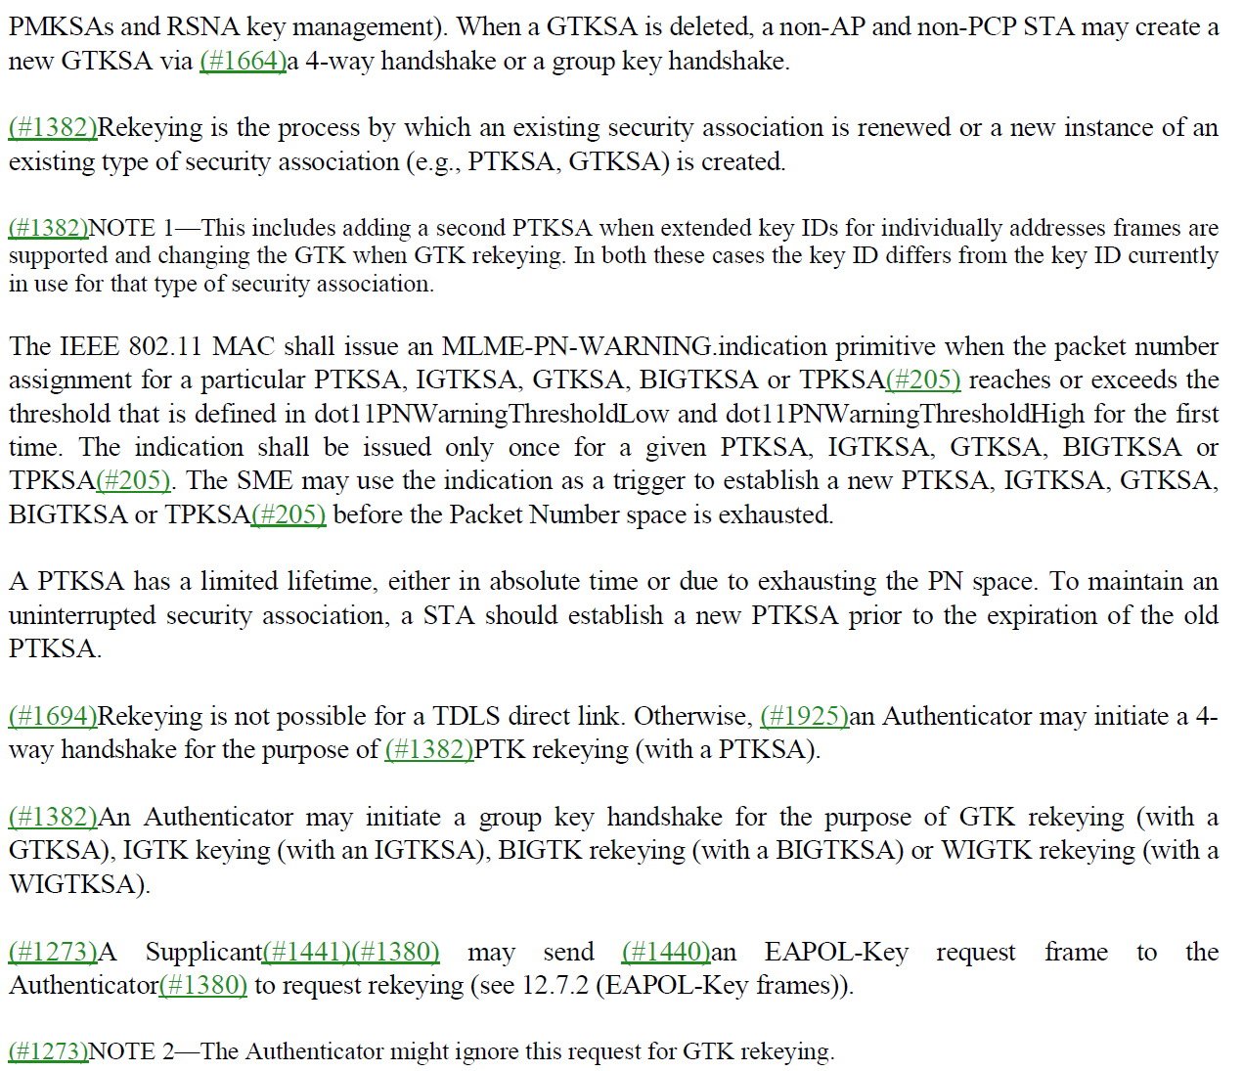

- First of all, the role of the Supplicant is to perform the group key handshake and install the updated key material in the MAC.
- When the group key handshake completes, the Supplicant installs the new group key which replaces the old group key….however could not find text to describe this.

Proposed Resolution: (3551)
More work required. Assign to commenter.

Comment
CID | Page | Clause | Duplicate of CID | Resn Status | Comment | Proposed Change
3575 |  | 12.5.3.4.4 |  |  | "If the recipient set the MFPC bit on a given link to 1, it(#199) shall maintain a single replay counter  for received individually addressed robust Management frames that are received with the To DS  subfield equal to 0," -- it is not clear why an AP should have to do so. Nor why this is only for PV0 | Delete "that are received with the To DS subfield equal to 0"

Discussion:
- This is the cited text in clause 12.5.2.4.4 PN and replay detection (assumed):
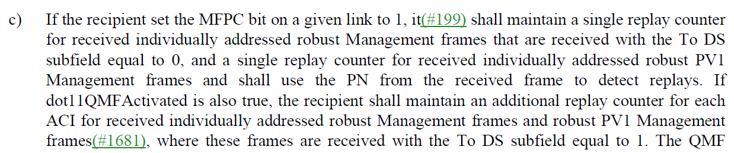
- Note from clause 9.3.3.1 on IQMF and GQMF:
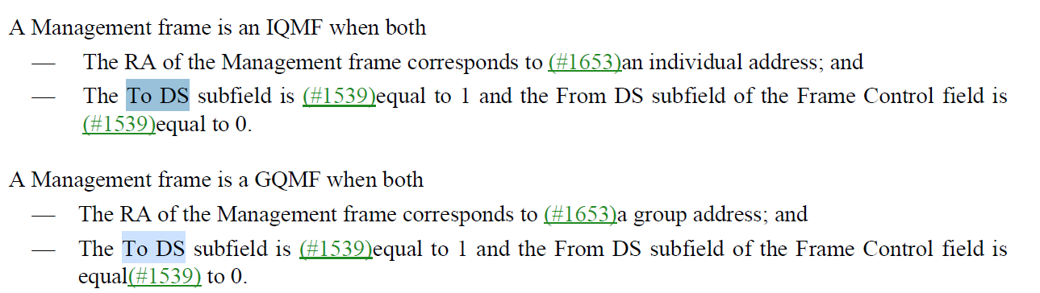
- To DS and From DS are set to 0 for non-QMF management frames. The “To DS subfield” indicates that the frame is not QMF.
- A PV1 Frame does not have a To DS field.
- Mark Rison comment “have an alternative proposal in 22/2069”. Downloaded document 11-22/2069r2 and there is no discussion or resolution in proposed for 3575.

Proposed Resolution: (3575)
Reviewed CID 3573, 3574, 3575 in document 11-22/2069.

Comment
CID | Page | Clause | Duplicate of CID | Resn Status | Comment | Proposed Change
3620 |  | 12 |  |  | The scope of 12.1 Conventions should be explicitly limited to Clause 12 | Change the first sentence to "In the context of Clause 12, reserved fields and subfields are set to 0 upon transmission and are ignored upon reception."

Discussion:
- This CID is a direct copy of previous CID 1898:
  - Comment: The scope of 12.1 Conventions should be explicitly limited to Clause 12
  - Proposed Change: Change the first sentence to "In the context of Clause 12, reserved fields and subfields are set to 0 upon transmission and are ignored upon reception."
- The TG considered this comment in the last round and rejected the comment. Since no further justification has been provided, the comment should be rejected. The resolution was “It was “REJECTED (SEC: 2022-09-15 22:32:15Z) - The TG reviewed the Comment and Proposed Change and concluded that the Proposed Change could not be accepted, as the issue raised is of broader scope than the resolution. The TG consensus was that a submission was required. However, no submission was provided.” so wasn’t rejected on any substantive grounds.

Proposed Resolution: (3620)
ACCEPTED

Comment
CID | Page | Clause | Duplicate of CID | Resn Status | Comment | Proposed Change
3638 |  | 12.7.2 |  |  | "4-way handshake message 1 is an EAPOL-Key frame with the Key Type subfield equal to 1. Use  of the Key Data field to indicate a PMKID when a cached PMKSA is being used in this key  derivation is defined in 12.6.10.3 (Cached PMKSAs and RSNA key management). When a cached  PMKSA is not being used, inclusion of the PMKID (if derived) is optional.(#589)(#190)" is both duplication (whether the PMKID is optional or not is specified in the subclause about M1) and incomplete (it's much more than just an EAPOL-Key frame with Key Type 1) | Delete " is an EAPOL-Key frame with the Key Type subfield equal to 1. Use  of the Key Data field to indicate a PMKID when a cached PMKSA is being used in this key  derivation is defined in 12.6.10.3 (Cached PMKSAs and RSNA key management). When a cached  PMKSA is not being used, inclusion of the PMKID (if derived) is optional.(#589)(#190)"
3639 |  | 12.7.2 |  |  | "4-way handshake message 1 is an EAPOL-Key frame with the Key Type subfield equal to 1. Use  of the Key Data field to indicate a PMKID when a cached PMKSA is being used in this key  derivation is defined in 12.6.10.3 (Cached PMKSAs and RSNA key management). When a cached  PMKSA is not being used, inclusion of the PMKID (if derived) is optional.(#589)(#190)" is both duplication (whether the PMKID is optional or not is specified in the subclause about M1) and incomplete (it's much more than just an EAPOL-Key frame with Key Type 1) | Delete " is an EAPOL-Key frame with the Key Type subfield equal to 1. Use  of the Key Data field to indicate a PMKID when a cached PMKSA is being used in this key  derivation is defined in 12.6.10.3 (Cached PMKSAs and RSNA key management). When a cached  PMKSA is not being used, inclusion of the PMKID (if derived) is optional.(#589)(#190)" and similarly for the other messages; put anything specified here that's not specified in 12.7.6/7 into those subclauses

Discussion:
- This is the cited text in context:
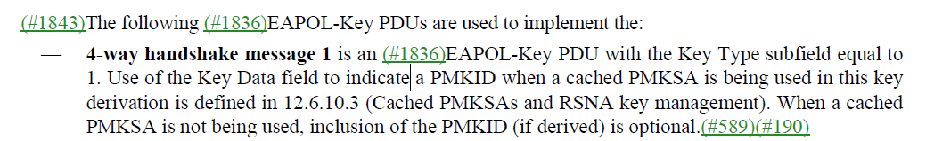

- Looking at Clause 12.7.6.2 and 12.6.10.3.
- It would be good to point to clause 12.7.6.2 in the description.
- The last sentence could be left out. See the revised text in the Proposed Resolution.
- Mark Rison comment “This resolution doesn’t really address 3639”

Proposed Resolution: (3638,)
REVISED. The description of message 1 is modified to point to the clause that describes the fields and parameters included in the message.
At 2906.15, change
“Use of the Key Data field to indicate a PMKID when a cached PMKSA is being used in this key derivation is defined in 12.6.10.3 (Cached PMKSAs and RSNA key management). When a cached PMKSA is not being used, inclusion of the PMKID (if derived) is optional.”
to
“The fields and their values in the EAPOL-Key PDU are described in 12.7.2. Use of the Key Data field to indicate a PMKID when a cached PMKSA is being used in this key derivation is defined in 12.6.10.3 (Cached PMKSAs and RSNA key management).”

3639
REJECTED. Insufficient detail.

Comment
CID | Page | Clause | Duplicate of CID | Resn Status | Comment | Proposed Change
3334 | 2786.00 | 12.2.9 |  |  | If a STA with OCVC capability receives a frame from a peer STA which is not on the same primary channel  (or frequency segment 1 channel number) used by the STA to receive PPDUs from the peer STA, or has  bandwidth that exceeds the maximum bandwidth used by the STA to receive PPDUs from the peer STA, the  frame is discarded.  -> that "or" parenthetical is not clear. How can you have the same  primary channel but not same FS1CN? What if the frame is a 40M or 80M  frame (when the BSS bandwidth is 80 or more)? | Change to "If a STA with OCVC capability receives a frame from a peer STA which is not on the same channel  used by the STA to receive PPDUs from the peer STA, or has  bandwidth that exceeds the maximum bandwidth used by the STA to receive PPDUs from the peer STA, the  frame is discarded."

Discussion:
- The cited text in context is here:
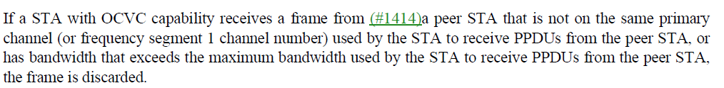
- The proposed change is:
"If a STA with OCVC capability receives a frame from a peer STA which is not on the same channel used by the STA to receive PPDUs from the peer STA, or has bandwidth that exceeds the maximum bandwidth used by the STA to receive PPDUs from the peer STA, the frame is discarded."
- The updated text looks clearer.

Proposed Resolution: (3334)
REVISED. Same resolution with a grammatical change “If a STA with OCVC capability receives a frame from a peer STA that is not on the same channel used by the STA to receive PPDUs from the peer STA, or has bandwidth that exceeds the maximum bandwidth used by the STA to receive PPDUs from the peer STA, the frame is discarded.”

Comment
CID | Page | Clause | Duplicate of CID | Resn Status | Comment | Proposed Change
3711 |  | 6 |  |  | It is not clear whether the SME picks the Key ID for transmission of encrypted frames (using the Key ID parameter of the MLME-SETKEYS.request) or whether the MAC does so | Specify that frames of a given classification (e.g. unicast, groupcast) are transmitted with the key ID most recently specified for that classification using MLME-SETKEYS.request

Discussion:
- The commenter does not cite text, but the relevant text in given in clause 6.5.14.1.4 (Effect of receipt) for MLME-SETKeys
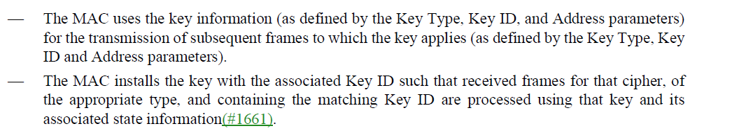
- The above behavior describes how the MAC uses the key information.
- Mark Rison comment: “I don’t think the first bullet is clear. I think it should be “The MAC uses the key with the associated Key ID for the transmission of …”

Proposed Resolution: (3711)
REVISED. Clarify the behavior of the MAC with the key information.
At 492.1 Change “The MAC uses the key information (as defined by the Key Type, Key ID, and Address parameters)”
to
“The MAC uses the key with the associated Key ID and Address parameters”

Comment
CID | Page | Clause | Duplicate of CID | Resn Status | Comment | Proposed Change
3397 | 2870 | 12.6.9 |  |  | "This means that Data frames other than those containing EAPOL PDUs are discarded when received  before the initial 4-way handshake (see 12.7.6 (4-way handshake)) completes, and the unprotected Data frames (other  than those containing retransmissions of the third message of the initial 4-way handshake (see 12.7.6.6 (4-way  handshake implementation considerations)) are discarded when received after the initial 4-way handshake completes." -- does this need to be extended to cover FILS/FT, where there isn't the usual assoc+4WH sequence? | As it says in the comment

Discussion:
- The cited text in context is:
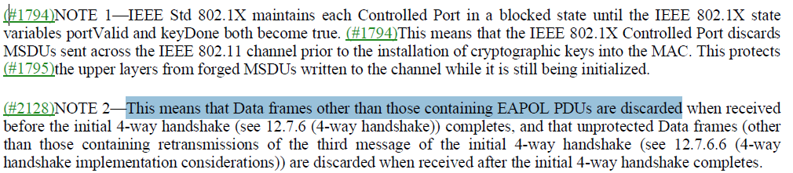
- In comment asks whether this needs to be extended to FILS/FT. FILS/FT protocols take place prior to the completion of association, so the state of the STAs in the link is State 1 or State 2. However the 4-way handshake takes place after association completes where the state of the STAs in the link are State 3 (permitting Data frame transmissions). Therefore this text does not need to be extended.”
- Mark Rison comment: “Always? Even on the initial round?” – Yes, FT Initial Mobility Domain Association refers to the initial round and FILS Authentication always results in a PTKSA.

Proposed Resolution: (3397)
REVISED. At cited location,
change “This means”
to
“When not using FILS authentication, FT Resource Request protocol, or FT protocol, this means”

