IEEE P802.11
Wireless LANs
Proposed resolution for CID 3079 – Self-protected Action Frames
Date: 2022-12-05
Author(s):
Name | Affiliation | Address | Phone | email
Joseph LEVY | InterDigital Communication, Inc. | 111 W 33rd Street  New York, NY 10120 | +1.631.622.4139 | jslevy@ieee.org
Abstract
During the TGme November 2022 Plenary meetings CID 3079 was discussed, the need for this definition was questioned as if the uses of Self-protected Action frame only refers to a particular frame defined in clause 9, there is no need for a definition, if it refers to a type of frame it may need a definitions. This contribution attempts to resolve this issue.

Comment

CID | P.L | C | Comment | Proposed Change | Resolution
3079 | 230.12 | 3.2 | The text that follows "self-protected action frame" is not a definition. | Revise definition to be "Action frames where the protocols that use the frames are responsible  for determining whether to protect these frames and for providing this protection when needed." | Revise:  Delete the definition for “self-protected action frame”.

Background

The summary of discussion from 11-20/1712r0 (Minutes for REVme 2022 November Plenary):

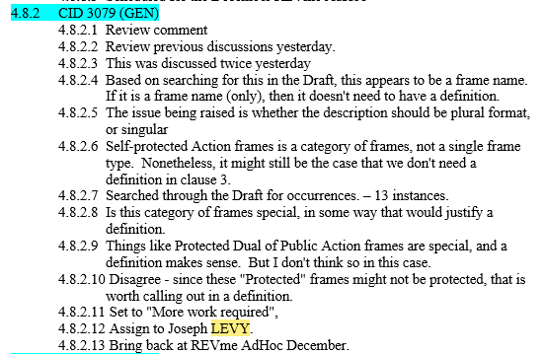

The term “Self-protected Action frame” and “Self-protected Action frames” occurs at the following locations:

30.52 – in the table of contents
230.12 – the definition (the focus of CID 3079 (two instances)
734.51 – in Table 9-71 – “The MIC element is present in a Self-protected Action frame if a (#1900)shared PMK exists between the sender and recipient of this frame; otherwise not present.”
734.54 – in Table 9-71 - ‘ “The Authenticated Mesh Peering Exchange element is present in a Self-protected Action frame if (#125)a (#1900)shared PMK exists between the sender and recipient of this frame; otherwise not
present.”
1643.15 – the clause 9.6.15 title “ 9.6.15 Self-protected Action frame details”
1643.20 – text in clause 9.6.15.1
1643.26 – text in clause 9.6.15.1
1643.29 - text in clause 9.6.15.1
1642.34 - text in clause 9.6.15.1
1642.42 - text in clause 9.6.15.1
1644.1 – text in a “Note” in 9.5.15.1

The term “Self-protected Action frame” is only used in clause 9 and a complete “definition” is provided in clause 9.6.15.1. It should be noted that there are several types of Self-protected Action frames (e.g. Mesh Peering Open, Mesh Peering Confirm, Mesh Peering Closed, …), however the frame type does not appear outside of clause 9. Therefore, there is no need for a definition of the term in clause 3.2.

Proposed Resolution

Delete the definition in clause 3.2 for Self-protected Action frame

