IEEE P802.11
Wireless LANs
LB270 GEN Adhoc Comment Resolutions
Date: 2023-01-17
Author(s):
Name | Affiliation | Address | Phone | email
Michael Montemurro | Huawei |  |  | montemurro.michael@gmail.com
Background
This contribution proposes comment resolutions to selected REVme GEN adhoc comments from LB270.

R0 – Initial version.
R1 –

Comment
CID | Page | Clause | Duplicate of CID | Resn Status | Comment | Proposed Change
3090 | 2395.00 | 11.2.3.14.2 |  |  | The text "A STA that supports FMS shall support a delivery interval of 1 for any stream" does not specify a unit | Revise text as "A STA that supports FMS shall support a delivery interval of 1 DTIM interval for any stream."

Discussion:
- The location of the cited phrases is here:

- The commenter is proposing to clarify that “1” means “1 DTIM interval”, except the commenter 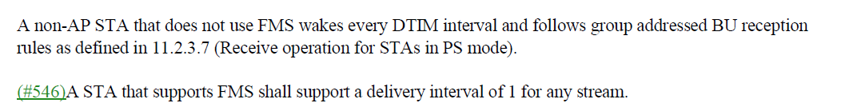likely meant “DTIM period.

Proposed Resolution: (3090)
ACCEPTED

Comment
CID | Page | Clause | Duplicate of CID | Resn Status | Comment | Proposed Change
3593 |  | 3.2 |  |  | "unless it is  known to the transmitter that all STAs in the BSS that are members of the multicast group" -- what is "the multicast group"? Also "the multicast groups" in 11.10.19, "leaves the multicast group" in 11.10.19. Also "multicast group" in 11.21.8, 11.21.16.3.2 (3x), dot11WNMRqstMcstGroup, dot11WNMMulticastDiagnosticRprtMcstGroup | Add a definition "multicast group: a group of logically related stations (STAs) associated by higher level convention." (based on definition of multicast-group address)

Discussion:
- The comment references places in the base standard that mention “multicast group(s)” and claims there is no definition.
- There is a definition of multicast group address:
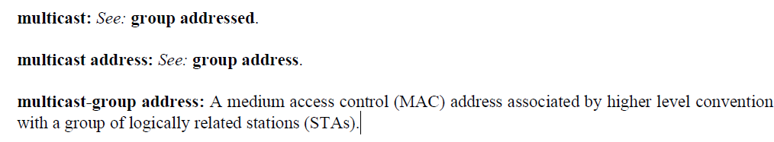
- Note that IEEE Std 802.1Q-2018 and multiple IETF RFCs use the term multicast group without defining it. It is a term of art that is common in networking.

Proposed Resolution: (3593)
Two options – extend the definition of multicast group address to mention multicast group:

REVISED. Extend the definition of multicast group address to describe a multicast group.

At 188.15, change:
“multicast-group address: A medium access control (MAC) address associated by higher level convention with a group of logically related stations (STAs).”
To
“multicast-group address: A medium access control (MAC) address associated by higher level convention with a group of logically related stations (STAs). The group of STAs is referred to as a multicast group.”

Comment
CID | Page | Clause | Duplicate of CID | Resn Status | Comment | Proposed Change
3456 |  | 5.2 |  |  | "data transfer" v. "data unit transfer" (5.2.3.2/5.2.4.2) | Pick one term and change the other to it

Discussion:
- In MA-UNITDATA.request and MA-UNITDATA.indication, both terms are used, see below:
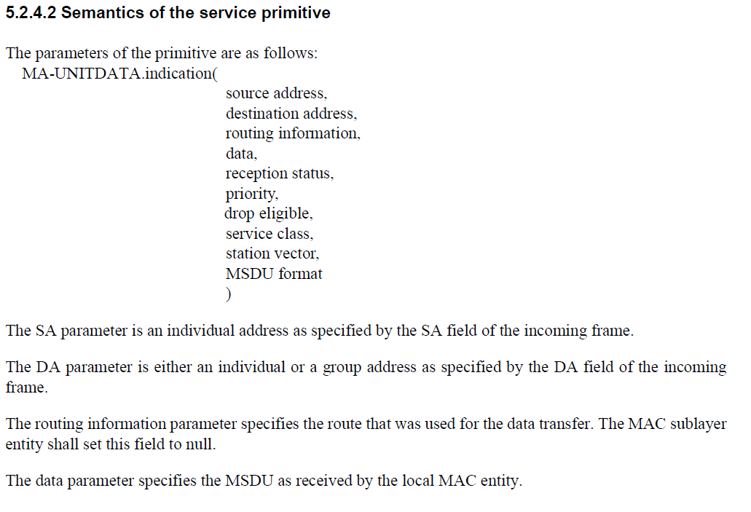
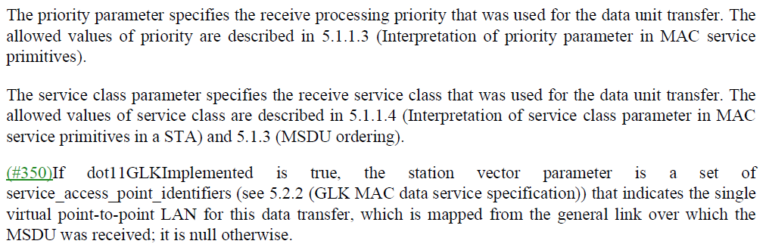

- IEEE 802.1Q and IEEE 802.1AC use “data transfer”. Also, “data transfer” is used in other parts of the draft.
- “data unit transfer” is used 6 times in the draft, all in the MA-UNITDATA primitive definition clauses.

Proposed Resolution: (3456)
REVISED. Use “data transfer”.

At 354.21, 354.33, 357.10, 357.15, 360.39, 360.43, change “data unit transfer” to “data transfer”

Comment
CID | Page | Clause | Duplicate of CID | Resn Status | Comment | Proposed Change
3317 |  | 6 |  |  | HE Color Change Announcement is not of interest to the SME | Delete the row at 384.24, 405.53, 428.37, 434.41, 442.62, 447.4, 454.54, 460.26, 469.65, 474.30

Discussion:
- The text describing the BSS Color Change Announcement, assuming that the commenter intended to refer to BSS Color rather than HE Color:
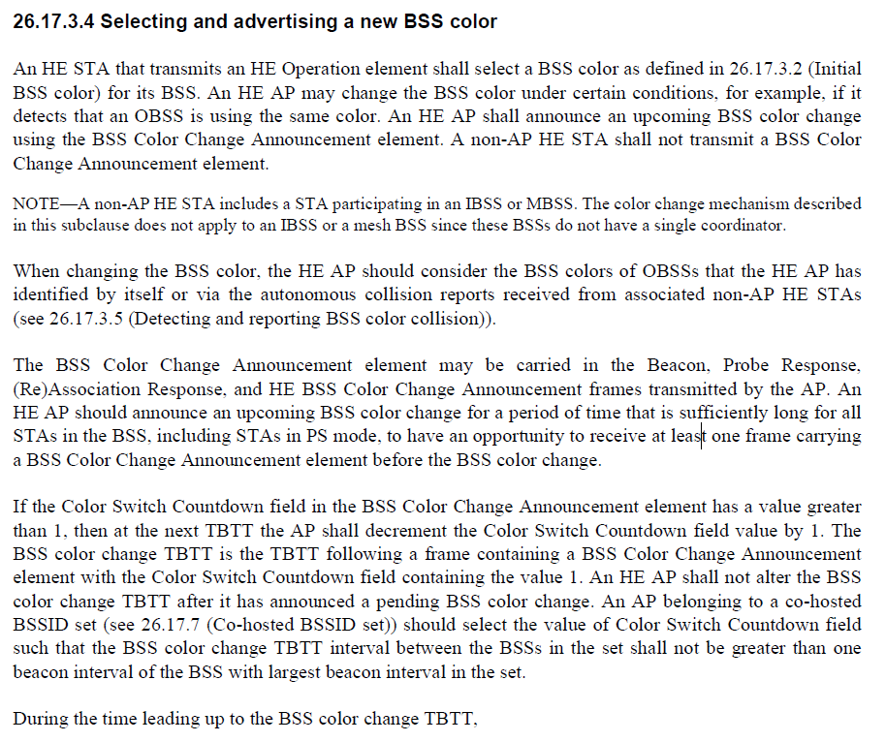
- The text above describes the usage of the BSS Color Change Announcement implies that an AP and STA manage BSS Color. There is nothing in the text above that implies that the BSS Color Change announcement is managed in the MAC or the SME, providing some implementation flexibility.
- The commenter does not give any explanation why the BSS Color Change Announcement would not be of interest to the SME.

Proposed Resolution: (3317)
REJECTED. The comment asserts that the (“HE”) BSS Color Change Announcement “is not of interest to the SME but does not give any explanation why the “BSS Color Change Announcement” would not be of interest.

Comment
CID | Page | Clause | Duplicate of CID | Resn Status | Comment | Proposed Change
3315 |  | 6 |  |  | Deauth and disassoc can be broadcast | Change third cell at 421.24, 422.11, 476.13 to "Any valid individual  address, or broadcast  address"

Discussion:
- The cited text in context is:
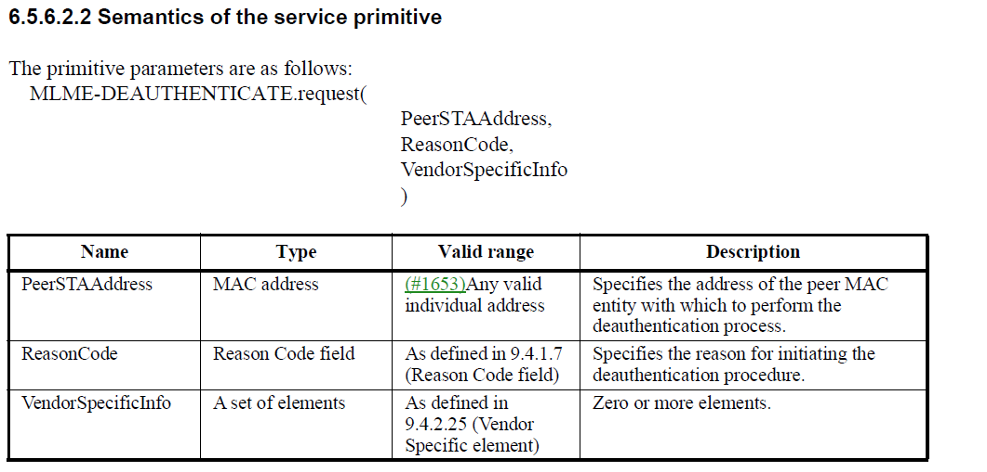
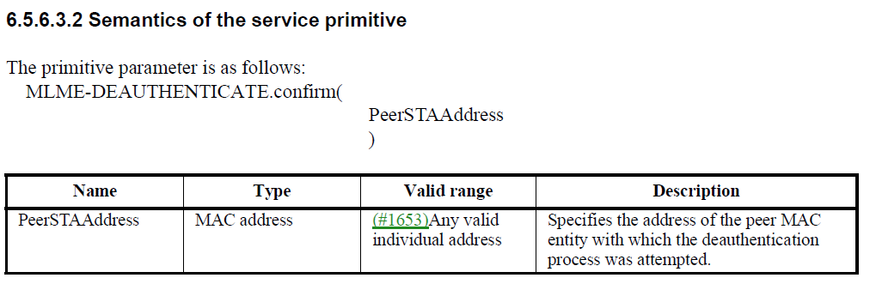
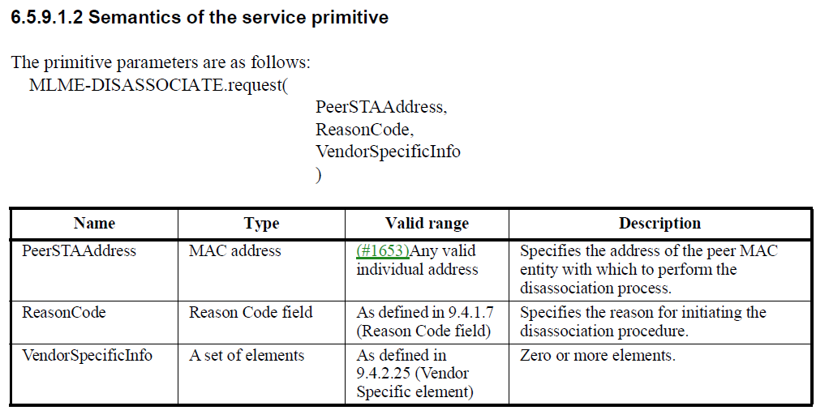

- The commenter is correct in the statement that Deauthentication and Disassociation frames can be broadcast.

Proposed Resolution: (3315)
ACCEPTED

Comment
CID | Page | Clause | Duplicate of CID | Resn Status | Comment | Proposed Change
3288 |  |  |  |  | "Lettered footnotes to tables and figures, however, are normative." is contradicted by the IEEE SA Style Manual 18.2 first sentence | As it says in the comment

Discussion:
- Section 18.2 from the IEEE SA Style Manual. Note the last sentence of the paragraph.
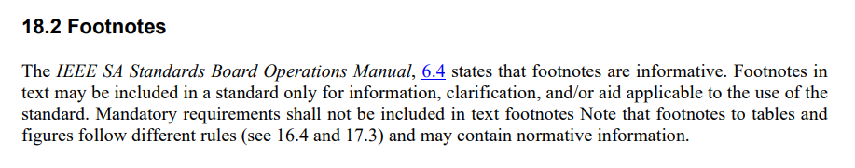

- Section 16.4
- Section 17.3
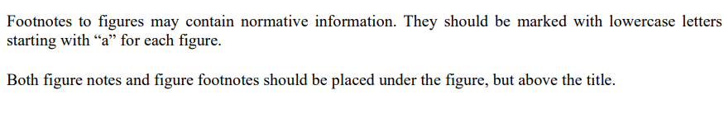
- The convention used in this draft is consistent with IEEE Std 802.11-2020. The published version of IEEE Std 802.11-2020 was reviewed by the IEEE SA Publication Editors
- Also note from the IEEE SA Ops Manual in section 5.4.3.3 Comments in the ballot

Proposed Resolution: (3288)
REJECTED. In last sentence in the same paragraph quoted from the IEEE SA Style Manual states “Note that footnotes to tables and figures follow different rules (see 16.4 and 17.3) and may contain normative information.” This draft uses footnotes in a style consistent with IEEE Std 802.11-2020.

Comment
CID | Page | Clause | Duplicate of CID | Resn Status | Comment | Proposed Change
3275 |  | 4.3.30.3.3 |  |  | Apparently all GLK STAs' bridge ports are always attached bridge ports | Add "attached" before "bridge ports" in all GLK contexts (or delete "attached" at 284.42, 299.50, 2871.20) and say all GLK bridge ports are attached bridge ports)

Discussion:
- CID 1516, which requested similar changes was rejected with the following reason:
“REJECTED (GEN: 2022-04-26 18:17:19Z)
Not all uses of “bridge port” are either “attached” or “not attached”. There are several uses of ""bridge port" as a distinct logical entity:
Deleting the adjective “attached” from “bridge port” is an incorrect change.”
- The cited text on page 284 is:
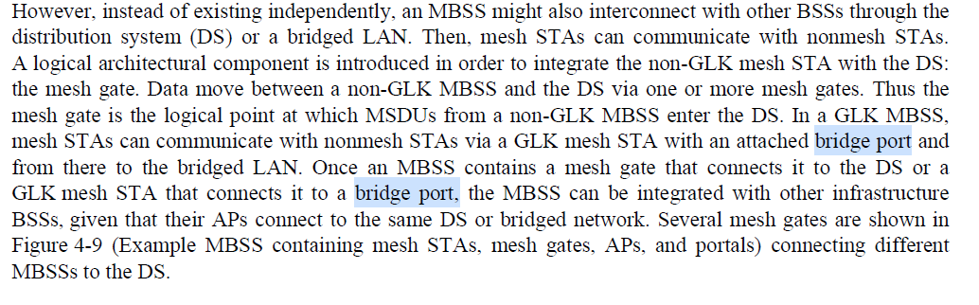
- The cited text at line 42 (the first instance) refers to a GLK MBSS, therefore “attached” appears before bridge port. The usage is correct.
- The cited text on page 299 is
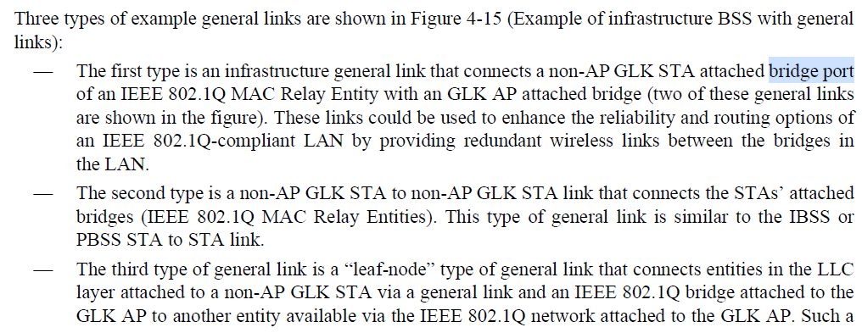
- The usage on line 50 of page 299 correctly refers to “GLK STA attached bridge port” which is correct.
- The cited text at page at 2871 is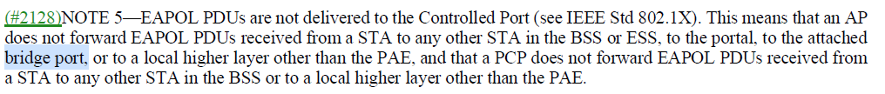
- The text correctly covers the conditions where an EAPOL PDU cannot be forwarded, which in the cited case is an attached bridge port.

Proposed Resolution: (3275)
REVISED. At 284.45, change “bridge port” to “attached bridge port”. The other locations correctly refer to “bridge ports”

Comment
CID | Page | Clause | Duplicate of CID | Resn Status | Comment | Proposed Change
3214 | 181.00 | 3.2 |  |  | "antenna selection (ASEL) transmitter: A station (STA) that performs transmit ASEL." -- useless circular definition | Delete the definition

Discussion:
- The cited text in context is:

- From p2033:
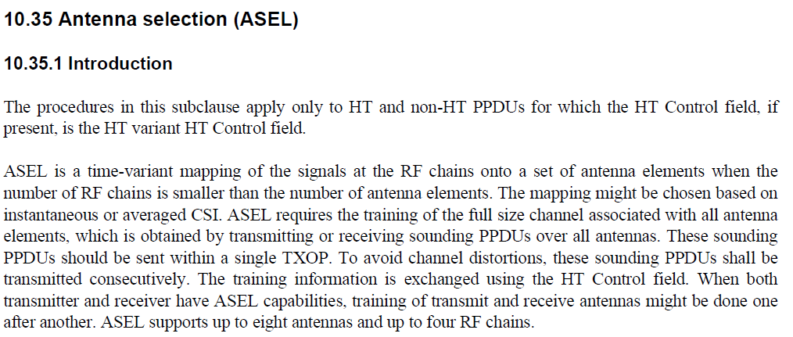
- Based on the above quoted text the definition of ASEL could be modified as “A station (STA) uses that uses an antenna selection procedure to perform the mapping of signals at radio frequency (RF) chains onto antenna elements when the number of RF chains is smaller than the number of antenna elements.”

Proposed Resolution: (3214)
REVISED. Change the cited definition to:
“A station (STA) that uses an antenna selection procedure to perform the mapping of signals at radio frequency (RF) chains onto antenna elements when the number of RF chains is smaller than the number of antenna elements.”

Comment
CID | Page | Clause | Duplicate of CID | Resn Status | Comment | Proposed Change
3086 | 694.00 | 9.3.3.2 |  |  | The addition of the text "and BSS membership selectors" makes it hard to parse the notes associated with Supported Rates and BSS Membership Selectors | Revise to "The Extended Supported Rates and BSS Membership Selectors element is present if the number of supported rates and BSS membership selectors together exceed eight; it is optional otherwise."  Apply change to Notes associated with "Supported Rates and BSS Membership Selectors" in other tables as well (i.e., (Re)Association Request/Response, Probe Request/Response, TDLS Discovery Response, Information for TDLS Setup Request Action field, Mesh Peering Open frame Action field, Mesh Peering Confirm frame Action field,

Discussion:
- The cited text refers to the following MLME primitive description:
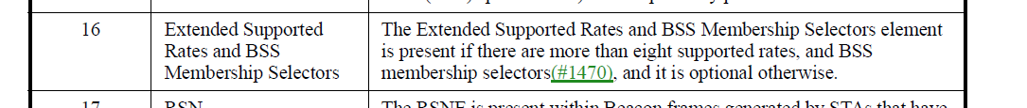
- Agree with the commenter that the wording is awkward.
- The text in the proposed resolution looks reasonable
“The Extended Supported Rates and BSS Membership Selectors element is present if the number of supported rates and BSS membership selectors together exceed eight; it is optional otherwise.”

Proposed Resolution: (3086)
REVISED. Make the proposed change to the text in the “Notes” column at the cited location (694.33) and the following locations: 1563.11, 1608.42, 1644.42, 1646.30, 700.12, 703.41, 708.27, 712.26, 718.24, and 722.6.

