IEEE P802.11
Wireless LANs
LC MIMO
Date: 2022-11-30
Author(s):
Name | Affiliation | Address | Phone | email
Robert Stacey | Intel |  |  | Robert.stacey@intel.com
Abstract
Comment resolution for SA ballot on P802.11bb/ D4.1

Revision History

R0: Initial draft
R1: Improved editing instructions

Comments

Comment # | Page | Subclause | Line | Comment | Proposed Change
I-14 | 18 | 32.3.5 | 7 | "When LC optical TX antennas operate at the same wavelength..." How an LC STA might operate at different wavelengths is not defined in the spec. The spec does not even define the required wavelenth sensitivity for "operation at the same wavelength" | Remove references to operation at the same or different wavelengths. Define what it means to operate in the 800 to 1000 nm band, for example, "An LC optical RX antenna shall be sensitive to radiation with wavelengths between 800 to 1000 nm." Ideally, the statement should include a minimum sensitivity requirement.
I-48 | 18 | 32.2.5 | 4 | The various options how to use MIMO together with LC, e.g. on line 9-11 for using spatial separation, lines 12-14 using WDM, and a third new option using a subset of antennas as LC and the complementary subset of antennas over RF and a fourth option by using FDM together with ultra-wideband OFE should be separated as one subclause for one such optional usage of MIMO together with LC. For the third option, please, refer to the latest version of 11-22/1114. | Restructure and update the text accordingly. Possibly develop one graph illustrating each Tx option for MIMO and replace figure 32-6 which is the receiver configuration.

Discussion

The LC architecture for supporting MIMO is not well described. Also, it is not clear that MIMO is supported through two techniques: wavelength division multiplexing and spatial division multiplexing.

Editing instructions

32.3.2 Transmitter block diagram

The transmitter block diagrams in 19.3.3 (Transmitter block diagram), 21.3.3 (Transmitter block diagram), and 27.3.5 (Transmitter block diagram) show an Analog and RF block that is described as upconverting the complex baseband waveform associated with each transmit chain to an RF signal.

In the LC PHY, the complex baseband waveform associated with each transmit chain is upconverted to an LC IF signal instead of an RF signal. A DC bias is added to LC IF signal which is then fed into an optical front end (OFE). The OFE converts the DC biased LC IF signal into an intensity modulated optical signal.
Because the LC channel is nearly transparent, it functions like a wireless cable.
In some implementations, the complex baseband waveform is upconverted directly to an LC IF signal as shown in Figure 32-1. In this example, the LC PHY TX/RX are HT/VHT/HE PHY TX/RX where the RF antennas are replaced by LC optical antennas.

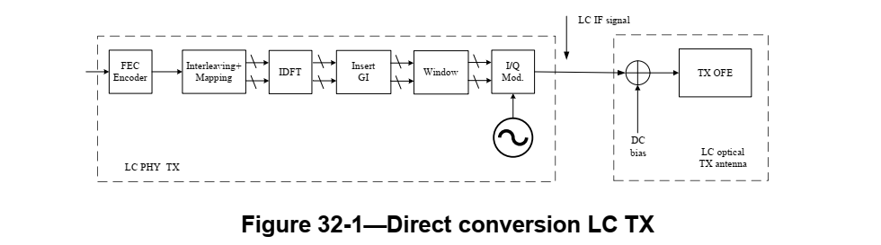

In other implementations, the complex baseband waveform might first be upconverted to an RF signal and then downconverted to the LC IF signal as shown in Figure 32-2.

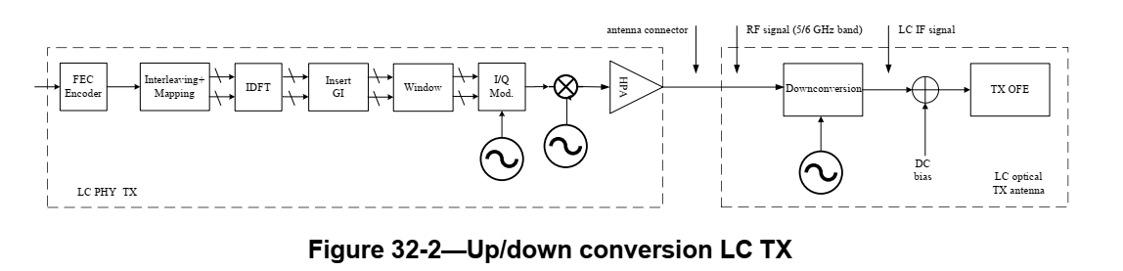

In this example, in the LC PHY TX, after the HPA, the RF signal, in the 5 GHz or 6 GHz spectrum, is downconverted such that the center frequency aligns with the LC IF channel frequency defined in 32.3.4 (Channel numbering). The reference clock of the local oscillator for the downconversion at the LC optical TX antenna is the same as in the LC PHY TX.

TGbb editor: Move the intro paragraph and Figures 32-5 and 32-6 from 32.3.5 to P14L21 as follows:

An LC PHY supports the use of multiple transmit chains and multiple receive chains. An example of the LC PHY TX connected to multiple LC optical TX antennas is shown in Figure 32-5, and an example of multiple LC optical RX antennas connected to the LC PHY RX is shown in Figure 32-6.

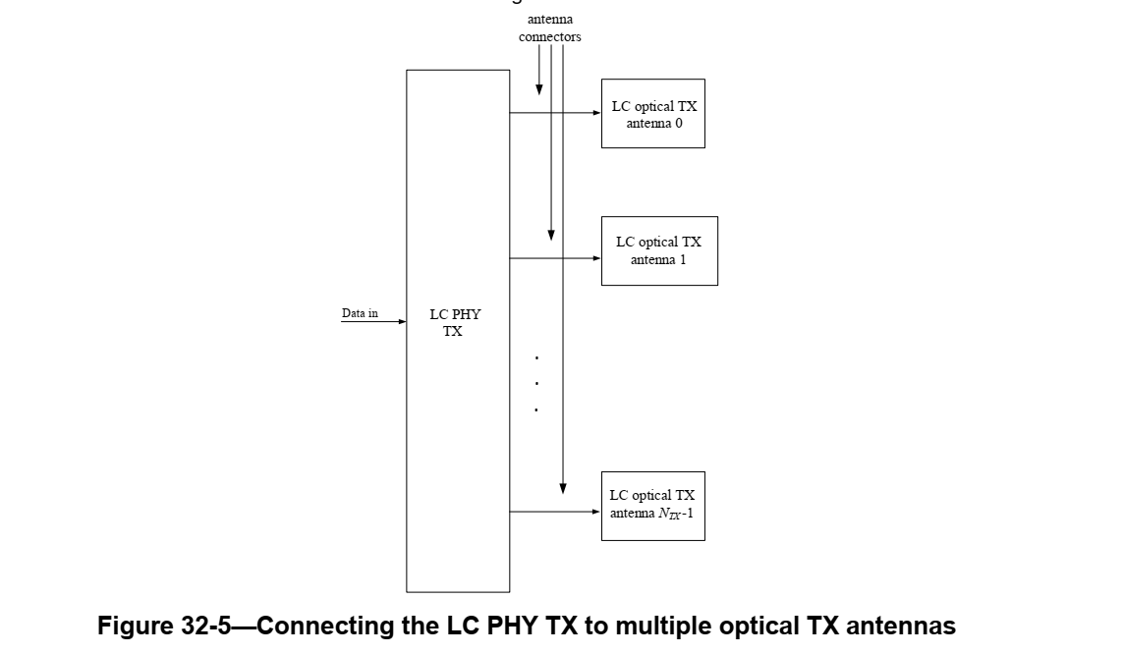

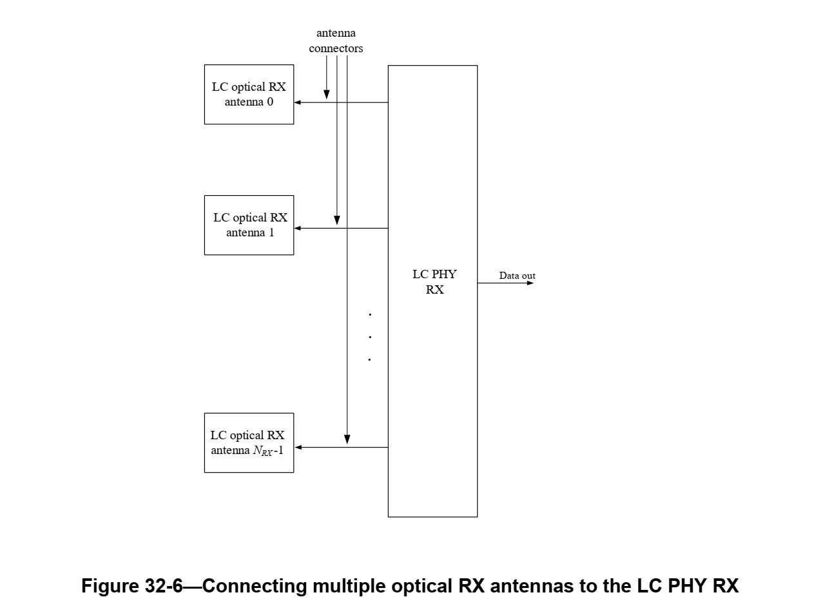
(changes from approved resolutions, such as that for i-9, still apply)

TGbb editor: The remainder of the subclause is unchanged.

A DC bias is always added to the LC IF signal before the signal is fed to the transmitting OFE because the current through an SSL device can only be positive, as illustrated in Figure 32-3.

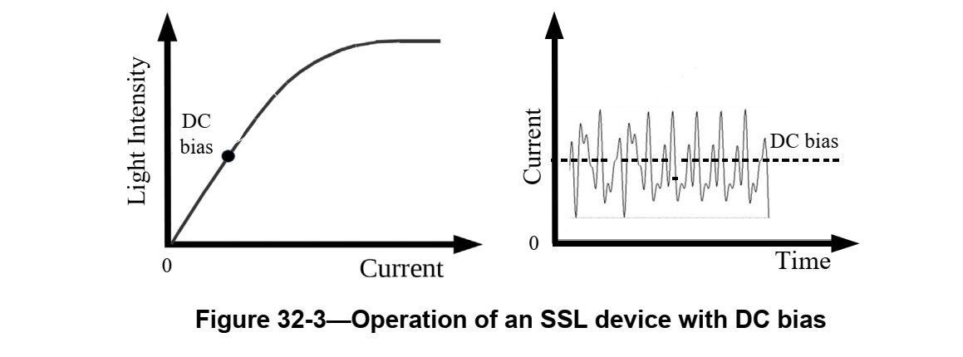

32.3.5 Multiple transmit chains and multiple receive chains

TGbb editor: Insert the following, effectively replacing the architectural description previously here:

The LC PHY may use multiple transmit chains and multiple receive chains to support wavelength division multiplexing and/or spatial division multiplexing.

Spatial multiplexing is supported when the LC optical RX antennas and LC optical TX antennas are positioned such that light transmitted by an LC optical TX antenna and incident on an LC optical RX antenna is isolated from the light transmitted by another LC optical TX antenna that is incident on another LC optical RX antenna. The isolation might be achieved by directing the light at the optical TX antenna or capturing light from a particular direction at the optical RX antenna. The isolation might also be achieved by spatially separating the LC optical TX antennas and/or LC optical RX antennas. This principle is illustrated in Figure X.
Figure X – Spatial multiplexing with an LC PHY

Wavelength division multiplexing is supported when the wavelenth of the light transmitted by one LC optical TX antenna is different from the wavelength of light transmitted by another LC optical TX antenna and, correspondingly, one LC optical RX antenna is sensitive to light of the first wavelength but not the second wavelength and another LC optical RX antenna is sensitive to light of the second wavelength but not the first wavelength. This principle is illustrated in Figure Y.

Figure Y – Wavelength division multiplexing with an LC PHY

TGbb editor: change Red to “lambda 1” and Green to “lambda 2” in the above figure.

For example, with two transmit chains one operating at 950 nm and the other at 850 nm, a shortpass dicroic beamsplitter with a cut-off wavelength of 900 nm can be used in front of both receive chains. The wavelength of the first transmit chain is longer than the cut-off wavelength. It is reflected by the dicroic beam splitter and detected by the first receive chain. The wavelength of the second transmit chain is shorter than the cut-off wavelength. It passes through the dicroic beam splitter and is detected by the second receive chain.

An LC STA with a single transmit chain is interoperable with an LC STA with multiple transmit and multiple receive chains operating in wavelength division multiplexing mode. The sum of transmitted and reflected signals from a dicroic beamsplitter is approximately the same, independent of the wavelength.

For example, a first LC STA with a single optical antenna supports a single stream. This stream can be detected by both receive chains of a second LC STA with two optical antennas by combining their signals. In the reverse link direction, both transmit chains of the second LC STA are used to transmit a single stream which can be detected by the single receive chain of the first LC STA.

Note that when using LEDs with different wavelengths, their optical spectra might be wider and cause residual crosstalk at a receive chain. It might be minimized by using multiple-transmit multiple-receive antenna processing.

In the above description, if the LC optical TX antennas are in one LC STA and the LC optical RX antennas are in another LC STA the arrangement supports SU-MIMO. If the LC optical antennas (TX or RX) at one end are in the same LC STA but the LC optical antennas (RX or TX) at the other end are in different LC STAs then the arrangment supports MU-MIMO.

An LC optical RX antenna shall be sensitive to light in one of the following wavelength ranges:
- 800 nm to 900 nm
- 900 nm to 1000 nm
- 800 nm to 1000 nm

An LC PHY shall have at least one receive chain with an LC optical RX antenna sensitive to light in the 800 nm to 1000 nm range or at least two receive chains with one receive chain with an LC optical RX antenna sensitive to light in the 800 nm to 900 nm range and the other receive chain with an LC optical RX antenna sensitive to light in the 900 nm to 1000 nm range.

The maximum number of spatial streams supported by an LC PHY using wave division multiplexing is 2.

TGbb editor: Change the remainder of the subclause as follows:

In an LC PHY that implements RF up/downconversion and has multiple transmit chains, the RF downconverters shall be synchronized to a common reference clock. In an LC PHY that implements RF up/downconversion and has multiple receive chains, the RF upconverters shall be synchronized to a common reference clock. (approved resolution for i-15)

(approved resolution for i-62 revises this statement, but I suggest we delete it and update the resolution – the need for spatial separation is explained above)

When operating the LC PHY with multiple optical TX antennas in the LC HT PHY mode, the LC PHY TX shall use the procedures defined in 19.3 (HT PHY), where NTX transmit chains in the HT PHY shall be connected to NTX LC optical TX antennas. (approved resolution for ?)
When operating the LC PHY with multiple optical TX antennas in the LC VHT PHY mode, the LC PHY TX shall use the procedures defined in 21.3 (VHT PHY), where NTX transmit chains in the VHT PHY shall be connected to NTX LC optical TX antennas.
When operating the LC PHY with multiple optical TX antennas in the LC HE PHY mode, the LC PHY TX shall use the procedures defined in 27.3 (HE PHY), where NTX transmit chains in the HE PHY shall be connected to NTX LC optical TX antennas.
(approved resolution for i-18 is to delete)

TGbb editor: insert a new subclause after 32.3.5 as follows:

32.3.5a Receive specification

The minimum receive sensitivity of an LC PHY shall be -15 dBm_opt measured as the average incident power in the range 800 to 1000 nm at the LC optical RX antennas.

.

