IEEE P802.11
Wireless LANs
CC40 CR for CIDs 100, 102 and 734
Date: 2022.12.01
Author(s):
Name | Company | Address | Phone | email
Mengshi Hu | Huawei Technologies | F3, Huawei Base, Bantian, Longgang, Shenzhen, Guangdong, China, 518129 |  | humengshi@huawei.com
Rui Du
Narengerile
Abstract
This submission contains the proposed comment resolutions for the remaining 3 defered CIDs in the Topics “Frames” and “Instance” shown in 22/0820 IEEE 802.11bf CC40 comments.

CIDs 100, 102 and 734.

Revision Notes
R0 | Initial version

CID 100 & 102
CID | Page.  Line | Clause Number | Comment | Proposed Chang | Resolution
100 | 69.65 | 11.21.18.6.2 | The note is not needed. It is clear that the frame and NDP will need to be defined. | Delete the Editor's Note. | ACCEPTED.
102 | 72.01 | 11.21.18.7 | The note is not needed. It is clear that the frame and NDPs will need to be defined. | Delete the Editor's Note. | ACCEPTED.

Discussion:
[Page 69 Line 65]
[Page 72 Line 01]

(see 11-22/1785r2 PDT Sensing NDPA Frame Format and 11-22/1937r3 PDT - NDP formats for sensing)
Discussion ends.

CID 734
Page.  Line | Clause Number | Comment | Proposed Change | Resolution
32.52 | 9.4.2.26 | Table 9-10 includes bit 90 as 'WLAN Sensing' as it would be more suited to replace it with three bits indicating; 1) TB measurement instance sensing 2) NTB measurement instance sensing and 3) TB measurement instance with STA-to-STA sensing | As per comment | REJECTED.  According to the latest discussions, there is no need to indicate the detailed capabilities of TB, NTB and SR2SR here. The capability of these three cases are included in the Sensing field of the Sensing element. See 802.11 DCN 22/1577 for more details.

Discussion:
The related figure in 802.11bf D0.4 is shown below:
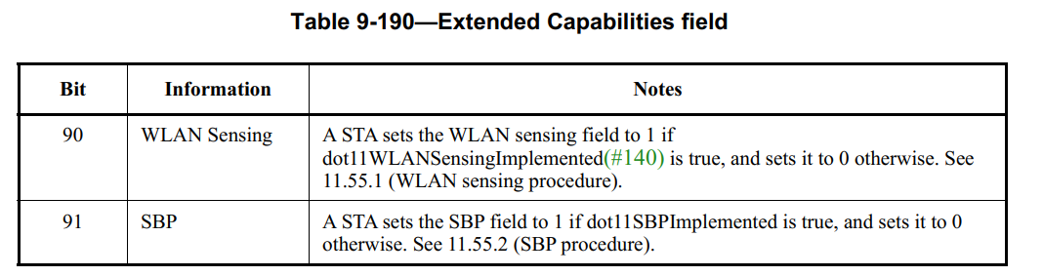

Regarding the capability “SR2SR”, a subfield called “SR2SR Support” is going to be included in the Sensing field of the Sensing element, indicating whether the transmitter STA supports SR2SR sensing.

Regarding the capability “TB” and “NTB”, a subfield called “Max Number Of Supported Setups As Responder” is going to indicate it. A value 0 implies that the device doesn’t support TB (when sent by non-AP STA) and NTB (when sent by AP STA).

Thus, no need to include these capability indications in the Extended Capabilities field.

Discussion ends.

SP

Do you support the proposed resolutions to the following CIDs and incorporate the text changes into the latest TGbf draft: 100, 102 and 734?

Y/N/A

