IEEE P802.11
Wireless LANs
CC40-misc-DMG-CIDs
Date: 2022-11-13
Author(s):
Name | Affiliation | Address | Phone | email
Assaf Kasher | Qualcomm |  |  | akasher@qti.qualcomm.com
Solomon Trainin | Qualcomm |  |  | strainin@qti.qualcomm.com
Abstract
This document proposes resolution to several DMG related CIDs.
All changes are based on D0.5

443 | 11.21.20.1 | 76.54 | "Each DMG sensing instance contains a sounding phase. The first DMG sensing instance in each DMG sensing  burst contains sounding and reporting phases separated by the SIFS interval." - is this normative text (it sounds like that) or does it only describe an example | demote all the example text to a subcluase so examples are separted from normative text | Revise  TGbf Editor: perform changes specified in 11-22-2073r0.

TGbf Editor: change the text in P163L62-65, P164L1-2
Coordinated Monostatic sensing is an extension of monostatic sensing to coordinate monostatic sensing. In the monostatic sensing with coordination sensing type, the transmissions by one or more devices that perform monostatic sensing are coordinated by a PCP/AP(#718).
Coordinated Bistatic sensing is an extension of bistatic type to coordinate multiple sensing responders by one sensing initiator.

TGbf Editor: change the text in P164L29-36
A sensing responder may participate in several DMG sensing measurement setups containing multiple and possibly overlapping DMG sensing bursts.
A sensing initiator may initiate several DMG sensing measurements containing multiple DMG sensing bursts with multiple, possibly overlapping sets of sensing responders(#207).

TGbf Editor: insert a new subcause header 11.53.3.2 in P114L
11.55.3.2 DMG Sensing Procedure examples

34 | 11.21.20.5.2 | 86.01 | Description of pure monostatic DMG sensing instance missings | Should have a section on "Monostatic DMG Sesning Instance". | Reject,  Monostatic sensing is something a STA performs itself, we no need for cooperation with other STAs. There is no need for triggering or sending reports. Scheduling is done or requested by the STA itself. Therefore, there is no need for spec text to resolve that. The resolution to CID 418, in document 11-22-1523 describes the allowed PHY behavior.

91 | 11.21.20 | 74.01 | Rules and guidelines for DMG Reporting are not written | Section 11.21.20 doesn't inlcude detailed guidelines about the DMG reporting. A technical submission on this is required. | Revise  TGbf Editor: perform changes specified in 11-22-2073r0.

Discussion:
We propose the following concept:
If the report type requested in the measurement setup parameters includes doppler the reporting is at the end of the burst per the definition of a burst. In other cases, the reporting is at the end of an instance. Due to the complexity in the processing, including the generation of the frame, the reporting in instance n is normally on measurement performed in instance n-1 (immediate reporting is allowed in BRP frames). To get the report of the last instance in the burst, the initiator may poll responders after the Intra Burst Interval specified in the DMG measurement setup parameters schedule subelement. To allow for Doppler calculation at the end of the burst, the initiator may poll the responders for images/maps including Doppler after an interval specified in the measurement setup frame sent by the responder. That interval must be shorter than the intra-burst interval.
We also propose to keep the unifying the Report type fields/subfields in the DMG Sensing Measurement Setup/DMG Sensing Report Control/BRP Sensing Element.
Besides that, we remove the Report Delay field from the Report Sensing Report Element and move it to the BRP Sensing Element. The Sensing Instance SN/Burst Id and/Measurement ID identify the report sufficiently. In the BRP there is a mix up between the report and the frame itself. (Because the legacy CSI feedback does not have instance identification)

This is what we have now as Report Type:

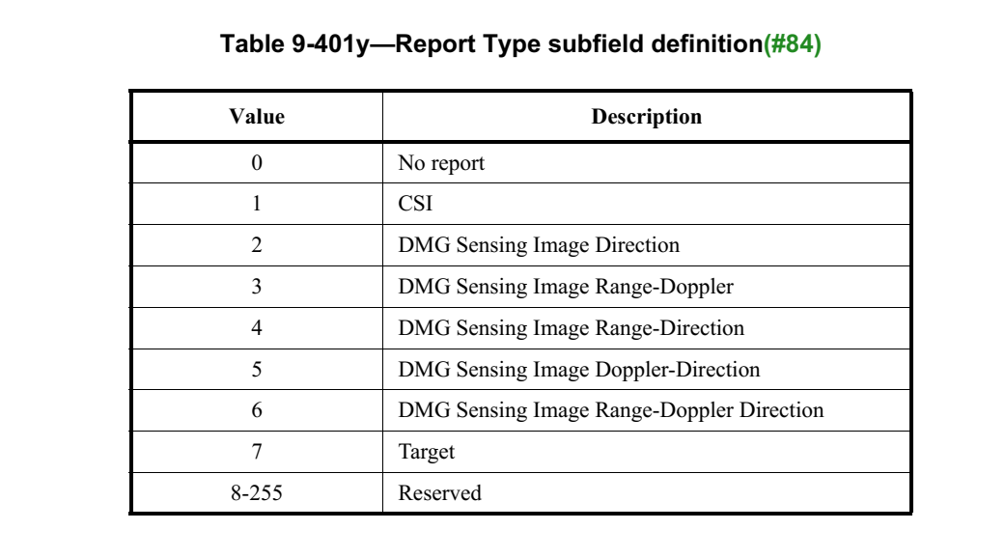

This is report control field of the report control element.

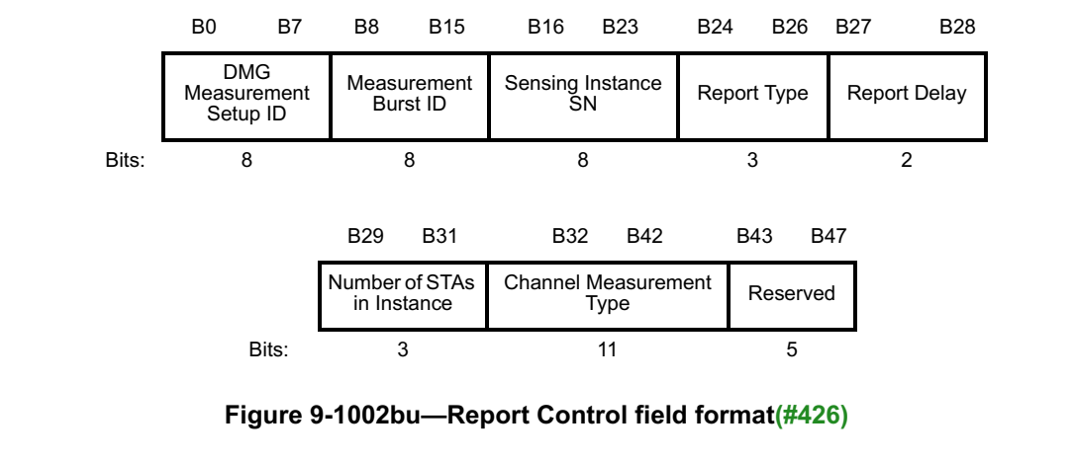

TGbf Editor: Remove the Report Delay subfield from figure 9-1002bu, increasing the size of the reserved field to 7. Remove the text in P102L7-22

TGbf Editor: change the text in P102L90:
The Report Type field is set one of the values described in Table 9-401w (Report Type subfield definitions).

TGbf Editor: Change the text in P103L43-54 as follows:

The Sensing Instance SN(#397, #223) field is reserved when

the Report Type subfield has the values 3, 5, 6, 7
The DMG Sensing Report Type field is set to one of the values described in Table 9-401w (Report Type subfield definitions). Values from 8-255 are reserved. (#697).

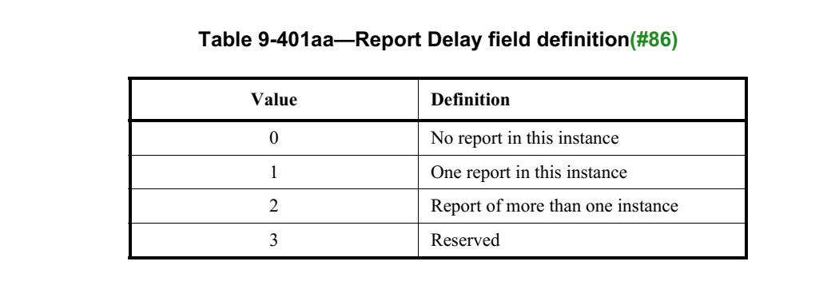

TGbf Editor: increase the size of the Report Delay field to 3 bits (decreasing the number of reserved bits to 2) in table 9-1002ck (Report Control field format) and replace table 9-401ac with the following table:
Value | Definition
0 | No report in this frame
1 | Report in this frame covering measurements in this instance
2 | Report in this frame covering measurements in the previous instance
3 | Report in this frame covering measurements in this burst
4 | Report in this frame covering measurements in the previous burst
5-7 | Reserved

TGbf Editor: Change the text in P75L54
The Report Type subfield is defined in Table 9-401w (Report Type subfield definitions).

TGbf Editor: Remove table 9-401ae and change the text in P75L56-67
The Report Delay subfield is defined in table 9-401ac (Report Delay subfield definition (#86)).

Discussion
It is beneficial to have the responder indicate how long it will need to calculate a sensing burst Doppler image/ target list. This tells the initiator how long after the end of the burst it may poll the responder.

TGbf editor: replace the last line in Table 9-401x—Subelements of DMG Sensing Measurement Setup definition with the following lines as follows

4 | Burst Response Delay | Yes
5-255 | Reserved | No

TGbf editor: Insert the following subclause after 9.4.2.324.3:

9.4.2.324.3.4 Burst Response Delay Subelement

 | Subelement Id | Length | Burst Response Delay
octets: | 1 | 1 | 1
Figure 1- Burst Response Delay subelement format
The Burst Response Delay field of the Burst Response Delay subelement contains the time in milliseconds after the end of the last PPDU in the burst it takes the responder the generate the report on the sensing measurements in the burst.

TGbf Editor: Add the following text after P175L19
If the initiator has set the report type field in the DMG Sensing Measurement Setup element to the values 3,5,6,7 (Values indicating Doppler reporting), the sensing responder shall include a Burst Response Delay subelement in the DMG Sensing Measurement Setup element with the Burst Response Delay field set to the time in milliseconds it needs to calculate the response to the DMG sensing burst defined in the initiator’s DMG Sensing Measurement Setup element.

TGbf Editor: insert the following new subclause after 11.55.3.6.5.3 updating the subclause headers following it.

11.55.3.7 DMG sensing measurement reporting
There are 6 types of report of DMG sensing as defined in Table 9-401y (Report Type subfield definitions).

If the initiator requested sensing types 1,2,4 (sensing types that do not include Doppler), in the DMG Measurement Setup frame, responders provide report in each instance, either through a DMG Sensing Report element or through Channel Measurement feedback elements.

For the Channel Measurement Feedback elements, carried inside a BRP frame, the measurements on which the report is based upon are defined in the Report Delay field of the Report Control field of the BRP Sensing element (9.4.2.329 BRP Sensing element). If the value of the field equals to 1 the report is based on measurement in the current instance. If the value of the field equals 2 the report is based on measurement in the previous instance. Report Type field in the first instance of the burst can take the value of 0 indicating no report in this instance or the value of 2 indicating report of measurements in the last instance of the previous burst.

For the DMG Sensing Report element, or Channel Measurement Feedback elements carried inside a DMG Sensing Report frame, the measurements on which the report is based, are indicated by the subfields DMG Measurement Setup ID, Measurement Burst ID, and Sensing Instance SN in the Report Control field of the DMG Sensing Report Control element (9.4.2.327 DMG Sensing Report Control element)

If the initiator requested sensing types 3,5,6 or 7 (sensing types that include Doppler), responders provide a report for the whole burst at the end of the burst. The initiator may use the DMG Sensing Poll frame to poll each of the responders $τ_{R}$ milliseconds after the end burst, where $τ_{R}$ is the time specified in Burst Report Delay field in DMG Sensing Scheduling subelement of the DMG Measurement Setup Element sent by each responder. If the responder specified $τ_{R}=0$ or if the initiator does not poll a responder, the report will be provided in the first instance of the next burst.

445 | 11.21.20.1 | 77.33 | The figure in the example indicates an invalid report option for a Report BRP frame. There is no such frame. In the BRP Sensing element the report control field does not have an "invalid report option" - (figure 11-41j) | reconcile fraem structure with example | Revise  TGbf Editor: perform changes specified in 11-22-2073r0.

TGbf Editor Replace figure 11-75o with the following figure:

447 | 11.21.20.2 | 81.57 | It is not clear that the session setup is over after the capabilities are exchanged. | Add a sentence saying: "The DMG sensign session setup is complete when the DMG STA and PCP/AP have exchanged their capabilities" | Revise  TGbf Editor: perform changes specified in 11-22-2073r0.

TGbf Editor: insert the following text in P172L36:
The DMG sensing session setup is compete when DMG STA and the PCP/AP have exchanged their capabilities.

355 | 11.21.20.1 | 81.05 | "The sensing responder STA A uses the preamble, and the sensing responder STA B uses the Sync  field to synchronize with the transmitter clock. The sensing initiator in the sensing transmitter role transmits  the TRN fields and the sensing responders STA A and STA B in the sensing receiver role measure the  reflected signals." Align the text and Figure 11-41n with the submissions of the Multistatic sounding and the Multistatic PPDU. | Align the text and Figure 11-41n with the submissions of the Multistatic sounding and the Multistatic PPDU. | Revise  TGbf Editor: perform changes specified in 11-22-2073r0.

TGbf editor: change the text in P171L31-35 as follows:
transmits the PPDU for synchronization and DMG sensing purposes. The sensing responder STA A uses the first Sync subfield, and the sensing responder STA B uses the second Sync subfield to synchronize with the transmitter clock. The sensing initiator transmits the TRN fields and the sensing responders STA A and STA B measure the reflected signals (#725, #726).

TGbf editor: Change figure 11-75s as follows:

368 | 11.21.20.5 | 85.34 | 11.21.20.5 DMG sensing instance. Lack of detailed rules | Provide detailed rules of normative behavior of the initiator/responder(s) and transmitter/receiver(s) during the DMG sensing instance, specific for each type of DMG sensing. The definition shall refer to the parameters/attributes established by the DMG measurement setup. | Revise:  TGbf Editor: perform changes specified in 11-22-2073r0

Discussion:
The description of DMG sensing instance in the current draft is quite full. It will be even longer after contributions on Monostatic sensing are presented. However, there is one issue which is not covered well and that is the set of beams used in each instance.

TGbf editor: Add the following text at the end of 9.4.2.325.1 (TX Beam List subelement)
If the value in the Report Type field is 3,5,6 or 7, (Values indicating Doppler measurement), and the DMG Sensing Scheduling subelement is present in DMG Sensing Setup element, the value of the Number Beam Indices field is equal to the value of the Number TX Beams Per Instance field of the DMG Sensing Scheduling subelement.

TGbf editor: Change the text in P112L49 as follows:
The First Beam Index field is an index into the Tx Beam List in the DMG Sensing Measurement Setup element. that indicates the first beam to be used in the transmission of the TRN

TGbf editor: Change the text in P177L54-59 (Bistatic DMG sensing Instance) as follows:
BRP frame from the sensing responder. The measurement covers the number of transmit AWV Combinations indicated by the Number TX Beams Per Instance field within the DMG Sensing Scheduling subelement of the DMG Sensing Measurement Setup element (see 9.4.2.324 (DMG Sensing Measurement Setup element)). The beams covered start from the First Beam Index specified in BRP Sensing element and continues with following beams in the Tx Beam List subelement. Per each of these AWV combinations, all the AWV combinations indicated in RX Beam List

TGbf editor: Change the text in P179L22-25 as follows:
assigned the value of 0 in the STA ID (#330, #871). The sensing initiator sets the First Beam Index field to a value that indicates the first beam that is used for transmission in the TRN field of the first EDMG Multistatic Sensing PPDU. The other beams used in the Multistatic Sensing PPDUs are the following beams in the Tx Beam List subelement. The sensing initiator sets the Start of #N PPDU subfields to the time, in microseconds,

TBD | Clause Number(C) | Page(C) | Line(C) | Text
TBD | 9.4.2.329.3 | 109 | 22 | In Monostatic sensing the Receiver Beam Index axis represents the Beam Index used by the STA to transmit and receive, and the Transmitter Beam Index axis is not present(#840). Beam Index is defined in TBD
Discussion: The main issue is that there is a question whether the Beam Index should be an index into the list in the DMG Sensing Beam Descriptor element or the list in the DMG Measurement Setup Tx Beam list subelement. I propose to unify all beam indices that are used in reporting to point into the DMG Sensing Beam Descriptor element.

TGbf Editor: change the text in P109L21-23 as follows
In Monostatic sensing the Receiver Beam Index axis represents the Beam Index used by the STA to transmit and receive, and the Transmitter Beam Index axis is not present(#840). The Receiver Beam Index is an index into the DMG Sensing Beam Descriptor Element.
References:

