IEEE P802.11
Wireless LANs
Proposed Resolution for REVme LB270 Editor1 ad-hoc Comments
Date: 2023-01-05
Author:
Name | Affiliation | Address | Phone | Email
Emily Qi | Intel Corporation | 2111 NE 25th Ave.  Hillsboro OR 97124 |  | Emily.h.qi@intel.com

This submission present proposed resolutions for comments in the Editor1 ad-hoc group.

The proposed changes are based on REVme/D2.0.

Revision history:

R0 – initial version
R1: incorporated the feedback from the TG meeting on 12/16/2022.
R2: updated unsolved comments with some thoughts.
R2: incorporated the feedback from the TG meeting on 1/6/2023

3775 | 1821.1 | 10.5 | The statement at 1821.1 (as inserted with #2200) splits a paragraph that should be read as a whole. Also, the inserted statement makes a reference to "fragmentation" in a subclause dealing with "defragmentation". | Delete the first sentence (Dynamic fragmentation allows A-MSDUs to be fragmented). Move the second sentence so that it is the first paragraph of this subclause.

Discussion:
Cited text:
10.5 MSDU, (11ax)A-MSDU, and MMPDU defragmentation
Each fragment contains information to allow the complete MSDU, A-MSDU,(#2200) or MMPDU to be
reassembled from its constituent fragments.
(#2200)Dynamic fragmentation allows A-MSDUs to be fragmented. Reception and reassembly of A-MSDU fragments shall follow the procedures defined in this subclause except where superseded by 26.3
(Fragmentation and defragmentation)

Proposed changes:
10.5 MSDU, (11ax)A-MSDU, and MMPDU defragmentation
Each fragment contains information to allow the complete MSDU, A-MSDU,(#2200) or MMPDU to be
reassembled from its constituent fragments.(#2200)Dynamic fragmentation allows A-MSDUs to be fragmented. Reception and reassembly of A-MSDU fragments shall follow the procedures defined in this subclause except where superseded by 26.3
(Fragmentation and defragmentation)

Proposed resolution:
Revised. Change the cited paragraphs as below:
Each fragment contains information to allow the complete MSDU, A-MSDU,(#2200) or MMPDU to be
reassembled from its constituent fragments.(#2200)Dynamic fragmentation allows A-MSDUs to be fragmented. Reception and reassembly of A-MSDU fragments shall follow the procedures defined in this subclause except where superseded by 26.3 (Fragmentation and defragmentation)

3011 | 1256.52 | 9.4.2.177 | Clause 11.1.4.3.9 doesn't provide any information on Max Channel Time. The reference to 11.1.4.3.9 seems incorrect. | As in comment

Discussion:
Cited text at 1256.52
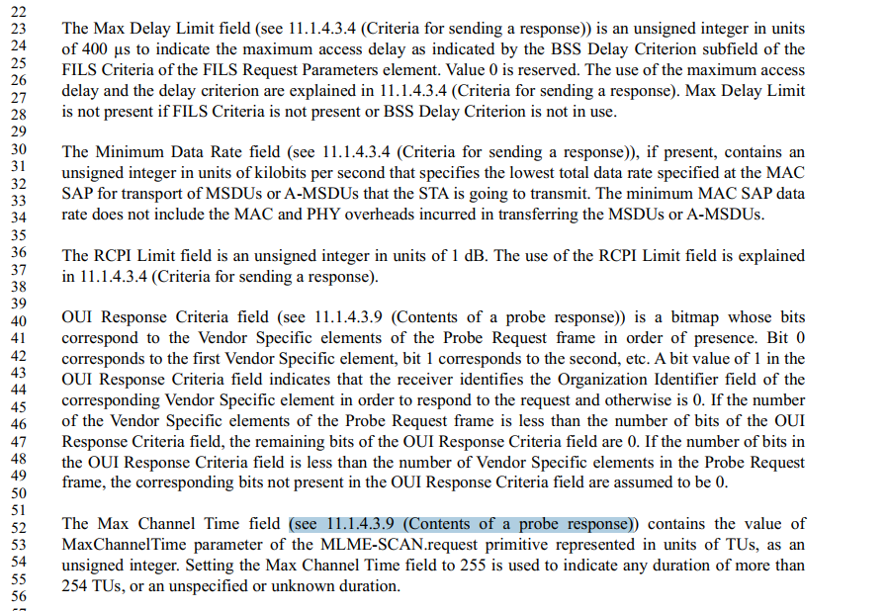

The correct reference should be 11.1.4.3.4 (Criteria for sending a response).

The reference for OUI Response Critteria Field also needs to be corrected.
Proposed resolution:
Revised.

At 1256.40 and 1256.52, change “11.1.4.3.9 (Contents of a probe response)” to “11.1.4.3.4 (Criteria for sending a response)”.
At 1256.40, Add “The” at the beginning of the line.

3782 | 1392.00 | 9.4.2.256 | Extended Service Area is only used once in the draft, so there is no point in defining the acronym "ESA". | Delete "(ESA)" on Page 184, Line 51Delete ESA on Page 245, Line 23Delete "(ESA)" on Page 1392, Line xxx

Discussion:
Agreed. Only once on page 1392.

Proposed resolution:
Revised.
Make changes as proposed by the commenter.
Also make the changes as follows:
extended service area (ESA): The area within which members of an extended service set (ESS) can
communicate. An extended service area ESA is larger than or equal to a basic service area (BSA) and might involve several basic service sets (BSSs) in overlapping, disjointed, or both configurations.

At 1392.3, change “Extended Service Area” to “extended service area”

Note to Edit: Line xxx is Line 3.

3110 | 1062.00 | 9.4.2.62 | The awake window is not a field or an element and therefore should not be capitalized. There are fields and elements that use the phrase in their names and in those cases capitalization is required. | Replace "...first Awake Window." with "...first awake window."also at:1064.24 replace "Awake Windows" with "awake windows".1064.28 replace "... duration of the Awake Window, ..." with "... duration of the awake window, ..."1064.31 replace "... duration of the Awake Window, ..." with "... duration of the awake window, ..."1195.24 replace "... duration of the Awake Window, ..." with "... duration of the awake window, ..."2391.1 replace "Awake Windows end .." with "Awake windows end ..."2391.1 replace "...the Maximum Awake Window Duration ..." with "...the maximum awake window duration ..."2391.8 replace " ... of the Awake Window shall ..." with "... of the awake window shall ..."2391.13 replace " ... the Awake Window and ..." with "... the awake window and ..."2391.19 replace "... the Awake Window duration ..." with "... the awake window duration..."2391.24 replace ".. the Awake Window is determined only by the Maximum Awake Window Duration. with "... the awake window is determined only by the maximum awake window duration."2391.26 replace "... during an Awake Window." with "... during an awake window."2391.57 replace "... periodic Awake Window, ..." with "... periodic awake window, ..."2391.57 replace "... duration of the Awake Window ..." with ".... duration of the awake window ..."2392 replace "... of an Awake Window, ..." with "...of an awake window, ..."2392.13 replace "... end of the Awake Window." with "... end of the awake window."2392.40 replace "... next Awake Window ..." with "... next awake window ..."2392.44 replace "... next Awake Window." with "... next awake window."2392.50 replace "... an Awake Window, ..." with "... an awake window, ...".2424.8 replace "... during the Awake Window, ..." with "... during the awake window, ..."2424.22 replace "... or Awake Window ..." with "... or awake window ..."2424.31 replace "... or Awake Window ..." with "... or awake window ..."2424.34 replace "... or Awake Window ..." with "... or awake window ..."2424.37 replace "... or Awake Window ..." with "... or awake window ..."2424.44 replace "... or Awake Window ..." with "... or awake window ..."2424.51 replace "... or Awake Window ..." with "... or awake window ..."2424.57 replace "... or Awake Window ..." with "... or awake window ..."5173.39 replace "... the mesh Awake Window .." with "... the mesh awake window ..."

Discussion

1064.20, Replace "...first Awake Window." with "...first awake window."also

1064.24 replace "Awake Windows" with "awake windows".
1064.28 replace "... duration of the Awake Window, ..." with "... duration of the awake window, ..."
1064.31 replace "... duration of the Awake Window, ..." with "... duration of the awake window, ..."
1195.24 replace "... duration of the Awake Window, ..." with "... duration of the awake window, ..."
2391.1 replace "Awake Windows end .." with "Awake windows end ..."
2391.1 replace "...the Maximum Awake Window Duration ..." with "...the maximum awake window duration ..."
2391.8 replace " ... of the Awake Window shall ..." with "... of the awake window shall ..."
2391.13 replace " ... the Awake Window and ..." with "... the awake window and ..."
2391.19 replace "... the Awake Window duration ..." with "... the awake window duration..."
2391.24 replace ".. the Awake Window is determined only by the Maximum Awake Window Duration. with "... the awake window is determined only by the maximum awake window duration."
2391.36 replace "... during an Awake Window." with "... during an awake window."
2391.57 replace "... periodic Awake Window, ..." with "... periodic awake window, ..."
2391.57 replace "... duration of the Awake Window ..." with ".... duration of the awake window ..."
2392 replace "... of an Awake Window, ..." with "...of an awake window, ..."
2392.13 replace "... end of the Awake Window." with "... end of the awake window."
2392.40 replace "... next Awake Window ..." with "... next awake window ..."
2392.44 replace "... next Awake Window." with "... next awake window."
2392.50 replace "... an Awake Window, ..." with "... an awake window, ...".
2424.8 replace "... during the Awake Window, ..." with "... during the awake window, ..."
2424.22 replace "... or Awake Window ..." with "... or awake window ..."
2424.31 replace "... or Awake Window ..." with "... or awake window ..."
2424.34 replace "... or Awake Window ..." with "... or awake window ..."
2424.37 replace "... or Awake Window ..." with "... or awake window ..."
2424.44 replace "... or Awake Window ..." with "... or awake window ..."
2424.51 replace "... or Awake Window ..." with "... or awake window ..."
2424.57 replace "... or Awake Window ..." with "... or awake window ..."
5173.39 replace "... the mesh Awake Window .." with "... the mesh awake window ..."

Proposed resolution:
Accepted.
Note to Editor: The first instance is at 1064.20.

3139 | 1297.31 | 9.4.2.200.2 | "Block Agreements" may be "block ack agreements". | Correct it if necessary.

Discussion

Cited text for CID 3139:
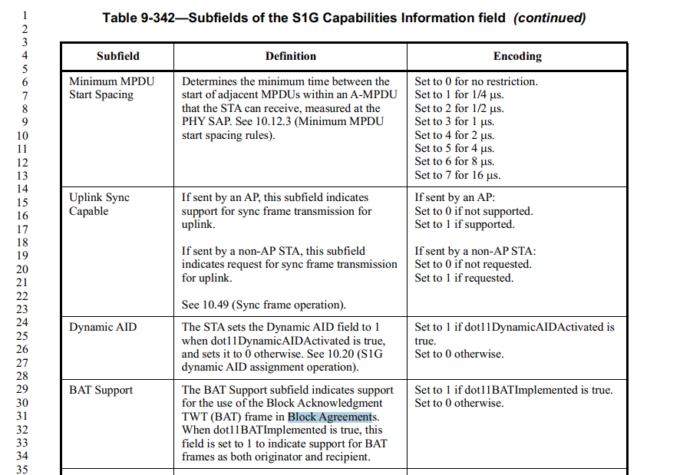

In 10.25.2 Setup and modification of the block ack parameters

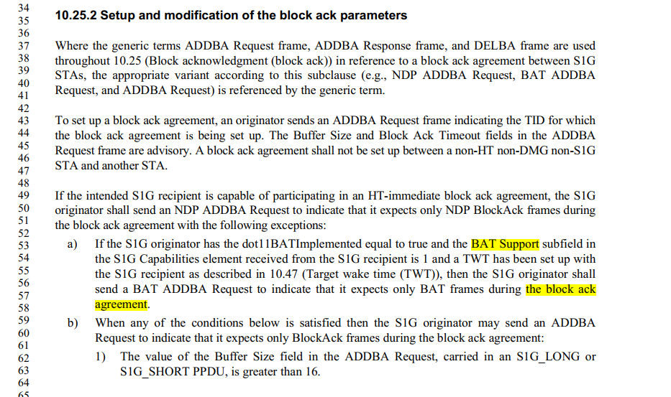

Proposed change: change “Block Agreements” to “block ack agreements”.

Proposed Resolution:
Revised. change “Block Agreements” to “block ack agreements” at 1297.31.

3140 | 1812.60 | 10.3.4.4 | "a block agreement" may be "a block ack agreement". | Correct it if necessary.

Discoussion
Cited text:
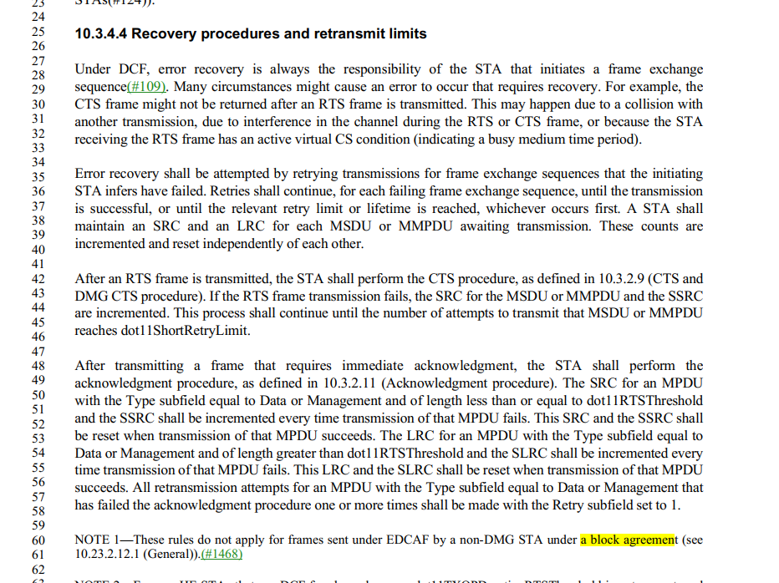

It should be “a block ack agreement”.

Proposed Resolution:
Revised. change “a block agreement” to “a block ack agreement” at 1812.60, 580.38,
Change “BlockAck agreement” to “block ack agreement” at 1794.57, 3911.32.

3167 | 1355.00 | 9.4.2.241 | The things in Table 9-363--Extended RSN Capabilities field are subfields, not fields | Change "field" to "subfield" throughout the table except for the first row (Field length)
3168 | 1355.00 | 9.4.2.241 | The things in Table 9-363--Extended RSN Capabilities field should be introduced as "A STA" | Change "The" to "A" throughout the table except for the first row (Field length). Change the first sentence of the last cell for the third row to "A STA sets the SAE hash-to-element subfield to 1 when it supports the hash-to-element method(#344) to obtain thePWE instead of looping, and sets it to 0 otherwise."

Discussion:

Cited text:
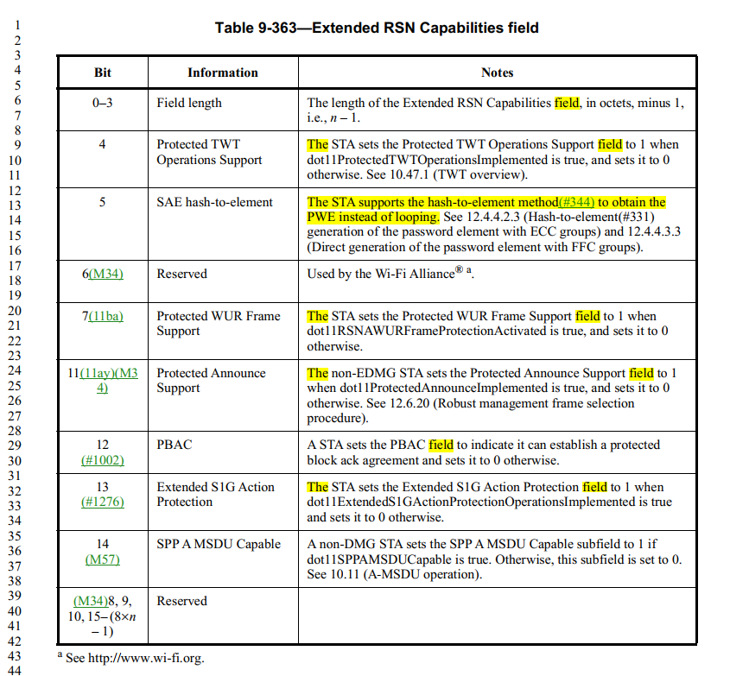

Proposed Resolution:
Accepted.

Note to Editor, locations are 1355L9, L12, L20, L24, L32 for CID 3168.

CID | Page | Clause | Comment | Proposed Change | Resolution | Owning Ad-hoc
3186 | 127.48 |  | For some reason the row for Figure 5-1 is not a hyperlink | Make it a hyperlink |  | ED1

Proposed Resolution:
Accepted.

3203 | 263.56 | 4.3.8 | "Enhanced cryptographic encapsulation mechanisms for robust Management frames" -- it's not clear in what way and w.r.t. what they are enhanced | Change to "Cryptographic encapsulation mechanisms for robust Management frames". Also change "Enhanced authentication mechanisms for STAs" to "Authentication mechanisms for STAs" at line 47

Discussion:

Cited text:
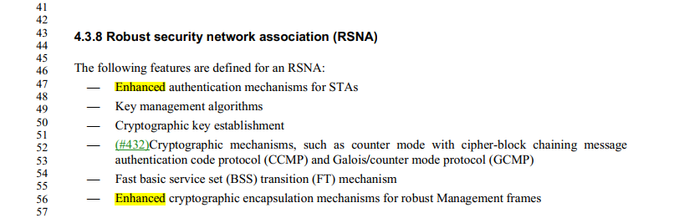

Proposed Resolution:
Accepted.

3212 |  | 10.38 | Weird formatting, with square brackets etc., e.g. "When the SA and the Mesh SA are not identical (the source address is therefore an external address), theMSDU shall be forwarded by using a frame with the three-address MAC header format [with the AddressExtension Mode subfield in the Mesh Control field set to "Address4" (see Table 9-35 (Valid values for theAddress Extension Mode subfield))] as specified in row "Mesh Data (proxied, group addressed)" of Table 9-75 (Address field usage for mesh Data and Multihop Action frames(#462)(#419)). Otherwise, the MSDUshall be forwarded by using a frame with the three-address MAC header format [with the Address ExtensionMode subfield in the Mesh Control field set to "None" (see Table 9-35 (Valid values for the AddressExtension Mode subfield))] as specified in row "Mesh Data (group addressed)" of Table 9-75 (Address fieldusage for mesh Data and Multihop Action frames(#462)(#419))." 7x [with the] in 10.38, 4x in 14.11 | Change square brackets to parentheses

Discussion:

Example of cited text:

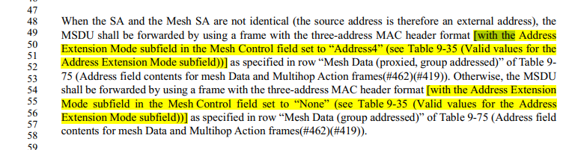

Proposed Resolutions:
Accepted.

Note to Editor: the locations are: 2049.52, 2050.4, 2051.54, 2052.49, 2052.54, 2053.38, 2055.43, 3085.20, 3085.42, 3086.6, 3086.35. 2049.54, 2433.2.

3233 |  |  | Make the fixes indicated in the comments in 22-0305-00-mgr | As it says in the comment
Discussion:

Doc 22-0305 is about “Defining OWE in 802.11”.
It is not clear what the comment is and what changes are.

Assigned to Mark R. More work required.

Proposed Resolutions: ??

Reject.

Insufficient details. -- The comment fails to identify a specific issue to be addressed. It fails to identify changes in sufficient detail so that the specific wording of the changes that will satisfy the commenter can be determined.

3235 | 1491.59 | 9.4.5.10 | "NAI Realm" when not part of a field name should be "NAI realm" (search excluding ""Realm ANQP" "Realm Count" "Realm subfield" "Realm Tuple" "Realm Data" "Realm Encoding") | Change "NAI Realm" to "NAI realm" at 1491.59/63 (second)/64 (second), 1492.1, 1499.42 (second), 2638.1
Discussion:

Example of cited text:

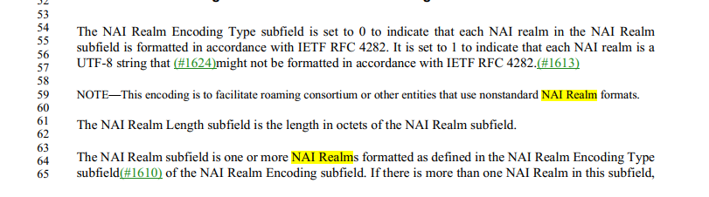

Proposed Resolutions:

Accepted.

3238 |  |  | CID 1027 suggests "power level" should be just "power" -- but there are still many "power level"s | Delete "level" in "power level" throughout

Discussion:

Resolution of CID 1027 is in doc 22/0218r2.

doc 22/0218r2 doesn’t include any changes for deleting "level" in "power level".

Here is the meeting minutes (from 22/0266r3)

- CID 1027 (ED2)
  - Off-line comment notes other uses of “power” in the paragraph. Do we need to say “power level” here?
  - Also noted another use of “raising” that should be “increasing”, and another place to add “signal”. Other editorial changes.
  - Is “power” the same as “power level”? “Power” could be the actual physical signal’s characteristic, but “power level” is used to talk about a threshold value used in signaling or the equipment implementation.
  - In the legacy PHY clauses, we use “power” to refer to the interfering signal’s power (level).
  - Do we have the same issue in the VHT clause? Let’s review off-line and consider that for a future comment.
  - Proposed Resolution: Revised. Incorporate the changes shown in 11-22/0218r1 (https://mentor.ieee.org/802.11/dcn/22/11-22-0218-01-000m-proposed-resolution-for-revme-lb258-comments-part-2.docx) for CID 1027.
  - Ready for motion.

Assigned to Mark R. More work required.
Moved to PHY ad hoc.

Proposed Resolutions:

?

3246 | 186.54 | 3.2 | Per March 2022 closing report he/she must not be used, but: "location subject third party: The term used when the location request is for the location of a station (STA)other than the requesting STA or the requested STA, (i.e., when the requesting STA asks, "Where is he/she?")"; "A salesman travels across town to a meeting at ACME Manufacturing. While there, this user needs to sendemail to get a document from engineering. On his laptop, he requests the WLAN via the laptop's UI tosearch for guest networks." | Use approved terminology at 186.54 and 5731.62

Discussion:

Cited Style Manual:

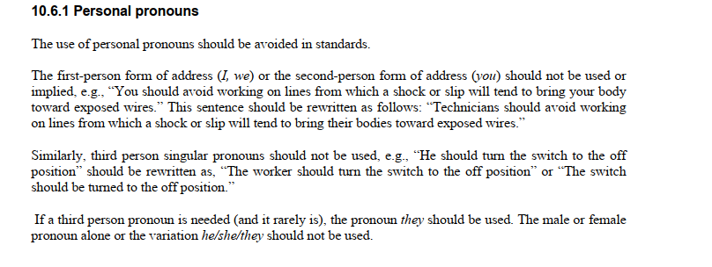
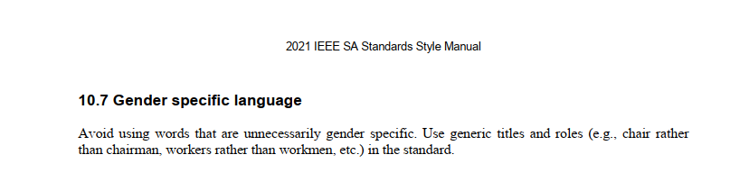

Cited text at 186.54

At 186.54, change “Where is he/she?” to “Where is station A?”

Cited text at 5731.62
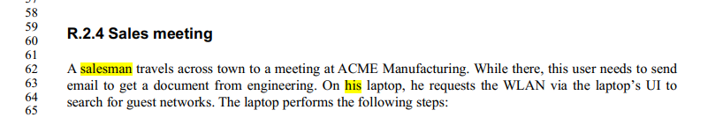
At at 5731.62, change “salesman” to “salesperson”

At 5731.63, change “On his laptop, he requests the WLAN via the laptop’s UI to search for guest networks.” to “The user requests the WLAN via their laptop’s UI to search for guest networks.”

Proposed Resolutions: Revised.
At 186.54, change “Where is he/she?” to “Where is station A?”.

At at 5731.62, change “salesman” to “salesperson”

At 5731.63, change “On his laptop, he requests the WLAN via the laptop’s UI to search for guest networks.” to “The user requests the WLAN via their laptop’s UI to search for guest networks.”

3272 | 235.27 | 3.2 | "A protocol that uses a specific Ethertype encapsulation to TDLSframes through an access point (AP) to establish a TDLS direct link. " should be "to tunnel" (or "to tunnel TDLS frames") | Change "to TDLS frames" to "to tunnel frames"
Discussion:

Cited text:

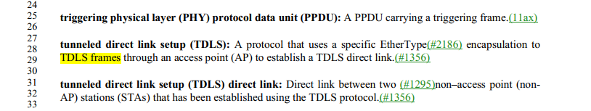.

Proposed Resolutions: Accepted.

3273 | 1034.39 | 9.4.2.45 | "The Timestamp and Beacon Interval fields, TIM, DSSS Parameter Set, IBSS Parameter Set,Country, Channel Switch Announcement, Extended Channel Switch Announcement, WideBandwidth Channel Switch, Transmit Power Envelope, Supported Operating Classes, IBSS DFS,ERP Information, HT Capabilities, HT Operation, VHT Capabilities, VHT Operation, S1G BeaconCompatibility, Short Beacon Interval, S1G Capabilities, S1G Operation, HE Capabilities, HE 6 GHzBand Capabilities, HE Operation, BSS Color Change Announcement, and Spatial Reuse ParameterSet elements are not included in the Nontransmitted BSSID Profile subelement; the values of theseelements for each nontransmitted BSSID are always the same as the corresponding transmittedBSSID element values.(11ax)" is a maintenance horror. Add a column to Table 9-128--Element IDs to say whther the element is inherited from the nontxbssid | As it says in the comment

Discussion:

Cited text:

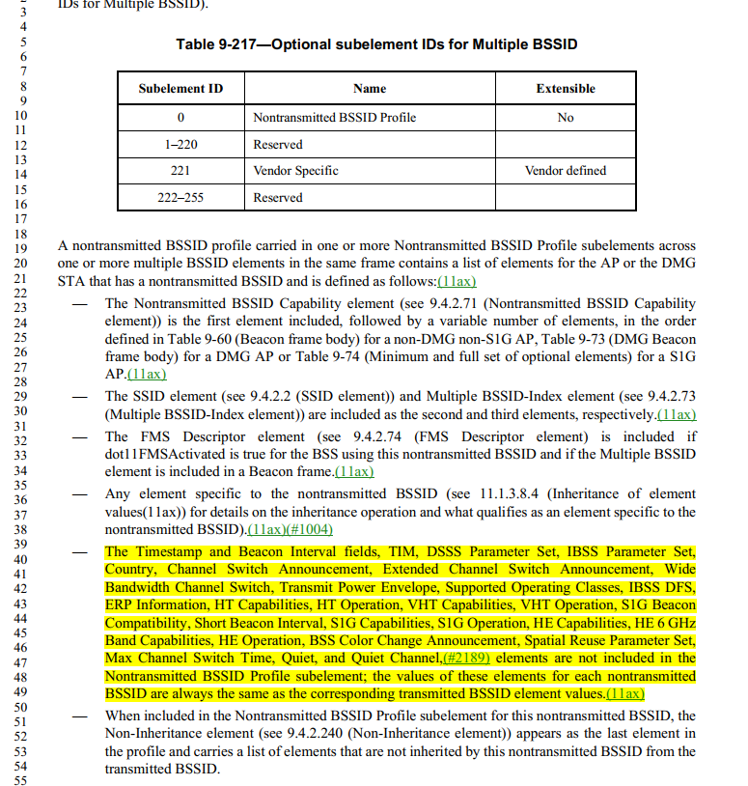.

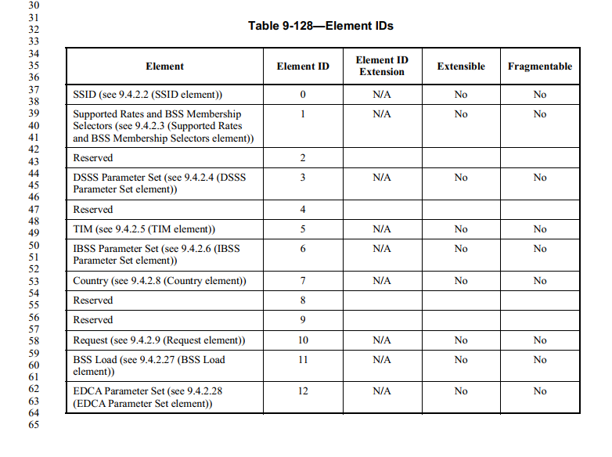

Need to direction from the group.
If the TG agree with the direction, this comment will be assigned to the commenter.
A submission required.
More work required. assigned to Mark R

Proposed Resolutions: ??

3287 | 206.9 | 3.2 | "bufferable medium access control (MAC) management protocol data unit (MMPDU): An MMPDUthat is eligible to be queued for delivery using a power saving mechanism (see Table 11-3 (Bufferable/nonbufferable classification of MMPDUs))." -- remove parenthesis since we don't normally give xrefs in C3 | As it says in the comment

Discussion:

Cited text:

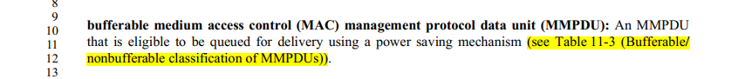

Proposed Resolutions: Accepted.

Note to editor: at cited location, remove “(see Table 11-3 (Bufferable/nonbufferable classification of MMPDUs)).”.

3298 |  |  | "on the medium" or "on the WM" is a dead heat | Pick one and change the others
Discussion:

29 instances of “on the medium”.
29 instances of “on the WM”

WM: wireless medium.

There is difference between “on the WM” and “on the medium”.

For example, at 260.25, we cannot change “on the WM” to “on the medium”.

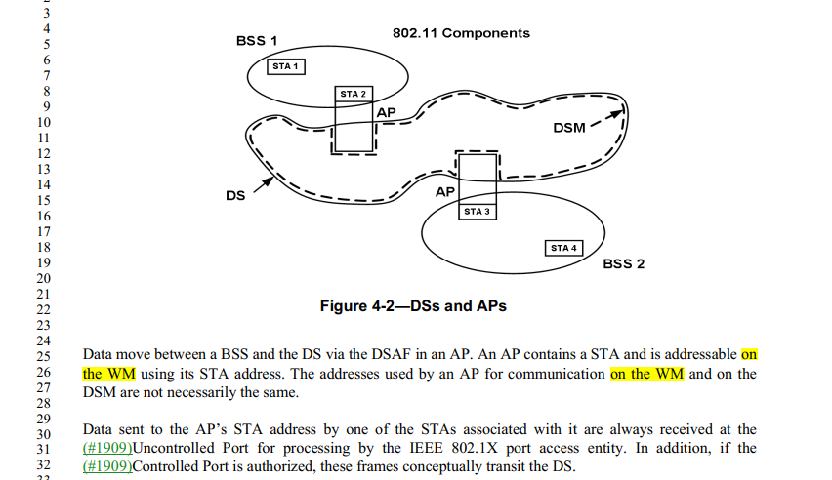

Let’s use “on the WM”.
Assigned to Mark R for more work required.

Proposed Resolutions:

3309 |  |  | We still have a few "DTIM Beacon [frame]"s (note it's not clear if those apply to S1G too, cf. DTIM beacon definition) | Change "DTIM Beacon"/"DTIM Beacon frame" to "DTIM beacon" at 240.62, 2283.14, 2389.49, 231.24, 282.34, 385.12, 1103 (3x), 1275 (3x), 1911.37, 1928.62, 2273.3, 2275.59, 2276.16, 2284 (5x), 2310.59, 2349 (2x), 2350 (2x), 2375.56, 2395.36, 2399.9, 2400.28, 2608.25, 3105 (2x), 3108.25, 3910.18, 3923.38
Discussion:

2 instances of “DTIM Beacon" (no “frame”): 2283.14; 2389.50.

34 instances of “DTIM Beacon frame".

“DTIM Beacon” can be changed to “DTIM beacon”.

Why do we need to change “DTIM Beacon frame" to “DTIM beacon”?

The resolution of CID 1000 was to:
- add definition for DTIM beacon
- change “DTIM Beacon” to “DTIM beacon” (not “DTIM Beacon frame” to “DTIM beacon”).
See 22/0535r2.

Mark R need to provide Figure 10-147.

Proposed Resolutions: Accepted

Note: Mark R will provide Figure 10-147,

3361 |  |  | Per CID 1630, "time priority Management frame:" etc. needs to become "time priority management frame:" | As it says in the comment

Discussion:

Agreed.

A general convention is that words that are being defined are in all lower case (except the acronyms, which are also spelled out and their constituent words are in lower case).

More instances need to be fixed.
Assigned to Commenter (Mark R). More work required.

Proposed Resolutions: Accepted

Note to editor: the location is 234.19.

3362 |  |  | "Key RSC = For PTK generation, starting TSC or PN that the Authenticator's STA uses in MPDUsprotected by GTK" and "a WUR PNthat is generated and partially included in the WUR frame" -- per CID 1422 the "PN"s should be "packet number"s | As it says in the comment
Discussion:

It is not clear how CID 3362 is related to CID 1422.

The resolution of CID 1422 is:
REVISED (ED1: 2022-07-12 22:08:08Z)
At 3155.13/20/26, delete “value”.
At 3212.36, change “The BIPN corresponds to the BIPN value” to “The BIPN field contains the BIPN”.
At 3212.52, change “The WIPN corresponds to the WIPN value” to “The WIPN field contains the WIPN”.

PN’s abbreviation is “packet number”. Why do you need to change “PN” to “packet number”?

Cited text at 2916.13:
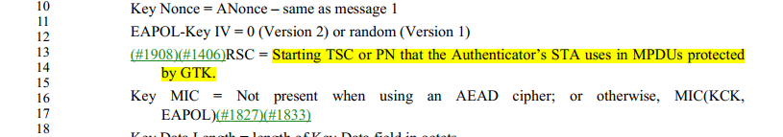

Cited text at 4572.17:
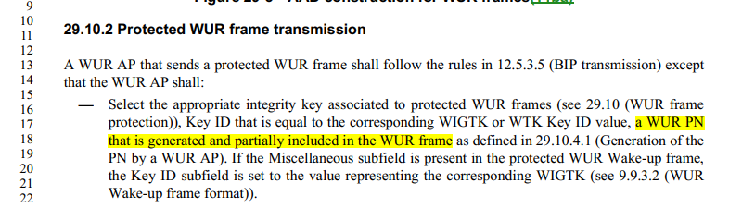

More work Required. Assigned to commenter. (Mark R).

Proposed Resolutions: Rejected.

Reject reason: The comment fails to identify a specific issue to be addressed. PN’s abbreviation is “packet number”.

3367 |  | 3.2 | Is it "DL MU-MIMO" or "DL-MU-MIMO"? | Pick one and change the others

Discussion:

Definition

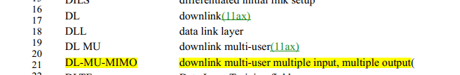

90 instances of “DL MU-MIMO".
43 instances of "DL-MU-MIMO".

11ax instrouced most of “DL MU-MIMO”.

Need direction.

Proposed Resolutions: revised.
Change “DL-MU-MIMO” to “DL MU-MIMO” throughout the draft.

3369 | 968.35 | 9.4.2.24.2 | "The Pairwise Cipher Suite List field contains a series of cipher suite selectorsthat indicate the pairwise cipher suites used in the BSS to protect individually addressed Data frames." should have been deleted per CID 1929 | Delete it (again)
Discussion:

The Resolution of CID 1929 is: ACCEPTED (MAC: 2022-06-24 14:25:50Z)

Note to Editors: The resulting text is still three paragraphs

Proposed Change:
Change to "The Pairwise Cipher Suite List field contains a series of cipher suite selectors that indicate the pairwise cipher suites used in the BSS to protect individually addressed Data frames and, if management frame protection is negotiated, individually addressed robust Management frames.

The Group Management Cipher Suite field contains the cipher suite selector that indicates the cipher suite used in the BSS to protect group addressed robust Management frames.

Use of BIP-CMAC-128, BIP-GMAC-128, BIP-GMAC-256, and BIP-CMAC-256 is not valid as a data cipher suite."

Cited text:
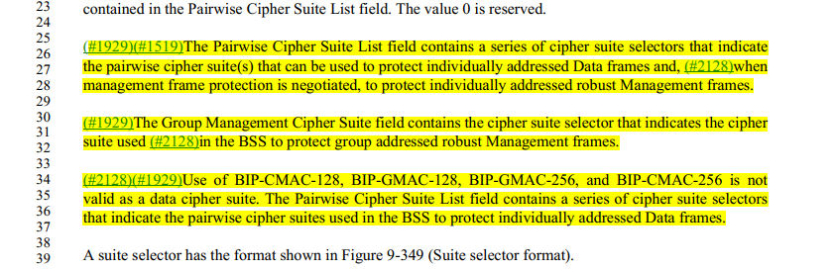

Agreed with the commenter.

Proposed Resolutions: Accepted

3379 |  | 9.4.2.25 | Vendor-specific fields are not described consistently:- sometimes not described at all- sometimes "The Vendor Specific field contains the vendor specific information."- sometimes "The Vendor Specific Content field is a variable length field whose content is defined by the entity identifiedin the OI field."- sometimes "The Vendor Specific Content field contains vendor-specific field(s)." | Pick one and change the others

Discussion:

They are different fields. They are vendor specific fields.
Is there any issue if different Vendor-specific fields are described differently?

Location is 979.58.
There is no definition for the Vendor-specific content filed. We might need to add the definition.

Assigned it to the commenter. More Work Required.

Proposed Resolutions: ?

3404 |  |  | TIME_OF_DEPARTURE descriptions in tables are not consistent | As it says in the comment

Discussion:
In Table 15-3,
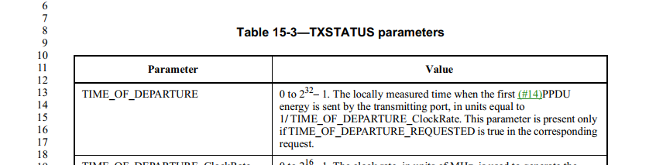

In Table 16-3,
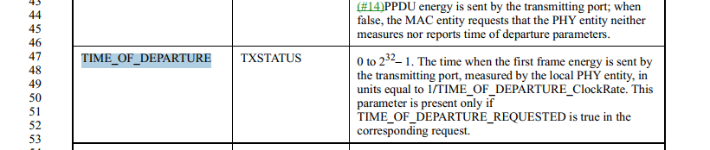

In Table 17-3,
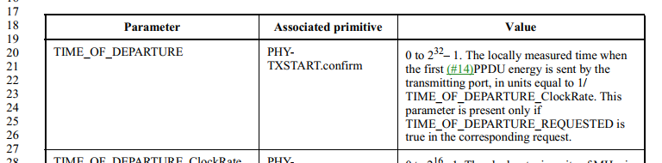

…
Those parameters for different PHYs.
Are there any issues with those descriptions? Or transfer to PHY ?

More work required. Assigned to Mark R and transfer to PHY.

Proposed Resolutions: ?

Rejected.
Reject Reason: The comment fails to identify a specific technical issue to be addressed.
While there is inconsistency, such inconsistency does not result in any issue.

3419 | 983.00 | 9.4.2.26 | "The Reject Unadmitted Frame bit" -> field | Change "bit" to "field" at 983.34/38/42 and change "frame" to "Frame" at 983.42

Discussion:

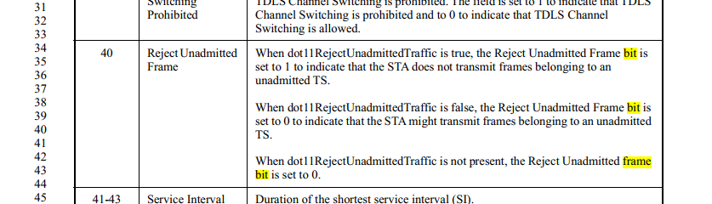

“subfield” should be used.

Proposed Resolutions: Revised.

Change "bit" to "subfield" at 983.34/38/42 and change "frame" to "Frame" at 983.42.

Note that Emily to bring this item (field vs. subfield in this table) to the editor meeting.

3428 |  | 9.4 | "Subelements are defined to have a common general format consisting of a 1-octet element-specificSubelement ID field, a 1-octet Length field, and a variable length subelement-specific Data field. " in 9.4.3 is duplication -- do it more like 9.4.2. Ditto 9.4.5.1 for ANQP-elements and 9.4.6.1 RLQP-elements | As it says in the comment

Discussion
Cited text at 1477:
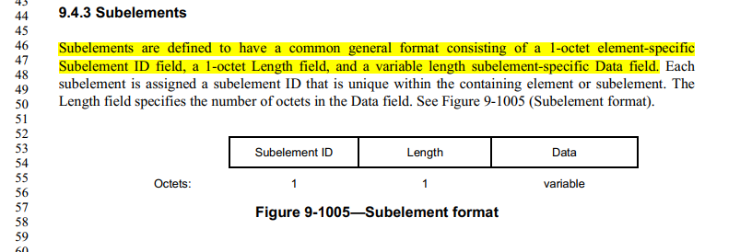
At 839:
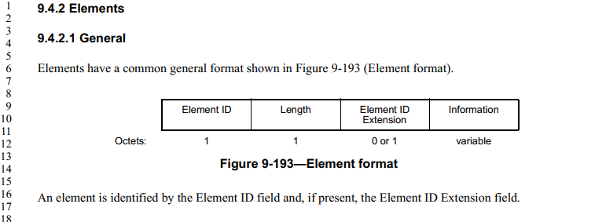

At 1483:
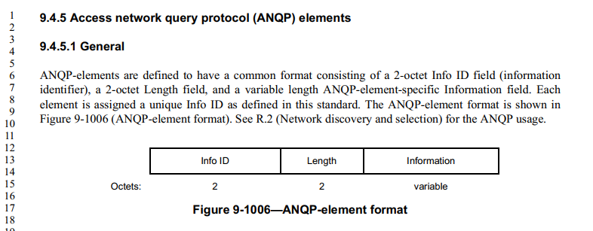

At 1511:
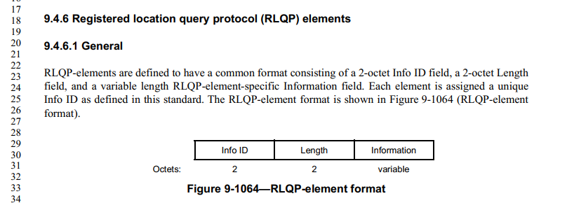

Proposed Resolution: Revised.

At 1477.46, change the cited paragraph as follows:

Subelements are defined to have a common general format shown in Figure 9-1005 (Subelement format) in consisting of a 1-octet element-specific Subelement ID field, a 1-octet Length field, and a variable length subelement-specific Data field. Each subelement is assigned a subelement ID that is unique within the containing element or subelement. The Length field specifies the number of octets in the Data field. See Figure 9-1005 (Subelement format).

At 1483.6, change the cited paragraph as follows:

ANQP-elements are defined to have a common format shown in Figure 9-1006 (ANQP-element format). consisting of a 2-octet Info ID field (information identifier), a 2-octet Length field, and a variable length ANQP-element-specific Information field. Each element is assigned a unique Info ID as defined in this standard. The ANQP-element format is shown in Figure 9-1006 (ANQP-element format). See R.2 (Network discovery and selection) for the ANQP usage.

At 1511.23, change the cited paragraph as follows:

RLQP-elements are defined to have a common format shown in Figure 9-1064 (RLQP-element format). consisting of a 2-octet Info ID field, a 2-octet Length field, and a variable length RLQP-element-specific Information field. Each element is assigned a unique Info ID as defined in this standard. The RLQP-element format is shown in Figure 9-1064 (RLQP-element format).

3430 | 1477.46 | 9.4.3 | "Subelements are defined to have a common general format consisting of a 1-octet element-specificSubelement ID field, a 1-octet Length field, and a variable length subelement-specific Data field." duplicates figure | Change to "Subelements are defined to have a common general format."

Discussion:

See: CID 3428.

Proposed Resolutions: Revised.

The same resolutions as CID 3428.

Note to Editor: No additional edit is needed.

3429 | 1045.1 | 9.4.2.53 | "The Operating Classes field lists, in descending order of preference, all 1-octet operating classes withinwhich the STA is currently configured to operate" -- all OC are 1-octet numbers | Change to "The Operating Classes field lists, in descending order of preference, all operating classes withinwhich the STA is currently configured to operate"
Discussion:

Cited text with changes:

The Operating Classes field lists, in descending order of preference, all 1-octet operating classes within which the STA is currently configured to operate.

Proposed Resolutions: Accepted.

3462 | 1743.00 | 9.8.5.3 | "Figure 9-1220--Frame Control field of PV1 Probe Response frame format" is missing the "(1)" after the "Protocol Version" | As it says in the comment
3463 | 1743.00 | 9.8.5.3 | "Figure 9-1220--Frame Control field of PV1 Probe Response frame format" is missing the "(1)" after the "Protocol Version" | Delete the "(1)" at 1739.5 and 1745.25

Discussion:

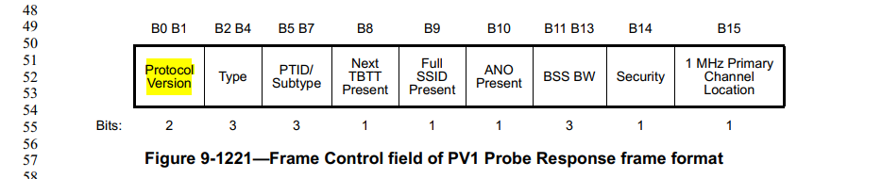

However, 1739.5:
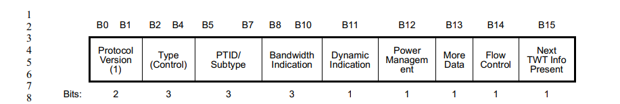
1745.25:
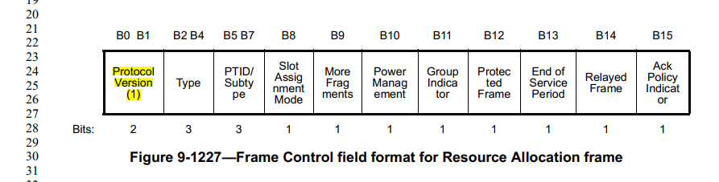

In general, the value of field should not be specified in the figure format.

Proposed Resolutions:
For CID 3462: Rejected.
Reject reason: the value of field should not be specified in the figure format.

For CID 3463: Accepted.

3525 |  |  | Text in figures should be searchable (i.e. a find in a normal PDF viewer should find it). This is sometimes the case, but not always, especially for older figures | Make Figure 12-16--Expanded CCMP MPDU searchable
Discussion:

A visio file of Figure 12-16 is available. Somehow Figure 12-16 was inserted in the framemaker is png file. Editor will change it to emf file.

Proposed Resolutions:
Accepted.

3619 |  | 10.50.2 | "The total duration of the BDT Initiator PPDUs shall not exceed the TXOP limit as described in 10.23.2.3" -- that subclause does not discuss TXOP limits | Put in the correct xref
Discussion:

Cited text at 2281.1
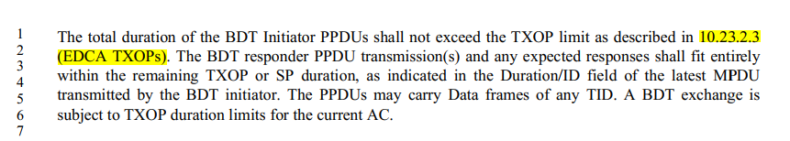

10.23.2.9 is about TXOP limits

Proposed Resolutions:
Revised. 2281.1, change “10.23.2.3 (EDCA TXOPs)” to “10.23.2.9 (TXOP limits).

3112 | 182.11 | 3.2 | There are locations where the counters are referred to using the field name capitalization. This is not in line with the style of the 802.11 specification. Counters should use lower case names, Fields and elements using the term "Counter' in their name should be capitalized. | Replace: "Counter Mode with cipher-block chaining message authentication code (CCM): A symmetric key block cipher mode providing confidentiality using (#1912)Counter Mode (CTR) and data origin authenticity using cipher-block chaining message authentication code (CBC-MAC)".With "Counter mode with cipher-block chaining message authentication code (CCM): A symmetric key block cipher mode providing confidentiality using (#1912) counter mode (CTR) and data origin authenticity using cipher-block chaining message authentication code (CBC-MAC)".Also the following similar changes should be made:At 224.49 Replace "... Counter Mode ..." with "... counter mode ...:
Discussion:

Location is 183.11.

Cited text:

(#1912)Counter Mode with cipher-block chaining message authentication code (CCM): A symmetric key block cipher mode providing confidentiality using (#1912)Counter Mode (CTR) and data origin authenticity using cipher-block chaining message authentication code (CBC-MAC)

“Counter Mode” is an external reference. It should be “Counter Mode”.

At 263.52/53, change “counter mode” to “Counter Mode”

Proposed Resolutions: Revised.

Revised. At 263.52 and 263.53 change "counter mode" to "Counter Mode". Note to commenter, “Counter Mode” is an external reference. It should be “Counter Mode” according to the style guide.

CID | Page | Clause | Comment | Proposed Change
3113 | 1105.57 | 9.4.2.76 | There are locations where the counters are referred to using the field name capitalization. This is not in line with the style of the 802.11 specification. Counters should use lower case names, Fields and elements using the term "Counter' in their name should be capitalized. | Replace: ".... the FMS Counter ID maintained in the AP." with ".... the FMS counter ID maintained in the AP."
Discussion:

Cited text:

Agreed to change “FMS Counter ID” to “FMS counter ID”. Also, found another location at 2395.33

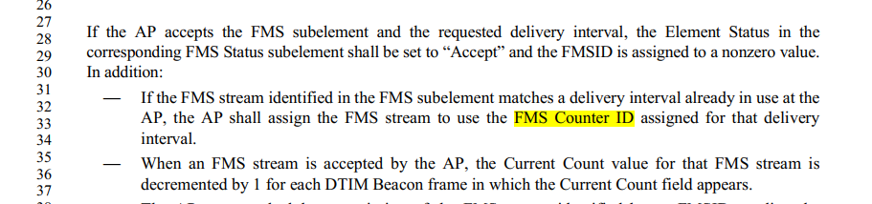

Proposed Resolutions: Revised.

At 1105.57 and 2395.33, change “FMS Counter ID” to “FMS counter ID”.

3621 |  |  |  | Should not use both "recipient" and "receiver" within the same subclause | Change "recipient" to "recevier" in 12.5.3.4.4 PN and replay detection

Discussion:

There is no 12.5.3.4.4. I think it is 12.5.3.4.

Cited text at 2846.41
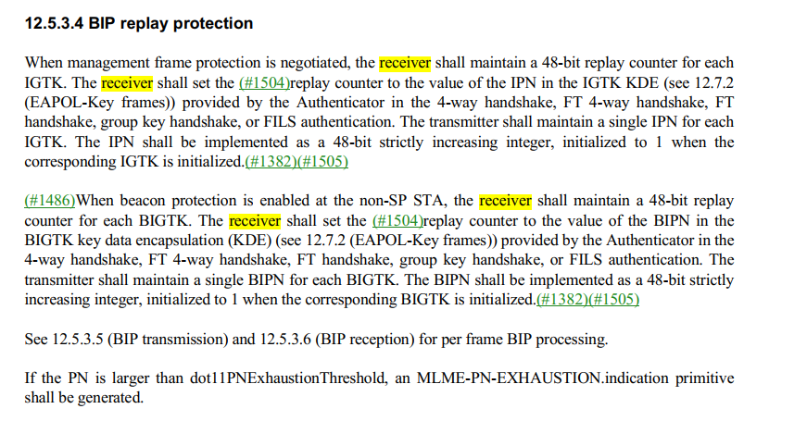
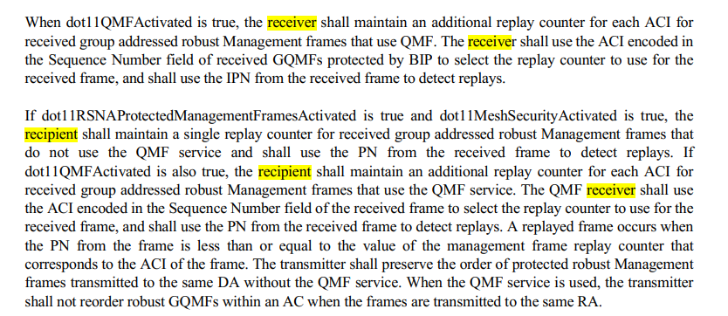

recipient vs. receiver? receiver preferred.

Proposed Resolutions: Revised.
In 12.5.3.4, change “recipient” to “receiver”, 2 instances.

