IEEE P802.11
Wireless LANs
CC40 CR document resolving CIDs for Sensing Measurmenet Setup
Date: 2022-11-13
Author(s):
Name | Affiliation | Address | Phone | email
Rajat Pushkarna | Panasonic |  |  | rajat.pushkarna@sg.panasonic.com
Rojan Chitrakar | Panasonic
Abstract
This submission proposes resolutions of comments received from TGbf comment collection 40 (TGbf Draft 0.1).
- CIDs: 245, 246, 247, 248, 249, 250, 270 and 271 (8 CIDs)

Revisions:

- Rev 0: Initial version of the document.

Introduction
Interpretation of a Motion to Adopt

A motion to approve this submission means that the editing instructions and any changed or added material are actioned in the TGbf Draft. The introduction and the explanation of the proposed changes are not part of the adopted material.

Editing instructions formatted like this are intended to be copied into the TGbf Draft (i.e., they are instructions to the 802.11bf editor on how to merge the text with the baseline documents).

TGbf Editor: Editing instructions preceded by “TGbf Editor” are instructions to the TGbf editor to modify existing material in the TGbf draft. As a result of adopting the changes, the TGbf editor will execute the instructions rather than copy them to the TGbf Draft.

CID | Commenter | Clause | Page | Line | Comment | Proposed Change | Resolution
245 | Xiandong Dong | 3.2 | 16 | 12 | 11be device is applicable to the WLAN sensing, so we should add "An AP or an AP affiliated with an AP MLD" | As in comment. | Revised.  TGbf Editor please make changes to the text with CID tagged as 245.
246 | Xiandong Dong | 3.2 | 16 | 9 | 11be device is applicable to the WLAN sensing, so we should add "A non-AP STA or a STA affiliated with a Non-AP MLD" | As in comment. | Revised.  TGbf Editor please make changes to the text with CID tagged as 246.
247 | Xiandong Dong | 3.2 | 16 | 16 | 11be device is applicable to the WLAN sensing, so we should add "A STA or a STA affiliated with an MLD" | As in comment. | Revised.  TGbf Editor please make changes to the text with CID tagged as 247.
248 | Xiandong Dong | 3.2 | 16 | 18 | 11be device is applicable to the WLAN sensing, so we should add "A STA or a STA affiliated with an MLD" | As in comment. | Revised.  TGbf Editor please make changes to the text with CID tagged as 248.
249 | Xiandong Dong | 3.2 | 16 | 21 | 11be device is applicable to the WLAN sensing, so we should add "A STA or a STA affiliated with an MLD" | As in comment. | Revised.  TGbf Editor please make changes to the text with CID tagged as 249.
250 | Xiandong Dong | 3.2 | 16 | 23 | 11be device is applicable to the WLAN sensing, so we should add "A STA or a STA affiliated with an MLD" | As in comment. | Revised.  TGbf Editor please make changes to the text with CID tagged as 250.
270 | Xiandong Dong | 11.21.18.2 | 66 | 41 | 11be device is applicable to WLAN sensing, please change the sentence a STA in which dot11SensingMsmtImplemented is true as a STA or a STA affiliated with an MLD in which dot11SensingMsmtImplemented is true. | As in comment. | Revised.  TGbf Editor please make changes to the text with CID tagged as 270.
271 | Xiandong Dong | 11.21.18.2 | 66 | 41 | 11be device is applicable to WLAN sensing, please change the sentence a STA in which dot11SensingMsmtImplemented is false as a STA or a STA affiliated with an MLD in which dot11SensingMsmtImplemented is true. | As in comment. | Revised.  TGbf Editor please make changes to the text with CID tagged as 271.
SP: Do you agree to the resolutions provided in the document 11-22/2067r0 for the following CIDs:245, 246, 247, 248, 249, 250, 270 and 271 for inclusion in the latest 11bf draft?

Discussion
In general, the comments are related to support WLAN sensing for devices that support MLD, i.e EHT STAs. In 802.11be EHT it is mandated that each EHT AP STA shall be affiliated to an AP MLD, in which case if an 11be device which is an AP, is an MLD and if it has to support sensing it has to be able to have support for MLD sensing.

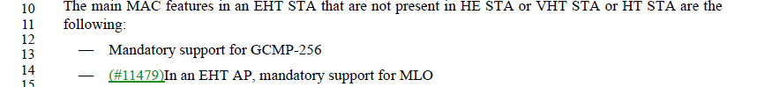

In 802.11bf, there are multiple contributions which highlight the use of EHT feature, for example, we have EHT sounding NDP frame to support 320MHz bandwidth. In that case, it is only reasonable if the devices, atleast AP performing WLAN Sensing shall support MLO features.

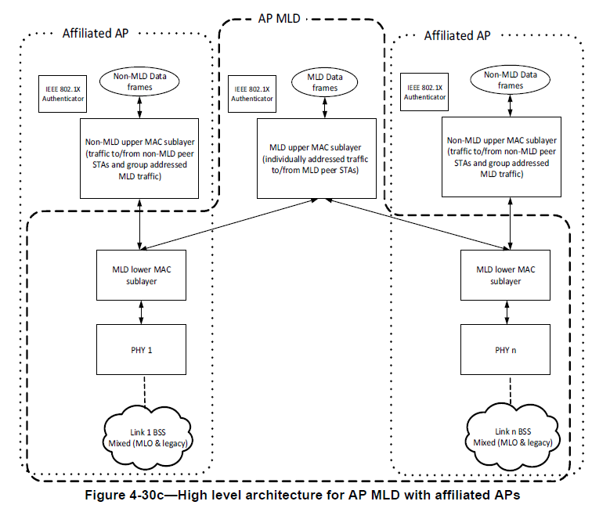

Definitions, acronyms, and abbreviations
  - Definitions specific to IEEE Std 802.11

sensing initiator: A station (STA) or a STA affiliated with an MLD that initiates a WLAN sensing procedure by transmitting the WLAN Sensing Measurement Setup Request frame (#246).

sensing receiver: A station (STA) or a STA affiliated with an MLD that receives PPDUs sent by a sensing transmitter and obtains measurements in a WLAN sensing procedure (#247).

sensing responder: A station (STA) or a STA affiliated with an MLD that participates in a WLAN sensing procedure by responding to a sensing initiator (#248).

sensing transmitter: A station (STA) or a STA affiliated with an MLD that transmits PPDUs used for measurements in a WLAN sensing procedure (#249).

wireless local area network (WLAN) sensing procedure: A procedure that allows a station (STA) or a STA affiliated with an MLD to perform WLAN sensing (#250).

11. MLME
11.55.1.2 Dependencies

A STA or a STA affiliated with an MLD in which dot11WLANSensingImplementedis true shall set the WLAN Sensing field of the Extended Capabilities element to 1. (#270)
A STA or a STA affiliated with an MLD in which dot11WLANSensingImplemented(#140) is false shall set the WLAN Sensing field of the Extended Capabilities element to 0. (#271)

References:
[1] P802.11be EHT D2.2
[2] P802.11bf D1.4

