IEEE P802.11
Wireless LANs
LB270 CR for CID 3166
Date: 2022-11-25
Author(s):
Name | Affiliation | Address | Phone | email
Mahmoud Kamel | InterDigital |  |  | mahmoud.kamel@interdigital.com
Rui Yang

Abstract
This submission proposes resolutions for CID 3166 in P802.11REVme D2.0:

NOTE – Set the Track Changes Viewing Option in the MS Word to “All Markup” to clearly see the proposed text edits.

Revision History:

R0: Initial version

CID | Clause | Page.Line | Comment | Proposed Change | Resolution
3166 | 21.4.4 | 3496.27 | aPSDUMaxLength is computed to 4 692 480 octets which does  not match my computations for the same parameter as indicated  in Eq. (21-114) which amounts to 4 692 478 octets. | Change the value of "aPSDUMaxLength" in Table 21-28 to 4 692 478 octets.  I can bring a contribution to resolve this comment. | Accepted

DISCUSSION

The calculations of this parameter as indicated in Table 21-28 using Eq. 21-114 ignored the subtraction of the 16 bits of the SERVICE field which would explain why there are 2 octets difference between the parameter value in the table below and Table 21-28.

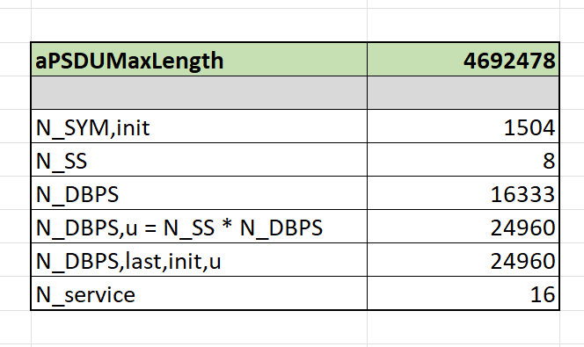

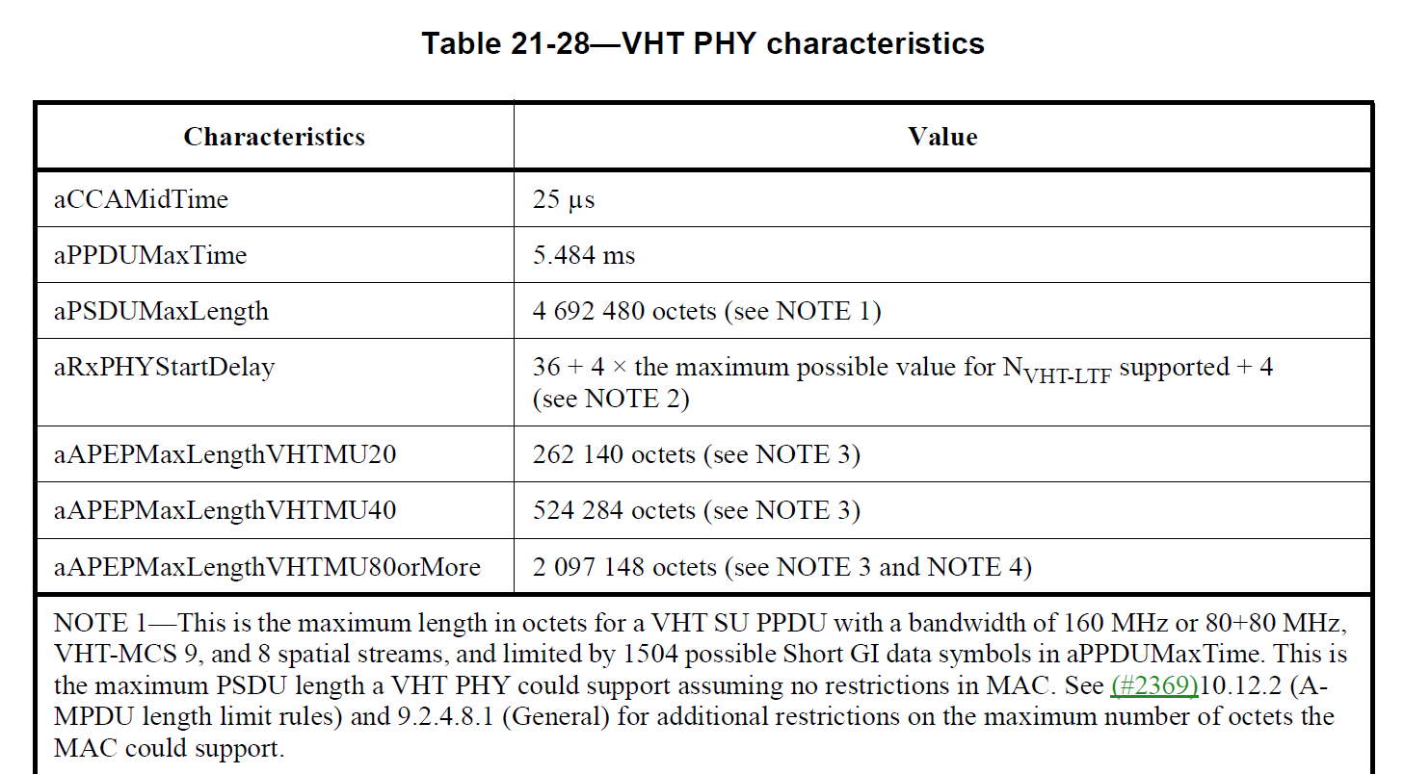

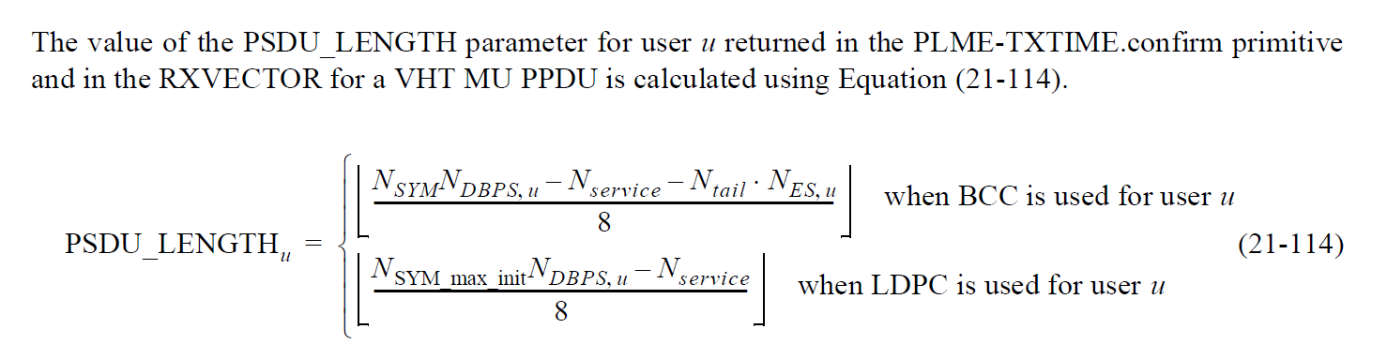

END OF DISCUSSION

