IEEE P802.11
Wireless LANs

PDT – CSD Setting for Sensing
Date: 2022-11-16
Author:
Name | Affiliation | Address | Phone | Email
Qinghua Li | Intel |  |  | Qinghua.li@intel.com
Cheng Chen | Intel
Dibakar Das | Intel
Ali Raissinia | Qualcomm
Steve Shellhammer | Qualcomm
Claudio da Silva | Meta

This submission includes the proposed draft text on the CSD setting of the sensing NDP for P802.11bf D0.4.

Revision history:

R0 – initial version

R1 – Added the CSD text of P802.11az D7.0 showing the PDT matches the 11az CSD setting.

Introduction
The following straw poll was passed in AM 2 session, Wednesday, Nov. meeting in TGbf with 11 yes and 2 no. Based on the straw poll, the draft text on the CSD setting of sensing NDP is proposed as follows. Because HE Ranging NDP is reused by 11bf sensing for up to 160 MHz bandwidth and the CSD setting in HE Ranging NDP is the same as what is proposed by the passed straw poll, there is no need to add CSD setting text for the NDP with less than or equal to 160 MHz. In addition, because the TF sounding and non-TB sensing modes don’t support 320 MHz operations, the only spec text we need is for the 320 MHz NDP in the NDPA sounding phase.

Passed Straw Poll:
Do you support that
for sub 7 GHz sensing, the spatial mapping matrix $Q_{k}$ shall be set to the identity matrix, which is the same as specified in 27.3.18a.1 HE Ranging NDP of 802.11az spec?

The corresponding text in 27.3.18a.1 HE Ranging NDP, P802.11az D7.0 is as follows:
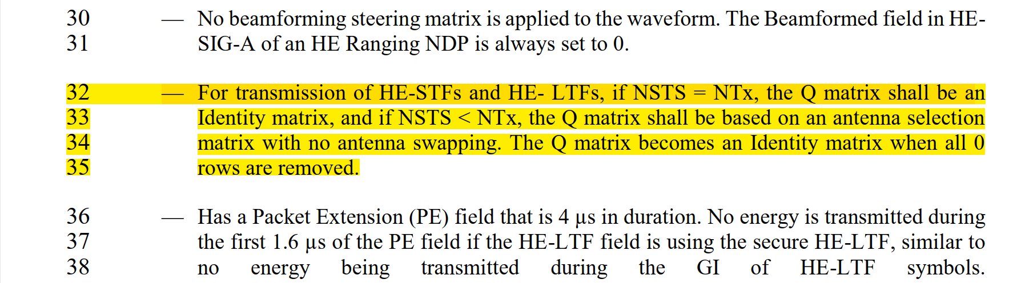

Motion:
Do you agree to add the following PDT to the end of 11.55.1.5.2.3 NDPA sounding phase, P802.11bf D0.4?
When a PPDU bandwidth equals 320 MHz, for transmission of EHT-STFs and EHT-LTFs, if N_{STS} = N_{Tx}, the spatial mapping matrix, Q matrix, shall be an Identity matrix, and if N_{STS} < N_{Tx}, the Q matrix shall be based on an antenna selection matrix with no antenna swapping. The Q matrix becomes an Identity matrix when all 0 rows are removed.

TGbf editor: Please modify Subclause 11.55.1.5.2.3 as follows:
          - NDPA sounding phase
In the NDPA sounding phase, the AP, which is a sensing transmitter, sends an SI2SR NDP to one or more STAs, on which the one or more STAs perform sensing measurement(#123, #309, #862). The NDPA sounding phase shall be present in a TB sensing measurement instance if at least one STA that is a sensing receiver in this NDPA sounding phase and that is not assigned to be polled or has responded in the polling phase(#761).

The AP shall transmit a Sensing NDP Announcement frame to one or more STAs that are sensing receivers in this NDPA sounding phase and that are not assigned to be polled or have responded in the polling phase, followed by a SIFS and SI2SR NDP transmission. The STA Info fields within the Sensing NDP Announcement frame specify STAs that shall perform sensing measurements on the SI2SR NDP sent by the AP(#763, #476, #621, #125, #863).

Add the following paragraphs as follows:

When a PPDU bandwidth equals 320 MHz, for transmission of EHT-STFs and EHT-LTFs, if N_{STS} = N_{Tx}, the spatial mapping matrix, Q matrix, shall be an Identity matrix, and if N_{STS} < N_{Tx}, the Q matrix shall be based on an antenna selection matrix with no antenna swapping. The Q matrix becomes an Identity matrix when all 0 rows are removed.

