IEEE P802.11
Wireless LANs
Proposed Resolution Text for 4.3.31.2.4
Date: 2022-11-14
Author(s):
Name | Affiliation | Address | Phone | email
Hitoshi Morioka | SRC Software | Fukuoka, JAPAN |  | hmorioka@src-soft.com
Abstract
This document describes the text proposal for clause 4.3.31.2.4.

Proposed text

The baseline is D4.0.

Modify 4.3.31.2.4 as follows:

4.3.31.2.4 Example of EBCS DL operation

Modify Figure 4-16a as follows:

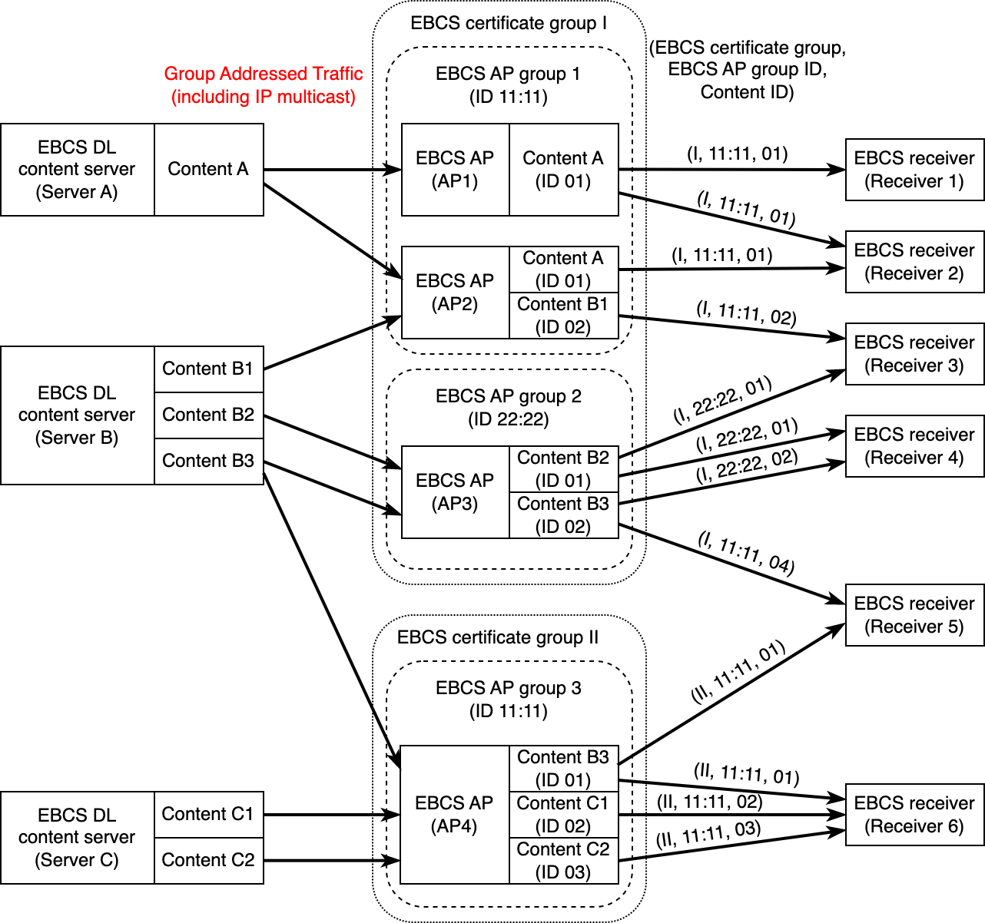

Figure 4-16a—Example of EBCS DL operation

Modify the paragraph at P28L41 as follows:

EBCS DL content servers are distributing group addressed traffic streams by IP multicast on IP network. Each EBCS DL content server can distribute multiple traffic streams that can be identified by the source MAC address and the destination MAC address. If a traffic stream is an IP multicast traffic, the traffic stream is identified by the source IP address, the destination IP address and the destination UDP port.

