IEEE P802.11
Wireless LANs
Proposed Resolution Text for 11.55.3
Date: 2022-11-14
Author(s):
Name | Affiliation | Address | Phone | email
Hitoshi Morioka | SRC Software | Fukuoka, JAPAN |  | hmorioka@src-soft.com
Abstract
This document describes the text proposal for clause 11.55.3.

Proposed text

The baseline is D4.0.

Modify 11.55.3.1 as follows:

11.55.3.1 General

EBCS DL allows an EBCS AP to distribute multicast content to both associated and unassociated EBCS receivers with data origin authenticity.

The frame sequence of the EBCS DL is shown in Figure 11-67 (EBCS DL frame sequence).

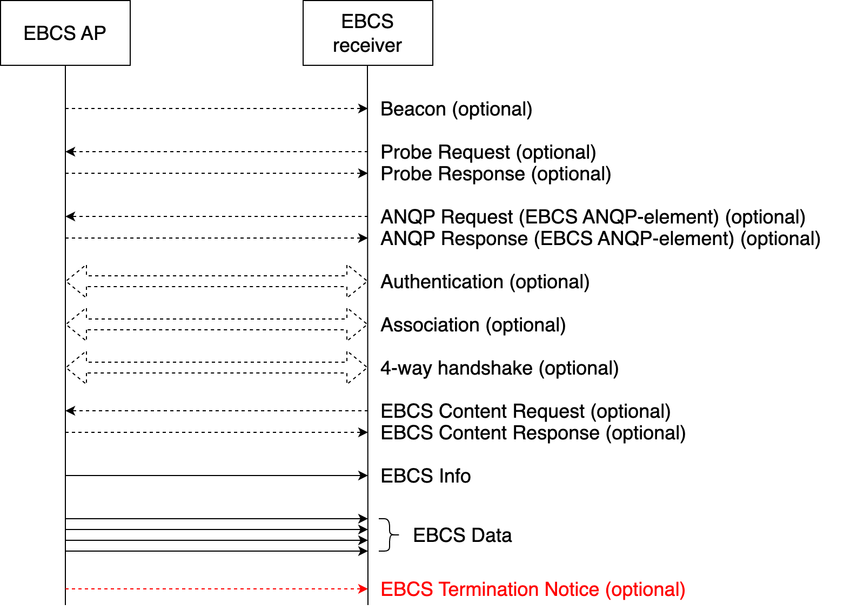

Figure 11-67—EBCS DL frame sequence

NOTE—An EBCS AP might transmit EBCS Info frames and EBCS Data frames that contain the same Frame Body field multiple times consecutively to increase redundancy.

Beacon, S1G Beacon, Probe Request/Response/PV1 Probe Response, ANQP Request/Response are optional. Authentication, Association Request/Response and EBCS Content Request/Response frames, and the 4-way handshake depends on the requirements and status of the desired EBCS traffic streams.

The usages of these frames are described in the following subclauses:

- Beacon, S1G Beacon, Prove Request/Response/PV1 Response, FILS Discovery: 11.55.3.2 and 11.55.3.3
- ANQP Request/Response: 11.22.3.3.17 and 11.55.3.8
- EBCS Content Request/Response: 11.55.3.7
- EBCS Termination Notice: 11.55.3.9

Modify 11.55.3.2 as follows:

11.55.3.2 EBCS DL operation at an EBCS AP

Delete from P82L23 to the end of the subclause

The frame sequence of the EBCS DL is shown in Figure 11-67 (EBCS DL frame sequence).

(snip)
Figure 11-67—EBCS DL frame sequence

NOTE—An EBCS AP might transmit EBCS Info frames and EBCS Data frames that contain the same Frame Body field multiple times consecutively to increase redundancy.

Beacon, S1G Beacon, Probe Request/Response/PV1 Probe Response, ANQP Request/Response,
Authentication, Association Request/Response and EBCS Content Request/Response frames, and the 4-way
handshake might be optional to receive EBCS traffic streams depending on the requirements and status of the
desired EBCS traffic streams.

