IEEE P802.11
Wireless LANs
CC40 CR for Instance CIDs – Part 2
Date: 2022-11-xx
Author(s):
Name | Affiliation | Address | Phone | email
Narengerile | Huawei | Shenzhen, China |  | narengerile@huawei.com
Rui Du
Mengshi Hu

Abstract
This contribution presents CR for CIDs 95, 496, 756, 791 and 541, which are related to the order of TF sounding and NDPA sounding.

R0: initial version.
R1: revised version, based on offline discussions.
R2: changed modifications for all CIDs, changed the reference to D0.5.

CID 95, 756, 496, 541
CID | Subclause | Page | Comment | Proposed change
496 | 11.21.18.6 | 68.37 | Since the order of TF sounding and NDPA sounding as shown in example 3, example 4, and example 5 is TBD as in Editor's Note, wouldn't it need to specify how the sequences are accommodated with a certain order in order for the STAs to prepare the sounding and reporting efficiently? | Specify how the order of sounding will be as in comment.
541 | 11.21.18.6 | 68.55 | As shown in figure 11-41c, various sounding configurations are considered in the TB sensing measurement. So, it needs to be signalled this configuration information if TB sensing measurement is used. Almost sensing parameters are determined by using the sensing measurement setup phase so that this information can be indicated during the sensing measurement setup phase. | Add the information for the configuration of sensing measurement instance in the sensing measurement setup frame.
95 | 11.21.18.6 | 68.36-40 | Define the order of the TF sounding and NDPA sounding phases. | Define the order as follows: Polling phase, NDPA sounding phase, and TF sounding phase (in this order). This order is preferred because it gives more time to clients to prepare measurement reports. Delete Editor's Note (other TBDs in this note have already been addressed). Also delete Figure 11-41c (no longer necessary) and paragraph in lines 25-34. Invert order of NDPA sounding and TF sounding phases in Figure 11-41d.
756 | 11.21.18.6 | 68.36-40 | Suggest defining the order of TB sounding to be before the NDPA sounding (now is TBD) so that it provides additional parsing time for receiver responder to be ready for immediate reporting when reporting phase begins. | As per comment
Proposed resolution: REVISED. Please incorporate the changes in 11/22-1918r2 under “Modification” for CIDs 95, 756, 496, 541 and 791.
Discussion:
CIDs 496 and 541 suggest specifying the order of sounding and CIDs 95 and 756 suggest defining the order of sounding. I agree with the commenters that the order of sounding shall be determined before performing the measurements, if both TF sounding and NDPA sounding are needed in a TB measurement instance.
It might be useful to list the cases we may have in a TB sensing measurement instance:
- A single TF sounding in an instance
- A single NDPA sounding in an instance
- Both TF and NDPA sounding phases in an instance
The order of sounding only applies to Case 3).

Based on the discussions from last call and offline discussions, the majority of TGbf do not like the idea of having a dynamic sequence in TB measurement instance(s), i.e., the order of sounding is negotiable. To make the implementation simple, I changed my modification from negotiating the order to having a fixed order. The order is defined to be NDPA sounding first and followed by TF sounding, as proposed in the comment. Please note that the order only has an impact on Case 3).

Since the TB measurement instance is initiated by the AP, the AP must know which sounding to perform first in the sounding phase. This leads to another question that whether or not to let the sensing responders be aware of the order? My initial feeling is that it is unnecessary. Since the order is already fixed, what the non-AP STA needs to do is to be ready in its scheduled availability window and wait to be invoked by the AP for measurements, such as to receive Sounding TF or NDPA addressed to it.

To summarise, the AP must know the order, but not the non-AP STA – which means we do not need any signalling. The following modifications are based on this conclusion.

Modifications (#95, #756, #496, #541, #791):
TGbf Editor: Please delete the Editor’s Note from L16 to L18 on P149 in D0.5.

TGbf Editor: Please modify Figure 11-75f on P151 by removing the TF sounding phase in the second instance in D0.5.
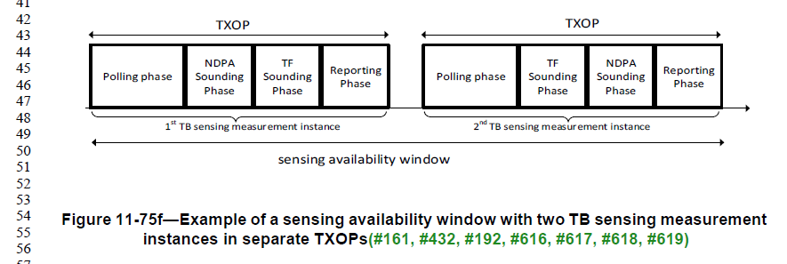

11.55.1.5.2.3 NDPA sounding phase
TGbf Editor: Please modify the following text on P151L61-L65 in D0.5.
In the NDPA sounding phase, the AP, which is a sensing transmitter, sends an SI2SR NDP to one or more STAs, on which the one or more STAs perform sensing measurement (#123, #309, #862). The NDPA sounding phase shall be present in a TB sensing measurement instance if at least one STA that is a sensing receiver in this NDPA sounding phase and that is not assigned to be polled or has responded in the polling phase(#761). If the NDPA sounding phase is present in a TB sensing measurement instance, and if the polling phase is also present, the NDPA sounding phase shall start a SIFS after the polling phase. If the NDPA sounding phase is present in a TB sensing measurement instance, and if the polling phase is not present, the AP shall send the Sensing NDP Announcement frame as the first frame in this measurement instance. (#95, #756, #496, #541, #791)

1111.55.1.5.2.4 TF sounding phase
TGbf Editor: Please modify the following text on P152L29-L33 in D0.5.
In the TF sounding phase, the AP, which is a sensing receiver, solicits NDP transmissions from one or more STAs, on which to perform sensing measurement (#864). The TF sounding phase shall be present in a TB sensing measurement instance if at least one STA that is a sensing transmitter in this TF sounding phase and that is not assigned to be polled or has responded in the polling phase(#622, #623, #764).
If the TF sounding phase is the only sounding phase present in a TB sensing measurement instance, and if the polling phase is also present, the TF sounding phase shall start a SIFS after the polling phase. If both NDPA sounding phase and TF sounding phase are present in a TB sensing measurement instance, the TF sounding phase shall start a SIFS after the NDPA sounding phase. (#95, #756, #496, #541, #791)

CID 791
CID | Subclause | Page | Comment | Proposed change
791 | 11.21.18.6.2 | 69.61 | Do you mean the sounding phase starts SIFS after the polling phase ? | Assuming the NDPA Sounding phase starts after the polling phase, mention in the first paragraph that "the NDPA Sounding phase, when present, starts SIFS after the Polling phase". Similarly, if the NDPA Sounding follows after the TF sounding phase.
Proposed resolution: REVISED. Please incorporate the changes in 11/22-1918r2 under “Modification” for CIDs 95, 756, 496, 541 and 791.

Discussion: I agree with the commenter that the IFS shall be specified for the polling phase and the sounding phase in a TB measurement instance. Please refer to the modifications above under the name “Modifications (#95, #756, #496, #541, #791)”.

SP
Do you support the proposed resolutions for the following CIDs in document 11-22/1918r1 and incorporate the changes into the latest TGbf draft:

95, 756, 496, 541, 791

Y/N/A

