IEEE P802.11
Wireless LANs
CC40 CR for CIDs 748 and 749
Date: 2022.11.07
Author(s):
Name | Company | Address | Phone | email
Mengshi Hu | Huawei Technologies | H3, Huawei Base, Bantian, Longgang, Shenzhen, Guangdong, China, 518129 |  | humengshi@huawei.com
Rui Du
Narengerile
Abstract
This submission contains the proposed comment resolutions for the following 2 CIDs in the Topic “Setup” shown in 22/0820 IEEE 802.11bf CC40 comments.

CIDs 748 and 749

Revision Notes
R0 | Initial version

CID 748
Page.  Line | Clause Number | Comment | Proposed Chang | Resolution
66.51 | 11.21.18.3 | Delete "A sensing session is an agreement between a sensing initiator and a sensing responder to participate in a WLAN sensing procedure" as participating in the WLAN procedure only occurs upon completion of the measurement setup exchange and not session setup exchange. | As per comment | REVISED.  According to the discussions, the sensing session is still needed. The same resolution has been provided in 22/1342r2 sensing session part 1.  Note to the Editor: The related text has been changed in 802.11bf D0.4. No further changes are needed.

Instructions to the editor: please make the following changes to the subclause 11.21.18.6.6 Threshold-based reporting phase in D0.3 and 22/1758r2 as shown below:

Discussion:
The text related to this CID in 802.11bf D0.1 is shown below:
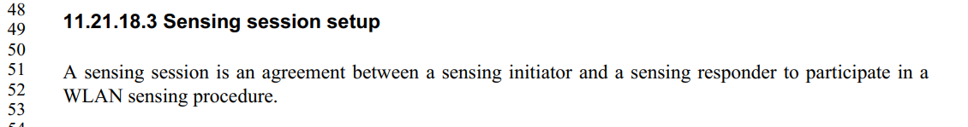
This text is moved to 11.55.1.1 Overview as shown in 802.11bf D0.4:
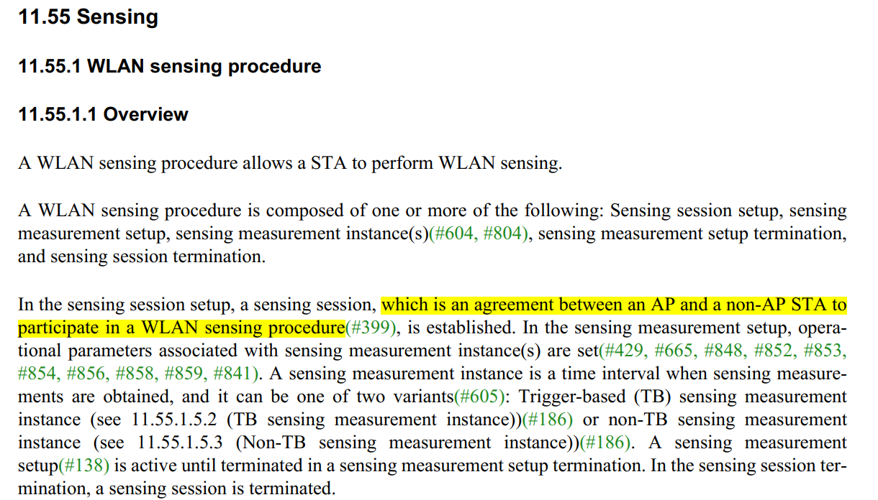
Discussion ends.

CID 749
Page.  Line | Clause Number | Comment | Proposed Change | Resolution
66.59 | 11.21.18.3 | Add the statement "AID/UID assignment is required for the TB measurement instace when AP is a sensing initiator." at the end of the statement in line 59. | As per cmment | REVISED.  The text has been changed in 802.11be D0.4. The new text already shows the cases in which the AID, UID and MAC Address are used.  Note to the Editor: The related text has been changed in 802.11bf D0.4. No further changes are needed.

Instructions to the editor: please make the following changes to the Reserved subfield in the Sensing field of the Sensing element shown in 22/1577r2:

Discussion:
The text in 802.11bf D0.1 is shown below:
The text in 802.11bf D0.4 is shown below:
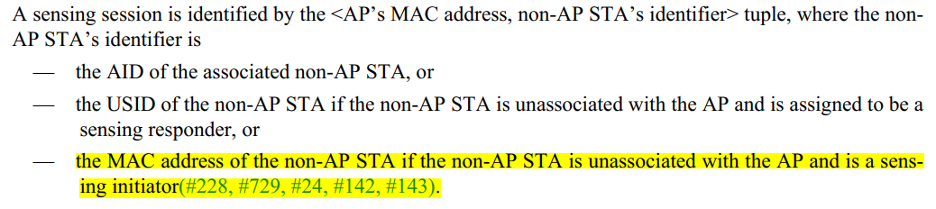
Note that the AID/UID mentioned in D0.1 has been divided into three subbullets:
- The first subbullet indicates that for the associated no-AP STA, an AID is assigned.
- The second subbullet indicates that for an unassociated STA a USID is assigned in the TB case;
- The third subbullet indicates that for an unassociated STA its MAC Address is used in the NTB case.
Thus, there is no need to mention that in the TB case, AID or UID should be assigned again.
Discussion ends.

SP

Do you support the proposed resolutions to the following CIDs and incorporate the text changes into the latest TGbf draft: 748, 749?

Y/N/A

