IEEE P802.11
Wireless LANs
Proposed Draft Text: Coordinated Monostatic DMG Sensing Instance
Date: 2022-11-15
Author(s):
Name | Affiliation | Address | Phone | email
Ning Gao | OPPO |  |  | gaoning1@oppo.com
Chaoming Luo | OPPO |  |  | luochaoming@oppo.com
Pei Zhou | OPPO |  |  | zhoupei1@oppo.com
Solomon Trainin | Qualcomm |  |  | strainin@qti.qualcomm.com
Abstract
This submission proposes the draft text for the Coordinated Monostatic DMG sensing instance.

Revisions:

- Rev 0: Initial version of the document.
- Rev 1: Modified the format of the PDT and reorganized some paragraphs.
- Rev 2: Incorporate the approach from Solomon which provides accurate estimation of the Duration field of the DMG Sensing Request frame. Incorporate the general description of the Coordinated Monostatic Sensing Instance in 22/0980r5 from Rui.
- Rev 3: Add two equations about the calculation of the Duration field. Modify the description of the Num of TX Beams in Instance subfield and the Num of Repeat in Instance subfield and make the subfield name consistent.
- Rev 4: Change the reporting phase to be a mandatory phase in coordinated monostatic instances.

Discussion

Discussion 1

A Timing Problem of the Sequential Coordinated Monostatic DMG Sensing instance was shown in 22/1558r0 as following:
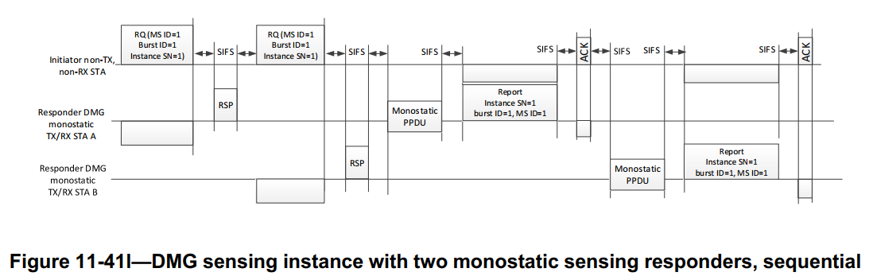

Problem: The STA B may not get the accurate timing when to send the Monostatic PPDU.
- The Ack frame is directionally sent from the initiator to the STA A so the STA B may not receive it.
- The length/duration of the Monostatic PPDU and the DMG Sensing Measurement Report frame of STA A are unknown to STA B.
As a result, the STA B may fail to send the Monostatic PPDU and the DMG Sensing Measurement Report frame or cause interference between STAs in this instance.

The SP and the result are as following:
SP 1: Which option do you support to solve the timing problem of the sequential Coordinated Monostatic DMG Sensing instance as shown in slide 3?
- Option 1-A: use a new poll frame to poll each responder STA, as shown in slide 5
- Option 1-B: use a new poll frame to poll each responder STA except the first, as shown in slide 6
- Option 2: use the DMG Sensing Request frame to poll each responder STA, as shown in slide 7
- Neither
- Abstain
Result: 0/1/16/0/5

Discussion 2

Two Timing Problems of the Parallel Coordinated Monostatic DMG Sensing instance were shown in 22/1670r4 as following:
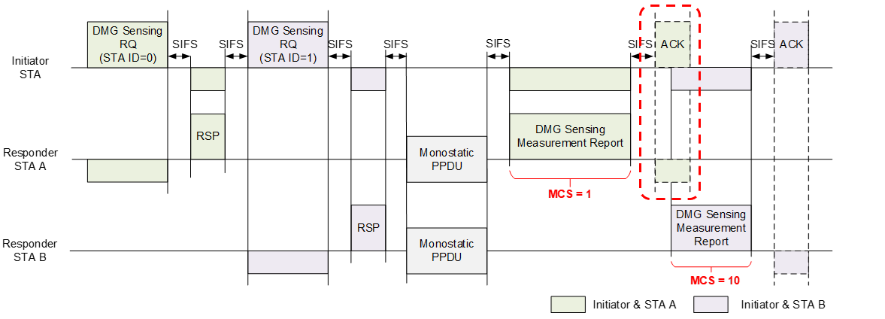
Figure 1–The Timing Problem of the STA B

Problem 1: The STA B does not know when to send the report frame.
- The STA B may not receive the Ack frame of the STA A for it is transmitted directionally.
- The STA B does not know the duration of the Report frame and the ACK frame of the STA A for different MCSs.
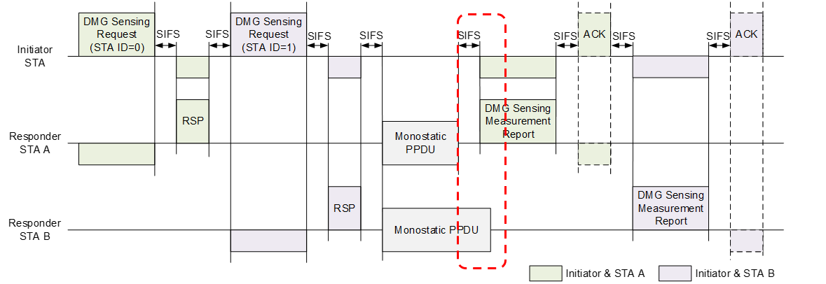
Figure 2–The Timing Problem of the STA A

Problem 2: The Report frame of STA A may overlap with the Monostatic PPDU of STA B for the duration of Monostatic PPDUs may be different.
- Monostatic PPDUs of different STAs may have Date fields of different lengths.
- Monostatic PPDUs of different STAs may use different PPDU types.
- Monostatic PPDUs of different STAs may use the L/EDMG-CEF or TRN field for sensing

The SP and the result are as following:
Do you support the following solutions?
In a Parallel Coordinated Monostatic DMG Sensing instance,
- Add a field (Duration of Monostatic PPDUs) into the TDD Beamforming Information field of the DMG Sensing Response frame to inform the sensing initiator of the duration from the start of the first Monostatic PPDU to the end of the last Monostatic PPDU.
- The sensing initiator shall poll each sensing responder for the report.
- The sensing initiator shall not send the first DMG Sensing Poll frame until the time the largest Duration of Monostatic PPDUs plus the SIFS and BRPIFS after the last DMG Sensing Response frame.

Result: Unanimously supported.

Discussion 3

Problem of TXOP:
In the Draft 0.4, three new TDD Beamforming frames are defined: DMG Sensing Request frame, DMG Sensing Response frame, and DMG Sensing Poll frame. For most DMG sensing types except the Bistatic, a DMG Sensing instance begins with a DMG Sensing Request frame transmitted by the sensing initiator.

The frame format for the TDD Beamforming frame is defined in Figure 9-102 (TDD Beamforming frame
format(11ay))

The Duration field is set to the time until the end of the current TDD slot. Therefore, the Duration field of the first DMG Sensing Request frame in a DMG Sensing instance should be set as the NAV which indicates the duration of the TXOP. In addition, a DMG Sensing instance is limited to one TXOP (see 11.55.3.6 DMG sensing instance). So, the TXOP should be no smaller than an instance.

In fact, the Duration of the report frame can be dynamic due to different MCSs. The duration of sounding PPDUs also can be dynamic if different instances have different number of Tx beams. So, the duration of TXOPs also should be dynamic. However, in a DMG Sensing instance, the sensing initiator does not know the duration of sounding and the duration of report of the instance when setting the TXOP. Because the Duration field is in the first DMG Sensing Request frame which is also the first frame of the instance.

Solution:
The sensing responder predicts the sounding duration and the report duration of the instance i (i > 1) to the sensing initiator by the DMG Sensing Response frame in the instance i-1. The sensing responder predicts the sounding duration and the report duration of the instance 1 by the DMG Sensing Measurement Setup Response frame in the MS phase.

In this way, the sensing initiator can provide an accurate estimation of the Duration field of the DMG Sensing Request frame.

Text proposal – Editor instructions

9.3.1 Control frames

9.3.1.25 TDD Beamforming frame format
9.3.1.25.5 DMG Sensing Request
TGbf editor: Modify the Figure 9-110a TDD Beamforming Information field format and the relevant paragraphs as follows:

Figure 9-110a—TDD Beamforming Information field format (#649, #109, #417)

The STA ID field indicates the index of the receiving STA sync subfield in the EDMG Multistatic Sensing PPDU(#330). The STA ID field indicate the order of sending DMG Sensing Request frames when the Sensing Type is set to the Coordinated Monostatic.

The First Beam Index field is an index into the Tx Beam List in the DMG Sensing Measurement Setup element. It indicates the first beam to be used in the DMG sensing instance.

The Num of STAs in Instance field indicates the number of STAs participating in the DMG sensing
instance.

The Num of PPDUs in Instance field indicates the number of DMG Multistatic Sensing PPDUs present in the DMG sensing instance. The Num of PPDUs in Instance field is reserved when the Sensing Type is set to the Coordinated Monostatic.

The EDMG TRN Length, RX TRN-Units per Each TX TRN-Unit, EDMG TRN-Unit P, EDMG TRN-Unit M, EDMG TRN-Unit N, TRN Subfield Sequence Length, and BW subfields contain the values of the corresponding header fields in the EDMG Multistatic Sensing PPDU(#417). These subfields are reserved when the Sensing Type is set to the Coordinated Monostatic.

The Monostatic Sounding Mode field indicates whether the sounding phase of the coordinated monostatic sensing instance is performed in sequential or parallel mode. A value of 1 indicates the sequential mode, a value of 0 indicates the parallel mode. This field is reserved when the Sensing Type is not set to the Coordinated Monostatic.

The Num of TX Beams in Instance field indicates the number of TX beams to be used in the next DMG Sensing instance. The Num of TX Beams in Instance field in the last instance of a burst indicates the number of TX beams to be used in the first instance of the next burst. This field is reserved in the last DMG Sensing instance of the last DMG sensing burst.

The Num of Repeat in Instance field indicates the number of times to repeat the transmission in the next DMG Sensing instance. The Num of Repeat in Instance field in the last instance of a burst indicates the number of times to repeat the transmission in the first instance of the next burst. This field is reserved in the last DMG Sensing instance of the last DMG sensing burst.

9.3.1.25.6 DMG Sensing Response
TGbf editor: Modify the following paragraph and insert a new figure as follows:

The TDD Beamforming Information field of a DMG Sensing Response frame is empty. The TDD Beamforming Information field of a DMG Sensing Response frame is shown in Figure 9-110b (TDD Beamforming Information field for the DMG Sensing Response frame).
Figure 9-110b—TDD Beamforming Information field for the DMG Sensing Response frame

The Sounding Duration subfield indicates the duration of sounding PPDUs including the SBIFS transmitted by the sensing responder in the next DMG Sensing instance. When the sensing type is set to the Coordinated Monostatic, the sounding PPDUs refer to Monostatic PPDUs. When the sensing type is set to the Coordinated Bistatic, the sounding PPDUs refer to BRP PPDUs with TRN field. This subfield is in the unit of microsecond. A value of 0 indicates that the sensing responder does not transmit any sounding PPDUs. This field is reserved in the last DMG sensing instance of the last DMG sensing burst.
The Report Duration subfield indicates the duration of the report frame transmitted by the sensing responder in the next DMG Sensing instance. When the sensing type is set to the Coordinated Monostatic or the Multistatic, the report frame refers to the DMG Sensing Measurement Report frame. When the sensing type is set to the Coordinated Bistatic, the report frame refers to the BRP PPDU with report. This subfield is in the unit of microsecond. A value of 0 indicates that the sensing responder does not transmit any report frame. This field is reserved in the last DMG sensing instance of the last DMG sensing burst.

9.4.2 Elements

9.4.2.1 General
TGbf editor: Add the following line at the end of the Table 9-128—Element IDs

Element | Element ID | Element ID Extension | Extensible | Fragmentable
DMG Sensing Instance Duration element(see 9.4.2.333 DMG Sensing Instance Duration element) | 255 | <ANA> | Yes | No

9.4.2.324 DMG Sensing Measurement Setup element
9.4.2.324.3 DMG Sensing Scheduling subelement

TGbf editor: Modify the paragraphs at P63 L34-39 as follows:

When the SP subfield in the Measurement Setup Control field is set to 1, tThe Number TX Beams Per Instance field contain the maximum number of TX beams to be used in one DMG Sensing instance. When the SP subfield in the Measurement Setup Control field is set to 0, the Number TX Beams Per Instance field contain the number of TX beams to be used in the first DMG Sensing instance. The use of this field is described in 11.55.3.6 (DMG sensing instance).

When the SP subfield in the Measurement Setup Control field is set to 1, tThe Repeat Per Instance field indicates the maximum number of times to repeat the transmission in one DMG Sensing instance. When the SP subfield in the Measurement Setup Control field is set to 0, the Repeat Per Instance field indicates the number of times to repeat the transmission in the first DMG Sensing instance.

TGbf editor: Add the following subclause into the draft

9.4.2.333 DMG Sensing Instance Duration element
The DMG Sensing Instance Duration element carries information used for NAV. The DMG Sensing Instance Duration element is contained in the DMG Sensing Measurement Setup Response frame. The format of the DMG Sensing Instance Duration element is defined in Figure 9-1002cl (DMG Sensing Instance Duration element format)
Figure 9-1002cl—DMG Sensing Instance Duration element format

The Element ID, Length, and Element ID Extension fields are defined in 9.4.2.1 (General).
If the SP subfield in the DMG Sensing Measurement Setup Request frame is set to 1, the Sounding Duration field contains the maximum duration of sounding PPDUs including the SBIFS transmitted by the sensing responder in all DMG sensing instances. If the SP subfield in the DMG Sensing Measurement Setup Request frame is set to 0, the Sounding Duration field contains the duration of sounding PPDUs including the SBIFS transmitted by the sensing responder in the first DMG sensing instance. When the sensing type is set to the Coordinated Monostatic, the sounding PPDUs refer to Monostatic PPDUs. When the sensing type is set to the Bistatic or the Coordinated Bistatic, the sounding PPDUs refer to BRP PPDUs with TRN field. When the sensing type is set to the Multistatic, the sounding PPDUs refer to EDMG multistatic sensing PPDUs. This field is in the unit of microsecond. A value of 0 indicates that the sensing responder does not transmit any sounding PPDUs.
If the SP subfield in the DMG Sensing Measurement Setup Request frame is set to 1, the Report Duration field contains the maximum duration of the report frame transmitted by the sensing responder in all DMG sensing instances. If the SP subfield in the DMG Sensing Measurement Setup Request frame is set to 0, the Report Duration field contains the duration of the report frame transmitted by the sensing responder in the first DMG sensing instances. When the sensing type is set to the Coordinated Monostatic or the Multistatic, the report frame refers to the DMG Sensing Measurement Report frame. When the sensing type is set to the Bistatic or Coordinated Bistatic, the report frame refers to the BRP PPDU with report. This field is in the unit of microsecond. A value of 0 indicates that the sensing responder does not transmit any report frame.

9.6.21 Unprotected DMG Action frame details

9.6.21.9 DMG Sensing Measurement Setup Response frame format
TGbf editor: Add the following line at the end of the Table 9-576b—DMG Sensing Measurement Setup Response frame Action field format and add the following paragraph at the end of this subclause:

Table 9-576b—DMG Sensing Measurement Setup Response frame Action field format
Order | Information
9 | DMG Sensing Instance Duration element

The DMG Sensing Instance Duration element is defined in 9.4.2.333 (DMG Sensing Instance Duration element). It is present in the Sensing Measurement Setup Response frame if the Status Code is set to SUCCESS. Otherwise, it is not present in the DMG Sensing Measurement Setup Response frame.

11.21.20 DMG sensing procedure

11.21.20.1 Overview
TGbf editor: Remove the following two paragraphs and two figures:

Figure 11-75o (DMG sensing instance with two monostatic sensing responders, sequential sounding(#90, #352)) and Figure 11-75p (DMG sensing instance with two monostatic sensing responders, parallel sounding(#90, #352)) illustrate one DMG sensing instance of the DMG sensing procedure(#354) presented in Figure 11-75n (DMG sensing procedure with three sensing responders(#406, #30, #32)), which is identified by the DMG Measurement Setup ID equal to 1, Measurement Burst ID(#424, #426) equal to 1, and Sensing Instance SN(#397, #223) equal to 1. In both figures, the DMG sensing instance is of the coordinated monostatic type, the PCP/AP is the sensing initiator, and the two monostatic sensing devices are sensing responders. The example illustrates(#723) the coordinated monostatic sensing type with two sensing responders STA A and STA B(#722, #442). In Figure 11-75p (DMG sensing instance with two monostatic sensing responders, parallel sounding(#90, #352)), the sounding phase of the two sensing responders happen in parallel.
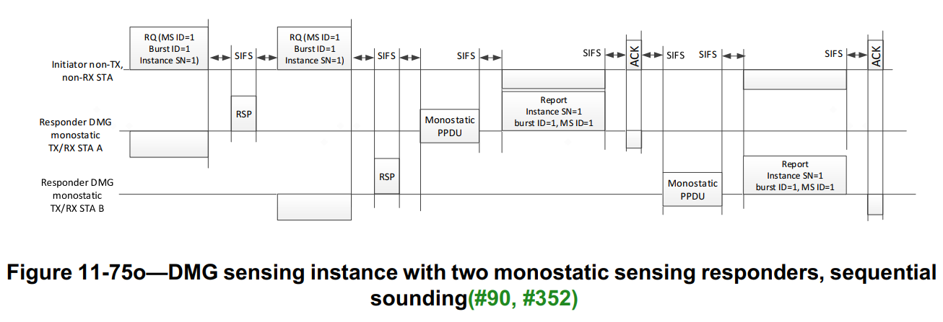
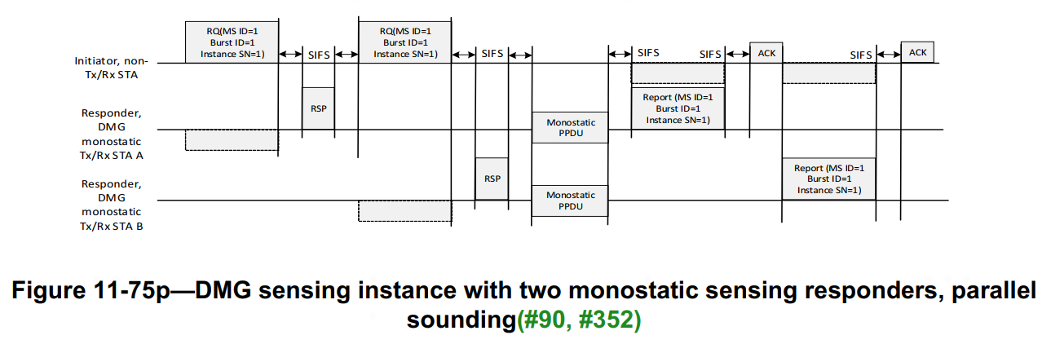

The examples given in both Figure 11-41o (DMG sensing instance with two monostatic sensing responders, sequential sounding (#90, #352)) and Figure 11-41p (DMG sensing instance with two monostatic sensing responders, parallel sounding (#90, #352)) start with the initiation phase. At the handshake of the DMG Sensing Request and DMG Sensing Response frames between the sensing initiator and the sensing responder, the sensing initiator transmits the DMG Sensing Request frame. The frame provides the sensing responders with the order of the sounding and reporting (#237). It also indicates to the sensing initiator the readiness of the sensing responders to participate in the sounding and reporting phases. The sounding phase of both monostatic devices in the instance may happen in parallel. In Figure 11-41o (DMG sensing instance with two monostatic sensing responders, sequential sounding (#90, #352)), the sounding phase is followed by the reporting phase of the same sensing responder and the sounding phases of the two sensing responders are sequential. In its sounding phase, the sensing responders (STA A and STA B) transmits the PPDU and receives the reflected signal. In the immediately following reporting phase, it reports results assigned with DMG Measurement Setup ID equal to 1, Measurement Burst ID (#424, #426) equal to 1, and Sensing Instance SN (#397, #223) equal to 1 to the sensing initiator (#229). In Figure 11-41p (DMG sensing instance with two monostatic sensing responders, parallel sounding (#90, #352)), the sounding phase is followed by the reporting phase of the sensing responders and the sounding phases of the two sensing responders are parallel. In its sounding phase, the sensing responders (STA A and STA B) transmit the PPDU and receive the reflected signal in parallel. In the immediately following reporting phase, both sensing responders report results assigned with DMG Measurement Setup ID (#217) equal to 1, Measurement Burst ID (#424, #426) equal to 1, and Sensing Instance SN (#397, #223) equal to 1 to the sensing initiator (#229).

11.21.20.6 DMG sensing instance
11.21.20.6.2 Coordinated monostatic DMG sensing instance
TGbf editor: Insert a new subclause and modify the following paragraphs as follows:

11.21.20.6.2a General

A coordinated monostatic DMG sensing instance is a DMG sensing instance of a DMG sensing procedure of sensing type coordinated monostatic. It can be performed in two modes: sequential and parallel. It includes one or more of the following phases: initiation phase, sounding phase, and reporting phase.

A coordinated monostatic DMG sensing instance is initiated by DMG Sensing Request(s) and answered by DMG Sensing Response(s). It is then followed by the sounding phase in which monostatic PPDUs are transmitted and received by the sensing responder(s). The measurement covers the number of transmit AWV indicated by the Number TX Beams Per Instance field within the DMG Sensing Scheduling subelement of the DMG Sensing Measurement Setup element (see 9.4.2.322 (DMG Sensing Measurement Setup element)). The sensing initiator shall determine the parameters of the monostatic PPDUs transmitted and received by the sensing responders in a way which is compatible with the sensing responders’ capabilities and covers all the desired transmit beams indicated in TX Beam List subelement (see 9.4.2.322.1 (TX Beam List subelement)). The first beam used by the sensing responders to transmit and receive monostatic PPDUs in a sensing instance, is indicated by the First Beam Index field. The sensing responders will cycle through the Num TX Beams Per Instance beams to transmit and receive the monostatic PPDUs. If the Repeat Per Instance field of the DMG Sensing Scheduling subelement ($N_{RI}$) is greater than 1, the sensing responder will repeat the Num TX beams Per Instance Beams in DMG sensing instances, $N_{RI}$ times. All the monostatic PPDUs transmitted and received by the sensing responders shall be separated by SBIFS. If a report is configured in the DMG sensing instance, sensing responders shall report no longer than SIFS after their last monostatic PPDU or after the polling by sensing initiator. The report may be based on Channel Measurement Feedback elements or DMG Sensing Report elements. The presence and type of the report is indicated by the DMG Sensing Report Control field of the DMG Sensing Report Control element (#52, #449).

The number of sensing responders in each coordinated monostatic DMG sensing instance of the same DMG Measurement Setup ID may be different
11.21.20.6.2a Initiation
In a coordinated monostatic DMG sensing instance, the following rules shall apply:
— The number of sensing responders in each coordinated monostatic DMG sensing instance of the same DMG Measurement Setup ID may be different
— The sensing initiator shall send a DMG Sensing Request frame to each sensing responder it requests to participate in the coordinated monostatic DMG sensing instance(#649)
— The sensing responder shall not respond with the DMG Sensing Response frame to the sensing initiator later than SIFS time after the request(#649)
—The sensing responder that responded to the sensing initiator shall proceed with monostatic sensing.
— The order of sounding is indicated in the STA ID field within the DMG Sensing Request frame(#649), and the sounding may be performed either sequentially or simultaneously.
— The interpretation of the fields of the DMG Sensing Request frame when used in coordinated monostatic sensing is TBD(#649)

11.21.20.6.2b Sounding
The RA shall be set equal to the TA in the PSDU contained in the monostatic PPDU (TBD).

11.21.20.6.2c Reporting
If the responses are configured to happen during the DMG sensing instance, each sensing responder shall respond in no longer than SIFS time after the monostatic PPDU.
If the polled responses are configured, each sensing responder shall respond in no longer than SIFS time after the polling by the sensing initiator.

11.21.20.6.2b Sequential Instance

In a sequential coordinated monostatic DMG sensing instance, the following rules shall apply:
- The sensing initiator shall interact with each intended sensing responder one by one in order of the STA ID field of the DMG Sensing Request frame.
- For each sensing responder, the interaction shall include an initiation phase, a sounding phase and a reporting phase.
  - In the initiation phase, the sensing initiator shall send a DMG Sensing Request frame to a sensing responder to request it to participate in the coordinated monostatic DMG sensing instance. The Monostatic Sounding Mode subfield of the TDD Beamforming Information field in the DMG Sensing Request frame shall be set to 1 to identify the sequential mode. The sensing responder shall not respond with the DMG Sensing Response frame to the sensing initiator later than SIFS time after the request. according The value of the Duration field of the first DMG Sensing Request frame in instance i shall be calculated by the Equation (11-xx):
Durationi=Ni-1*TREQ+Ni*TRSP+4Ni-1*SIFS+n=1Ni(SoundingDurationni-1+ReportDurationni-1) (11-xx)

where
Ni is the value of the Num of STAs in Instance subfield of the DMG Sensing Request frame in instance i.
TREQ is the TXTIME of a DMG Sensing Request frame.
TRSP is the TXTIME of a DMG Sensing Response frame.
SoundingDurationni-1 is the value of the Sounding Duration subfield of the DMG Sensing Response frame delivered by sensing responder n in instance i-1(i > 1). ${SoundingDuration}_{n}^{0}$ is the value of the Sounding Duration field of the DMG Sensing Instance Duration element in the DMG Sensing Measurement Setup Response frame delivered by sensing responder n.
ReportDurationni-1 is the value of the Report Duration subfield of the DMG Sensing Response frame delivered by sensing responder n in instance i-1(i > 1). ${ReportDuration}_{n}^{0}$ is the value of the Report Duration field of the DMG Sensing Instance Duration element in the DMG Sensing Measurement Setup Response frame delivered by sensing responder n.

  - In the sounding phase, the sensing responder shall start to send one or more Monostatic PPDUs in no later than SIFS time after the DMG Sensing Response frame. Monostatic PPDUs transmitted by the same sensing responder shall be separated by SBIFS time. When the Sensing Instance SN subfield of the TDD Beamforming Information field in the DMG Sensing Request frame is set to 1, the Monostatic PPDUs shall cover the number of transmitting AWV indicated by the Number TX Beams Per Instance field and the times of repetition indicated by the Repeat Per Instance field in the DMG Sensing Scheduling subelement of the DMG Sensing Measurement Setup element. The time of the transmission of the Monostatic PPDUs including the SBIFS shall be equal to the Sounding Duration field of the DMG Sensing Instance Duration element delivered by the sensing responder in the DMG Sensing Measurement Setup Response frame. When the Sensing Instance SN subfield of the TDD Beamforming Information field in the DMG Sensing Request frame is set to i (i > 1), the Monostatic PPDUs shall cover the number of transmitting AWV indicated by the Num of TX Beams in Instance subfield and the times of repetition indicated by the Num of Repeat in Instance subfield in the TDD Beamforming Information field of the DMG Sensing Request frame with Sensing Instance SN subfield equals i-1. The time of the transmission of the Monostatic PPDUs including the SBIFS shall be equal to the Sounding Duration field of the DMG Sensing Response frame of the instance with the Sensing Instance SN subfield equals i-1.
  - In the reporting phase, the sensing responder shall send a DMG Sensing Measurement Report frame to the initiator no later than SIFS time after the last Monostatic PPDU. When the Sensing Instance SN subfield of the TDD Beamforming Information field in the DMG Sensing Request frame is set to 1, the duration of the transmission of the DMG Sensing Measurement Report frame shall be equal to the Report Duration field of the DMG Sensing Instance Duration element delivered by the sensing responder in the DMG Sensing Measurement Setup Response frame. When the Sensing Instance SN subfield of the TDD Beamforming Information field in the DMG Sensing Request frame is set to i (i > 1), the duration of the transmission of the DMG Sensing Measurement Report frame shall be equal to the Report Duration field of the DMG Sensing Response frame of the instance with the Sensing Instance SN subfield equals i-1.
- The sensing initiator shall interact with the next sensing responder no later than SIFS time after the DMG Sensing Measurement Report frame of the current sensing responder.

Figure 11-75o—Coordinated Monostatic DMG sensing instances with two sensing responders, sequential sounding mode (#90, #352)

Figure 11-75o (Sequential Coordinated Monostatic DMG sensing instances with two sensing responders, sequential sounding mode (#90, #352)) gives an example of two sequential coordinated monostatic DMG sensing instances. The PCP/AP is the sensing initiator and the two monostatic sensing devices (STA A and STA B) are sensing responders. The SP is not used and the measurement results need to be reported. In the DMG sensing measurement setup phase, the STA A and STA B delivered the Sounding Duration 0a, Report Duration 0a, Sounding Duration 0b, and Report Duration 0b of the first instance to the sensing initiator by the DMG Sensing Instance Duration element of DMG Sensing Measurement Setup Response frame. In this example, the sensing initiator first interacts with STA A (STA ID = 0) and then with STA B (STA ID = 1) in each instance.

In Instance 1, in the initiation phase of STA A, the sensing initiator sends a DMG Sensing Request frame to STA A and receives a DMG Sensing Response frame from STA A. The DMG Sensing Request frame activates STA A to be ready to participate in the sounding and reporting phases. The DMG Sensing Response frame indicates to the sensing initiator the readiness of STA A and the Sounding Duration 1a and the Report Duration 1a of the Instance 2. In the first DMG Sensing Request frame, the Monostatic Sounding Mode subfield is set to 1 to indicate the sequential mode and the Duration field is set to the time from the end of this DMG Sensing Request frame to the end of the DMG Sensing Measurement Report frame of the STA B based on the Sounding Duration 0a, Report Duration 0a, Sounding Duration 0b, and Report Duration 0b delivered in the DMG Sensing Measurement Setup Response frame. In the following sounding phase of STA A, STA A transmits Monostatic PPDUs and receives the reflected signal for sensing measurement. The time of the transmission of Monostatic PPDUs including the SBIFS is equal to the Sounding Duration 0a. The measurement in the Monostatic PPDU covers the number of transmit AWV indicated by the Number TX Beams Per Instance field and the times of repetition indicated by the Repeat Per Instance field within the DMG Sensing Scheduling subelement of the DMG Sensing Measurement Setup element. In the following reporting phase of STA A, STA A sends a DMG Sensing Measurement Report frame to the sensing initiator. The time of the transmission of the DMG Sensing Measurement Report frame is equal to the Report Duration 0a. Then, the sensing initiator proceed initiation phase, sounding phase, and reporting phase with STA B. In the initiation phase of STA B, the sensing initiator sends a DMG Sensing Request frame to STA B and receives a DMG Sensing Response frame from STA B. The DMG Sensing Response frame transmitted by STA B contains the Sounding Duration 1b and the Report Duration 1b of the Instance 2. In the following sounding phase of STA B, STA B transmits Monostatic PPDUs and receives the reflected signal for sensing measurement. The time of the transmission of the Monostatic PPDUs including the SBIFS is equal to the Sounding Duration 0b. In the following reporting phase of STA B, STA B sends a DMG Sensing Measurement Report frame with the report to the sensing initiator. The time of the transmission of the DMG Sensing Measurement Report frame is equal to the Report Duration 0b.

In Instance 2, the Duration field of the first DMG Sensing Request frame is set based on the Sounding Duration 1a, Report Duration 1a, Sounding Duration 1b, and Report Duration 1b delivered in the DMG Sensing Response frames in the Instance 1. The measurement in Monostatic PPDUs covers the number of transmit AWV indicated by the Num of TX Beams in Instance field and the times of repetition indicated by the Num of Repeat in Instance field in the TDD Beamforming Information field of the DMG Sensing Request frame of the Instance 1. The time of the transmission of the Monostatic PPDUs of STA A including the SBIFS is equal to the Sounding Duration 1a and the Monostatic PPDUs of STA B including the SBIFS is equal to the Sounding Duration 1b. The time of the transmission of the DMG Sensing Measurement Report frame of STA A is equal to the Report Duration 1a and the DMG Sensing Measurement Report frame of STA B is equal to the Report Duration 1b.

11.21.20.6.2c Parallel Instance

In a parallel coordinated monostatic DMG sensing instance, the following rules shall apply:
- A parallel coordinated monostatic DMG sensing instance shall include an initiation phase, a sounding phase and a reporting phase.
  - In the initiation phase, the sensing initiator shall send a DMG Sensing Request frame to each intended sensing responder to request them to participate in the coordinated monostatic DMG sensing instance. The STA ID field of the DMG Sensing Request frame shall indicate the order of DMG Sensing Request frames and the Monostatic Sounding Mode field shall be set to 0 to identify the parallel sounding mode. Each sensing responder shall not respond with the DMG Sensing Response frame to the sensing initiator later than SIFS time after the request. If the sensing initiator does not receive a desired DMG Sensing Response frame in SIFS after a DMG Sensing Request frame, it shall not send the next DMG Sensing Request frame until the duration of a DMG Sensing Response frame plus 2*SIFS after the DMG Sensing Request frame. The value of the Duration field of the first DMG Sensing Request frame in instance i shall be calculated by the Equation (11-xy):
Durationi=Ni-1*TREQ+Ni*TRSP+Ni*TPOL+4Ni-1*SIFS+BRPIFS+max1≤n≤NiSoundingDurationni-1+n=1NiReportDurationni-1
(11-xy)
where
Ni is the value of the Num of STAs in Instance subfield of the DMG Sensing Request frame in instance i.
TREQ is the TXTIME of a DMG Sensing Request frame.
TRSP is the TXTIME of a DMG Sensing Response frame.
TPOL is the TXTIME of a DMG Sensing Poll frame.
SoundingDurationni-1 is the value of the Sounding Duration subfield of the DMG Sensing Response frame delivered by sensing responder n in instance i-1(i > 1). ${SoundingDuration}_{n}^{0}$ is the value of the Sounding Duration field of the DMG Sensing Instance Duration element in the DMG Sensing Measurement Setup Response frame delivered by sensing responder n.
ReportDurationni-1 is the value of the Report Duration subfield of the DMG Sensing Response frame delivered by sensing responder n in instance i-1(i > 1). ReportDurationn0 is the value of the Report Duration field of the DMG Sensing Instance Duration element in the DMG Sensing Measurement Setup Response frame delivered by sensing responder n.

  - In the sounding phase, sensing responders shall start to send one or more Monostatic PPDUs in parallel no later than SIFS time after the last DMG Sensing Response frame. Monostatic PPDUs transmitted by each sensing responder shall be separated by SBIFS time. When the Sensing Instance SN subfield of the TDD Beamforming Information field in the DMG Sensing Request frame is set to 1, the Monostatic PPDUs transmitted by each sensing responder shall cover the number of transmitting AWV indicated by the Number TX Beams Per Instance field and the times of repetition indicated by the Repeat Per Instance field within the DMG Sensing Scheduling subelement of the DMG Sensing Measurement Setup element. The time of the transmission of the Monostatic PPDUs including the SBIFS shall be equal to the Sounding Duration field of the DMG Sensing Instance Duration element delivered by the sensing responder in the DMG Sensing Measurement Setup Response frame. When the Sensing Instance SN subfield of the TDD Beamforming Information field in the DMG Sensing Request frame is set to i (i > 1), the Monostatic PPDUs shall cover the number of transmitting AWV indicated by the Num of TX Beams in Instance subfield and the times of repetition indicated by the Num of Repeat in Instance subfield in the TDD Beamforming Information field of the DMG Sensing Request frame with Sensing Instance SN subfield equals i-1. The time of the transmission of the Monostatic PPDUs including the SBIFS shall be equal to the Sounding Duration field of the DMG Sensing Response frame of the instance with the Sensing Instance SN subfield equals i-1.
  - In the reporting phase, the sensing initiator shall send a DMG Sensing Poll frame to each sensing responder for the report in order of the STA ID field. Each sensing responder shall respond with a DMG Sensing Measurement Report frame to the sensing initiator no later than SIFS time after the DMG Sensing Poll frame. The sensing initiator shall not send the first DMG Sensing Poll frame until the largest Sounding Duration plus the SIFS and BRPIFS after the last DMG Sensing Response frame. When the Sensing Instance SN subfield of the TDD Beamforming Information field in the DMG Sensing Request frame is set to 1, the duration of the transmission of the DMG Sensing Measurement Report frame shall be equal to the Report Duration field of the DMG Sensing Instance Duration element delivered by the sensing responder in the DMG Sensing Measurement Setup Response frame. When the Sensing Instance SN subfield of the TDD Beamforming Information field in the DMG Sensing Request frame is set to i (i > 1), the duration of the transmission of the DMG Sensing Measurement Report frame shall be equal to the Report Duration field of the DMG Sensing Response frame of the instance with the Sensing Instance SN subfield equals i-1.

Figure 11-75p—Coordinated Monostatic DMG sensing instances, parallel sounding mode (#90, #352)

Figure 11-75p (Coordinated Monostatic DMG sensing instances with two sensing responders, parallel sounding mode(#90, #352)) gives an example of two parallel coordinated monostatic DMG sensing instances The PCP/AP is the sensing initiator and the two monostatic sensing devices (STA A and STA B) are sensing responders. The SP is not used and the measurement results need to be reported. In the DMG sensing measurement setup phase, the STA A and STA B delivered the Sounding Duration 0a, Report Duration 0a, Sounding Duration 0b, and Report Duration 0b of the first instance to the sensing initiator by the DMG Sensing Instance Duration element of DMG Sensing Measurement Setup Response frames.

In Instance 1, in the initiation phase, the sensing initiator sends a DMG Sensing Request frame to STA A (STA ID = 0) and receives a DMG Sensing Response frame from STA A. Then the sensing initiator sends a DMG Sensing Request frame to STA B (STA ID = 1) and receives a DMG Sensing Response frame from STA B. The DMG Sensing Request frames activate the STA A and STA B to be ready to participate in the sounding and reporting phases. The DMG Sensing Response frames indicate to the sensing initiator the readiness of the STA A and STA B and include the Sounding Duration 1a, Report Duration 1a, Sounding Duration 1b, and Report Duration 1b of the Instance 2. Based on the STA ID field and the Num of STAs in Instance filed in the received DMG Sensing Request frame, STA A infers that there is one remaining sensing responder to be initiated and estimates when the last DMG Sensing Response ends. In the first DMG Sensing Request frame transmitted by the sensing initiator, the Duration field is set to the time from the end of first DMG Sensing Request frame to the end of the DMG Sensing Measurement Report frame of the STA B. The sensing initiator calculates it based on the Sounding Duration 0a, Report Duration 0a, Sounding Duration 0b, and Report Duration 0b fields delivered in the DMG Sensing Instance Duration element of the DMG Sensing Measurement Setup Response frames. In the following sounding phase, STA A and STA B transmit Monostatic PPDUs and receive the reflected signal in parallel. The time of the transmission of Monostatic PPDUs of STA A including the SBIFS is equal to the Sounding Duration 0a. The time of the transmission of Monostatic PPDUs of STA B including the SBIFS is equal to the Sounding Duration 0b. The measurement in Monostatic PPDUs covers the number of transmit AWV indicated by the Number TX Beams Per Instance field and the times of repetition indicated by the Repeat Per Instance field within the DMG Sensing Scheduling subelement of the DMG Sensing Measurement Setup element. The Sounding Duration of STA A and STA B may have different duration for different PPDU types or different Data Length. In the following reporting phase, after the largest Sounding Duration (Sounding Duration 0b) plus SIFS and BRPIFS time from the end of the last DMG Sensing Response frame, the sensing initiator sends the first DMG Sensing Poll frame to STA A for the report and receives a DMG Sensing Measurement Report frame from STA A. Then the sensing initiator sends another DMG Sensing Poll frame to STA B for the report and receives a DMG Sensing Measurement Report frame from STA B. The time of the transmission of the DMG Sensing Measurement Report frame of STA A is equal to the Report Duration 0a. The time of the transmission of the DMG Sensing Measurement Report frame of STA B is equal to the Report Duration 0b.

In Instance 2, the Duration field of the first DMG Sensing Request frame is set based on the Sounding Duration 1a, Report Duration 1a, Sounding Duration 1b, and Report Duration 1b delivered in the DMG Sensing Response frames in the Instance 1. The measurement in Monostatic PPDUs covers the number of transmit AWV indicated by the Num of TX Beams in Instance field and the times of repetition indicated by the Num of Repeat in Instance field in the TDD Beamforming Information field of the DMG Sensing Request frame of the Instance 1. The time of the transmission of the Monostatic PPDUs of STA A including the SBIFS is equal to the Sounding Duration 1a and the Monostatic PPDUs of STA B including the SBIFS is equal to the Sounding Duration 1b. The time of the transmission of the DMG Sensing Measurement Report frame of STA A is equal to the Report Duration 1a and the DMG Sensing Measurement Report frame of STA B is equal to the Report Duration 1b.

