IEEE P802.11
Wireless LANs
Proposed Draft Text: Coordinated Monostatic DMG Sensing Instance
Date: 2022-11-15
Author(s):
Name | Affiliation | Address | Phone | email
Ning Gao | OPPO |  |  | gaoning1@oppo.com
Chaoming Luo | OPPO |  |  | luochaoming@oppo.com
Pei Zhou | OPPO |  |  | zhoupei1@oppo.com
Abstract
This submission proposes the draft text for the Coordinated Monostatic DMG sensing instance.

Revisions:

- Rev 0: Initial version of the document.
- Rev 1: Modified the format of the PDT and reorganized some paragraphs.

Discussion

Discussion 1

A Timing Problem of the Sequential Coordinated Monostatic DMG Sensing instance was shown in 22/1558r0 as following:
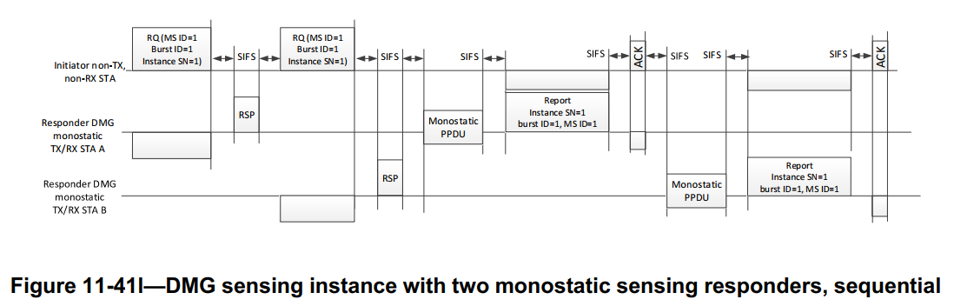

Problem: The STA B may not get the accurate timing when to send the Monostatic PPDU.
- The Ack frame is directionally sent from the initiator to the STA A so the STA B may not receive it.
- The length/duration of the Monostatic PPDU and the DMG Sensing Measurement Report frame of STA A are unknown to STA B.
As a result, the STA B may fail to send the Monostatic PPDU and the DMG Sensing Measurement Report frame or cause interference between STAs in this instance.

The SP and the result are as following:
SP 1: Which option do you support to solve the timing problem of the sequential Coordinated Monostatic DMG Sensing instance as shown in slide 3?
- Option 1-A: use a new poll frame to poll each responder STA, as shown in slide 5
- Option 1-B: use a new poll frame to poll each responder STA except the first, as shown in slide 6
- Option 2: use the DMG Sensing Request frame to poll each responder STA, as shown in slide 7
- Neither
- Abstain
Result: 0/1/16/0/5

Discussion 2

Two Timing Problems of the Parallel Coordinated Monostatic DMG Sensing instance were shown in 22/1670r2 as following:
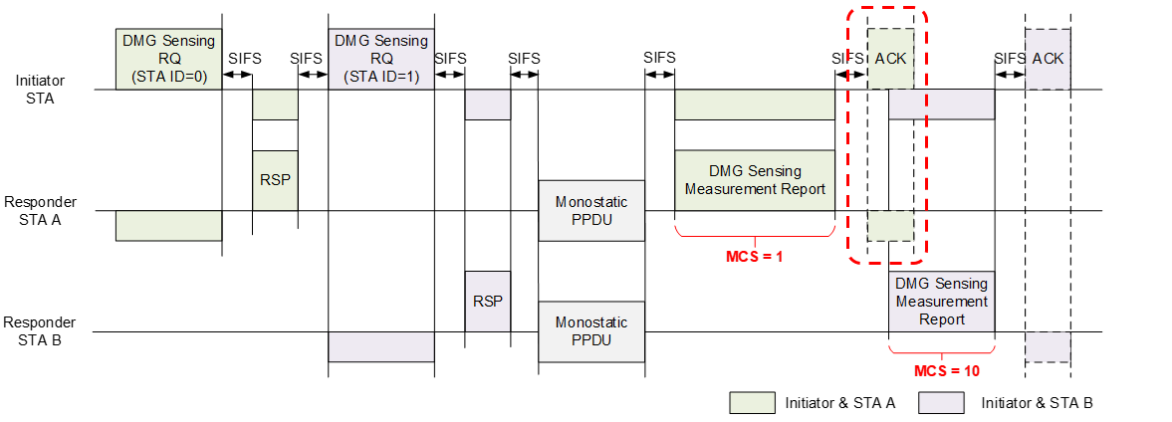
Figure 1–The Timing Problem of the STA B

Problem 1: The STA B does not know when to send the report frame.
- The STA B may not receive the Ack frame of the STA A for it is transmitted directionally.
- The STA B does not know the duration of the Report frame and the ACK frame of the STA A for different MCSs.
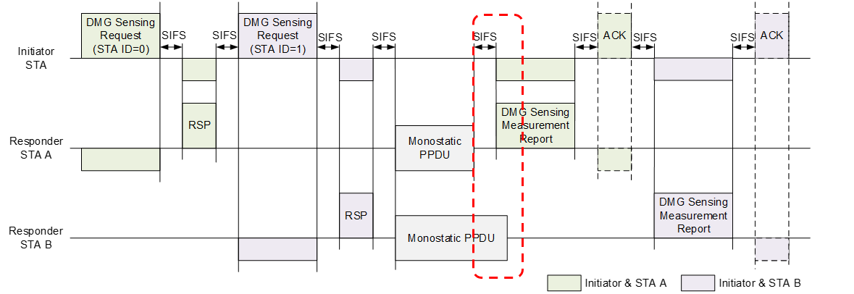
Figure 2–The Timing Problem of the STA A

Problem 2: The Report frame of STA A may overlap with the Monostatic PPDU of STA B for the duration of Monostatic PPDUs may be different.
- Monostatic PPDUs of different STAs may have Date fields of different lengths.
- Monostatic PPDUs of different STAs may use different PPDU types.

The SP and the result are as following:
Do you support the following solutions?
In a Parallel Coordinated Monostatic DMG Sensing instance,
- Add a field (Duration of Monostatic PPDUs) into the TDD Beamforming Information field of the DMG Sensing Response frame to inform the sensing initiator of the duration of one or more Monostatic PPDUs containing the interval time.
- The sensing initiator shall poll each sensing responder for the report.
- The sensing initiator shall send the first DMG Sensing Poll frame no later than SIFS time after the longest Duration of Monostatic PPDUs.
Result: 6 Yes/5 No/15 Abstain

Then, I had an offline discussion with several commenters about this contribution. After the discussion, we reached a consensus about the solutions proposed in this contribution.

Text proposal – Editor instructions

9.3.1.25 TDD Beamforming frame format
9.3.1.25.5 DMG Sensing Request
TGbf editor: Modify the Figure 9-110a TDD Beamforming Information field format and the relevant paragraphs as follows:

Figure 9-110a—TDD Beamforming Information field format (#649, #109, #417)

The STA ID field indicates the index of the receiving STA sync subfield in the EDMG Multistatic Sensing PPDU(#330). The STA ID field indicate the order of sending DMG Sensing Request frames when the Sensing Type is set to the Coordinated Monostatic.

The First Beam Index field is an index into the Tx Beam List in the DMG Sensing Measurement Setup element. It indicates the first beam to be used in the DMG sensing instance.

The Num of PPDUs in Instance field indicates the number of DMG Multistatic Sensing PPDUs present in the DMG sensing instance. The Num of PPDUs in Instance field is reserved when the Sensing Type is set to the Coordinated Monostatic.

The EDMG TRN Length, RX TRN-Units per Each TX TRN-Unit, EDMG TRN-Unit P, EDMG TRN-Unit M, EDMG TRN-Unit N, TRN Subfield Sequence Length, and BW subfields contain the values of the corresponding header fields in the EDMG Multistatic Sensing PPDU(#417).

The Monostatic Sounding Mode field indicates whether the sounding phase of the coordinated monostatic sensing instance is performed in sequential or parallel mode. A value of 1 indicates the sequential mode, a value of 0 indicates the parallel mode. This field is reserved when the Sensing Type is not set to the Coordinated Monostatic.

9.3.1.25.6 DMG Sensing Response
TGbf editor: Modify the following paragraph and insert a new figure as follows:

The TDD Beamforming Information field of a DMG Sensing Response frame is empty. The TDD Beamforming Information field of a DMG Sensing Response frame is shown in Figure 9-110b (TDD Beamforming Information field for the DMG Sensing Response frame).
Figure 9-110b—TDD Beamforming Information field for the DMG Sensing Response frame

The Duration of Monostatic PPDUs field indicates the duration from the start of the first Monostatic PPDU to the end of the last Monostatic PPDU in the current DMG Sensing instance. This field is in the unit of microsecond. The Duration of Monostatic PPDUs field is reserved if the sensing type of the DMG sensing instance is not the Coordinated Monostatic.

11.21.20 DMG sensing procedure
11.21.20.1 Overview
TGbf editor: Remove the following two paragraphs and two figures:

Figure 11-75o (DMG sensing instance with two monostatic sensing responders, sequential sounding(#90, #352)) and Figure 11-75p (DMG sensing instance with two monostatic sensing responders, parallel sounding(#90, #352)) illustrate one DMG sensing instance of the DMG sensing procedure(#354) presented in Figure 11-75n (DMG sensing procedure with three sensing responders(#406, #30, #32)), which is identified by the DMG Measurement Setup ID equal to 1, Measurement Burst ID(#424, #426) equal to 1, and Sensing Instance SN(#397, #223) equal to 1. In both figures, the DMG sensing instance is of the coordinated monostatic type, the PCP/AP is the sensing initiator, and the two monostatic sensing devices are sensing responders. The example illustrates(#723) the coordinated monostatic sensing type with two sensing responders STA A and STA B(#722, #442). In Figure 11-75p (DMG sensing instance with two monostatic sensing responders, parallel sounding(#90, #352)), the sounding phase of the two sensing responders happen in parallel.
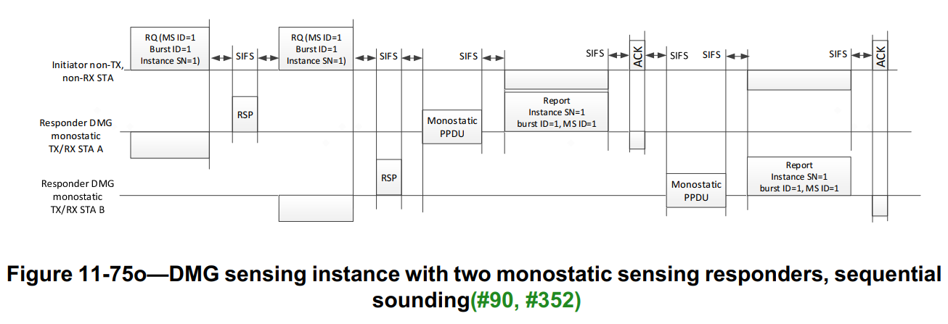
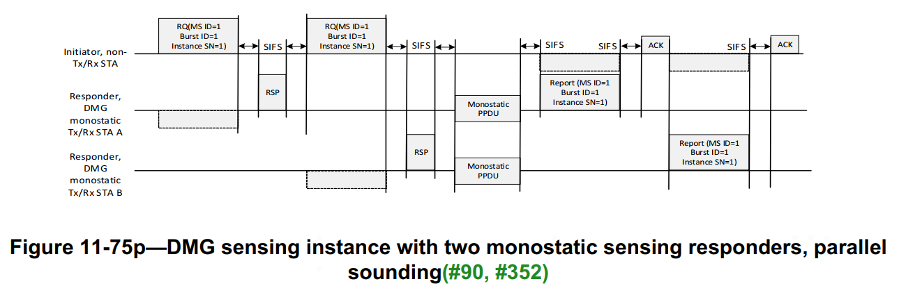

The examples given in both Figure 11-41o (DMG sensing instance with two monostatic sensing responders, sequential sounding (#90, #352)) and Figure 11-41p (DMG sensing instance with two monostatic sensing responders, parallel sounding (#90, #352)) start with the initiation phase. At the handshake of the DMG Sensing Request and DMG Sensing Response frames between the sensing initiator and the sensing responder, the sensing initiator transmits the DMG Sensing Request frame. The frame provides the sensing responders with the order of the sounding and reporting (#237). It also indicates to the sensing initiator the readiness of the sensing responders to participate in the sounding and reporting phases. The sounding phase of both monostatic devices in the instance may happen in parallel. In Figure 11-41o (DMG sensing instance with two monostatic sensing responders, sequential sounding (#90, #352)), the sounding phase is followed by the reporting phase of the same sensing responder and the sounding phases of the two sensing responders are sequential. In its sounding phase, the sensing responders (STA A and STA B) transmits the PPDU and receives the reflected signal. In the immediately following reporting phase, it reports results assigned with DMG Measurement Setup ID equal to 1, Measurement Burst ID (#424, #426) equal to 1, and Sensing Instance SN (#397, #223) equal to 1 to the sensing initiator (#229). In Figure 11-41p (DMG sensing instance with two monostatic sensing responders, parallel sounding (#90, #352)), the sounding phase is followed by the reporting phase of the sensing responders and the sounding phases of the two sensing responders are parallel. In its sounding phase, the sensing responders (STA A and STA B) transmit the PPDU and receive the reflected signal in parallel. In the immediately following reporting phase, both sensing responders report results assigned with DMG Measurement Setup ID (#217) equal to 1, Measurement Burst ID (#424, #426) equal to 1, and Sensing Instance SN (#397, #223) equal to 1 to the sensing initiator (#229).

11.21.20.6 DMG sensing instance
11.21.20.6.2 Coordinated monostatic DMG sensing instance
TGbf editor: Modify the following paragraphs as follows:

A coordinated monostatic DMG sensing instance is a DMG sensing instance of a DMG sensing procedure of sensing type coordinated monostatic.

A coordinated monostatic DMG sensing instance can be performed in two modes: sequential mode and parallel mode.

The number of sensing responders in each coordinated monostatic DMG sensing instance of the same DMG Measurement Setup ID may be different
11.21.20.6.2a Initiation
In a coordinated monostatic DMG sensing instance, the following rules shall apply:
— The number of sensing responders in each coordinated monostatic DMG sensing instance of the same DMG Measurement Setup ID may be different
— The sensing initiator shall send a DMG Sensing Request frame to each sensing responder it requests to participate in the coordinated monostatic DMG sensing instance(#649)
— The sensing responder shall not respond with the DMG Sensing Response frame to the sensing initiator later than SIFS time after the request(#649)
—The sensing responder that responded to the sensing initiator shall proceed with monostatic sensing.
— The order of sounding is indicated in the STA ID field within the DMG Sensing Request frame(#649), and the sounding may be performed either sequentially or simultaneously.
— The interpretation of the fields of the DMG Sensing Request frame when used in coordinated monostatic sensing is TBD(#649)

11.21.20.6.2b Sounding
The RA shall be set equal to the TA in the PSDU contained in the monostatic PPDU (TBD).

11.21.20.6.2c Reporting
If the responses are configured to happen during the DMG sensing instance, each sensing responder shall respond in no longer than SIFS time after the monostatic PPDU.
If the polled responses are configured, each sensing responder shall respond in no longer than SIFS time after the polling by the sensing initiator.

11.21.20.6.2a Sequential

In a sequential coordinated monostatic DMG sensing instance, the following rules shall apply:
- The sensing initiator shall interact with each intended sensing responder one by one in order of the STA ID field of the DMG Sensing Request frame.
- For each sensing responder, the interaction shall include an initiation phase and a sounding phase and may include a reporting phase.
  - In the initiation phase, the sensing initiator shall send a DMG Sensing Request frame to the sensing responder to request it to participate in the coordinated monostatic DMG sensing instance. The Monostatic Sounding Mode field of the DMG Sensing Request frame shall be set to 1 to identify the sequential mode. The sensing responder shall not respond with the DMG Sensing Response frame to the sensing initiator later than SIFS time after the request. The sensing responder that responded to the sensing initiator shall send one or more Monostatic PPDUs no later than SIFS time after the DMG Sensing Response frame.
  - In the sounding phase, the sensing responder shall start to send one or more Monostatic PPDUs in no later than SIFS time after the DMG Sensing Response frame. The Monostatic PPDUs shall cover the number of transmitting AWV indicated by the Number TX Beams Per Instance field and the times of repetition indicated by the Repeat Per Instance field within the DMG Sensing Scheduling subelement of the DMG Sensing Measurement Setup element. Monostatic PPDUs transmitted by the sensing responder shall be separated by SBIFS time.
  - In the reporting phase, if the report is needed, the sensing responder shall send a DMG Sensing Measurement Report frame to the initiator no later than SIFS time after the last Monostatic PPDU.
- The sensing initiator shall interact with the next sensing responder no later than SIFS time after the DMG Sensing Measurement Report frame or the Ack frame of the current sensing responder.

Figure 11-75o—DMG sensing instance with two monostatic sensing responders, sequential sounding mode (#90, #352)

Figure 11-75o (DMG sensing instance with two monostatic sensing responders, sequential sounding(#90, #352)) gives an example of the sequential coordinated monostatic DMG sensing instance which is identified by the DMG Measurement Setup ID equal to 1, Measurement Burst ID(#424, #426) equal to 1, and Sensing Instance SN(#397, #223) equal to 1. The PCP/AP is the sensing initiator, and the two monostatic sensing devices (STA A and STA B) are sensing responders. Measurement results need to be reported.

In this example, the sensing initiator first interacts with STA A (STA ID = 0) and then with STA B (STA ID = 1). In the initiation phase, the sensing initiator sends a DMG Sensing Request frame to STA A and receives a DMG Sensing Response frame from STA A. The DMG Sensing Request frame activates STA A to be ready to participate in the sounding and reporting phases. The DMG Sensing Response frame indicates to the sensing initiator the readiness of STA A. In the following sounding phase, STA A transmits a Monostatic PPDU and receives the reflected signal for sensing measurement. The measurement in the Monostatic PPDU covers the number of transmit AWV indicated by the Number TX Beams Per Instance field and the times of repetition indicated by the Repeat Per Instance field within the DMG Sensing Scheduling subelement of the DMG Sensing Measurement Setup element. In the following reporting phase, STA A sends a DMG Sensing Measurement Report frame with the report to the sensing initiator. The report is assigned with DMG Measurement Setup ID equal to 1, Measurement Burst ID equal to 1, and Sensing Instance SN equal to 1. After that, the sensing initiator sends another DMG Sensing Request frame to STA B and repeats the same procedure as STA A with STA B.

11.21.20.6.2b Parallel

In a parallel coordinated monostatic DMG sensing instance, the following rules shall apply:
- A parallel coordinated monostatic DMG sensing instance shall include a initiation phase and a sounding phase and may include a reporting phase.
  - In the initiation phase, the sensing initiator shall send a DMG Sensing Request frame to each intended sensing responder to request them to participate in the coordinated monostatic DMG sensing instance. Within the DMG Sensing Request frames, the STA ID field indicates the order of DMG Sensing Request frames and the Monostatic Sounding Mode field shall be set to 0 to identify the parallel sounding mode. Each sensing responder shall not respond with the DMG Sensing Response frame to the sensing initiator later than SIFS time after the request. Within the DMG Sensing Response frames, each sensing responder shall inform the sensing initiator of the Duration of Monostatic PPDUs of the instance. If the sensing initiator does not receive a desired DMG Sensing Response frame, it shall not send the next DMG Sensing Request frame until the time the duration of a DMG Sensing Response frame plus 2*SIFS time after the current DMG Sensing Request frame.
  - In the sounding phase, all sensing responders shall start to send one or more Monostatic PPDUs in parallel no later than SIFS time after the last DMG Sensing Response frame. Monostatic PPDUs transmitted by each sensing responder shall cover the number of transmitting AWV indicated by the Number TX Beams Per Instance field and the times of repetition indicated by the Repeat Per Instance field within the DMG Sensing Scheduling subelement of the DMG Sensing Measurement Setup element. Monostatic PPDUs transmitted by each sensing responder shall be separated by SBIFS time.
  - In the reporting phase, if the reports are needed, the sensing initiator shall send a DMG Sensing Poll frame to each sensing responder for the report in order of the STA ID field in the DMG Sensing Request frames. Each sensing responder shall respond with a DMG Sensing Measurement Report frame to the sensing initiator no later than SIFS time after the DMG Sensing Poll frame. The sensing initiator shall not send the first DMG Sensing Poll frame until the time the largest Duration of Monostatic PPDUs plus the SIFS and BRPIFS after the last DMG Sensing Response frame.

Figure 11-75p—DMG sensing instance with two monostatic sensing responders, parallel sounding mode(#90, #352)

The Figure 11-75p (DMG sensing instance with two monostatic sensing responders, parallel sounding (#90, #352)) gives an example of the parallel coordinated monostatic DMG sensing instance which is identified by the DMG Measurement Setup ID equal to 1, Measurement Burst ID(#424, #426) equal to 1, and Sensing Instance SN(#397, #223) equal to 1. The PCP/AP is the sensing initiator, and the two monostatic sensing devices (STA A and STA B) are sensing responders. Measurement results need to be reported.

In the initiation phase, the sensing initiator sends a DMG Sensing Request frame to STA A (STA ID = 0) and receives a DMG Sensing Response frame from STA A. Then the sensing initiator sends a DMG Sensing Request frame to STA B (STA ID = 1) and receives a DMG Sensing Response frame from STA B. The DMG Sensing Request frames activate the STA A and STA B to be ready to participate in the sounding and reporting phases. The DMG Sensing Response frames indicate to the sensing initiator the readiness of the STA A and STA B and include the Duration of Monostatic PPDUs in this instance. Based on the STA ID field and the Num of STAs in Instance filed in the received DMG Sensing Request frame, STA A infers that there is one remaining sensing responder to be initiated and estimates when the last DMG Sensing Response ends. In the following sounding phase, STA A and STA B transmit a Monostatic PPDU and receive the reflected signal in parallel. The measurement in each Monostatic PPDU covers the number of transmit AWV indicated by the Number TX Beams Per Instance field and the times of repetition indicated by the Repeat Per Instance field within the DMG Sensing Scheduling subelement of the DMG Sensing Measurement Setup element. The Monostatic PPDUs sent by STA A and STA B may have different duration for different PPDU type or different Data field. In the following reporting phase, after the largest Duration of Monostatic PPDUs plus SIFS and BRPIFS time from the end of the last DMG Sensing Response frame, the sensing initiator sends the first DMG Sensing Poll frame to STA A for the report and receives a DMG Sensing Measurement Report frame from STA A. Then the sensing initiator sends another DMG Sensing Poll frame to STA B for the report and receives a DMG Sensing Measurement Report frame from STA B. Both report frames are assigned with DMG Measurement Setup ID(#217) equal to 1, Measurement Burst ID(#424, #426) equal to 1, and Sensing Instance SN(#397, #223) equal to 1.

