IEEE P802.11
Wireless LANs
Proposed Draft Text: Coordinated Monostatic DMG Sensing Instance
Date: 2022-11-8
Author(s):
Name | Affiliation | Address | Phone | email
Ning Gao | OPPO |  |  | gaoning1@oppo.com
Chaoming Luo | OPPO |  |  | luochaoming@oppo.com
Pei Zhou | OPPO |  |  | zhoupei1@oppo.com
Abstract
This submission proposes the draft text for the Coordinated Monostatic DMG sensing instance.

Revisions:

- Rev 0: Initial version of the document.

Discussion

Discussion 1

A Timing Problem of the Sequential Coordinated Monostatic DMG Sensing instance was shown in 22/1558r0 as following:
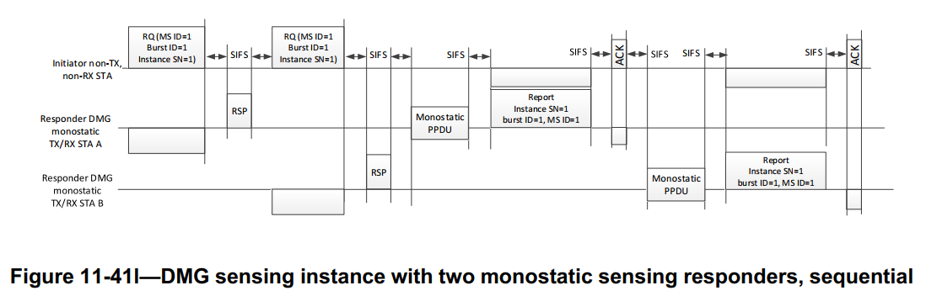

Problem: The STA B may not get the accurate timing when to send the Monostatic PPDU.
- The Ack frame is directionally sent from the initiator to the STA A so the STA B may not receive it.
- The length/duration of the Monostatic PPDU and the DMG Sensing Measurement Report frame of STA A are unknown to STA B.
As a result, the STA B may fail to send the Monostatic PPDU and the DMG Sensing Measurement Report frame or cause interference between STAs in this instance.

The SP and the result are as following:
SP 1: Which option do you support to solve the timing problem of the sequential Coordinated Monostatic DMG Sensing instance as shown in slide 3?
- Option 1-A: use a new poll frame to poll each responder STA, as shown in slide 5
- Option 1-B: use a new poll frame to poll each responder STA except the first, as shown in slide 6
- Option 2: use the DMG Sensing Request frame to poll each responder STA, as shown in slide 7
- Neither
- Abstain
Result: 0/1/16/0/5

Discussion 2

Two Timing Problems of the Parallel Coordinated Monostatic DMG Sensing instance were shown in 22/1670r2 as following:
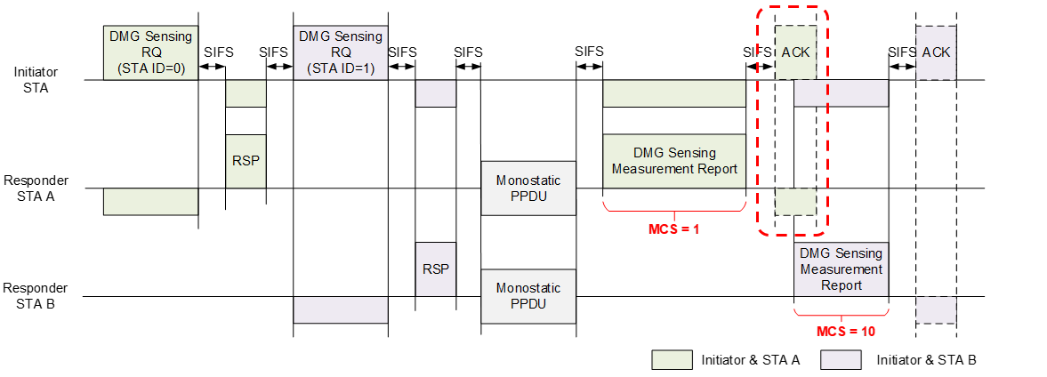
Figure 1–The Timing Problem of the STA B

Problem 1: The STA B does not know when to send the report frame.
- The STA B may not receive the Ack frame of the STA A for it is transmitted directionally.
- The STA B does not know the duration of the Report frame and the ACK frame of the STA A for different MCSs.
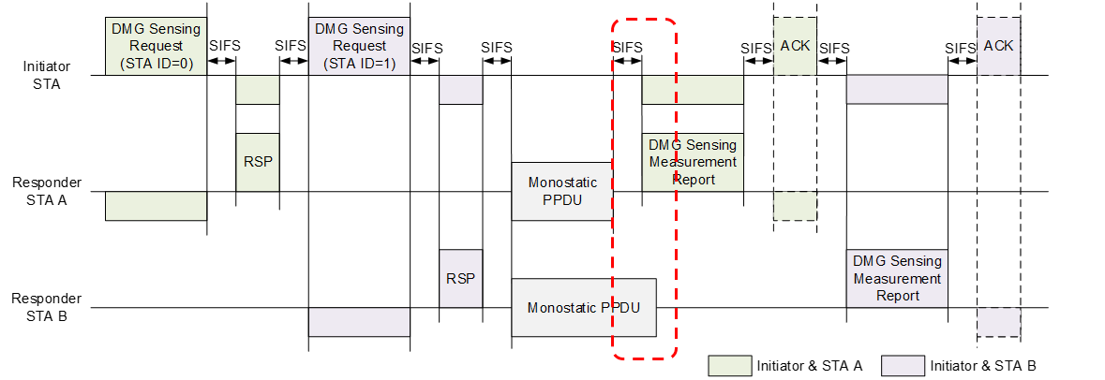
Figure 2–The Timing Problem of the STA A

Problem 2: The Report frame of STA A may overlap with the Monostatic PPDU of STA B for the duration of Monostatic PPDUs may be different.
- Monostatic PPDUs of different STAs may have Date fields of different lengths.
- Monostatic PPDUs of different STAs may use different PPDU types.

The SP and the result are as following:
Do you support the following solutions?
In a Parallel Coordinated Monostatic DMG Sensing instance,
- Add a field (Duration of Monostatic PPDUs) into the TDD Beamforming Information field of the DMG Sensing Response frame to inform the sensing initiator of the duration of one or more Monostatic PPDUs containing the interval time.
- The sensing initiator shall poll each sensing responder for the report.
- The sensing initiator shall send the first DMG Sensing Poll frame no later than SIFS time after the longest Duration of Monostatic PPDUs.
Result: 6 Yes/5 No/15 Abstain

Then, I had an offline discussion with several commenters about this contribution. After the discussion, we reached a consensus about the solutions proposed in this contribution.

Text proposal – Editor instructions

9.3.1.25 TDD Beamforming frame format
9.3.1.25.5 DMG Sensing Request
TGbf editor: Modify the Figure 9-110a TDD Beamforming Information field format and the relevant paragraph as follows:

Figure 9-110a—TDD Beamforming Information field format (#649, #109, #417)

The Num of PPDUs in Instance field indicates the number of DMG Multistatic Sensing PPDUs present in the DMG sensing instance. The Num of PPDUs in Instance field is reserved when the Sensing Type is set to the Coordinated Monostatic.

The EDMG TRN Length, RX TRN-Units per Each TX TRN-Unit, EDMG TRN-Unit P, EDMG TRN-Unit
M, EDMG TRN-Unit N, TRN Subfield Sequence Length, and BW subfields contain the values of the corresponding header fields in the EDMG Multistatic Sensing PPDU(#417).

The Sounding Mode field indicates whether the sounding phase of the coordinated monostatic sensing instance happens in sequential or parallel mode. A value of 1 indicates the sequential mode, a value of 0 indicates the parallel mode. This field is reserved when the Sensing Type is not set to the Coordinated Monostatic.

9.3.1.25.6 DMG Sensing Response
TGbf editor: Modify the following paragraph and insert a new figure as follows:

If the sensing type of the DMG sensing instance is set to the Coordinated Monostatic, the TDD Beamforming Information field of a DMG Sensing Response frame is shown in Figure 9-110b (TDD Beamforming Information field for the DMG Sensing Response frame). Otherwise, the TDD Beamforming Information field of a DMG Sensing Response frame is empty.
Figure 9-110b—TDD Beamforming Information field for the DMG Sensing Response frame if the sensing type is coordinated monostatic

The Duration of Monostatic PPDUs field indicates the duration from the start of the first Monostatic PPDU to the end of the last Monostatic PPDU in the current DMG Sensing instance. This field is in the unit of TSF.

11.21.20 DMG sensing procedure
11.21.20.1 Overview
TGbf editor: Change the following two figures and the following paragraph as follows:

Figure 11-75o—DMG sensing instance with two monostatic sensing responders, sequential
sounding(#90, #352)

The Figure 11-75o (DMG sensing instance with two monostatic sensing responders, sequential sounding(#90, #352)) gives an example of the sequential coordinated monostatic DMG sensing instance. In a sequential coordinated monostatic DMG sensing instance, the initiation phase, sounding phase, and reporting phase are repeated per responder STA in order of the STA ID. In this example, STA A is the first and STA B is the second. In the initiation phase of STA A, the sensing initiator sends a DMG Sensing Request frame to STA A and receives a DMG Sensing Response frame from STA A. The DMG Sensing Request frame activates STA A to be ready to participate in the sounding and reporting phases. The DMG Sensing Response frame indicates to the sensing initiator the readiness of STA A to participate in the sounding and reporting phases. In the immediately following sounding phase, STA A transmits a Monostatic PPDU and receives the reflected signal. In the immediately following reporting phase, STA A reports results assigned with DMG Measurement Setup ID equal to 1, Measurement Burst ID equal to 1, and Sensing Instance SN equal to 1 to the sensing initiator. After that, the sensing initiator repeats the same procedure as STA A with STA B.

Figure 11-75p—DMG sensing instance with two monostatic sensing responders, parallel
sounding(#90, #352)

The Figure 11-75p (DMG sensing instance with two monostatic sensing responders, parallel sounding (#90, #352)) gives an example of the parallel coordinated monostatic DMG sensing instance. In a parallel coordinated monostatic DMG sensing instance, the initiation phase, sounding phase, and reporting phase occur only once. In the initiation phase, the sensing initiator sends a DMG Sensing Request frame to STA A and receives a DMG Sensing Response frame from STA A. Then the sensing initiator sends a DMG Sensing Request frame to STA B and receives a DMG Sensing Response frame from STA B. The DMG Sensing Request frames activate the STA A and STA B to be ready to participate in the sounding and reporting phases. The DMG Sensing Response frames indicate to the sensing initiator the readiness of the STA A and STA B to participate in the sounding and reporting phases. In the following sounding phase, the STA A and STA B transmit Monostatic PPDUs and receive the reflected signal in parallel. The Monostatic PPDUs sent by STA A and STA B may have different duration. In the following reporting phase, after waiting the largest duration of Monostatic PPDUs plus BRPIFS time, the sensing initiator sends a DMG Sensing Poll frame to STA A for the report and receives a DMG Sensing Measurement Report frame from STA A. Then the sensing initiator sends a DMG Sensing Poll frame to STA B for the report and receives a DMG Sensing Measurement Report frame from STA B. Both report frames are assigned with DMG Measurement Setup ID(#217) equal to 1, Measurement Burst ID(#424, #426) equal to 1, and Sensing Instance SN(#397, #223) equal to 1.

11.21.20.6 DMG sensing instance
11.21.20.6.2 Coordinated monostatic DMG sensing instance
TGbf editor: Modify the following paragraphs as follows:

A coordinated monostatic DMG sensing instance is a DMG sensing instance of a DMG sensing procedure of sensing type coordinated monostatic.
11.21.20.6.2a Initiation
In a coordinated monostatic DMG sensing instance, the following rules shall apply:
— The number of sensing responders in each coordinated monostatic DMG sensing instance of the same DMG Measurement Setup ID may be different
— The sensing initiator shall send a DMG Sensing Request frame to each sensing responder it requests to participate in the coordinated monostatic DMG sensing instance(#649)
— The sensing responder shall not respond with the DMG Sensing Response frame to the sensing initiator later than SIFS time after the request(#649)
—The sensing responder that responded to the sensing initiator shall proceed with monostatic sensing.
.

11.21.20.6.2b Sounding
— The RA shall be set equal to the TA in the PSDU contained in the monostatic PPDU.
— If the Sounding Mode field of the TDD Beamforming Information field in the DMG Sensing Request frame is set to 1, the sounding phase shall be performed sequentially. If the Sounding Mode field of the TDD Beamforming Information field in the DMG Sensing Request frame is set to 0, the sounding phase shall be performed in parallel.

11.21.20.6.2c Reporting
— If the sounding phase of an instance is performed sequentially and reports are needed, each sensing responder shall report in no longer than SIFS time after its last Monostatic PPDU.
— If the sounding phase of an instance is performed in parallel and reports are needed, each sensing responder shall respond in no longer than SIFS time after the polling by the sensing initiator. The sensing initiator shall send the first DMG Sensing Poll frame after waiting the largest Duration of Monostatic PPDUs plus SIFS and BRPIFS time from the end of the last DMG Sensing Response frame.

