IEEE P802.11
Wireless LANs
CC40 CR for CID 834, 896
Date: 2022-11-08
Author(s):
Name | Affiliation | Address | Phone | email
Narengerile | Huawei | Shenzhen, China |  | narengerile@huawei.com
Rui Du
Mengshi Hu

Abstract
This document proposes comment resolutions for CID 834, 896.

R0: Initial version.
R1: Made editorial changes, changed resolution for CID 896 based on offline discussions.

CID 834
Subclause | Page | Comment | Proposed change | Proposed resolution
9.4.2.26 | 32.54 | It is clear that an AP STA must indicate in the extended capabilities field that it supports the SPB responder role. However, it is not clear why a non-AP STA would need to indicate it supports a SBP initiator role in the extended capabilities. The SBP bit is described as being set by a STA, which would require a non-AP STA to also set that bit. Define the SBP bit as being set to 1 by an AP STA if dot11SBPImplemented is true, and 0 otherwise. Note: other bit definations in Table 9-190 are defined for AP STAs only, for example bit 12 (Proxy ARP Service). | Change text to:  "The AP sets the SBP field to 1 if dot11SBPImplemented is true, and sets it to 0 otherwise. See 11.21.19 (SBP procedure). A non-AP STA sets the SBP field to 0." | REJECTED.  This comment was also raised in CID 868, which has been resolved in 1674r2. The given resolution was REJECTED. I agree with the resolution because the non-AP STA as being the SBP initiator also needs to indicate such a capability so that the AP can set up the SBP service accordingly.
Discussion:
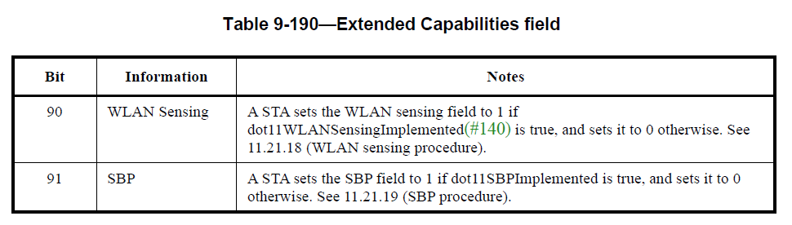

CID 896
Subclause | Page | Comment | Proposed change | Proposed resolution
9.4.2.1 | 31.54 | Why Different Elements have the same Element ID in Table 9-128? | Specify different Element ID for different Element | REJECTED.  The differentiation of different elements can only be achieved by Element ID Extension, not Element ID. For 11bf, all elements for sensing in Table 9-128 will be eventually assigned an Element ID Extension by Assigned Numbers Authority (ANA).
Discussion:
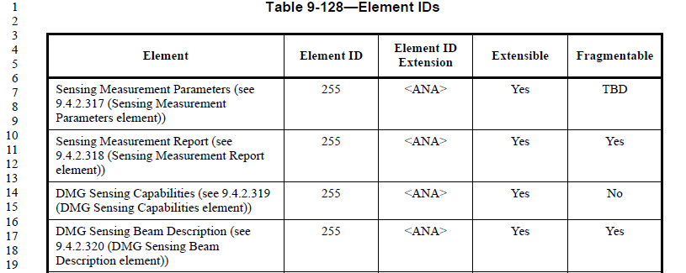

SP:
Do you agree to include the resolutions for CID 834, 896 in the latest 11bf Draft?
Y/N/A

