IEEE P802.11
Wireless LANs
CC40 CR for Topic Instance - Part 2
Date: 2022.11.15
Author(s):
Name | Company | Address | Phone | email
Mengshi Hu | Huawei Technologies | H3, Huawei Base, Bantian, Longgang, Shenzhen, Guangdong, China, 518129 |  | humengshi@huawei.com
Rui Du
Narengerile
Abstract
This submission contains the proposed comment resolutions for the following 9 CIDs in the Topic “Instance” shown in 22/0820 IEEE 802.11bf CC40 comments.

CIDs 243, 478, 557, 626, 627, 795, 796, 867, 909

Revision Notes
R0 | Initial revision

CID 557 & 627 & 867
Page.  Line | Clause Number | Comment | Proposed Change | Resolution
70.44  (CID 557) | 11.21.18.6.4 | In the sensing procedure, the negotiation does not exist. So, the text" When negociated" should be modified with other text. | Change " When negotiated " with " after the sensing measurement setup phase". | REVISED.  The related text has been deleted in 802.11bf D0.4. Thus, there is no need to do revision on the basis of the sentence.  Note to the Editor: The related text has been deleted in 802.11bf D0.4. No further changes are needed.
70.44  (CID 627) | 11.21.18.6.4 | What are the information being negotiated? | Change "When negotiated" to "When 'aggregate report' subfield in the corresponding measurement setup parameters is set to 1" | REVISED.  The related text has been deleted in 802.11bf D0.4. Thus, there is no need to do revision on the basis of the sentence.  Note to the Editor: The related text has been deleted in 802.11bf D0.4. No further changes are needed.
70.39  (CID 867) | 11.21.18.6.4 | Incorrrect word | Change text to: The sensing receiver which is a sensing responder shall provide a Sensing Measurement Report frame in the assigned RUs with either results obtained from the I2R NDP of the current measurement instance, when negotiated to deliver immediate feedback reporting, or results obtained from the I2R NDP of one or more previous measurement instances, when negotiated to deliver delayed feedback reporting." | REVISED.  The related text has been changed into “previous measurement instance”, and there is no aggregated reporting now. Thus, there is no need to mention “one or more” here.  Note to the Editor: The related text has been changed in 802.11bf D0.4. No further changes are needed.

Discussion:
The text in Draft 0.1 is shown below:
When negotiated, the sensing transmitter which is a sensing initiator shall send a Sensing Trigger Report frame during the reporting phase and assign RUs to the sensing receiver which is a sensing responder to obtain a Sensing Measurement Report frame containing sensing measurement results. The sensing receiver which is a sensing responder shall provide a Sensing Measurement Report frame in the assigned RUs with either results obtained from the I2R NDP of the current measurement instance, when negotiated to deliver immediate feedback reporting, or results obtained from the I2R NDP of the previous measurement instance (related to CID 867), when negotiated to deliver delayed feedback reporting.

For delayed reporting, sensing measurement reports of multiple sensing measurement setups of a sensing responder may be included in a single Sensing Measurement Report frame. When negotiated (related to CIDs 557, 627), the sensing initiator may assign RUs to obtain more than one sensing measurement report in a single Sensing Measurement Report frame. A sensing responder may optionally transmit more than one delayed measurement results during the assigned RUs sent by the sensing initiator in the Sensing Trigger Report frame.

In Draft 0.4, the related text is changed into (No aggregated reporting now):
In the basic reporting phase(#199, #282), the sensing initiator shall send a Sensing Report Trigger frame(#401, #464, #196) assigning RUs to one or more sensing receivers in order to obtain a Sensing Measurement Report frame containing sensing measurement results(#195, #625).

During a TB sensing measurement instance, the sensing responder upon receiving the Sensing Report Trigger frame shall transmit either a measurement report frame corresponding to the sensing measurement result of the SI2SR NDP for the current measurement instance or the previous measurement instance consistently throughout all the subsequent TB measurement instances corresponding to the same measurement setup(#376, #552, #577).

NOTE—In the TB sensing measurement instance, if the responder is not assigned to deliver sensing measurement report, then Sensing Report Trigger frame is not addressed to it(#376, #552, #577).
Discussion ends.

CID 243 & 478 & 796
Page.  Line | Clause Number | Comment | Proposed Change | Resolution
70.43 (CID 243) | 11.21.18.6.4 | For delayed report, please confirm if it is allowed to include sensing measurement reports of multiple sensing measurement *instances* of a sensing responder. If it is allowed, please add more details about aggregated reporting. | As in the comment. | REJECTED.  According to the discussions, the aggregated reporting has been deleted. Thus, there is no need to add more details about the aggregated reporting.
70.43 (CID 478) | 11.21.18.6.4 | For delayed reporting, sensing measurement  reports of multiple sensing measurement setups of a sensing responder may be included in a single Sensing Measurement Report frame. When negotiated, the sensing initiator may assign RUs to obtain more than one sensing measurement report in a single Sensing Measurement Report frame. A sensing responder may optionally transmit more than one delayed measurement results during the assigned RUs sent by the sensing initiator in the Sensing Trigger Report frame. | When more than one measurement results are reported in a report frame, then, do we need a measurement set-up ID field in addition to the Measurement Instance ID field in the Measurement Report frame? | REJECTED.  According to the discussions, the aggregated reporting has been deleted. Thus, there is no need to add more details about the aggregated reporting.
70.47 (CID 796) | 11.21.18.6.4 | It is not clear how the AP would know how many measurements a STA will be ready with at a given time and allocate time within its TF accordingly. | Add a figure showing example of aggregating multiple delayed reports in response to a TF and clarify how the AP allocates time for it. | REJECTED.  According to the discussions, the aggregated reporting has been deleted. Thus, there is no need to add more details about aggregating multiple delayed reports in response to a TF and clarify how the AP allocates time for it.

CID 626
Page.  Line | Clause Number | Comment | Proposed Change | Resolution
70.43 | 11.21.18.6.4 | A measurement report may be large and could be segmented, AP may resolicit the segments when transmission failure occurs. | As commented. | REVISED.  The detailed sensing measurement report frame including segments has been given in 22/1579r3. Here the resolution is provided for the case when transmission failure occurs.  Instructions to the editor:  Please make the changes as shown under CID 626 in 11-22/1897r1.

Instructions to the editor: please add the following paragraph to Page 108, Line 54 in the subclause 11.55.1.5.2.5.1 Basic reporting phase in 802.11bf D0.4 as shown below:

In the reporting phase of a TB measurement instance, the sensing initiator, which fails to receive some or all of the report segments of the sensing measurement report from the sensing responder, shall not use a Sensing Report Trigger frame to request retransmission of the report segments.

Discussion:
The text related to the segment feedback in 11be:
An EHT beamformer, which fails to receive some or all of the feedback segments of the EHT compressed beamforming/CQI report from the EHT beamformee, shall not use a BFRP Trigger frame to request retransmission of the feedback segments. In this case, the EHT beamformer may repeat the entire sounding sequence.

The following text could be added to
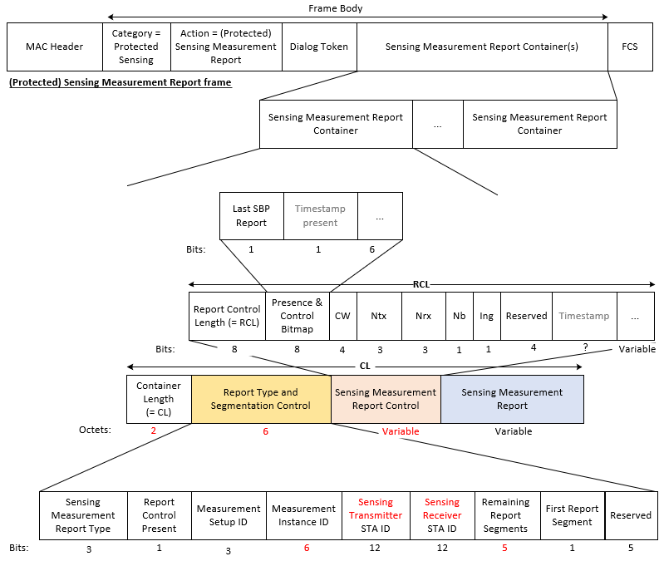
Discussion ends.

CID 795
Page.  Line | Clause Number | Comment | Proposed Change | Resolution
70.49 | 11.21.18.6.4 | Its possible that due to error in reception of an NDP, the STA is not able to generate a correct measurement report. If so, the STA needs to unambigiously report this. | Define the signaling from a responder STA to initiator to indicate how a measurement report associated with a given measurement instance is invalid. Also, differentiate this from the case when there is no error in receiving the NDP but the STA is not ready with a measurement report yet. | REVISED.  A 1-bit indication for the status “Invalid” should be added to the Sensing Measurement Report frame. This has been reflected in 22/1651r3  Note to the Editor: The 1-bit indication for the status “Invalid” has been reflected in 22/1651r3. No further changes are needed.

Discussion:
The related text in 1651r3:
 | Sensing Measurement Report Type | Report Control Present | Measurement Setup ID | Measurement Instance ID | Sensing Transmitter STA ID | Sensing Receiver STA ID | Remaining Report Segments | First Report Segment | Invalid Measurement | Reserved
Bits | 3 | 1 | 3 | 6 | 12 | 12 | 5 | 1 | 1 | 4

The Invalid Measurement subfield indicates whether the reported measurement result is invalid. An Invalid Measurement field value of 1 indicates that the reported measurement result is invalid. A value of 0 indciates that the reported measurement result is valid.

Whether we need a 2-bit indication can be discussed. As suggested by the commenter, the 2-bit indication can be used to indicates the following three types:
- Valid
- Invalid (Not ready)
- Invalid for other reasons (For example, the NDP is not received.)
Discussion ends.

CID 909
Page.  Line | Clause Number | Comment | Proposed Change | Resolution
70.31 | 11.21.18.6.4 | If there is any latency requirement on the delayed sensing measurement reporting? | Please add the latency requirement for the delayed sensing measurement reporting | REJECTED.  According to the discussions, the reporting of a sensing measurement instance at most allows one-instance latency and has been shown in 802.11be D0.4. Thus, there is no need to more latency requirement for the delayed sensing measurement reporting.

SP

Do you support the proposed resolutions to the following CIDs and incorporate the text changes into the latest TGbf draft: 243, 478, 557, 626, 627, 795, 796, 867, 909?

Y/N/A

