IEEE P802.11
Wireless LANs
CC40 CR for Topic Instance - Part 2
Date: 2022.11.8
Author(s):
Name | Company | Address | Phone | email
Mengshi Hu | Huawei Technologies | H3, Huawei Base, Bantian, Longgang, Shenzhen, Guangdong, China, 518129 |  | humengshi@huawei.com
Rui Du
Narengerile
Abstract
This submission contains the proposed comment resolutions for the following 9 CIDs in the Topic “Instance” shown in 22/0820 IEEE 802.11bf CC40 comments.

CIDs 243, 478, 557, 626, 627, 795, 796, 867, 909

Revision Notes
R0 | Initial revision

CID 557 & 627 & 867
Page.  Line | Clause Number | Comment | Proposed Change | Resolution
70.44  (CID 557) | 11.21.18.6.4 | In the sensing procedure, the negotiation does not exist. So, the text" When negociated" should be modified with other text. | Change " When negotiated " with " after the sensing measurement setup phase". | REVISED.  The related text has been deleted in 802.11bf D0.4. Thus, there is no need to do revision on the basis of the sentence.  Note to the Editor: The related text has been deleted in 802.11bf D0.4. No further changes are needed.
70.44  (CID 627) | 11.21.18.6.4 | What are the information being negotiated? | Change "When negotiated" to "When 'aggregate report' subfield in the corresponding measurement setup parameters is set to 1" | REVISED.  The related text has been deleted in 802.11bf D0.4. Thus, there is no need to do revision on the basis of the sentence.  Note to the Editor: The related text has been deleted in 802.11bf D0.4. No further changes are needed.
70.39  (CID 867) | 11.21.18.6.4 | Incorrrect word | Change text to: The sensing receiver which is a sensing responder shall provide a Sensing Measurement Report frame in the assigned RUs with either results obtained from the I2R NDP of the current measurement instance, when negotiated to deliver immediate feedback reporting, or results obtained from the I2R NDP of one or more previous measurement instances, when negotiated to deliver delayed feedback reporting." | REVISED.  The related text has been changed into “previous measurement instance”, and there is no aggregated reporting now. Thus, there is no need to mention “one or more” here.  Note to the Editor: The related text has been changed in 802.11bf D0.4. No further changes are needed.

Discussion:
The text in Draft 0.1 is shown below:
When negotiated, the sensing transmitter which is a sensing initiator shall send a Sensing Trigger Report frame during the reporting phase and assign RUs to the sensing receiver which is a sensing responder to obtain a Sensing Measurement Report frame containing sensing measurement results. The sensing receiver which is a sensing responder shall provide a Sensing Measurement Report frame in the assigned RUs with either results obtained from the I2R NDP of the current measurement instance, when negotiated to deliver immediate feedback reporting, or results obtained from the I2R NDP of the previous measurement instance (related to CID 867), when negotiated to deliver delayed feedback reporting.

For delayed reporting, sensing measurement reports of multiple sensing measurement setups of a sensing responder may be included in a single Sensing Measurement Report frame. When negotiated (related to CIDs 557, 627), the sensing initiator may assign RUs to obtain more than one sensing measurement report in a single Sensing Measurement Report frame. A sensing responder may optionally transmit more than one delayed measurement results during the assigned RUs sent by the sensing initiator in the Sensing Trigger Report frame.

In Draft 0.4, the related text is changed into (No aggregated reporting now):
In the basic reporting phase(#199, #282), the sensing initiator shall send a Sensing Report Trigger frame(#401, #464, #196) assigning RUs to one or more sensing receivers in order to obtain a Sensing Measurement Report frame containing sensing measurement results(#195, #625).

During a TB sensing measurement instance, the sensing responder upon receiving the Sensing Report Trigger frame shall transmit either a measurement report frame corresponding to the sensing measurement result of the SI2SR NDP for the current measurement instance or the previous measurement instance consistently throughout all the subsequent TB measurement instances corresponding to the same measurement setup(#376, #552, #577).

NOTE—In the TB sensing measurement instance, if the responder is not assigned to deliver sensing measurement report, then Sensing Report Trigger frame is not addressed to it(#376, #552, #577).
Discussion ends.

CID 243 & 478 & 796
Page.  Line | Clause Number | Comment | Proposed Change | Resolution
70.43 (CID 243) | 11.21.18.6.4 | For delayed report, please confirm if it is allowed to include sensing measurement reports of multiple sensing measurement *instances* of a sensing responder. If it is allowed, please add more details about aggregated reporting. | As in the comment. | REJECTED.  According to the discussions, the aggregated reporting has been deleted. Thus, there is no need to add more details about the aggregated reporting.
70.43 (CID 478) | 11.21.18.6.4 | For delayed reporting, sensing measurement  reports of multiple sensing measurement setups of a sensing responder may be included in a single Sensing Measurement Report frame. When negotiated, the sensing initiator may assign RUs to obtain more than one sensing measurement report in a single Sensing Measurement Report frame. A sensing responder may optionally transmit more than one delayed measurement results during the assigned RUs sent by the sensing initiator in the Sensing Trigger Report frame. | When more than one measurement results are reported in a report frame, then, do we need a measurement set-up ID field in addition to the Measurement Instance ID field in the Measurement Report frame? | REJECTED.  According to the discussions, the aggregated reporting has been deleted. Thus, there is no need to add more details about the aggregated reporting.
70.47 (CID 796) | 11.21.18.6.4 | It is not clear how the AP would know how many measurements a STA will be ready with at a given time and allocate time within its TF accordingly. | Add a figure showing example of aggregating multiple delayed reports in response to a TF and clarify how the AP allocates time for it. | REJECTED.  According to the discussions, the aggregated reporting has been deleted. Thus, there is no need to add more details about aggregating multiple delayed reports in response to a TF and clarify how the AP allocates time for it.

CID 626
Page.  Line | Clause Number | Comment | Proposed Change | Resolution
70.43 | 11.21.18.6.4 | A measurement report may be large and could be segmented, AP may resolicit the segments when transmission failure occurs. | As commented. | REVISED.  The detailed sensing measurement report frame has been given in 22/1579r3. Here the resolution is provided for the case how the AP resolicit the segments when transmission failure occurs.  Instructions to the editor:  Please make the changes as shown under CID 626 in 11-22/1897r0.

Instructions to the editor: please add the following paragraph to Page 108, Line 54 in the subclause 11.55.1.5.2.5.1 Basic reporting phase in 802.11bf D0.4 as shown below:

In the reporting phase of a TB measurement instance, a sensing initiator that fails to receive some or all of the report segments of the sensing measurement report from the sensing responder may solicit the selective retransmission of missing report segments by sending a Sensing Report Trigger frame that indicates in the Report Segment Retransmission Bitmap subfield of the User Info field identifying the responder the list of feedback segments solicited for retransmission.

An initiator that fails to receive the first report segment (identified by the First Report Segment field set to 1), may solicit the selective retransmission of the missing report segments assuming the sensing measurement report is split into 32 report segments. The initiator may also solicit the retransmission of all report segments by setting all of the bits in the Report Segment Retransmission Bitmap subfield to 1 in the User Info field identifying the responder of the Sensing Report Trigger frame.

NOTE 1—In the non-TB measurement instance, if the initiator does not receive all report segments from the responder, the initiator cannot use a Sensing Report Trigger frame to request retransmission of the report segments. In this case the initiator can only repeat the entire non-TB measurement instance.

Instructions to the editor: please add the following paragraph to the subclause Sensing Report Trigger frame as shown below:
The Trigger Dependent User Info subfield of the Sensing Report Trigger frame is defined in Figure xx (Trigger Dependent User Info subfield format in the Sensing Report Trigger frame).

 | Report Segment Retransmission Bitmap
Octets | 4

Figure xx - Trigger Dependent User Info subfield format in the Sensing Report Trigger frame

The Report Segment Retransmission Bitmap subfield indicates the requested report segments of a sensing measurement report. If the bit in position n (n = 0 for LSB and n = 31 for MSB) is 1, then the report segment with the Remaining Report Segments subfield in the Reprot Type and Segmentation Control field equal to n is requested. If the bit in position n is 0, then the report segment with the Remaining Report Segments subfield in the Reprot Type and Segmentation Control field equal to n is not requested.

Discussion:
Segment in 11ax:
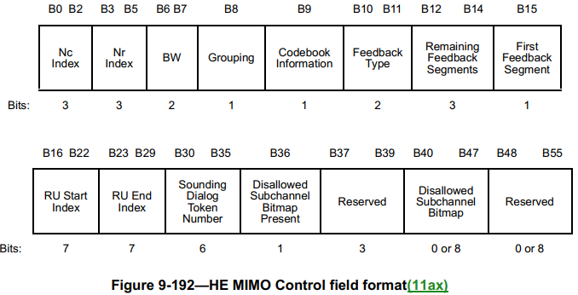

Text in 26.7.4 Rules for generating segmented feedback

If the HE compressed beamforming/CQI report solicited by the HE beamformer would result in an HE Compressed Beamforming/CQI frame that exceeds 11 454 octets in length, then the HE compressed beamforming/CQI report shall be split into up to 8 feedback segments. Each feedback segment shall be included in a separate HE Compressed Beamforming/CQI frame and shall contain successive portions of the HE compressed beamforming/CQI report. Each feedback segment shall be of equal length, except the last feedback segment that may be smaller. Each HE Compressed Beamforming/CQI frame that includes a feedback segment that is not the last feedback segment shall have a length of 11 454 octets. Each feedback segment is identified by the value of the Remaining Feedback Segments subfield and the First Feedback Segment subfield in the HE MIMO Control field as defined in 9.4.1.64 (HE MIMO Control field(11ax)); the other nonreserved subfields of the HE MIMO Control field shall be the same for all feedback segments. All feedback segments shall be sent in a single A-MPDU contained in a PPDU and shall be included in the A-MPDU in the descending order of the Remaining Feedback Segments subfield values.

An HE beamformer that sends a BFRP Trigger frame, in its first attempt to retrieve an HE compressed beamforming/CQI report from an HE beamformee, shall solicit all possible feedback segments by setting all of the bits in the Feedback Segment Retransmission Bitmap subfield to 1 in the User Info field identifying the HE beamformee.

An HE beamformer that fails to receive some or all of the feedback segments of the HE compressed beamforming/CQI report from the HE beamformee may solicit the selective retransmission of missing feedback segments by sending a BFRP Trigger frame that indicates in the Feedback Segment Retransmission Bitmap subfield of the User Info field identifying the HE beamformee the list of feedback segments solicited for retransmission (see 9.3.1.22.3 (BFRP Trigger frame format)).

NOTE 1—In an HE non-TB sounding sequence, if the HE beamformer does not receive all feedback segments from the HE beamformee, the HE beamformer cannot use a BFRP Trigger frame to request retransmission of the feedback segments. In this case the HE beamformee can only repeat the entire non-TB sounding sequence.

An HE beamformer that fails to receive the first feedback segment (identified by the First Feedback Segment field set to 1), may solicit the selective retransmission of the missing feedback segments assuming the HE compressed beamforming/CQI report is split into 8 feedback segments. The HE beamformer may also solicit the retransmission of all feedback segments by setting all of the bits in the Feedback Segment Retransmission Bitmap subfield to 1 in the User Info field identifying the HE beamformee.

…

9.3.1.22.3 BFRP Trigger frame format
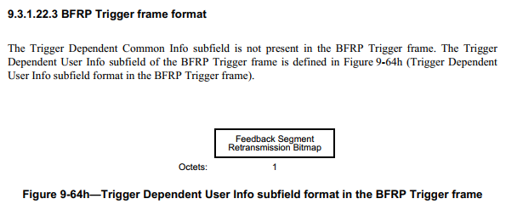
The Feedback Segment Retransmission Bitmap subfield indicates the requested feedback segments of an HE compressed beamforming report. If the bit in position n (n = 0 for LSB and n = 7 for MSB) is 1, then the feedback segment with the Remaining Feedback Segments subfield in the HE MIMO Control field equal to n is requested. If the bit in position n is 0, then the feedback segment with the Remaining Feedback Segments subfield in the HE MIMO Control field equal to n is not requested.

Now in 11bf, the Trigger Dependent User Info subfield of the Sensing Report Trigger frame is not present in the Sensing Report Trigger frame. This limit the snenisng initiator to soliciting the retransmission of the missing feedback segements.

Sensing Measuremen Report frame in Sensing (in 22/1579r3)
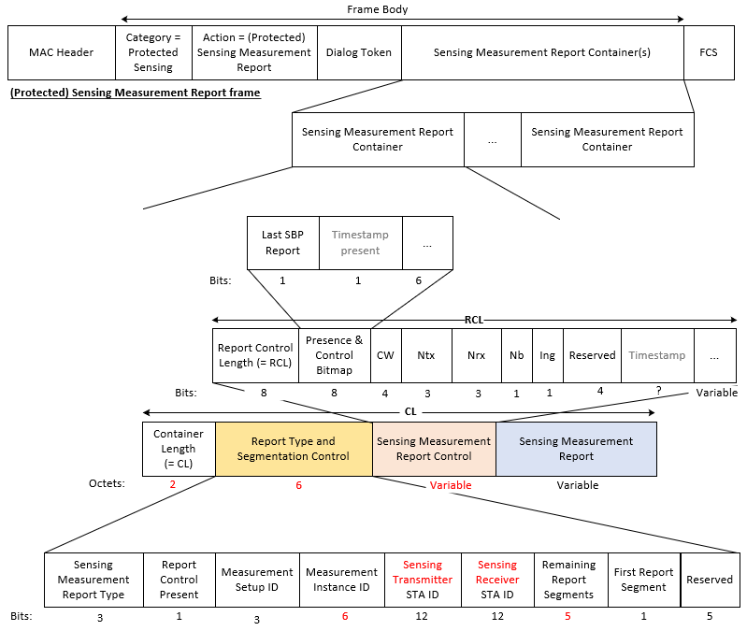
Discussion ends.

CID 795
Page.  Line | Clause Number | Comment | Proposed Change | Resolution
70.43 (CID 627) | 11.21.18.6.4 | Its possible that due to error in reception of an NDP, the STA is not able to generate a correct measurement report. If so, the STA needs to unambigiously report this. | Define the signaling from a responder STA to initiator to indicate how a measurement report associated with a given measurement instance is invalid. Also, differentiate this from the case when there is no error in receiving the NDP but the STA is not ready with a measurement report yet. | REVISED.  A 1-bit indication for the status “Invalid” is added to the Sensing Measurement Report frame.  Instructions to the editor:  Please make the changes as shown under CID 795 in 11-22/1897r0.

Instructions to the editor: please add the following paragraph to the subclause Sensing Measurement Report Container field as shown below:

The Report Type and Segmentation Control field provides the information related to the type and segments of the Sensing Measurement Report. The fields of the Report Type and Segmentation Control field are specified in Table 9-xxxx - Report Type and Segmentation Control field.

Table XXX: Report Type and Segmentation Control field
Field | Size (bits) | Definition
Sensing Measurement Report Type | 3 | The Sensing Measurement Report Type field is set to a number that identifies the type of sensing measurement report. The Sensing Measurement Report Type values that have been allocated are shown in Table 9-401s (Sensing Measurement Report Type field definition).
Report Control Present | 1 | Set to 1 to indicate that the Sensing Measurement Report Control field is present in the Sensing Measurement Report Container. Otherwise, set to 0.
Measurement Setup ID | 3 | Identifies the sensing measurement Setup corresponding to the Sensing Measurement Report
Measurement Instance ID | 6 | Identifies the sensing measurement instance corresponding to the Sensing Measurement Report
Sensing Transmitter STA ID | 12 | AID or USID of the Sensing Transmitter corresponding to the Sensing Measurement Report
Sensing Receiver STA ID | 12 | AID or USID of the Sensing Receiver corresponding to the Sensing Measurement Report
Remaining Report Segments | 5 | Indicates the number of remaining report segments for corresponding to the Sensing Measurement Report:  Set to 0 for the last report segment of a segmented report or the only report segment of an unsegmented report.  Set to a value between 1 and 32 for a feedback segment that is not the last report segment of a segmented report.
First Report Segment | 1 | Set to 1 for the first report segment of a segmented report or the only feedback segment of an unsegmented report. Otherwise set to 0.
Invalid Sensing Measurement Report | 1 | Set to 1 to indicate an invalid sensing measurement report, and the corresponding Sening Measurement Report Control field and the Sensing Measurement Report field are not present. Otherwise, set to 0.
Reserved | 4 | Reserved

Discussion:
Whether we need a 2-bit indication can be discussed. As suggested by the commenter, the 2-bit indication can be used to indicates the following three types:
- Valid
- Invalid (Not ready)
- Invalid for other reasons (For example, the NDP is not received.)

Discussion ends.

CID 909
Page.  Line | Clause Number | Comment | Proposed Change | Resolution
70.31 | 11.21.18.6.4 | If there is any latency requirement on the delayed sensing measurement reporting? | Please add the latency requirement for the delayed sensing measurement reporting | REJECTED.  According to the discussions, the reporting of a sensing measurement instance at most allows one-instance latency and has been shown in 802.11be D0.4. Thus, there is no need to more latency requirement for the delayed sensing measurement reporting.

SP

Do you support the proposed resolutions to the following CIDs and incorporate the text changes into the latest TGbf draft: 243, 478, 557, 626, 627, 795, 796, 867, 909?
?

Y/N/A

