IEEE P802.11
Wireless LANs
CR for Setup CIDs Part IV (11.21.8.1)
Date: 2022-11-04
Author(s):
Name | Affiliation | Address | Phone | email
Zinan Lin | InterDigital |  |  | zinan.lin@interdigital.com
Mahmoud Kamel | InterDigital
Abstract

This submission present proposed resolutions for the following 3 CIDs: 603, 326, 845

The proposed changes are based on 802.11bf/D0.4.

Revision history:

r0 - initial version

CID | Commenter | Clause | Page(C) | Comment | Proposed Change
603 | Chaoming Luo | 11.21.18.1 | 64.39 | There is no procedure supporting mono static radar for sub-7. | Change the second sentence to "WLAN sensing is a service that enables a STA to obtain sensing measurements of the channel(s) between two or more non-DMG STAs."
326 | Solomon Trainin | 11.21.18.1 | 64.38 | Channel is always between antennas | replace by "between receive and transmit antennas of two or more STAs and/or the channel ..."
845 | Chris Beg | 11.21.18.1 | 64.40 | and/or condition implies monostatic type sensing, which is not applicable for all STA types. | Change text to specify DMG STA (and/or the channel between a receive antenna and transmit antenna of a DMG STA).

Resolution: Revised.

Discussion: The first paragraph of 11.21.18.1 in 802.11bf0.1 has been updated as 11.55.1.1 in 802.11bf0.4 as follows:
802.11bf D0.1
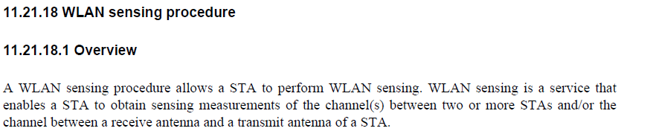

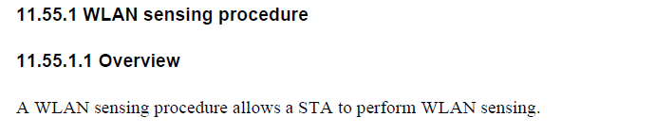
802.11bf D0.4
Furthermore, CID 89 in 0927r4 which addressed the comments shown above passed the SP in the meeting of Nov. 1.

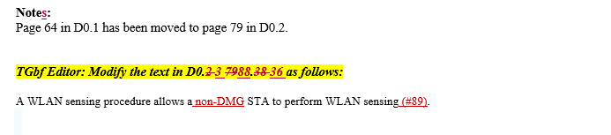
11-22/0927r4

Therefore, there is no action for TGbf Editor.

