IEEE P802.11
Wireless LANs
CR for CIDs related to STA Statistics request and report
Date: Nov. 7, 2022
Author(s):
Name | Affiliation | Address | Phone | email
Jay Yang | Nokia |  |  | Zhijie.yang@nokia-sbell.com
Kasslin Mika
Lorenzo Galati Giordano
Okan Mutgan
Jianguo Liu |  |  |  | jianguo.a.liu@nokia-sbell.com

Abstract
This submission proposes resolution for 2 CIDs received for TGbe LB266:

SP: Do you agree to the resolutions provided in doc 11-22/xxxxr0 for the following 2 CIDs for inclusion in the latest 11be draft?

Result: Yes/No/Abstain

Revisions:
- Rev 0: Initial version of the document.

Interpretation of a Motion to Adopt

A motion to approve this submission means that the editing instructions and any changed or added material are actioned in the TGbe Draft. This introduction is not part of the adopted material.

Editing instructions formatted like this are intended to be copied into the TGbe Draft (i.e. they are instructions to the 802.11 editor on how to merge the text with the baseline documents).

TGbe Editor: Editing instructions preceded by “TGbe Editor” are instructions to the TGbe editor to modify existing material in the TGbe draft. As a result of adopting the changes, the TGbe editor will execute the instructions rather than copy them to the TGbe Draft.

CID | Clause | Page.Line | Comment | Proposed Change | Resolution
10009 | 9.4 | 177.36 | MLD Average Access delay is missing, 11be should have a solution to extend BSS average Access Delay to MLD level average access dely. | the commenter will provide a resolution | Revised—  Agree in principle with the comment. More detailed discussion for this aspect  And the proposal change  can be found in 1876r1  TGbe editor please implement changes as shown in doc 1876r1  tagged as 10009
10010 | 9.4.2 | 1210.01 | 11be should provide a solution to extend STA Statistics request/report to MLD level | the commenter will provide a resolution on it. | Revised—  Agree in principle with the comment. More detailed discussion for this aspect  And the proposal change  can be found in 1876r1  TGbe editor please implement changes as shown in doc 1876r1  tagged as 10009

Discussion:

STA statistic information involved by 11k is widely used in trouble shooting, remote diagnose, Client steering and Load balance scenario. Some silicon vendors like QCLM, BRCM, Intel, etc. already support such feature in their legacy AP and STA products. The motivation is to extend such feature to MLO to support STA statistic information in WIFI7 AP/STA products.

On the one hand, 11be group agreed the MLD level association, MLD level unicast data frames delivery between AP MLD and non-AP MLD. It’s essential to have MLD level STA statistic information via STA statistic request/report frame exchange.
On the other hand, let’s assume the baseline only support link level STA statistic information, in order to distinguish MLD level from link level STA statistic information between two MLDs, STA statistic request &report carrying Basic Multi-Link subelement is only applied in MLD level STA statistic information exchange.
1. Based on peer’s link level STA statistic information, MLD can re-map it’s TIDs to different links to have the better performance or load balance.
2. Based on the peer’s MLD level STA statistic information or current associated non-AP MLD number, non-AP MLD may decide to associate with neighbor AP MLD.
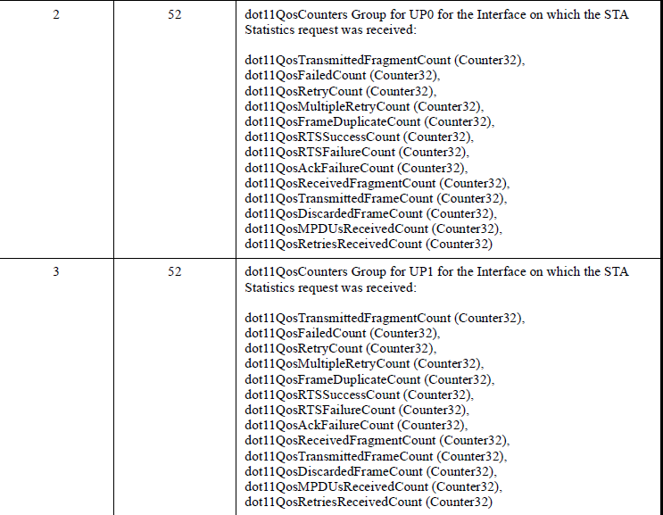
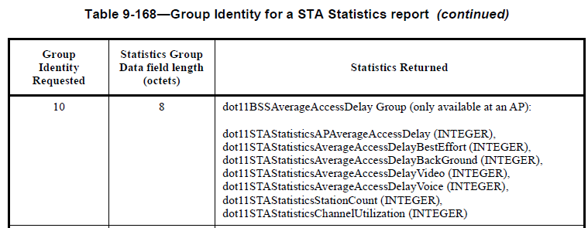

TGbe editor: Please note Baseline is 11be D2.2

TGbe editor: Please update the following clause
9.4.2.20.9 STA Statistics request
TGbe editor: Insert the following paragraph before the last paragraph
The Basic Multi-Link subelement is the same as the Basic Multi-Link element defined in
9.4.2.312.2 (Basic Multi-Link element). The Basic Multi-Link subelement is present in a STA Statistics request if an MLD intends to obtain the STA Statistics information from its peer’s MLD. Otherwise, the Basic Multi-Link subelement is not present.
NOTE 1----A Basic Multi-Link subelement included in a STA Statistics request element does not carry the Link Info field as described in 35.3.3 (Advertisement of multi-link information in Multi-Link element)[#10009]
NOTE 2--- The Basic Multi-link subelement is not present in a STA Statistics request if the Group Identity is not in [2,9].

TGbe editor: Insert the following new rows in Table 9-145—Optional subelement IDs for STA Statistics request[#10009]
Subelement ID | Name | Extensible
<Last assigned + 1> | Basic Multi-Link | Yes

9.4.2.21.9 STA Statistics report
TGbe editor: Insert the following paragraph
The Optional Subelements field contains zero or more subelements. The subelement format and ordering of
subelements are defined in 9.4.3 (Subelements).
The Basic Multi-Link subelement is the same as the Basic Multi-Link element defined in
9.4.2.312.2 (Basic Multi-Link element). The Basic Multi-Link subelement is present in a STA Statistics report if an MLD intends to report the STA Statistics information from its peer’s MLD. Otherwise, the Basic Multi-Link subelement is not present.
NOTE 1----A Basic Multi-Link subelement included in a STA Statistics report element does not carry the Link Info field as described in 35.3.3 (Advertisement of multi-link information in Multi-Link element) )[#10009]
NOTE 2—When the non-AP MLD receives a STA Statistics request from its associated AP MLD carrying Basic Multi-Link subelement and Group Identity Requested equal to 10, the non-AP MLD should respond with a STA Statistics report carrying Basic Multi-Link subelement and Group Identity Requested equal to 10, in which only dot11STAStatisticsStationCount is carried in Statistics Group Data field.
The Subelement ID field values for the defined subelements are shown in Table 9-169 (Optional subelement
IDs for STA Statistics report).
TGbe editor: Insert the following new rows in Table 9-169—Optional subelement IDs for STA Statistics report)[#10009]
Subelement ID | Name | Extensible
<Last assigned + 1> | Basic Multi-Link | Yes

11.10.9.5 STA Statistics report
TGbe editor: Insert the following paragraph at the end of this paragraph
If a STA affiliated with an MLD receive a STA Statistic request carrying Basic Multi-Link subelement from a STA affiliated with its peer’s MLD, the MLD should send STA Statistic report carrying Basic Multi-Link subelement. )[#10009]

