IEEE P802.11
Wireless LANs
LB266 CR on 35.15.1
Date: 2022-11-07
Author(s):
Name | Affiliation | Address | Phone | Email
Yanjun Sun | Qualcomm
Alfred Asterjadhi
George Cherian
Youhan Kim
Bin Tian
Abhishek Patil
Duncan Ho
Gaurang Naik
Abdel Karim Ajami

Abstract

This submission proposes resolutions for the following 9 CIDs for TGbe LB266:
- 11886,11888,11141,12566,12567,13449,11013,11026,11889

Revisions:
- Rev 0: Initial version of the document.

TGbe editor: Please note Baseline is REVme_D2.0 and 11be D2.2

CID | Commenter | Clause | Page | Comment | Proposed Change | Resolution
11886 | Alfred Asterjadhi | 35.16.1 | 530.42 | Kind of an odd way to start a subclause related to BSS operation with non-AP STA behavior. Suggest starting the subclause with the usual statements, e.g., an EHT STA has dot11EHTOptionImplemented equal to true, and an EHT STA that starts (or operates an EHT BSS shall be able to receive and transmit each of the MCSs, NSS (paragrapsh that are found to the end of the subclause to be moved up front). | As in comment. | Revised  Agree with the commenter in principle. The 3 related paragraphs have been moved to the beginning of the subclause.  Tgbe editor, please move up the last 3 paragraphs (P572L59 to P573L12 in D2.2) as the first 3 paragraphs of 35.15.1.
11888 | Alfred Asterjadhi | 35.16.1 | 531.08 | Obvious statement due to the presence of the element in the beacon frame body. Do we need to mention it here again? Delete. | As in comment. | Accepted
11141 | Youhan Kim | 35.16.1 | 531.10 | This is a generic requirement on EHT STA, not just related to EHT BSS operation. | Move "An EHT STA has dot11EHTOptionImplemented equal to true." to P399L9. | Accepted
12566 | Mahmoud Kamel | 35.16.1 | 531.06 | The 3 sentences in D2.0P531L6, D2.0P531L8, and D2.0P531L10 are out of place It is not clear if they add to the restrictions mentioned in D2.0P530L56 or they address different issues. | Fix the readability of these sentences either by adding them to the previous bullet list or starting a new meaningful paragraph. | Revised  Agree with the commenter in principle. D2.0P531L8 is deleted based on CID 11888, and D2.0P531L10 have been moved forward based on CID 11141. No action is needed for D2.0P531L6 as it has been deleted based on 22/1460r3 (motioned).  Tgbe editor please implement changes as shown in doc 11-22/1866r1 tagged as #11888 and #11141, same as above
12567 | Mahmoud Kamel | 35.16.1 | 531.06 | The sentence in D2.0P531L6 is in normative language, however, the sentences in D2.0P531L8 and D2.0P531L10 are in informative language. This is confusing and not consistent since the reader cannot find any meaningful relation between the 3 sentences and the previous or the preceding paragraphs. | Change the sentence "An EHT AP shall have dot11BeaconProtectionEnabled set to 1." to informative language. | Revised  Agree with the commenter on the inconsistency. D2.0P531L6 has been deleted based on 22/1460r3 (motioned).  Tgbe editor, please delete the cited sentence.
13449 | Liwen Chu | 35.16.1 | 530.49 | The relaationship of EHT MCS, Nss and HE MCS, Nss supported by an EHT STA should be defined with the same relationship between HE MCS, NSS and VHT MCS , Nss supported by an HE STA. | As in comment | Revised  Agree with the commenter in principle. The resolution to CID 10990 has addressed this comment with the following text in D2.2: “If an EHT STA supports transmitting or receiving a PPDU, where the PPDU bandwidth is less than 320 MHz, at an <EHT-MCS, NSS> tuple, where the EHT-MCS is equal to the HE-MCS and less than 12, then it shall also support the corresponding transmitting or receiving <HE-MCS, NSS> tuple, respectively. For a lower EHT-MCS, the EHT STA shall support an equal or greater NSS than a higher EHT-MCS.”  Tgbe editor, no further action is needed.
11013 | Yanjun Sun | 35.16.1 | 530.60 | Please to replace " Disabled Subchannel Bitmap field" with " Disabled Subchannel Bitmap subfield" throughout this subclause to aligned with the latest EHT Option element format | As in comment | Accepted
11026 | Hanqing Lou | 9.4.2.311 | 209.43 | "The EHT Operation Information Present subfield is set to 1 if the channel width indicated in an HT Operation, VHT Operation, or HE Operation element that is present in the same Manage  ment frame is different from the Channel Width field indicated in the EHT Operation Information field". The Disabled Subchannel Bitmap subfield is in the EHT Operation Information field. If the channel width is the same as VHT Operation Element, but Disabled subchannel Bitmap is updated, will the EHT Operation Information Present subfield be set to 1? | When Disabled Subchannel Bitmap Present subfield is 1, the EHT Operation Information Present subfield shall be 1. | Revised  Agree with the commenter in principle  Tgbe editor please implement changes as shown in doc 11-22/1866r1 tagged as #11026
11889 | Alfred Asterjadhi | 35.16.1 | 531.31 | Seems this statement (and the other one on EHT PPDU in 2G4) are limiting the MPDU sizes for two PPDU formats. What about other PPDU formats exchanged? Please clarify/ | As in comment. | Revised  Agree with the commenter in principle that some clarification is needed for HT PPDU. As the size limit for HT PPDU is governed by the maximum A-MSDU length indicated in the HT Capabilities element, we added a rule that clarifies the value for the maximum A-MSDU length.  Specifically, we inherited similar text from P1864L46 of D2.0 of 11me, which describes how the Maximum MPDU Length subfield for VHT limits the Maximum A-MSDU Length in the HT Capabilities element  Tgbe editor please implement changes as shown in doc 11-22/1866r1 tagged as #11889

Interpretation of a Motion to Adopt

A motion to approve this submission means that the editing instructions and any changed or added material are actioned in the TGbe Draft. This introduction is not part of the adopted material.

Editing instructions formatted like this are intended to be copied into the TGbe Draft (i.e. they are instructions to the 802.11 editor on how to merge the text with the baseline documents).

TGbe Editor: Editing instructions preceded by “TGbe Editor” are instructions to the TGbe editor to modify existing material in the TGbe draft. As a result of adopting the changes, the TGbe editor will execute the instructions rather than copy them to the TGbe Draft.

35.15.1 Basic EHT BSS operation

TGbe editor: Please add the following paragraph to the end of 35.15.1 (track changes enabled):

(#11026) If the Disabled Subchannel Bitmap Present subfield of the EHT Operation Parameters field of the EHT Operation element is equal to 1, an EHT AP shall set the EHT Operation Information Present subfield of the field to 1.

Discussion for CID 11889: As the band of interest is 2.4GHz, the remaining PPDU types are non-HT PPDU and HT PPDU. NOTEs in table 9-34 show that MPDU size in an HT PPDU is indirectly limited by maximum A-MPDU size (3839 or 7935 octets) and MPDU size in a non-HT PPDU is indirectly limited by MSDU/MMPDU size (2304 octets). As the maximum MPDU length capability in the EHT Capabilities element is chosen from 3895, 7991 and 11454, the only corner case we need to avoid is to have 3895 as the limit in the EHT Capabilities element while having 7935 as the limit for HT PPDU.
In 5GHz, a similar corner case is avoided by the following rule:
A VHT STA that sets the value of the Maximum MPDU Length subfield in the VHT Capabilities
Information field of the VHT Capabilities element to indicate 3895 octets shall set the Maximum A-MSDU
Length in the HT Capabilities element to indicate 3839 octets. A VHT STA that sets the Maximum MPDU
Length in the VHT Capabilities element to indicate 7991 octets or 11 454 octets shall set the Maximum
A-MSDU Length in the HT Capabilities element to indicate 7935 octets.

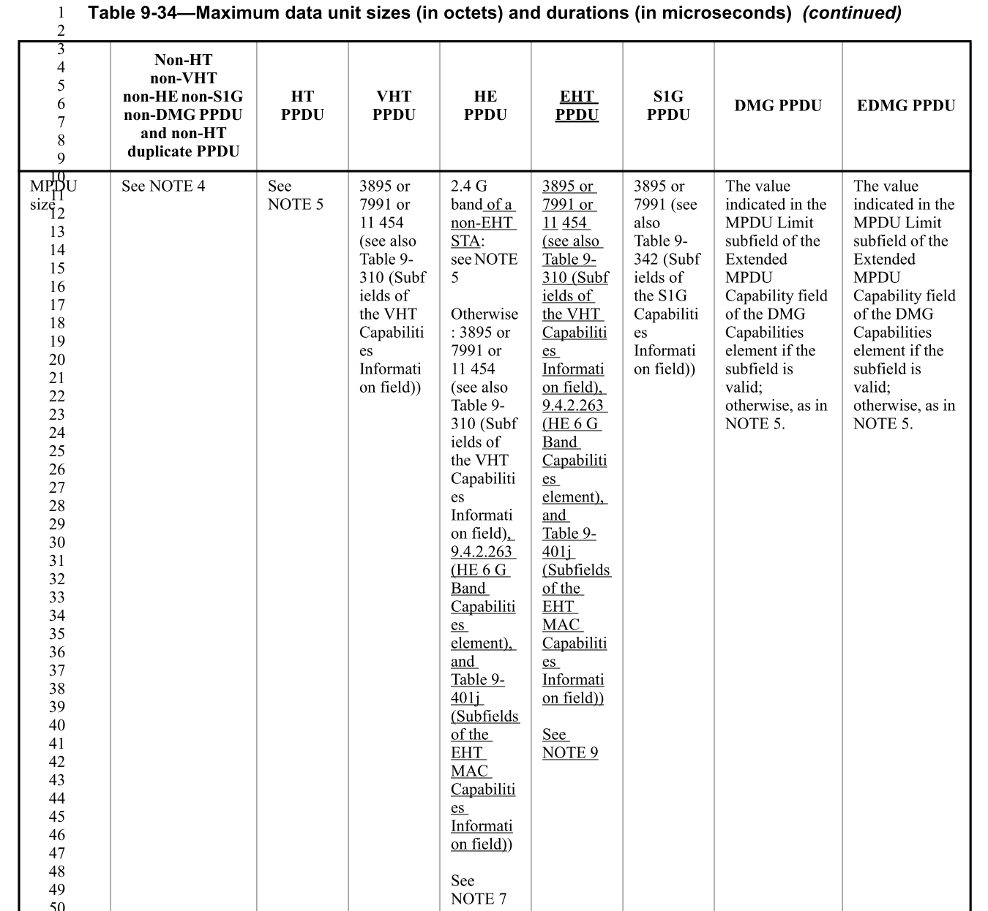

TGbe editor: Please insert a new paragraph after the paragraph on the MPDU size limit in 2.4GHz (P571L43 in D2.2) (track changes enabled):
In the 2.4 GHz band, an EHT STA shall not transmit an HE PPDU to a recipient EHT STA that carries a
frame that is not an HE Compressed Beamforming/CQI frame (see 26.7.3 (Rules for HE sounding protocol
sequences)) and that exceeds the maximum MPDU length capability indicated in the EHT Capabilities element last received from the recipient EHT STA.

(#11889) In the 2.4 GHz band, an EHT STA that sets the value of the Maximum MPDU Length subfield in the EHT MAC Capabilities Information field of the EHT Capabilities element to indicate 3895 octets shall set the Maximum A-MSDU Length in the HT Capabilities element to indicate 3839 octets. In the 2.4 GHz band, an EHT STA that sets the Maximum MPDU Length in the EHT Capabilities element to indicate 7991 octets or 11 454 octets shall set the Maximum A-MSDU Length in the HT Capabilities element to indicate 7935 octets.

