IEEE P802.11
Wireless LANs
SR2SR Link Identification
Date: 2022-10-31
Author(s):
Name | Affiliation | Address | Phone | email
Rajat Pushkarna | Panasonic Corp. |  |  | rajat.pushkarna@sg.panasonic.com
Rojan Chitrakar | Panasonic Corp.
Abstract
This submission proposes resolutions of comments received from TGbf comment collection 40 (TGbf Draft 0.1).
- CIDs: 295 (1 CID)

Revisions:

- Rev 0: Initial version of the document.

Introduction

Interpretation of a Motion to Adopt

A motion to approve this submission means that the editing instructions and any changed or added material are actioned in the TGbf Draft. The introduction and the explanation of the proposed changes are not part of the adopted material.

Editing instructions formatted like this are intended to be copied into the TGbf Draft (i.e., they are instructions to the 802.11bf editor on how to merge the text with the baseline documents).

TGbf Editor: Editing instructions preceded by “TGbf Editor” are instructions to the TGbf editor to modify existing material in the TGbf draft. As a result of adopting the changes, the TGbf editor will execute the instructions rather than copy them to the TGbf Draft.

CID | Commenter | Clause | Page | Line | Comment | Proposed Change | Resolution
295 | Rojan Chitrakar | 9.4.2.318 | 34 | 1 | It is not clear how R2R links are identified in a Sensing Measurement Report. | Add signaling to identify R2R link(s) in a Sensing Measurement Report. | Revised.  Agree with the commenter in principle that the initator receiving the measurement report should be able to identify the SR2SR measurement report for which signalling is required. 22/1579r3 proposes signalling where TX and Rx of sensing measurement report can be assigned using the USID/AID which is included in the sensing measurement report.  TGbf Editor to make no changes for all headings that include CID 295.

Baseline is TGbf D0.3

SP: Do you agree to incorporate the changes provided in IEEE 11-22/1839r0 for CID 295 to the next revision of 802.11bf draft?

Discussion
Please refer to 22/1579r3 for discussion related to this topic. The discussion points the use of USID/AID for the receiver and transmitter to be added in the report Type and Segmentation Control which carries the parameters required for report segmentation. It is always present in all over-the-air (OTA) reports, including segments.

The format of sensing measurement report frame as referenced from 22/1579r3 is as follows:
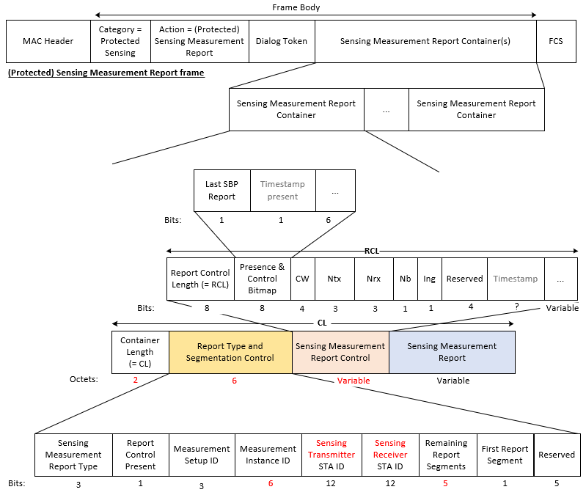

Report Type and Segmentation Control: Carries the Sensing Measurement Report Type and the parameter required for segmentation of reports. Always present in all Over-the-air (OTA) reports, including segments.
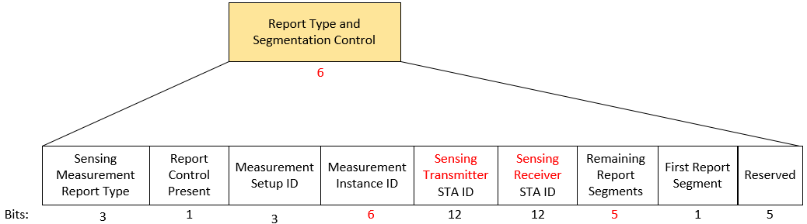

The USID/AID is a unique identifier for a sensing responder and therefore it can help in differentiating the reports which are from different TX-RX pairs. AID/UID does not reveal the identity of a sensing responder, thus preserving security and privacy.

References:
[1] IEEE 11-22-1579r3, Sensing Mesurement Report, Rojan Chitrakar (Panasonic)
[2] 802.11bf D0.3

