IEEE P802.11
Wireless LANs
LB266 CIDs in 9-4-2-313 EHT Capabilities Element-2
Date: 2022-10-31
Author(s):
Name | Affiliation | Address | Phone | email
Kanke Wu | Qualcomm Inc |  |  | kankew@qti.qualcomm.com
Bin Tian | Qualcomm Inc

Abstract
This submission proposes resolutions for the following comments from LB266 in P802.11be D2.0:
10809, 10810, 11853, 11313, 11307, 11308, 11309, 10393, 12571, 11213,
10338, 12004, 12478, 11805, 11522, 10178, 10173, 11060, 11058, 11059
This proposed text changes in this document are based on TGbe Draft 2.1

Revisions:

- Rev 0: Initial version of the document.

CID 10809
CID | Clause | Page.Line | Comment | Proposed Change | Resolutions
10809 | 9.4.2.313.3 | 233.29 | In EHT, the supported Max Nss is defined as 8. and Mac Nc is related to the Max Nss. So, there is no need to assign 4 bits for the Max Nc. Modify the assigned bits for Max Nc as 3bits in Figure 9-1002ag. | As in the comment. | REJECTED  According to previous agreement in the group. We agreed to not define 16ss in 11be and there will not be changes to the existing signalling. See also CID 12214 in DCN 22/1104r3.  The SP is shown here: " Do you agree that 802.11be shall not define operation with more than 8 spatial streams and that the format of all subfields related to spatial streams shall remain unchanged (i.e. no changing the number of bits)?" and the result in PHY ad-hoc was 22Y, 4N, 5A while the result in Joint was 51Y, 12N, 26A".
  - Background
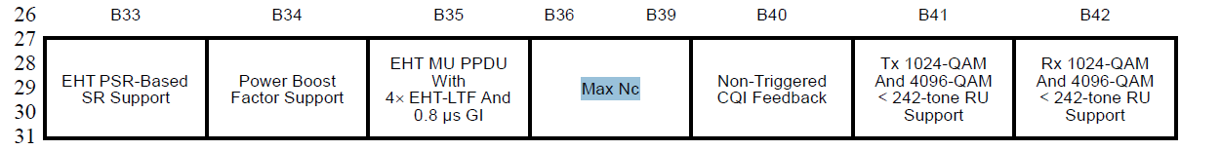

CID 10810
CID | Clause | Page.Line | Comment | Proposed Change | Resolutions
10810 | 9.4.2.313.3 | 241 | In EHT, the supported Max Nss is defined as 8. So, there is no need to assign more bits for the larger Nss than 8. by considering this, modify the assigned bit size related to Max Nss in clause 9.4.2.313.4. | Modify the bit size in Figure 9-1002ah, Figure 9-1002ai , and Figure 9-1002aj. Also, in Table 9-401m, Delete the last row and delete the below text of Table 9-401m.. | REJECTED  According to previous agreement in the group. We agreed to not define 16ss in 11be and there will not be changes to the existing signalling. See also CID 12214 in DCN 22/1104r3.  The SP is shown here: " Do you agree that 802.11be shall not define operation with more than 8 spatial streams and that the format of all subfields related to spatial streams shall remain unchanged (i.e. no changing the number of bits)?" and the result in PHY ad-hoc was 22Y, 4N, 5A while the result in Joint was 51Y, 12N, 26A".

CID 11853
CID | Clause | Page.Line | Comment | Proposed Change | Resolutions
11853 | 9.4.2.313.3 | 234.6 | What about 320 MHZ OFDMA? Is it covered by this cap bit as well? Please clarify. | As in comment. | REJECTED.  320MHz PPDU in the 6GHz frequency band using OFDMA is mandatory supported due to support for 80MHz and 160MHz operating STAs support in wider bandwidths being mandatory if the corresponding BWs are supported. This subfield is meant for non-OFDMA 320MHz PPDUs only as defined in the definition column.
  - Background
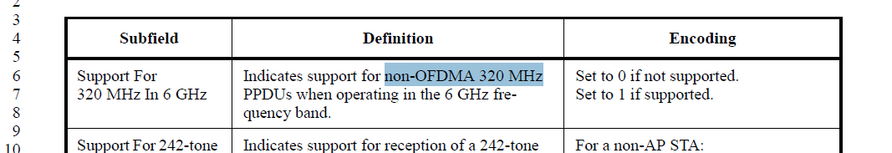
Page 556 “A non-AP EHT STA shall support the following features:”
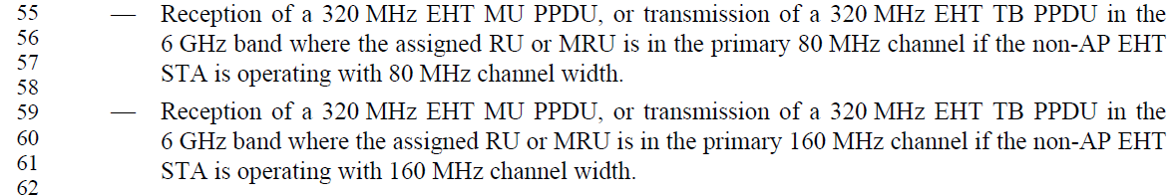

CID 11313, 11307, 11308, 11309
CID | Clause | Page.Line | Comment | Proposed Change | Resolutions
11313 | 9.4.2.313.3 | 237.12 | "Tx 1024-QAM And 4096-QAM < 242-tone RU Support" and "Rx 1024-QAM And 4096-QAM  < 242-tone RU Support" should be reserved for 20 MHz-only STA (since these capabilities depend on presence of "Tx EHT-MCS Map (â‰¤80 MHz) subfield.", ...) | "Tx 1024-QAM And 4096-QAM < 242-tone RU Support" and "Rx 1024-QAM And 4096-QAM  < 242-tone RU Support" should be reserved for 20 MHz-only STA (since these capabilities depend on presence of "Tx EHT-MCS Map (â‰¤80 MHz) subfield.", ...) | REVISED  A 20MHz-only device may still want to support Tx 1kQAM and 4kQAM for 242 tone RUs but not <242-tone RUs.  The description of this field should be updated to include 20MHz only devices and the reference of the subfields should be updated for clarity.  Instruction to the editor:  Please make the changes in the table at P240 L12 in D2.1 as indicated in 22/1818r0
11307 | 9.4.2.313.3 | 237.13 | "Set to 0 if 1024-QAM and 4096-QAM are not supported" should be "Set to 0 if 1024-QAM and 4096-QAM are not supported for RUs/MRUs smaller than 242 tones" | See comment | ACCEPTED
11308 | 9.4.2.313.3 | 237.21 | "Set to 0 if 1024-QAM and 4096-QAM are not supported" should be "Set to 0 if 1024-QAM and 4096-QAM are not supported for RUs/MRUs smaller than 242 tones" | See comment | ACCEPTED
11309 | 9.4.2.313.3 | 237.21 | Shouldn't "Rx 1024-QAM And 4096-QAM  < 242-tone RU Support" be "reserved" for the AP? There appears to be no need for the AP to indicate this capability since it will only receive RUs < 242 if it explicitly asking for it in a Trigger frame. | See comment | REJECTED  The definition of this field follows the style used in 11ax 1024-QAM <242-tone RU Support.  The RX capability applied to both client and non-client in 11ax because 11ax had 20 MHz HE MU PPDU with only one RU106 as a “SU” transmission.  Strictly speaking, there is no need for AP advertise that capability for 11be. However, there are many other capabilities like this one, for example, UL MU-MIMO Rx, SU beamformer, and triggered SU beamforming feedback and so on…  For consistency reasons and to avoid making too much changes, we think it is better to keep the description of this field as is.
  - Background
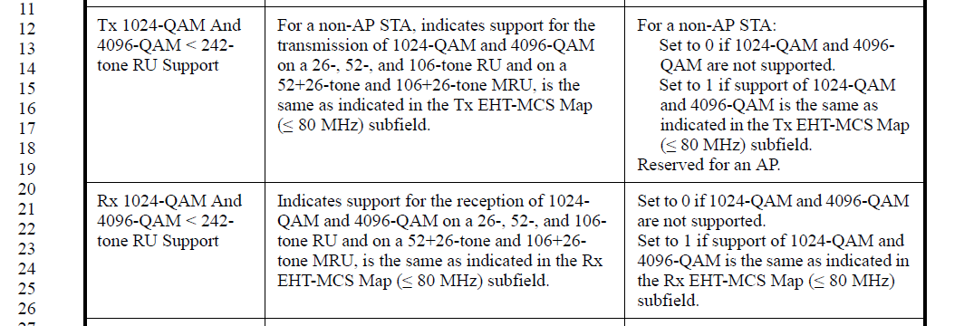
Instruction to the editor:
Please make the modifications in the table at P240 L12 as follows:
Tx 1024-QAM And 4096-QAM < 242-tone RU Support | For a non-AP STA, indicates support for the transmission of 1024-QAM and 4096-QAM on a 26-, 52-, and 106-tone RU and on a 52+26-tone and 106+26-tone MRU, is the same as indicated in the Tx EHT-MCS Map (20 MHz-Only Non-AP STA) for 20 MHz-only non-AP STAs, and the Tx EHT-MCS Map (BW≤ 80 MHz, Except for 20 MHz-Only Non-AP STA) subfield for non-AP STAs that are not 20 MHz-only non-AP STAs. | For a non-AP STA:  Set to 0 if 1024-QAM and 4096-QAM are not supported for RU/MRUs smaller than 242 tones.  Set to 1 if support of 1024-QAM and 4096-QAM is the same as indicated in the Tx EHT-MCS Map (20 MHz-Only Non-AP STA) for 20 MHz-only non-AP STAs, and Tx EHT-MCS Map (BW≤80 MHz, Except for 20 MHz-Only Non-AP STA) subfield for non-AP STAs that are not 20 MHz-only non-AP STAs.  Reserved for an AP.
Rx 1024-QAM And 4096-QAM < 242-tone RU Support | Indicates support for the reception of 1024-QAM and 4096-QAM on a 26-, 52-, and 106-tone RU and on a 52+26-tone and 106+26-tone MRU, is the same as indicated in the Rx EHT-MCS Map (20 MHz-Only Non-AP STA) for 20 MHz-only non-AP STAs, and the Rx EHT-MCS Map (BW≤ 80 MHz, Except for 20 MHz-Only Non-AP STA) subfield for non-AP STAs that are not 20 MHz-only non-AP STAs. | Set to 0 if 1024-QAM and 4096-QAM are not supported for RU/MRUs smaller than 242 tones.  Set to 1 if support of 1024-QAM and 4096-QAM is the same as indicated in the Rx EHT-MCS Map (20 MHz-Only Non-AP STA) for 20 MHz-only non-AP STAs and the Rx EHT-MCS Map (BW≤80MHz, Except for 20 MHz-Only Non-AP STA) subfield for non-AP STAs that are not 20 MHz-only non-AP STAs.

CID 10393
CID | Clause | Page.Line | Comment | Proposed Change | Resolutions
10393 | 9.4.2.313.3 | 237.28 | Change "indicates whether or not the PPE Thresholds field is present" into "indicates whether or not the EHT PPE Thresholds field is present" | Change "indicates whether or not the PPE Thresholds field is present" into "indicates whether or not the EHT PPE Thresholds field is present" | ACCEPTED
  - Background

CID 12571
CID | Clause | Page.Line | Comment | Proposed Change | Resolutions
12571 | 9.4.2.313.4 | 246.07 | In Table 9-401m, the setting of Max Nss subfield value of 1 would lead in some scenarios to announce mandatory features. One example is a 20 MHz-only STA which supports only the mandatory EHT-MCSs 0-7 Tx and Rx. In this example, There should be no need to include the Supported EHT-MCS And NSS Set field in the EHT Capabilities element, since these features are already mandatory. However, according to the current design, this field will be includes and will contain the values [0001 0001 0000 0000 0000 0000 0000 0000] | Add a note to exclude the scenarios where the supported MCSs and NSS combination is mandatory. | REJECTED  This field is to indicate the number of spatial streams supported for each MCS, so it is not just indicating whether an MCS is supported. Introducing such an optimization at this late stage and excluding the signalling for mandatory supports may cause some parsing issue.
  - Background
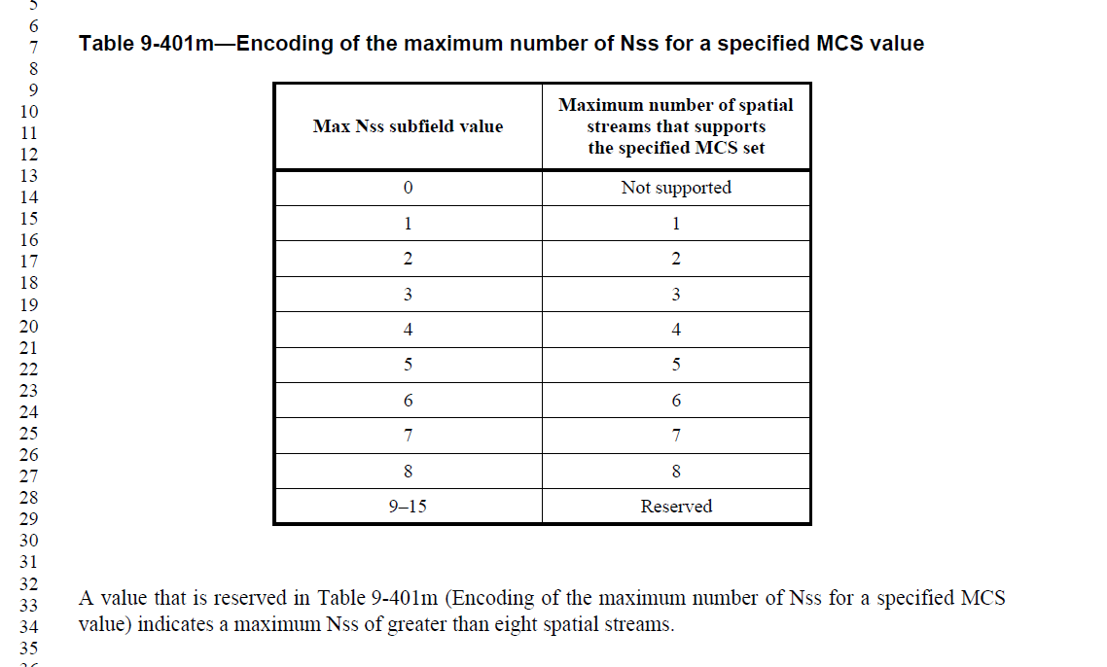

CID 11213
CID | Clause | Page.Line | Comment | Proposed Change | Resolutions
11213 | 9.4.2.313.3 | 233.38 | "Support Of EHT DUP (MCS 14) In 6 GHz " creates unclarity about non-6GHz operation. It is not made explicit that "EHT DUP" is not supported in 5GHz, because the capability only refers to 6GHz. | rename capability to "Support of EHT DUP (MCS 14)", (throughout the document).  Together with the already existing remark in Table 9-401k: "Set to 0 if 6 GHz is not supported", it is more clear that DUP is not supported outside 6GHz. | REJECTED.  Removing “in 6 GHz” in the name of this subfield can also lead to questions on MCS 14 supports in other bands. Since this subfield is really only about support for MCS 14 in the 6 GHz band, the current name is also more descriptive, and in line with the naming of other subfields.

CID 10338
CID | Clause | Page.Line | Comment | Proposed Change | Resolutions
10338 | 9.4.2.313.3 | 233.38 | It is better to use "EHT-MCS 14" rather than "MCS 14" for consistency. | Replace "EHT-MCS 14" with "MCS 14" | REVISED.  Agree with the commenter. In the current standard, EHT-MCS 14 is used throughout while “MCS 14” is used in reference to this subfield only.  To keep the naming consistent, we will also need to modify the adjacent subfield “Support Of MCS 15” to “Support Of EHT-MCS 15”.  Instruction to the editor:  Please change “MCS 14” to “EHT-MCS 14” at the following locations in D2.1:  P235L43  P241L54  P530L18  P534L27  P537L7  P724L22 and L23  Please change “MCS 15” to “EHT-MCS 15” at the following locations in D2.1  P235L44  P241L40 (twice), L43, L46, and L50  P530L14  P537L13
  - Background
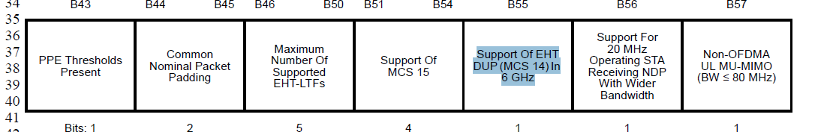

CID 12004
CID | Clause | Page.Line | Comment | Proposed Change | Resolutions
12004 | 9.4.2.313.4 | 244.06 | Since small RUs and MRUs are also supported in the bandwidth of 160 or 320 MHz, similar to the EHT-MCS Map (BW<=80 MHz, Except 20 MHz-Only Non-AP STA) subfield, description for support for tx and rx of 1024-QAM and 4096-QAM on small RUs and MRUs should be added in EHT-MCS Map (BW=160 MHz) and EHT-MCS Map (BW=320 MHz) subfields. | As in comment. | REVISED  Agree with the commenter. The description for Tx and Rx of 1k and 4k QAM in small RU and MRUs is currently missing for EHT-MCS Map (BW=160 MHz) and EHT-MCS Map (BW=320 MHz) subfields.  In addition, the support for <242-tone RUs in wideband is also missing in current <=80MHz capability and 16MHz capability descriptions  Instruction to the editor:  Please make the changes in the table at P247 L14 in D2.1 as indicated in 22/1818r0
 | 9.4.2.313.4
  - Background
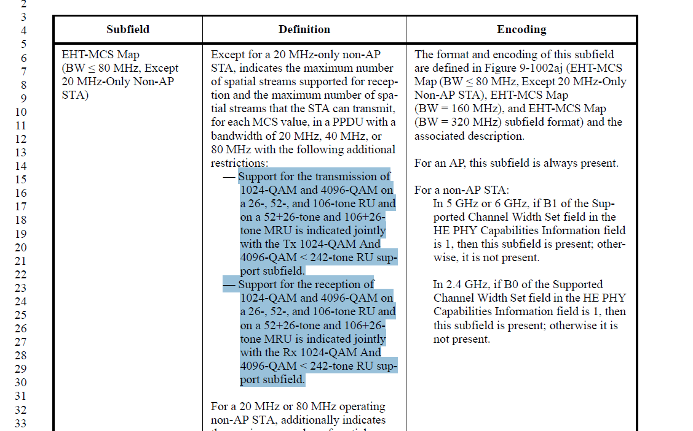
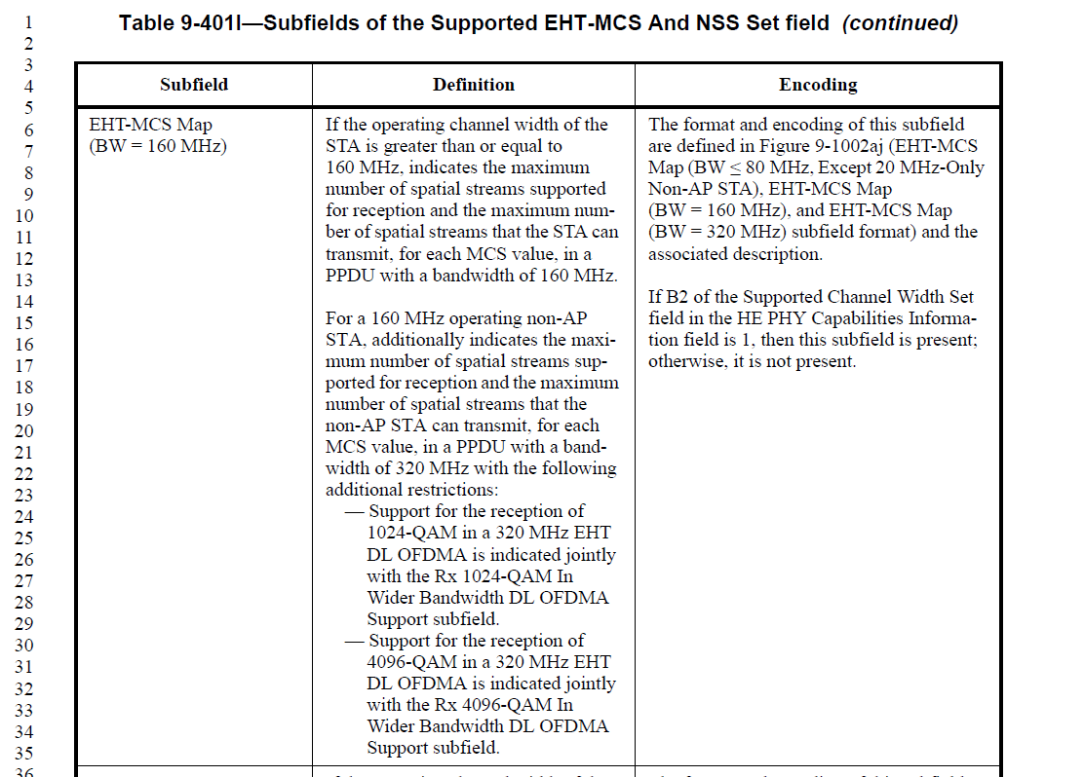
Instruction to the editor:
Please make the modifications starting at P246 L14 as follows:

EHT-MCS Map (BW ≤ 80 MHz, Except 20 MHz-Only Non-AP STA) | Except for a 20 MHz-only non-AP STA, indicates the maximum number of spatial streams supported for reception and the maximum number of spatial streams that the STA can transmit, for each MCS value, in a PPDU with a bandwidth of 20 MHz, 40 MHz, or 80 MHz with the following additional restrictions:  — Support for the transmission of 1024-QAM and 4096-QAM on a 26-, 52-, and 106-tone RU and on a 52+26-tone and 106+26-tone MRU is indicated jointly with the Tx 1024-QAM And 4096-QAM < 242-tone RU support subfield.  — Support for the reception of 1024-QAM and 4096-QAM on a 26-, 52-, and 106-tone RU and on a 52+26-tone and 106+26-tone MRU is indicated jointly with the Rx 1024-QAM And 4096-QAM < 242-tone RU support subfield.  For a 20 MHz or 80 MHz operating non-AP STA, additionally indicates the maximum number of spatial streams supported for reception and the maximum number of spatial streams that the non-AP STA can transmit, for each MCS value, in a PPDU with a bandwidth of 160 MHz or 320 MHz with the following additional restrictions:  — Support for the transmission of 1024-QAM and 4096-QAM on a 26-, 52-, and 106-tone RU and on a 52+26-tone and 106+26-tone MRU in EHT UL OFDMA is indicated jointly with the Tx 1024-QAM And 4096-QAM < 242-tone RU support subfield.  — Support for the reception of 1024-QAM in a 160 MHz, or 320 MHz EHT DL OFDMA is indicated jointly with the Rx 1024-QAM In Wider Bandwidth DL OFDMA Support subfield. And support for the reception of 1024-QAM on a 26-, 52-, and 106-tone RU and on a 52+26-tone and 106+26-tone MRU in EHT DL OFDMA is additionally jointly indicated with the Rx 1024-QAM And 4096-QAM < 242-tone RU sup-port subfield.  — Support for the reception of 4096-QAM in a 160 MHz, or 320 MHz EHT DL OFDMA is indicated jointly with the Rx 4096-QAM In Wider Bandwidth DL OFDMA Support subfield. And support for the reception of 4096-QAM on a 26-, 52-, and 106-tone RU and on a 52+26-tone and 106+26-tone MRU in EHT DL OFDMA is additionally jointly indicated with the Rx 1024-QAM And 4096-QAM < 242-tone RU sup-port subfield. | The format and encoding of this subfield are defined in Figure 9-1002ai (EHT-MCS Map (BW ≤ 80 MHz, Except 20 MHz-Only Non-AP STA), EHT-MCS Map (BW = 160 MHz), and EHT-MCS Map (BW = 320 MHz) subfield format) and the associated description.  For an AP, this subfield is always present.  For a non-AP STA:  In 5 GHz or 6 GHz, if B1 of the Supported Channel Width Set field in the HE PHY Capabilities Information field is 1, then this subfield is present; otherwise, it is not present.  In 2.4 GHz, if B0 of the Supported Channel Width Set field in the HE PHY Capabilities Information field is 1, then this subfield is present; otherwise it is not present.
EHT-MCS Map (BW = 160 MHz) | If the operating channel width of the STA is greater than or equal to 160 MHz, indicates the maximum number of spatial streams supported for reception and the maximum number of spatial streams that the STA can transmit, for each MCS value, in a PPDU with a bandwidth of 160 MHz with the following additional restrictions:  —Support for the transmission of 1024-QAM and 4096-QAM on a 26-, 52-, and 106-tone RU and on a 52+26-tone and 106+26-tone MRU is indicated jointly with the EHT-MCS Map (BW ≤ 80 MHz, Except 20 MHz-Only Non-AP STA) subfield and Tx 1024-QAM And 4096-QAM < 242-tone RU support subfield.  — Support for the reception of 1024-QAM and 4096-QAM on a 26-, 52-, and 106-tone RU and on a 52+26-tone and 106+26-tone MRU is indicated jointly with the EHT-MCS Map (BW ≤ 80 MHz, Except 20  MHz-Only Non-AP STA) subfield and Rx 1024-QAM And 4096-QAM < 242-tone RU support subfield.  For a 160 MHz operating non-AP STA, additionally indicates the maximum number of spatial streams supported for reception and the maximum number of spatial streams that the non-AP STA can transmit, for each MCS value, in a PPDU with a bandwidth of 320  MHz with the following additional restrictions:  —Support for the transmission of 1024-QAM and 4096-QAM on a 26-, 52-, and 106-tone RU and on a 52+26-tone and 106+26-tone MRU in EHT UL OFDMA is indicated jointly with the EHT-MCS Map (BW ≤ 80 MHz, Except 20 MHz-Only Non-AP STA) subfield and Tx 1024-QAM And 4096-QAM < 242-tone RU support subfield.  — Support for the reception of 1024-QAM in a 320 MHz EHT DL OFDMA is indicated jointly with the Rx 1024-QAM In Wider Bandwidth DL OFDMA Support subfield. And support for the reception of 1024-QAM on a 26-, 52-, and 106-tone RU and on a 52+26-tone and 106+26-tone MRU in EHT DL OFDMA is additionally jointly indicated with the Rx 1024-QAM And 4096-QAM < 242-tone RU sup-port subfield and the EHT-MCS Map (BW ≤ 80 MHz, Except 20 MHz-Only Non-AP STA) subfield.  — Support for the reception of 4096-QAM in a 320 MHz EHT DL OFDMA is indicated jointly with the Rx 4096-QAM In Wider Bandwidth DL OFDMA Support subfield. And support for the reception of 4096-QAM on a 26-, 52-, and 106-tone RU and on a 52+26-tone and 106+26-tone MRU in EHT DL OFDMA is additionally jointly indicated with the Rx 1024-QAM And 4096-QAM < 242-tone RU sup-port subfield and the EHT-MCS Map (BW ≤ 80 MHz, Except 20 MHz-Only Non-AP STA) subfield. | The format and encoding of this subfield are defined in Figure 9-1002ai (EHT-MCS  Map (BW ≤ 80 MHz, Except 20  MHz-Only Non-AP STA), EHT-MCS Map (BW = 160 MHz), and EHT-MCS Map (BW  = 320 MHz) subfield format) and the associated description.  If B2 of the Supported Channel Width Set field in the HE PHY Capabilities Information field is 1, then this subfield is present; otherwise, it is not present.
EHT-MCS Map (BW = 320 MHz) | If the operating channel width of the STA is 320 MHz, indicates the maximum number of spatial streams supported for reception and the maximum number of spatial streams that the STA can transmit, for each MCS value, in a PPDU with a bandwidth of 320 MHz with the following additional restrictions:  —Support for the transmission of 1024-QAM and 4096-QAM on a 26-, 52-, and 106-tone RU and on a 52+26-tone and 106+26-tone MRU is indicated jointly with the EHT-MCS Map (BW ≤ 80 MHz, Except 20 MHz-Only Non-AP STA) subfield and Tx 1024-QAM And 4096-QAM < 242-tone RU support subfield.  — Support for the reception of 1024-QAM and 4096-QAM on a 26-, 52-, and 106-tone RU and on a 52+26-tone and 106+26-tone MRU is indicated jointly with the EHT-MCS Map (BW ≤ 80 MHz, Except 20  MHz-Only Non-AP STA) subfield and Rx 1024-QAM And 4096-QAM < 242-tone RU support subfield. | The format and encoding of this subfield are defined in Figure 9-1002ai (EHT-MCS  Map (BW ≤ 80 MHz, Except 20 MHz-Only Non-AP STA), EHT-MCS Map (BW = 160 MHz), and EHT-MCS Map (BW = 320 MHz) subfield format) and the associated description.  If the Support For 320 MHz In 6 GHz subfield, in the EHT PHY Capabilities Information field is 1, then this subfield is present; otherwise, it is not present.

CID 12478
CID | Clause | Page.Line | Comment | Proposed Change | Resolutions
12478 | 9.4.2.313.3 | 238.18 | For a STA supporting Nss <= 4, the number of EHT-LTF it can receive is 1, 2, 4, 8 in EHT-SU and EHT-NDP packet.  However, for OFDMA & TB the selection of the number of EHT-LTF is based on the Nss,r,total which can take values 1, 2, 4, 6, 8.  To unify at the STA side, it might be better to add in one more capability entry to indicate the processing of EHT-LTF as 1, 2, 4, 8 (excluding 6).  In Table 9-401k, subfield "Maximum number of EHT-LTF" modify the following statement in Encoding:  "A B3-B4 value of 0 indicates a maximum of four EHT-LTFs.  A B3-B4 value of 1 indicates a maximum of eight EHT-LTFs.  B3-B4 values of 2 and 3 are reserved."  as  "A B3-B4 value of 0 indicates a maximum of four EHT-LTFs.  A B3-B4 value of 1 indicates a maximum of eight EHT-LTFs with possible values as 1, 2, 4, 6, 8.  A B3-B4 value of 2 indicates a maximum of eight EHT-LTFs with possible values as 1, 2, 4, 8.  B3-B4 value of 3 is reserved." | As in the comment. | REJECTED.  This subfield is to indicate the Maximum Number of Supported EHT-LTFs. It is not meant to specify the set of number of LTFs a STA supports. The current definition of this subfield already indicates the maximum and there’s no need to list all the possible values.
  - Background
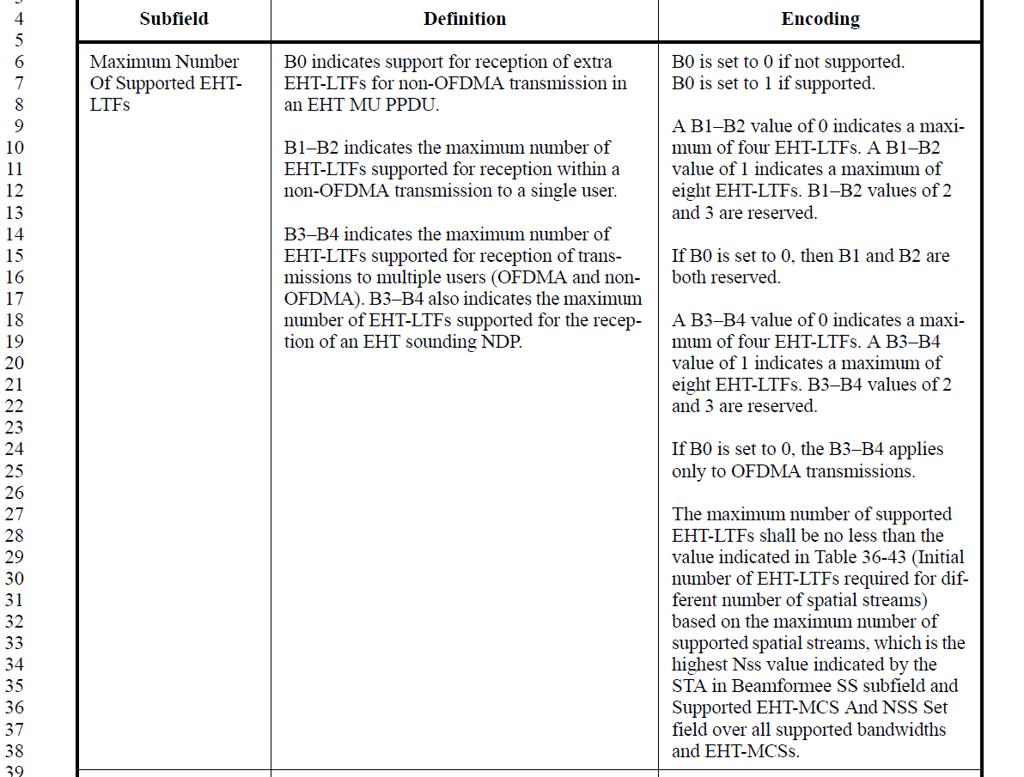

CID 11805
CID | Clause | Page.Line | Comment | Proposed Change | Resolutions
11805 |  | 0.00 | Does this capability apply only to MRUs? Seems like it and if the case then call it out. Add "in MRU" to the name of the field. | EHT Capabilities (PHY) field: Support Of MCS 15. | REJECTED.  This subfield indeed only applies to MRUs. The name of this subfield is already changed to “Support Of MCS 15 in MRU” based on CIDs 11854 and 11140 to reflect this
  - Background
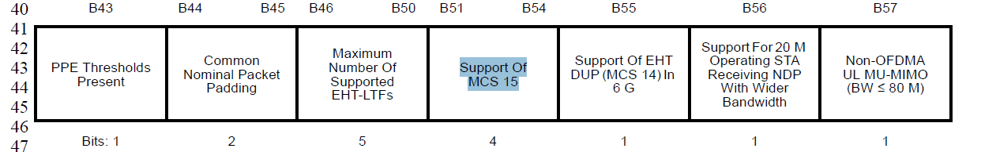

CID 11522
CID | Clause | Page.Line | Comment | Proposed Change | Resolutions
11522 | 9.4.2.313.2 | 239.06 | should this field be reserved for APs? | as in comment | REVISED.  This subfield should be used only by a 20MHz operating non-AP STA to indicate the ability to received wider bandwidth NDP (see PHY introduction section)  Instruction to the editor:  Please insert at P242L9 the third column in D2.1:  “Reserved for an AP”
  - Background
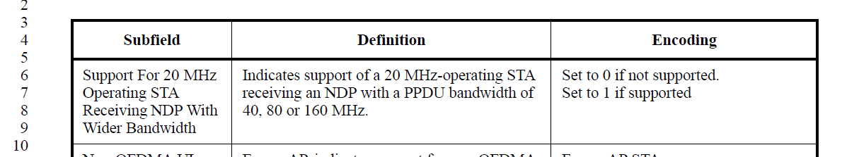
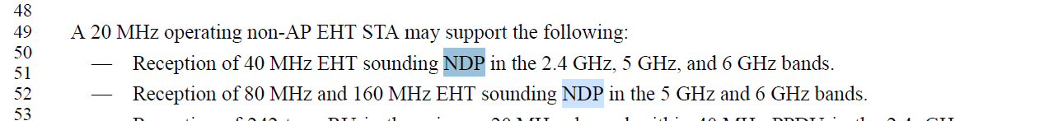

CID 10178
CID | Clause | Page.Line | Comment | Proposed Change | Resolutions
10178 | 9.4.2.313.3 | 233.01 | reserved bits in "Supported channel width set" field is set to 0 by default. But vendors set them randomly in 11ax. | Propose to mandate the reserved bits set to 0 in 11be | REJECTED  By mandating all reserved bits to be set to 0, they will not be reserved anymore (they will have a mandated value and this value has a meaning). Making such change may result in changing definition of reserved bits and cause other issues.  In addition, “supported channel width set” field is not found at the indicated location. There is a “Supported channel width set” subfield in HE PHY Capabilities Information field in the HE Capabilities element. 11be did not alter the definitions of those fields and only made use of those fields when interpretating the capabilities of the STAs.

CID 10173, 11060
CID | Clause | Page.Line | Comment | Proposed Change | Resolutions
10173 | 9.4.2.313.3 | 234.01 | "Support For 320 MHz In 6 GHz" ,need to clarify the setting if STA operate in 2.4/5Ghz band | e.g. set to 0 if STA operate in 2.4/5GHz | REJECTED  This subfield name and description is already very clear that it applies only to indicate the capability when operating in the 6GHz frequency band. It does not apply to 2.4/5GHz cases and there’s no need to mandate settings for those cases.
11060 | 9.4.2.313.3 | 234.06 | Presence of EHT-MCS Map (BW=320 MHz) depending on the setting of Support For 320 MHz In 6 GHz. However, the description in Table 9-401k may be interpreted that the field is reserved in 2.4 GHz and 5 GHz, which should be ignored by the receiver per the current spec definition of reserved. If the field is used for other purposes in the future, then there will be parsing issue for EHT STA. | Suggest to revise the encoding as "Set to 1 if 320 MHz is supported and in 6 GHz. Set to 0 otherwise." | REJECTED  This subfield name and description is already very clear that it applies only to indicate the capability when operating in the 6GHz frequency band. It does not apply to 2.4/5GHz cases and there’s no need to mandate settings for those cases
  - Background
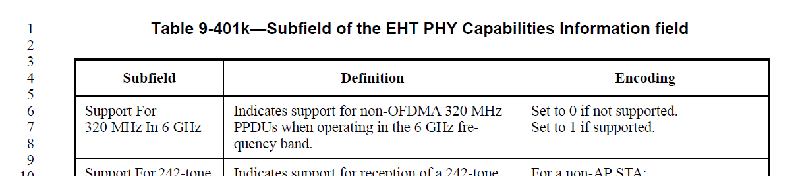

CID 11058, 11059
CID | Clause | Page.Line | Comment | Proposed Change | Resolutions
11058 | 9.4.2.313.4 | 242.06 | Presence of EHT-MCS Map (20 MHz-only Non-AP STA) currently depends on the band information, this is different from the Presence of EHT-MCS Map (BW=320 MHz) and Presence of EHT-MCS Map (BW=160 MHz), which depends directly on specific bit setting independent of the band information. Relying on specific bit setting will significantly reduce the complexitiy of parsing and will align the presence of the fields condition based on specific bit setting like 11ax. | Suggest to simply say "if B0, B1, B2, B3 of the Supported Channel Width Set field in the HE PHY Capabilities Information field are all 0, then this subfield is present; otherwise, it is not present." | REJECTED  Refer to the summary of supported channel widths field below. The current field description results in the same logic as the commenter is suggesting. i.e. in 2.4GHz, if B0 is set to 0 then B1, B2, B3 are automatically 0 already. There’s no need to make suggested change
11059 | 9.4.2.313.4 | 243.06 | Presence of EHT-MCS Map (BW â‰¤ 80 MHz, Except 20 MHz-Only Non-AP STA) currently depends on the band information, this is different from the Presence of EHT-MCS Map (BW=320 MHz) and Presence of EHT-MCS Map (BW=160 MHz), which depends directly on specific bit setting independent of the band information. Relying on specific bit setting will significantly reduce the complexitiy of parsing and will align the presence of the fields condition based on specific bit setting like 11ax. | Suggest to simply say If B0 or B1 of the Supported Channel Width Set field in the HE PHY Capabilities Information field is 1, then this subfield is present; otherwise, it is not present. | REJECTED  Refer to the summary of supported channel widths field below. The current field description results in the same logic as the commenter is suggesting. There’s no need to make suggested change
  - Background
