IEEE P802.11
Wireless LANs
11be D2.0 CR for 35.16.1
Date: 2022-10-26
Author(s):
Name | Affiliation | Address | Phone | email
Po-Kai Huang | Intel Corporation | 2200 Mission College Blvd, Santa Clara, CA 950542200 |  | po-kai.huang@intel.com
Robert Stacy
Abstract
This submission proposes resolutions for the following CIDs:

11061, 10943, 11887, 13710, 11062, 11063, 11064, 11065, 11066, 12565,
11067, 11068, 11069, 11070

Revisions:

- Rev 0: Initial version of the document.
- Rev 1: Add related CIDs 10943, 11887, 13710, 12565

Interpretation of a Motion to Adopt

A motion to approve this submission means that the editing instructions and any changed or added material are actioned in the TGbe D2.2 Draft. This introduction is not part of the adopted material.

Editing instructions formatted like this are intended to be copied into the TGbe D2.2 Draft (i.e. they are instructions to the 802.11 editor on how to merge the text with the baseline documents).

TGbe Editor: Editing instructions preceded by “TGbe Editor” are instructions to the TGbe editor to modify existing material in the TGbe draft. As a result of adopting the changes, the TGbe editor will execute the instructions rather than copy them to the TGbe Draft.

CID | Commenter | Clause | P.L | Comment | Proposed Change | Resolution
11061 | Po-Kai Huang | 35.16.1 | 530.49 | The paragraph below can have some improvement. The confusion is that it talks about BSS operating channel width announced to different STAs and also talks about EHT BSS operating channel width, which can be the value announced in old (when no new signaling) and new signaling (togehter with old signaling) depending on the context. "An EHT AP may announce a BSS operating channel width that is different from the BSS operating channel width that it announces to non-AP EHT STAs if the EHT BSS operating channel width includes at least one punctured 20 MHz subchannel and/or if the announced EHT BSS operating channel width is not supported by an HE BSS." | suggest revision like the following. "An EHT AP may set EHT Operation Information Present subfield in EHT Operation element to 1 to announce a BSS operating channel width to EHT non-AP STAs in EHT Operation element that is different from the BSS operating channel width that it announces to non-EHT non-AP STAs if the BSS operating channel width announced in the EHT Operation element includes at least one punctured 20 MHz subchannel and/or if the BSS operating channel width announced in the EHT Operation element is 320 MHz. Otherwise, an EHT AP shall set EHT Operation Information Present subfield in EHT Operation element to 0 and shall not announce a BSS operating channel width to a EHT non-AP STA in EHT Operation element." | Revised –  Agree in principle with the commenter.  TGbe editor to make the changes shown in 11-22/1816r1 under all headings that include CID 11061
10943 | Youhan Kim | 35.16.1 | 530.48 | If you follow P530L55-62, then an EHT AP must indicate the same BSS operating BW for non-EHT VHT/HE STAs and EHT STAs except when (1) EHT BSS is 320 MHz or (2) EHT BSS has puncturing within the Primary 160 MHz.  This means that an EHT AP must set the EHT Operation Information Present to 0 (see P290L43) in the EHT Operation element except for the two conditions mentioned above.  It would be better to spell that out instead of having readers 'figure it out'. | Add at P530L28:  "An EHT AP shall set EHT Operation Information subfield to 0 in the EHT Operation element if the BSS operating channel width is less than 320 MHz and the AP does not puncture any subchannels for the BSS." | Revised –  Agree in principle with the commenter.  TGbe editor to make the changes shown in 11-22/1816r1 under all headings that include CID 11061
11887 | Alfred Asterjadhi | 35.16.1 | 530.49 | Suggest amending as follows: "An EHT AP may announce a BSS operating channel width to non-EHT non-AP STAs that is different from the BSS operating channel width that it announces to non-AP EHT STAs if the EHT BSS operating channel width includes at least one punctured 20  MHz subchannel and/or if the announced EHT BSS operating channel width is not supported by an HE BSS." Also what is a BSS operating channel width that is not supported by an HE BSS? I take it is only the 320 MHz case (reading the next paragraphs)? Please call it out. | As in comment. | Revised –  Agree in principle with the commenter.  TGbe editor to make the changes shown in 11-22/1816r1 under all headings that include CID 11061
13710 | Yunbo Li | 35.16.1 | 530.49 | If the EHT BSS operating channel width includes at least one punctured 20  MHz subchannel and/or if the announced EHT BSS operating channel width is not supported by an HE BSS, the EHT AP doesn't have other choice, it must announce a different EHT BSS operating channel width | change "may announce ..." to "shall announce ..." | Revised –  Agree in principle with the commenter.  TGbe editor to make the changes shown in 11-22/1816r1 under all headings that include CID 11061
11062 | Po-Kai Huang | 35.16.1 | 530.49 | Given that the EHT BSS operating channel width will depend on the context, which can be the value announced in old (when no new signaling) and new signaling (togehter with old signaling). Suggest to add a paragraph to properly define it. | Suggest to add the following. "If a BSS operating channel width is announded in the EHT Operation element, then the announced BSS operating channel width is the EHT BSS operating channel width. If a BSS operating channel width is not announded in the EHT Operation element,  - In 6 GHz band, the BSS operating channel width announced in the HE Operation element is the EHT BSS operating channel width  - In 5 GHz band, the BSS operating channel width announced in the HT and VHT Operation element is the EHT BSS operating channel width  - In 2.4 GHz band, the BSS operating channel width announced in the HT operation element is the EHT BSS operating channel width" | Revised –  Agree in principle with the commeter.  TGbe editor to make the changes shown in 11-22/1816r1 under all headings that include CID 11062
11063 | Po-Kai Huang | 35.16.1 | 530.55 | There has been confusion that this paragraph can be applied to 5 GHz. This is not true. In 5 GHz, the BSS operating channel width is announced in VHT operation element. There is another argument claiming that it is possible to remove VHT operation element in 5 GHz and move the information to HE operation element included in 5 GHz band (at the same time VHT capabilities element is still kept). This is also not true. VHT Operation element includes Basic VHT-MCS And NSS Set, and it is not incldued in HE Operation element at all. As a result, claiming that VHT PPDU will still work in 5 GHz by removing VHT operation element and including VHT Operation Information in HE Operation elemnt is not correct. Note that the spec does not even define the situation when VHT PPDU if Basic VHT-MCS And NSS Set is missing. For example, consider the baseline texts below. "When transmitting a VHT PPDU, a STA shall select a <VHT-MCS, NSS> tuple from the basic VHT-MCS and  NSS set when protection is required (as defined in 10.27 (Protection mechanisms)) and shall select a <VHTMCS, NSS> tuple from the operational VHT-MCS and NSS set parameter of the intended receiver when  protection is not required." In addition, the spec also mandates to get information from VHT operation element in 5 GHz band as described below. "An HE STA shall determine the channelization using the information in the Primary Channel field of the HT Operation element when operating in 2.4 GHz and using the combination of the information in the Primary Channel field in the HT Operation element and the Channel Center Frequency Segment 0 and Channel Center Frequency Segment 1 subfields in the VHT Operation Information field in the VHT Operation element if operating in the 5 GHz band (see 21.3.14 (Channelization))." In sum, EHT BSS in 5 GHz shall not operate in a situation that will cause problems for VHT PPDU transmission. | To avoid the confusion, change "An EHT AP shall announce the BSS operating channel width in the HE Operation element with the  following restriction:" to "An EHT AP operating in the 6 GHz band shall announce the BSS operating channel width in the HE Operation element with the following restriction:" | Revised –  Agree in principle with the commenter. We use a general paragraph to accommodate cases in 6 GHz and 5 GHz.  TGbe editor to make the changes shown in 11-22/1816r1 under all headings that include CID 11063
11064 | Po-Kai Huang | 35.16.1 | 530.55 | There has been confusion that this paragraph can be applied to 5 GHz. This is not true. In 5 GHz, the BSS operating channel width is announced in VHT operation element. Interpret the sentence as saying that in 5 GHz, the BSS operating channel width shall be announced in HE Operation element just for puncturing is not accurate either. | To avoid the confusion, change "An EHT AP shall announce the BSS operating channel width in the HE Operation element with the  following restriction:" to "An EHT AP operating in the 6 GHz band shall announce the BSS operating channel width in the HE Operation element with the following restriction:" | Revised –  Agree in principle with the commenter. We use a general paragraph to accommodate cases in 6 GHz and 5 GHz.  TGbe editor to make the changes shown in 11-22/1816r1 under all headings that include CID 11063
11065 | Po-Kai Huang | 35.16.1 | 530.58 | For the first bullet, this sentence only makes sense if the Disabled Subchannel Bitmap field in the EHT Operation element is present. | Add "If the Disabled Subchannel Bitmap field in the EHT Operation element is present" at the beginning of the first bullet. | Revised –  Agree in principle with the commenter. “if condition” is added.  TGbe editor to make the changes shown in 11-22/1816r1 under all headings that include CID 11063
11066 | Po-Kai Huang | 35.16.1 | 531.01 | Missing bullet point for the first paragraph in page 531 | Add bullet point. | Revised –  Agree in principle with the commenter. Bullet point is added.  TGbe editor to make the changes shown in 11-22/1816r1 under all headings that include CID 11063
12565 | Mahmoud Kamel | 35.16.1 | 531.01 | This sentence should be a bullet following the previous bullet as it states another restriction with regard to the restrictions motioned in D2.0P530L56. | Start this sentence with a bullet. | Revised –  Agree in principle with the commenter. Bullet point is added.  TGbe editor to make the changes shown in 11-22/1816r1 under all headings that include CID 11063
11067 | Po-Kai Huang | 35.16.1 | 531.01 | this sentence only makes sense if a BSS operating channel width is announced in the EHT Operation element | Add "If a BSS operating channel width is announced in the EHT Operation element" at the beginning of the paragraph. | Revised –  Agree in principle with the commenter. “if condition” is added.  TGbe editor to make the changes shown in 11-22/1816r1 under all headings that include CID 11063
11068 | Po-Kai Huang | 35.16.1 | 531.05 | There has been debate about whether puncturing can be used in 5 GHz. If the intention is to allow the operation, then proper restriction needs to be added. | Add the following if the intention is to allow puncturing in 5 GHz. "An EHT AP operating in the 5 GHz band shall announce the BSS operating channel width in the VHT Operation element and HT Operation element with the following restriction:  -- If the Disabled Subchannel Bitmap field in the EHT Operation element is present, the announced BSS operating channel width in the VHT Operation element and HT Operation element is the maximum width including the primary channel without covering any punctured 20 MHz subchannels indicated in the Disabled Subchannel Bitmap field in the EHT Operation element as defined in 35.16.2 (Preamble puncturing operation).  -- If a BSS operating channel with is announced in the EHT Operation element, the announced BSS operating channel width in VHT Operation element and HT Operation element is less than the BSS operating channel width in the EHT Operation element and the corresponding BSS shall not operate as an 80+80 MHz BSS." | Revised –  Agree in principle with the commenter. We use a general paragraph to accommodate cases in 6 GHz and 5 GHz.  TGbe editor to make the changes shown in 11-22/1816r1 under all headings that include CID 11063
11069 | Po-Kai Huang | 35.16.1 | 531.01 | The sentence uses "no more than" in the restriction, but it should be "less than". Specifically, the design is only needed if puncturing is used or 320 MHz is used. In either case, the limitation is "less than". "The announced BSS operating channel width in HE Operation element is no more than the BSS operating channel width in the EHT Operation element and the corresponding BSS shall not operate as an 80+80 MHz  BSS." | Change "no more than" to "less than". | Revised –  Agree in principle with the commenter. The suggested change is accommodated.  TGbe editor to make the changes shown in 11-22/1816r1 under all headings that include CID 11063

Discussion:

There are discussions on enabling 5 GHz static puncturing. However, the current texts do not support this operation. Specifically, to support static puncturing, a different EHT BSS operation bandwidth needs to be announced different from the BSS operation bandwidth announced by today’s method. We have a way to announced different EHT BSS Operation bandwidth, but since 6 GHz and 5 GHz announced the BSS operation bandwidth differently (6 GHz uses HE operation element and 5 GHz uses VHT operation element and HT operation element or HE operation element and HT operation element combination). Texts need to be carefully updated to handle 5 GHz static puncturing. It is not correct to assume that BSS operation bandwidth for non-EHT STA will be announced through HE operation element in 5 GHz.

Propose:

TGbe editor: Modify 35.15.1 Basic EHT BSS operation as follows: (track change on)

35.15 EHT BSS operation

35.15.1 Basic EHT BSS operation(#7913)

(#6645)If the peer AP is operating as an EMA AP, an EHT non-AP STA should follow the procedure described in 11.1.3.8.3 (Discovery of a nontransmitted BSSID profile) for efficient discovery during scanning and to save power after association.

An EHT AP shall not assign an AID value of 2007 to any STA.

An EHT AP operating in 5 or 6 GHz band (#11044)(#11045)shall set the EHT Operation Information Present subfield to 1 to announce to EHT non-AP STAs an BSS operating channel width through the EHT Operation Information field that is different from the BSS operating channel width(s) that it announces to non-EHT non-AP STAs in the same Management frame if the BSS operating channel width announced to EHT non-AP STAs includes at least one punctured 20 MHz subchannel and/or is 320 MHz. Otherwise, the EHT AP shall set the EHT Operation Information Present subfield to 0. (#11061)

If a BSS operating channel width is announced in the EHT Operation element, then the announced BSS operating channel width is the EHT BSS operating channel width. If a BSS operating channel width is not announced in the EHT Operation element,
- In 6 GHz band, the HE BSS operating channel width announced in the HE Operation element is the EHT BSS operating channel width
- In 5 GHz band, the HE BSS operating channel width announced by the combination of the HT and VHT Operation element or announced by the combination of the HT and HE operation element with VHT Operation Information field is the EHT BSS operating channel width
- In 2.4 GHz band, the HE BSS operating channel width announced in the HT operation element is the EHT BSS operating channel width (#11062)

The announced HE BSS operating channel width by an EHT AP shall not be 80+80 MHz. (#11062)

If a BSS operating channel width is announced in the EHT Operation element, then an EHT AP shall announce the BSS operating channel width(s) to non-EHT non-AP STAs with the following restrictions:
- The announced BSS operating channel width(s) to non-EHT non-AP STAs are less than the BSS operating channel width in the EHT Operation element and the corresponding BSS shall not operate as an 80+80 MHz BSS.
- If the Disabled Subchannel Bitmap field in the EHT Operation element is present, the announced BSS operating channel width to non-EHT non-AP STAs is the (#7364)maximum width including the primary channel without covering any punctured 20 MHz subchannel indicated in the Disabled Subchannel Bitmap field in the EHT Operation element as defined in 35.16.2 (Preamble puncturing operation(#1086)(#1667)(#2148)(#2147)).(#11063)

- (#11063)

11070 | Po-Kai Huang | 35.16.1 | 531.05 | There has been debate about whether puncturing can be used in 5 GHz. Using puncturing in 5 GHz should work if we carefully design to avoid the complicated hack introduced to VHT Nss interpretation using CCFS0/CCFS1/CCFS2 in in Table 9-311 (Setting of the Supported Channel Width Set subfield and Extended NSS BW Support subfield at a STA transmitting the VHT Capabilities Information field), Table 9-109 (Setting of the Channel Width subfield and 160/80+80 BW subfield at a VHT STA transmitting the Operating Mode field), and Table 26-9 (Setting of VHT Channel Width and VHT NSS at an HE STA transmitting the OM Control subfield). | Add the following if we want to allow puncturing in 5 GHz. "Note - In 5 GHz band, based on the above rule, a BSS operating channel width is only announced in the EHT Operation element if the Disabled Subchannel Bitmap field in the EHT Operation element is present. In this case, the announced BSS operating channel width in VHT Operation element and HT Operation element can not be 160 MHz or 80+80 MHz. As a result, CCFS1 in VHT Operation element is set to 0 and CCFS2 in HT Operation element is set to 0 if a BSS operating channel width is announced in the EHT Operation element. (new paragraph) In 5 GHz band, if an associated EHT AP announces BSS operating channel width in VHT Operation element and HT Operation element and announces BSS operating channel width in EHT Operation element, then BSS bandwidth described in Table 9-311 (Setting of the Supported Channel Width Set subfield and Extended NSS BW Support subfield at a STA transmitting the VHT Capabilities Information field), Table 9-109 (Setting of the Channel Width subfield and 160/80+80 BW subfield at a VHT STA transmitting the Operating Mode field), and Table 26-9 (Setting of VHT Channel Width and VHT NSS at an HE STA transmitting the OM Control subfield) for the Location of 160 MHz channel center frequency and Location of secondary 80 MHz channel center frequency is the BSS bandwidth announced in VHT Operation element and HT Operation element." | Revised –  Agree in principle with the commenter.  TGbe editor to make the changes shown in 11-22/1816r1 under all headings that include CID 11070

Discussion:

In 5 GHz, there are also questions on the interpretation of BSS operating channel width in Table 9-109 , Table 9-311 and Table 26-9 when EHT STA sees announced BSS operating in both EHT operation element and VHT operation element. Ideally, the BSS bandwidth in Table 9-109 , Table 9-311 and Table 26-9 should mean the BSS bandwidth announced by VHT Operation element and HT Operation element since CCFS1 and CCFS2 in the table only has meaning in this interpretation.

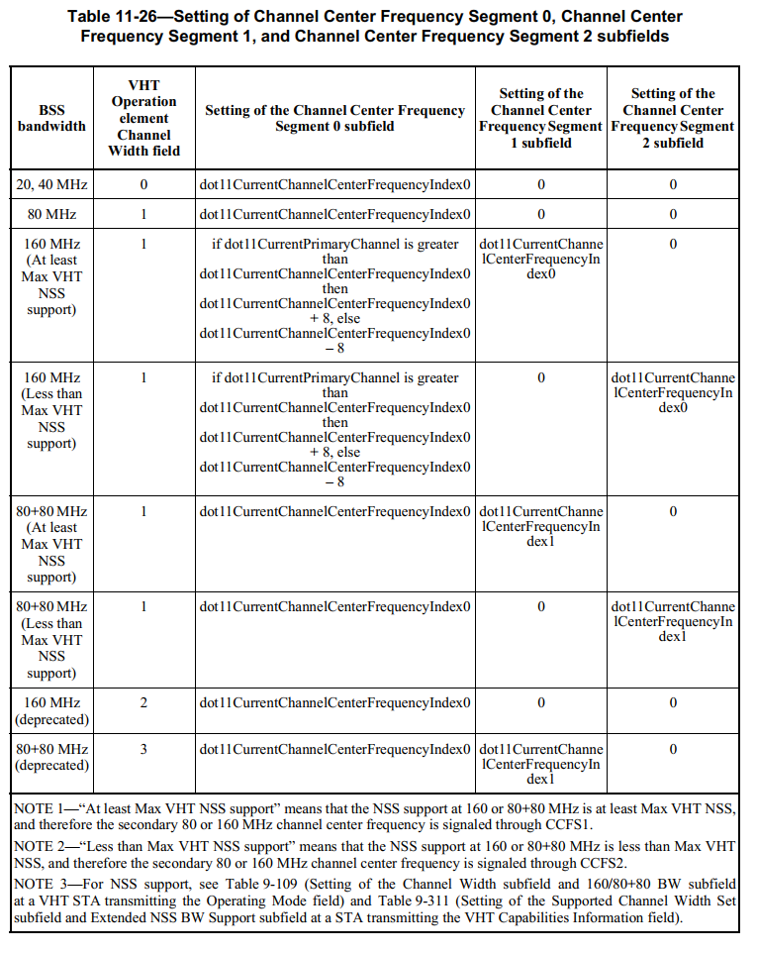

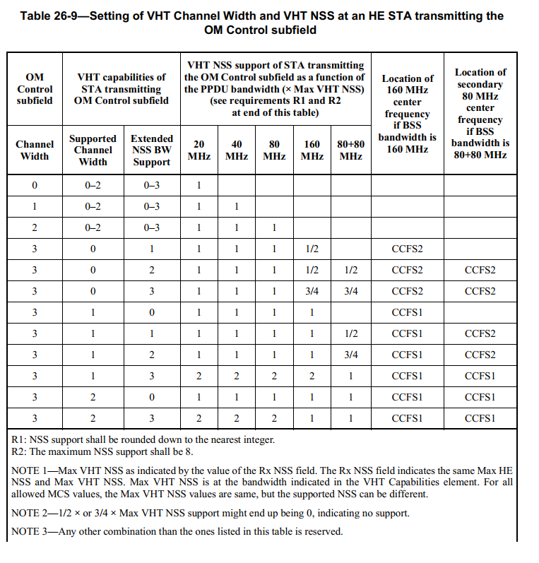

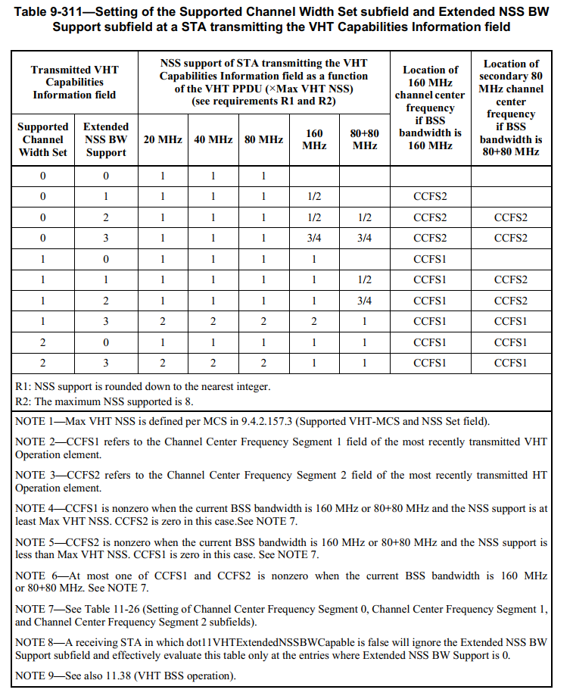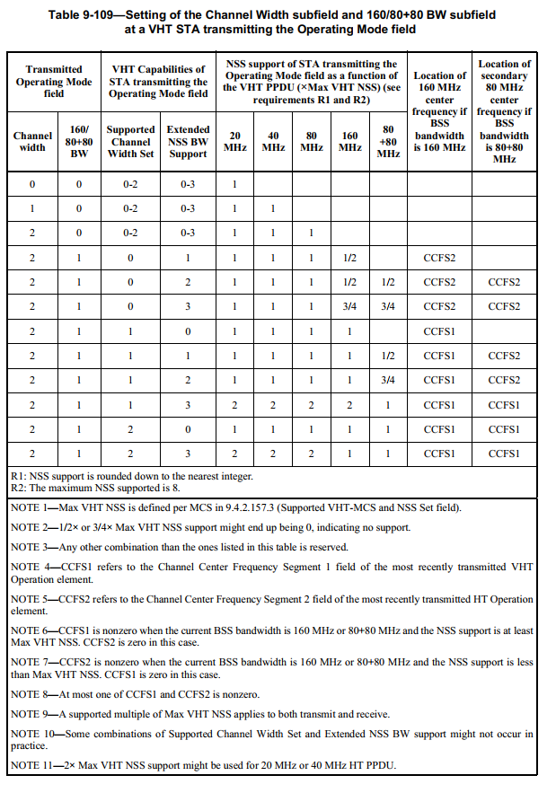

The following proposed texts fix the confusion above.

TGbe editor: Insert the following at the end of 35.15.1 Basic EHT BSS operation as follows: (track change on)

(…existing texts...)

In 5 GHz band, if an associated EHT AP announces a BSS operating channel width in EHT Operation element, then CCFS1 indicated in the EHT Operation element shall not be used for the Location of 160 MHz channel center frequency and Location of secondary 80 MHz channel center frequency in Table 9-311 (Setting of the Supported Channel Width Set subfield and Extended NSS BW Support subfield at a STA transmitting the VHT Capabilities Information field), Table 9-109 (Setting of the Channel Width subfield and 160/80+80 BW subfield at a VHT STA transmitting the Operating Mode field), and Table 26-9 (Setting of VHT Channel Width and VHT NSS at an HE STA transmitting the OM Control subfield) to determine NSS support.
(#11070)

(…existing texts…)

