IEEE P802.11
Wireless LANs
LB266 CR for RU_ALLOCATION in 36.2.2
Date: 2022.10.26
Author(s):
Name | Company | Address | Phone | email
Mengshi Hu | Huawei Technologies | H3, Huawei Base, Bantian, Longgang, Shenzhen, Guangdong, China, 518129 |  | humengshi@huawei.com
Ross Jian Yu
Ming Gan
Abstract
This submission contains the proposed comment resolutions of the following 3 CIDs in 22/0971 IEEE 802.11be LB266 comments, for the parameter RU_ALLOCATION in the subclause 36.2.2 TXVECTOR and RXVECTOR parameters.
- These three CIDs were deferred when the CR document 22/1076r1 was presented.

CIDs 12180, 12864, 12865.

Revision Notes
R0 | Initial revision

CID 12180 & 12864 & 12865
Page.  Line | Clause Number | Comment | Proposed Change | Resolution
556.18  (CID 12180) | 36.2.2 | "144 bits for a 320 MHz-1 or 320 MHz-2 PPDU", the number of "RU_ALLOCATION" bits does not distinguish between 320 MHz-1 and 320 MHz-2. There also no definition and usage of "320 MHz-1 or 320 MHz-2 PPDU" elsewhere. | change to "144 bits for a 320 MHz PPDU" | ACCEPTED.  Note: The resolutions of CIDs 12180, 12864, and 12865 are the same.
556.18  (CID 12864) | 36.2.2 | Define "320 MHz-1 or 320 MHz-2 PPDU". |  | REVISED.  No need to distinguish 320 MHz-1 and 320 MHz-2 PPDUs here. It is fine to use 320 MHz PPDU.  Instructions to the editor:  Change “320 MHz-1 or 320 MHz-2 PPDU” to “320 MHz PPDU”.  Note: The resolutions of CIDs 12180, 12864, and 12865 are the same.
556.18  (CID 12865) | 36.2.2 | The number of "RU_ALLOCATION" bits does not cover 320 MHz-1 and 320 MHz-2. | change"144 bits for a 320 MHz-1 or 320 MHz-2 PPDU" to "144 bits for a 320 MHz PPDU" | ACCEPTED.  Note: The resolutions of CIDs 12180, 12864, and 12865 are the same.

Discussion:
9 bits for a 20 MHz PPDU;
18 bits for a 40 MHz PPDU;
36 bits for a 80 MHz PPDU;
72 bits for a 160 MHz PPDU;
144 bits for a 320 MHz PPDU.

Agree with the commenter. No need to distinguish 320 MHz-1 and 320 MHz-2 PPDUs here. It is fine to use the description “320 MHz PPDU” for the case that 144 bits are used.

Table in 802.11be D2.2:
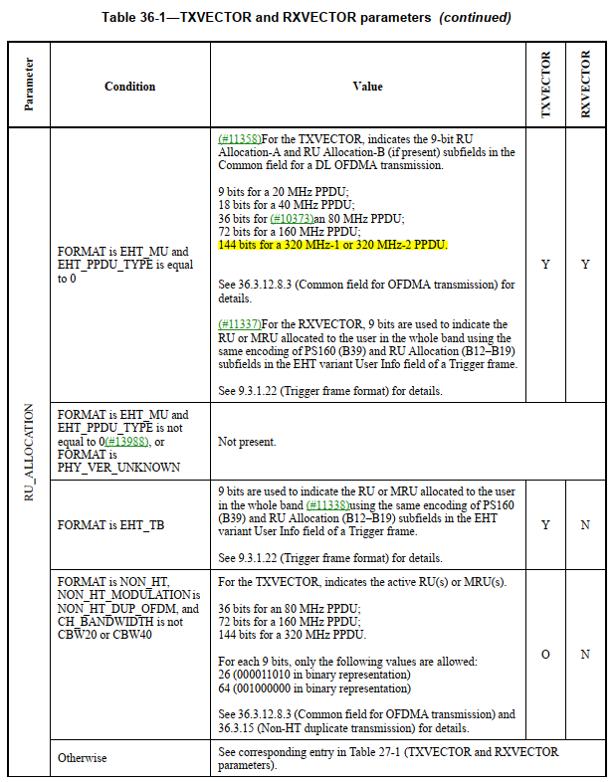
Discussion ends.

