IEEE P802.11
Wireless LANs
11bh D0.2 CR for device ID in PASN
Date: 2023-4-23
Author(s):
Name | Affiliation | Address | Phone | email
Okan Mutgan | Nokia |  |  | okan.mutgan@nokia-sbell.com
Jay Yang | Nokia |  |  | zhijie.yang@nokia-sbell.com
Abstract
This submission proposes resolutions for device ID support for PASN in P802.11bh/D0.2:

Revisions:
Rev 0: Initial version of the document.
Rev 1: Modification based on the previous discussion (reduced to one option where device ID is exchanged in Auth Msg2 and Auth Msg3 encrypted)
Rev 2: Modification based on 22/1329r17 and 23/0129r4.
Rev 3: Proposed text modification for two options (Option 1- Device ID exchange in PASN Auth Msg2 & Msg3, Option 2- Device ID exchange in PASN Auth Msg1 & Msg2)
Rev 4: Proposed text modification for Option 2 (Device ID exchange in PASN Auth Msg1 & Msg2) based on 23/0129r7.

Interpretation of a Motion to Adopt

A motion to approve this submission means that the editing instructions and any changed or added material are actioned in the TGbh D0.2 Draft. This introduction is not part of the adopted material.

Editing instructions formatted like this are intended to be copied into the TGbh D0.2 Draft. (i.e. they are instructions to the 802.11 editor on how to merge the text with the baseline documents).

TGbh Editor: Editing instructions preceded by “TGbh Editor” are instructions to the TGbh editor to modify existing material in the TGbh draft. As a result of adopting the changes, the TGbh editor will execute the instructions rather than copy them to the TGbh Draft.

Discussion

Based on the discussion on 22/1732r2, this document proposes that AP/ESS and non-AP STA should exchange device ID in PASN authentication as follows: (referred to as Option 2 in 22/1732r2):
- AP/ESS should assign device ID to non-AP STA encrypted in Auth Msg2
- non-AP STA should use the assigned device ID unencrypted in Auth Msg1

Note:
To fully cover the use case, device ID (or opaque ID, if used) should be exchanged
- for each FTM session and
- for each return to the same ESS

Example Scenario:
Non-AP STA activates Device ID in Auth Msg1 (set Device ID Active field to 1in RSNXE).
Non-AP STA is assigned unique Device ID/opaque ID in each Auth Msg2.
Non-AP STA uses previously assigned Device ID/opaque ID in each Auth Msg1 (while using different MAC addresses (MAC1, MAC2, MAC3, MAC4) for each FTM session session and for each return to the same ESS (AP1 & AP2).
Device ID/opaque ID is encrypted differently in each PASN Auth Msg2.
Assigned Device ID/opaque ID is used only once in PASN Auth Msg1, thus, is not trackable it to third parties (see green color for third party exposure).

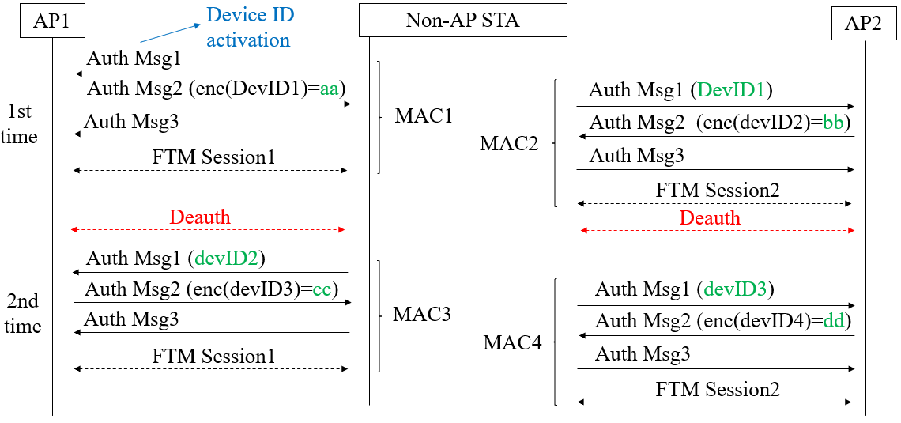
Figure 1 – Device ID usage in PASN

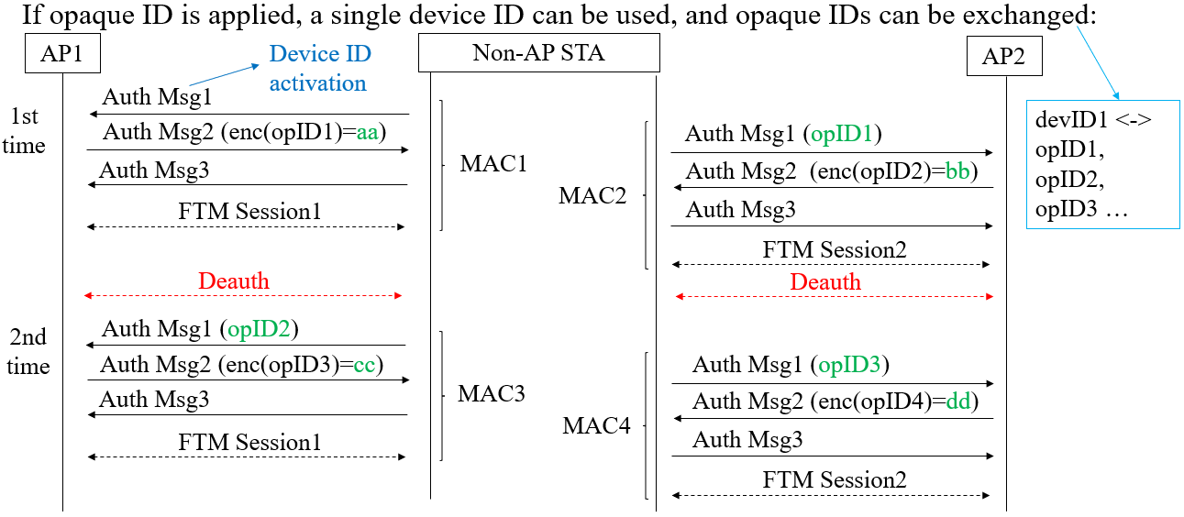
Figure 2 – Opaque ID usage in PASN

Proposed Text
(Proposed text modifications are for Draft 11bh 0.2 and 802.11az-2022)
TGbh editor: Modify the subclause 12.2.11 Device ID indication as follows:
Note to Editor: This text is taken from of 23/0129r7 therefore, the proposed text is based on this
12.2.11.1 Device ID indication

A non-AP STA indicates activation of device ID for a particular ESS by setting the Device ID Active field to 1 in the Extended RSN Capabilities field (see 9.4.2.241 - RSNExtension Element) in (Re)Association Request frames or first PASN Authentication Frame (when using PASN) sent to any AP in the ESS. An AP indicates activation of Device ID by setting the Device ID Active field to 1 in the Extended RSN Capabilities field in Beacon, (Re)Association Response, and Probe Response, and second PASN Authentication (when using PASN) frames. All APs in a given ESS shall set this field to the same value.

A STA shall not send a device ID to any STA that does not indicate Device ID is active.

A non-AP STA shall send a device ID when required by the procedures described below via the following frames (known as “non-AP STA Identity frames”):
- When using FILS authentication in the Device ID element in the (Re)Association Request frame.
- When not using FILS authentication in the Device ID KDE in message 2 of the 4 way handshake.
- When using PASN authentication in the Device ID element in the first PASN Authentication frame.

An AP shall send a device ID when required by the procedures described below via the following frames (known as “AP Identity frames”):
- When using FILS authentication in the Device ID element in the (Re)Association Response frame.
- When not using FILS authentication, in the Device ID KDE in message 3 of the 4 way handshake.
- When using PASN authentication in the Device ID element in the second PASN Authentication frame.

A non-AP STA that is associating with any AP in an ESS or that is using PASN with any AP in an ESS, when Device ID is active for both the non-AP STA and the AP and the non-AP STA has not previously associated or used PASN with any AP in the ESS, shall not send a device ID in the non-AP STA Identity frame. Similarly, if the non-AP STA is associating with any AP in an ESS or that is using PASN with any AP in an ESS, when Device ID is active for both the non-AP STA and the AP but the non-AP STA no longer has a device ID for that ESS for implementation-specific reasons (for example, configuration changes have lost the device ID, or sufficient time has passed since the last association to the ESS so that the device ID has been deleted), then the non-AP STA shall not send a device ID in the non-AP STA Identity frame.

A non-AP STA that is associating or using PASN with any AP in an ESS with Device ID active for both the non-AP STA and the AP and the non-AP STA has a saved device ID for the ESS shall send the most recently received device ID for that ESS in the non-AP STA Identity frame.

When an AP with Device ID active receives a non-AP STA Identity frame from a non-AP STA with Device ID active and the received device ID is recognized, the AP shall perform one of the following actions:
- Send a zero-length device ID (indicating the current device ID is maintained) and set Identifier Status to “Recognized” in the appropriate AP Identity frame.
- Assign a new device ID to the non-AP STA, send the device ID, and set Identifier Status to “Recognized” in the appropriate AP Identity frame.
When using PASN, AP shall perform the second action.

When a non-AP STA receives an AP Identity frame with Identifier Status equal to “Recognized” it can proceed with the assumption that the shared identity state with the AP or ESS (as per the concepts of 12.2.10) is now bound to the non-AP STA’s current MAC address.

When a non-AP STA receives an AP Identity frame with the Identifier Status equal to “Not Recognized”, it must assume that no shared identity state exists with the AP or ESS (as per the concepts of 12.2.10) and the non-AP STA must (re)establish any desired, shared identity state per the procedures previously described.

TGbh editor: Modify the subclause 12.12.3.2 PASN Frame Construction and Processing as follows:

12.12.3.2 PASN Frame Construction and Processing

The first PASN Authentication frame (see 9.3.3.11 (Authentication frame format)) of the exchange is constructed as follows:
— 9.4.1.1 (Authentication Algorithm Number field) set to 7 (PASN Authentication)

— 9.4.1.2 (Authentication Transaction Sequence Number field) set to 1;
— Including the constructed RSN
…

— If dot11RSNAOperatingChannelValidationActivated is true including an OCI Element containing an OCI element as defined in 9.4.2.236 (OCI element).
— If dot11DeviceIDActivated is true, including a Device ID element contains a device identifier as defined in (9.4.2.296a Device ID element), if any.
The AP begins the construction the second PASN frame as follows:

— 9.4.1.1 (Authentication Algorithm Number field) set to 7 (PASN Authentication)
— 9.4.1.2 (Authentication Transaction Sequence Number field) set to 2
— Status code indicating the processing status
…..

— If dot11RSNAOperatingChannelValidationActivated is true, including an OCI Element containing an OCI element as defined in 9.4.2.236 (OCI element), if dot11RSNAOperatingChannelValidationActivated is true — 9.4.2.118 (A MIC element) with MIC computed as specified in 12.12.8.1 (MIC computation for PASN second frame.
— If dot11DeviceIDActivated is true, including a Device ID element contains a device identifier as defined in (9.4.2.296a Device ID element), if any. The Device ID element shall be encrypted with the cipher suite of AES-128-CMAC.
— 9.4.2.118 (A MIC element) with MIC computed as specified in 12.12.8.1 (MIC computation for PASN second frame)

