IEEE P802.11
Wireless LANs
LB266 CR for 9.3.1.22.4 EHT Variant User Info Field
Date: 2022.10.24
Author(s):
Name | Company | Address | Phone | email
Mengshi Hu | Huawei Technologies | H3, Huawei Base, Bantian, Longgang, Shenzhen, Guangdong, China, 518129 |  | humengshi@huawei.com
Ross Jian Yu
Ming Gan
Abstract
This submission contains the comment resolutions of the following 5 CIDs related to EHT variant user info field and 1 CID related to Common Info field in Trigger frame in 22/0971 IEEE 802.11be LB266 comments.

CIDs 10980, 11314, 11315, 11494, 13551, 10327.

Revision Notes
R0 | Initial revision

CID 10980
Page.  Line | Clause Number | Comment | Proposed Change | Resolution
163.64 | 9.3.1.22.4 | the description of RU or MRU index indicates the RU or MRU index for the 320 MHz channel looks vague by itself. It seems that this can be deleted, as the following text on the P164L46 is more specific. "If the bandwidth indicates 320 MHz, the mapping of the PHY MRU index to MRU is defined in Table 36-12 (Indices for small size MRUs in an OFDMA 320 MHz EHT PPDU) and Table 36-15 (Indices for large size MRUs in an OFDMA 320 MHz EHT PPDU and in a non-OFDMA 320 MHz EHT PPDU) in increasing order." | As in comment | REVISED.  The motivation of the mentioned sentences is different. The first one indicates that the RU or MRU index obtained in this table is equal to the PHY RU or MRU index in the case of 320 MHz, while the second one indicates that the detailed RU or MRU pattern can be obtained by knowing the PHY RU index and checking Table 36-7.  Instructions to the editor:  Please make the changes as shown under CID 10980 in 11-22/1798r0.

Instructions to the editor: please make the following changes to Page 174, Line 64 in the subclause 9.3.1.22.4 EHT Variant User Info field in D2.2 as shown below:
For 4×996-tone RU, 2×996+484-tone MRU, 3×996-tone MRU, and 3×996+484-tone MRU, the description of RU or MRU index is the same as that of the PHY RU or MRU index for the 320 MHz channel.

Discussion:
The motivation of the following two sentences is different:
- The first one in the following talks about that the RU or MRU index obtained in this table = PHY RU or MRU index (The last two columns shown in the table are equal);
- The second one talks about the detailed RU or MRU pattern can be obtained by knowing the PHY RU index and checking Table 36-7.
To make it clear, the wording is revised in this resolution.
The related text is shown below:
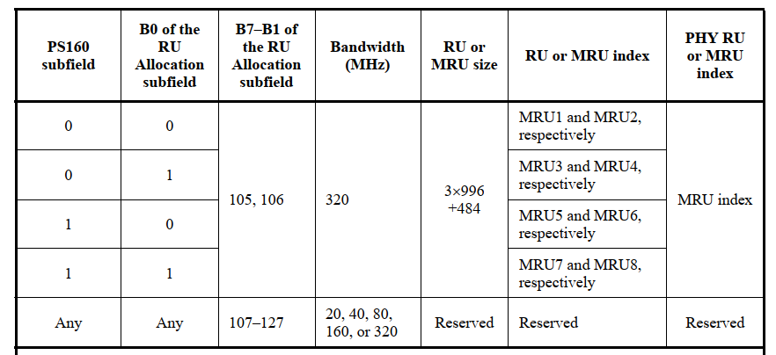
Discussion ends.

CID 13551 &11314
Page.  Line | Clause Number | Comment | Proposed Change | Resolution
162.24  (CID 13551) | 9.3.1.22.4 | Adding if the size of RU or MRU is smaller or equal to 996 tone. | As in comment | REVISED.  Agree with the commenter.  Instructions to the editor:  Please make the changes as shown under CID 11314 in 11-22/1798r0.
158.15  (CID 11314) | 9.3.1.22.4 | "80 MHz subblock where the MRU is located" is not clearly identified by the number 0-3. Specify how this numbering maps to the subblocks. | See comment | REVISED.  Although NOTE 1 has shown the details of how to identify the number 0-3, the number of B1 is discussed implicitly. To make it clear, the value of B1 is given explicitly, and a reference is added.  Instructions to the editor:  Please make the changes as shown under CID 11314 in 11-22/1798r0.
Instructions to the editor: please make the following changes to Page 173, Line 24 in the subclause 9.3.1.22.3 HE variant User Info field in D2.2 as shown below:
NOTE 1—B0 of the RU Allocation subfield is set to 0 to indicate that the RU or MRU allocation applies to the primary 80 MHz channel and set to 1 to indicate that the RU allocation applies to the secondary 80 MHz channel in the primary 160 MHz, if B1 is equal to 0 and the RU or MRU size is smaller than or equal to 996 tones. B0 of the RU Allocation subfield is set to 0 to indicate that the RU or MRU allocation applies to the lower 80 MHz in the secondary 160 MHz and is set to 1 to indicate that the RU or MRU allocation applies to upper 80 MHz in the secondary 160 MHz, if B1 is equal to 1 and the RU or MRU size is smaller than or equal to 996 tones.

Instructions to the editor: please make the following changes to Page 169, Line 16 in the subclause 9.3.1.22.4 EHT Variant User Info field in D2.2 as shown below:
Change “80 MHz subblock where the MRU is located” into “80 MHz subblock where the RU is located (see NOTE 1)”.

Instructions to the editor: please make the following changes to Page 171, Line 11 in the subclause 9.3.1.22.4 EHT Variant User Info field in D2.2 as shown below:
Change “80 MHz subblock where the MRU is located” into “80 MHz subblock where the MRU is located (see NOTE 1)”.

Discussion:
Text in 802.11be D2.2:
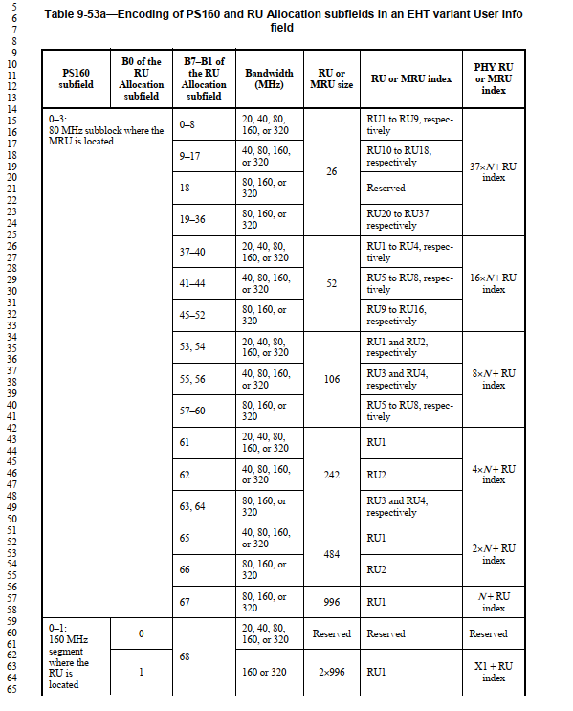
Discussion ends.

CID 11315
Page.  Line | Clause Number | Comment | Proposed Change | Resolution
158.60 | 9.3.1.22.4 | "160 MHz segment where the RU is located" is not clearly identified by the number 0-1. Is this low to high, or primary/secondary? | Clarify | REVISED.  This has been clarified in NOTE 3 in this table (primary/secondary). To make it clear, a reference is added to the sentence.  Instructions to the editor:  Please make the changes as shown under CID 11315 in 11-22/1798r0.
Instructions to the editor: please make the following changes to Page 169, Line 60 in the subclause 9.3.1.22.4 EHT Variant User Info field in D2.2 as shown below:
Change “160 MHz segment where the RU is located” into “160 MHz segment where the RU is located (see NOTE 3)”.

Instructions to the editor: please make the following changes to Page 171, Line 60 in the subclause 9.3.1.22.4 EHT Variant User Info field in D2.2 as shown below:
Change “160 MHz segment where the MRU is located” into “160 MHz segment where the MRU is located (see NOTE 3)”.

Discussion:
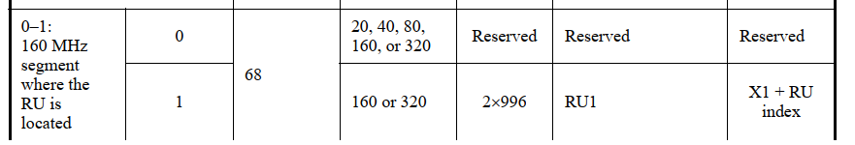
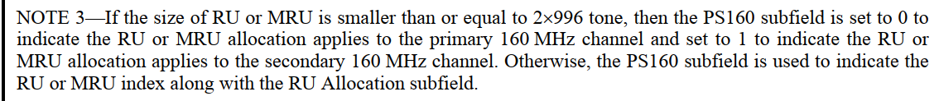
Discussion ends.

CID 11494
Page.  Line | Clause Number | Comment | Proposed Change | Resolution
157.11 | 9.3.1.22.4 | why is B7-B1 used, normally B1-B7 is used in increasing order, is that meant to indicate big endian encoding? If so, it is better to clearly state so | as in comment | REJECTED.  B7-B1 of the RU Allocation subfield are transmitted in unsigned binary format, LSB first. The reason that B7-B1 is used here is that the MSB-first description way is straight forward to denote the conversion between binary and decimal. Note that the binary description is used in the table.  In 802.11ax-2021, the similar description way is used. Thus, there is no need to add a Note here to clarify it here.
Discussion:
The mapping of B7–B1 of the RU Allocation subfield for a Trigger frame that is not an MU-RTS Trigger frame is defined in Table 9-52 (B7–B1 of the RU Allocation subfield in an HE variant User Info field). See 9.3.1.22.9 (MU-RTS Trigger frame format) for the encoding of the RU Allocation subfield in an MU-RTS Trigger frame.

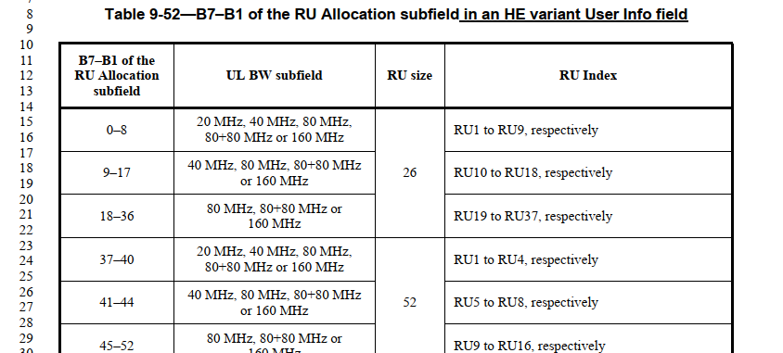
Discussion ends.

CID 10327
Page.  Line | Clause Number | Comment | Proposed Change | Resolution
146.13 | 9.3.1.22.2 | Regarding the GI And HE/EHT-LTF Type/Triggered TXOP Sharing Mode subfield, it is confusing whether there are three types of this subfield or two types of this subfield because two "/" are used here for different meanings. Suggest changing it into "GI And HE Or EHT-LTF Type/Triggered TXOP". | Change " GI And HE/EHT-LTF Type/Triggered TXOP" into "GI And HE Or EHT-LTF Type/Triggered TXOP". | REJECTED.  “HE/EHT” is also used in some other subfields such as “Number Of HE/EHT-LTF Symbols”. If this is changed into “Or”, the wording will be inconsistent with the other subfields. Thus, it is better to keep the existing format.
Discussion:
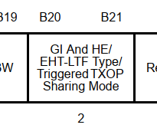
Discussion ends.

