IEEE P802.11
Wireless LANs
11be D2.0 CR for EHT Transmit Procedure
Date: 2022-10-20
Author(s):
Name | Affiliation | Address | Phone | email
Hao Song | Intel Corporation |  |  | hao.song@intel.com
Abstract
This submission proposes resolutions for the following CIDs:

12205, 12475

Revisions:
- Rev 0: Initial version of the document.

Interpretation of a Motion to Adopt

A motion to approve this submission means that the editing instructions and any changed or added material are actioned in the TGbe D2.0 Draft. This introduction is not part of the adopted material.

Editing instructions formatted like this are intended to be copied into the TGbe D2.0 Draft. (i.e. they are instructions to the 802.11 editor on how to merge the text with the baseline documents).

TGbe Editor: Editing instructions preceded by “TGbe Editor” are instructions to the TGbe editor to modify existing material in the TGbe draft. As a result of adopting the changes, the TGbe editor will execute the instructions rather than copy them to the TGbe Draft.

CID | Commenter | Clause | P.L | Comment | Proposed Change | Resolution
12205 | Shimi Shilo | 36.3.21 | 733.20 | The phrase 'EHT Training Symbols', which means EHT-STF & EHT-LTF, is not defined anywhere in the spec; consider explicitly defining that it pertains to EHT-STF and EHT-LTF. It may confuse readers because there is also a phrase called 'EHT Training Signal' in the spec which corresponds to the EHT Sounding NDP. | Add an explanation/definition of 'EHT Training Symbols' being EHT-STF and EHT-LTF; note phrase this is also used in Fig. 36-76, 36-78 and 36-79. | Revised –  Agree in principle with the commenter.  Compared to adding explanation/definition, it is better to directly change “EHT Training Symbols” to “EHT-STF & EHT-LTF”.
12475 | Dror Regev | 36.3.21 | 733.20 | Clarify what 'EHT Training Symbols' means, it is not defined anywhere. | Add a definition for the term 'EHT Training Symbols' (e.g. EHT-STF & EHT-LTF). | Revised –  Agree in principle with the commenter.  Compared to adding explanation/definition, it is better to directly change “EHT Training Symbols” to “EHT-STF & EHT-LTF”.

Discussion: None

TGbe editor: Change 36.3.21 EHT transmit procedure and 36.3.22 EHT receive procedure as follows (track change on):

36.3.21. EHT transmit procedure

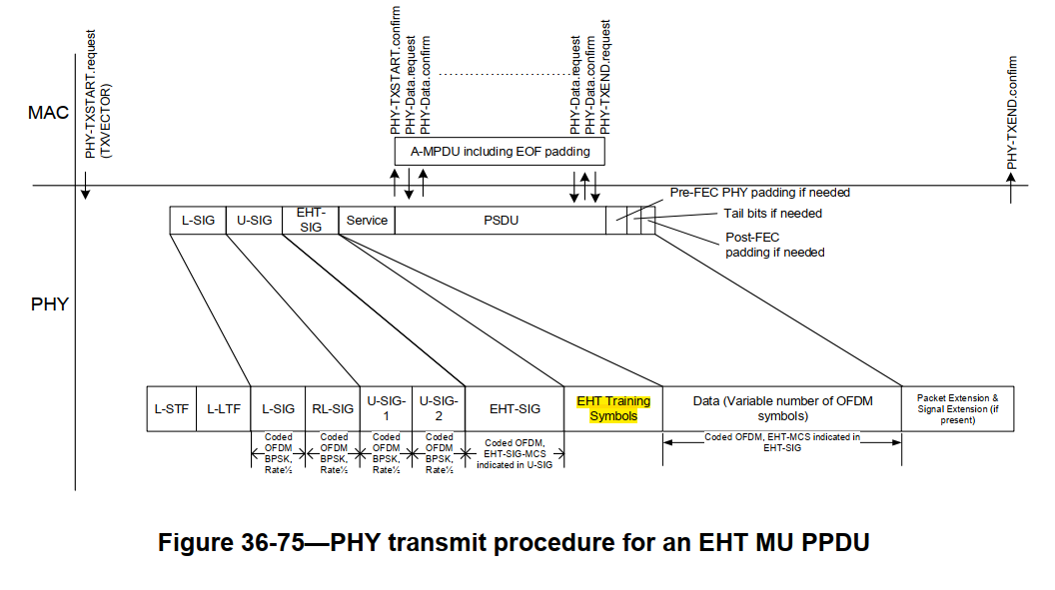
EHT-STF & EHT-LTF
(# 12205, # 12475)

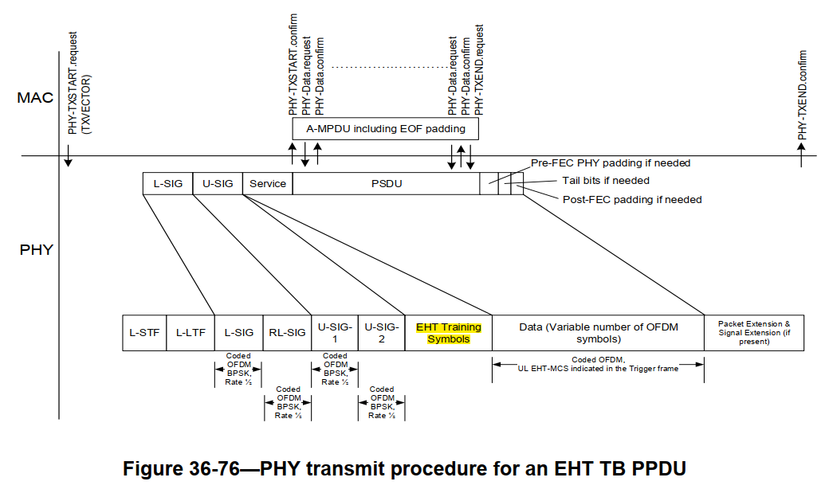
EHT-STF & EHT-LTF
(# 12205, # 12475)

NOTE 1—For an EHT MU PPDU the A-MPDU is per user in the MAC sublayer and the EHT-STF & EHT-LTF (# 12205, # 12475), and Data are per user in the PHY in Figure 36-75 (PHY transmit procedure for an EHT MU PPDU).

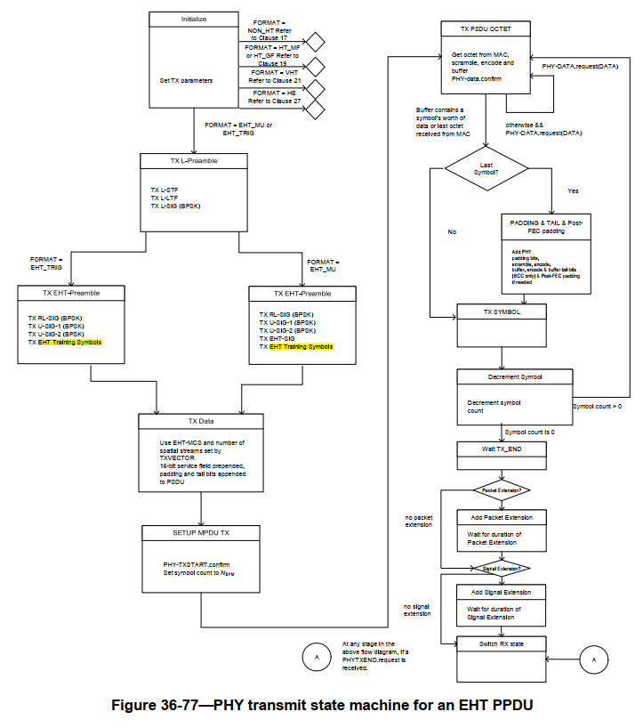
EHT-STF & EHT-LTF
(# 12205, # 12475)

EHT-STF & EHT-LTF
(# 12205, # 12475)

36.3.22. EHT receive procedure

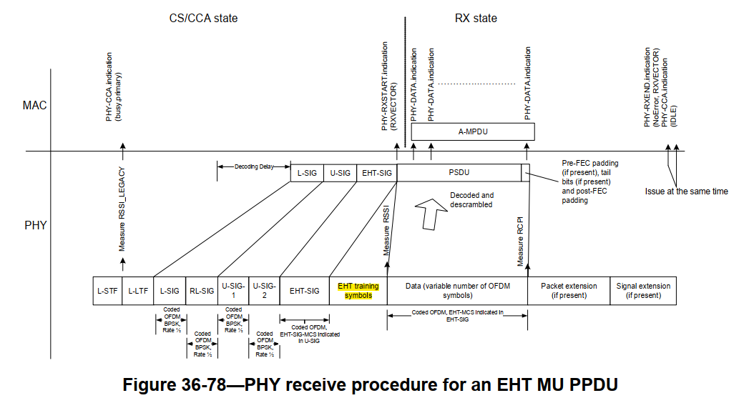
EHT-STF & EHT-LTF
(# 12205)

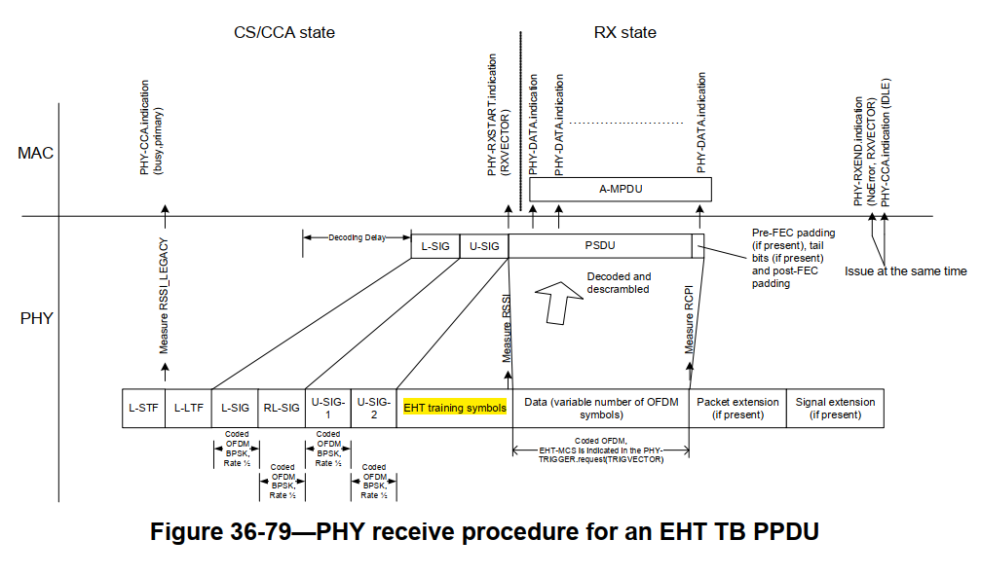
EHT-STF & EHT-LTF
(# 12205)

