IEEE P802.11
Wireless LANs
LB266 CR for CR10013
Date: Oct 19, 2022
Author(s):
Name | Affiliation | Address | Phone | email
Jay Yang | Nokia |  |  | Zhijie.yang@nokia-sbell.com
Kasslin Mika
Lorenzo Galati Giordano
Okan Mutgan
Jianguo Liu |  |  |  | jianguo.a.liu@nokia-sbell.com

Abstract
This submission proposes resolutions for following 1 CID received for TGbe LB266:
10013

Revisions:
- Rev 0: Initial version of the document.
- Rev 1: Update according to Abhi’s and Guogang’s comments
- Rev 2: Revised according to Xiangxin, Yongho,Po-kai and Laurent’s comments
- Rev3: Minor update the proposed text according to Pooya and Brain’s suggestion(highlight part).

Interpretation of a Motion to Adopt

A motion to approve this submission means that the editing instructions and any changed or added material are actioned in the TGbe Draft. This introduction is not part of the adopted material.

Editing instructions formatted like this are intended to be copied into the TGbe Draft (i.e. they are instructions to the 802.11 editor on how to merge the text with the baseline documents).

TGbe Editor: Editing instructions preceded by “TGbe Editor” are instructions to the TGbe editor to modify existing material in the TGbe draft. As a result of adopting the changes, the TGbe editor will execute the instructions rather than copy them to the TGbe Draft.

CID | Commenter | Page | Clause | Comment | Proposed Change | Resolution
10013 | Jay Yang | 427.05 | 35.3.7 | if one of the affiliated AP operating on CAC state, the link should be disable and enabled again once it's out of CAC mode. | 11be SPEC should have a solution to indicate the CAC mode and the remaing time, so that the non-AP MLD can decide whether to associated with such AP MLD. | Revised—  Agree in principle with the comment. More detailed discussion for this aspect  And the proposal change  can be found in 1782r3  TGbe editor please implement changes as shown in doc 1782r3  tagged as 10013

Discussion:
The following text copy from:
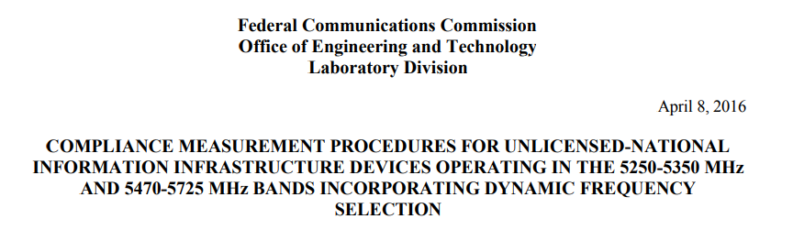
/*******************start********************/
5.1.1 Master Devices
a) The Master Device will use DFS in order to detect Radar Waveforms with received signal strength above the DFS Detection Threshold in the 5250 − 5350 MHz and 5470 − 5725 MHz bands. DFS is not required in the 5150 − 5250 MHz or 5725 − 5825 MHz bands.
b) Before initiating a network on a Channel, the Master Device will perform a Channel Availability Check for a specified time duration (Channel Availability Check Time) to ensure that there is no radar system operating on the Channel, using DFS described under subsection a) above.
c) The Master Device initiates a U-NII network by transmitting control signals that will enable other U-NII devices to Associate with the Master Device.
d) During normal operation, the Master Device will monitor the Channel (In-Service Monitoring) to ensure that there is no radar system operating on the Channel, using DFS described under a).
e) If the Master Device has detected a Radar Waveform during In-Service Monitoring as described under d), the Operating Channel of the U-NII network is no longer an Available Channel. The Master Device will instruct all associated Client Device(s) to stop transmitting on this Channel within the Channel Move Time. The transmissions during the Channel Move Time will be limited to the Channel Closing Transmission Time.
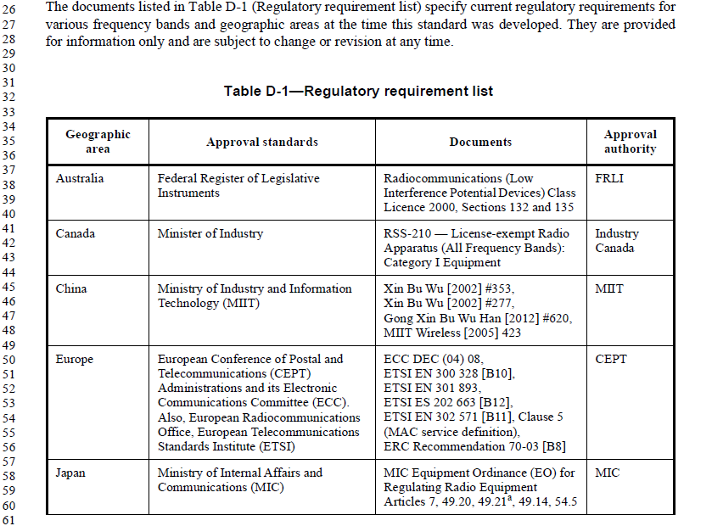
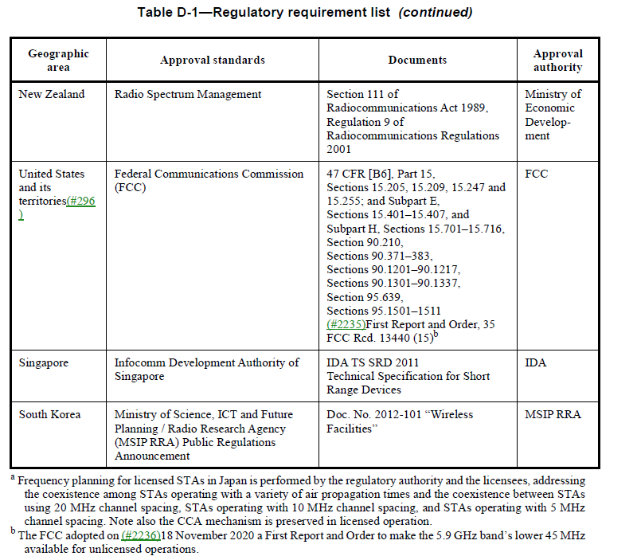

/*******************end********************/
Obviously, when the AP MLD disables a link on DFS channel and intends to resume it, the AP MLD shall guarantee no radar signal detected on that channel in advance, like perform CAC procedure again .
TGbe editor: Please note baselines are Draft P802.11be_D2.2 and REVme D1.0

TGbe editor: Please incorporate the following change in subclause 35.3.7.1.1 General
A STA affiliated with an MLD that operates on a link disabled by an advertised TID-to-link mapping (see 35.3.7.1.7 (Advertised TID-to-link mapping in Beacon and Probe Response frames(#14054))) shall suspend all wireless functionalities on that link until the link is enabled. (#14054)
NOTE 1— Suspension of wireless functionalities refers to functionalities such as frame generation, schedules, scoreboard maintenances, etc., while still preserving previously negotiated parameters with the peer EHT STA(s)
NOTE 2—Group addressed frames delivery procedure is defined in 35.3.15 (Multi-link group addressed frame delivery and reception).
If a link that is setup on a DFS owner’s operating channel is advertised as disabled by AP MLD(see 35.3.7.1.7 (Advertised TID-to-link mapping in Beacon and Probe Response frame), then before resuming operations on it (i.e., enabling the link), the AP MLD shall perform procedures described in 11.8 (DFS procedures) to ensure that a radar is not detected on the channel shall comply with the applicable regulatory requirements. ( #10013)”
If a TID is mapped in UL to a set of enabled links for a non-AP MLD, then the non-AP MLD may use any link within this set of enabled links to transmit individually addressed MSDUs or A-MSDUs (#12628)that are destined to the AP MLD and that correspond to that TI

