IEEE P802.11
Wireless LANs
LB266 CR for CR10013
Date: Oct 19, 2022
Author(s):
Name | Affiliation | Address | Phone | email
Jay Yang | Nokia |  |  | Zhijie.yang@nokia-sbell.com
Kasslin Mika
Lorenzo Galati Giordano
Okan Mutgan
Jianguo Liu |  |  |  | jianguo.a.liu@nokia-sbell.com

Abstract
This submission proposes resolutions for following 1 CID received for TGbe LB266:
10013

Revisions:
- Rev 0: Initial version of the document.

Interpretation of a Motion to Adopt

A motion to approve this submission means that the editing instructions and any changed or added material are actioned in the TGbe Draft. This introduction is not part of the adopted material.

Editing instructions formatted like this are intended to be copied into the TGbe Draft (i.e. they are instructions to the 802.11 editor on how to merge the text with the baseline documents).

TGbe Editor: Editing instructions preceded by “TGbe Editor” are instructions to the TGbe editor to modify existing material in the TGbe draft. As a result of adopting the changes, the TGbe editor will execute the instructions rather than copy them to the TGbe Draft.

CID | Commenter | Page | Clause | Comment | Proposed Change | Resolution
10013 | Jay Yang | 427.05 | 35.3.7 | if one of the affiliated AP operating on CAC state, the link should be disable and enabled again once it's out of CAC mode. | 11be SPEC should have a solution to indicate the CAC mode and the remaing time, so that the non-AP MLD can decide whether to associated with such AP MLD. | Revised—  Agree in principle with the comment. More detailed discussion for this aspect  And the proposal change  can be found in 1782r0  TGbe editor please implement changes as shown in doc 1782r0  tagged as 10013

Discussion:
The following text copy from:
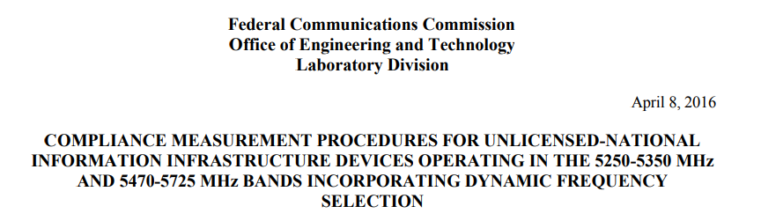
/*******************start********************/
7.8.2.1 Initial Channel Availability Check Time
The Initial Channel Availability Check Time tests that the UUT does not emit beacon, control, or data signals on the test Channel until the power-up sequence has been completed and the U-NII device checks for Radar Waveforms for one minute on the test Channel. This test does not use any Radar Waveforms and only needs to be performed one time.
a) The U-NII devices will be powered on and be instructed to operate on the appropriate U-NII Channel that must incorporate DFS functions. At the same time the UUT is powered on, the spectrum analyzer will be set to zero span mode with a 3 MHz RBW and 3 MHz VBW on the Channel occupied by the radar (Chr) with a 2.5 minute sweep time. The spectrum analyzer’s sweep will be started at the same time power is applied to the U-NII device.
b) The UUT should not transmit any beacon or data transmissions until at least 1 minute after the completion of the power-on cycle.
c) Confirm that the UUT initiates transmission on the channel
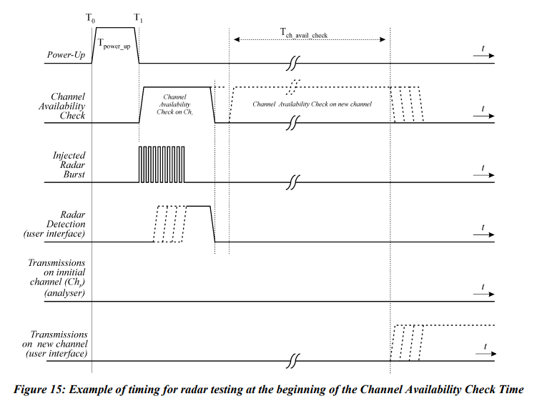
/*******************end********************/
Obviously, the affiliated AP doesn’t suspend its wireless functionalities when it’s in disabled mode and in CAC state.

TGbe editor: Please note baselines are Draft P802.11be_D2.2 and REVme D1.0

TGbe editor: Please incorporate the following change in subclause 35.3.7.1.1 General
A STA affiliated with an MLD that operates on a link disabled by an advertised TID-to-link mapping (see 35.3.7.1.7 (Advertised TID-to-link mapping in Beacon and Probe Response frames(#14054))) shall suspend all wireless functionalities except detecting radar operation subject to (11.8 DFS procedures) on that link until the link is enabled. (#14054)( #10013)
NOTE 1— Suspension of wireless functionalities refers to functionalities such as frame generation, schedules, scoreboard maintenances, etc., while still preserving previously negotiated parameters with the peer EHT STA(s)

