IEEE P802.11
Wireless LANs
LB266 Remaining CR on EHT PHY Introduction
Date: 2022-10-10
Author(s):
Name | Affiliation | Address | Phone | email
Kanke Wu | Qualcomm Inc |  |  | kankew@qti.qualcomm.com
Bin Tian | Qualcomm Inc

Abstract
This submission proposes resolutions for the following 7 comments from CC36 in P802.11be D2.0:
12133, 11332, 12476, 10923, 12013, 13114, 11214

This proposed text changes in this document are based on TGbe Draft 2.0

Revisions:

- Rev 0: Initial version of the document.

CID 12133

CID | Clause | Page.Line | Comment | Proposed Change | Resolution
12133 | 36.1.1 | 542.40 | An EHT STA shall support the transmission of the EHT-SIG field in an EHT MU PPDU at EHT-MCS 0, 1, 3 and 15 as well. | Change "Reception of the EHT-SIG field in an EHT MU PPDU at EHT-MCS 0, 1, 3, and 15."  to "Transmission and reception of the EHT-SIG field in an EHT MU PPDU at EHT-MCS 0, 1, 3, and 15." | ACCEPTED

Background:

CID 11332

CID | Clause | Page.Line | Comment | Proposed Change | Resolution
11332 | 36.1.1 | 544.63 | There are some duplications on the mandatory support of 2x LTF+0.8us GI, 2x LTF+1.6us GI and 4x LTF+3.2us GI for MU PPDU. May want to cean up | as in the comment | REVISED  Instructions to the editor:  Please make the changes indicated in document DCN:22/1770r0

Background:
The following sections are current descriptions regarding EHT-LTF+GI support for EHT MU PPDU:
In an EHT STA shall support section:
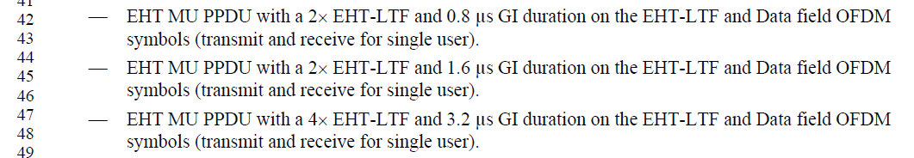
In an EHT AP shall support section:
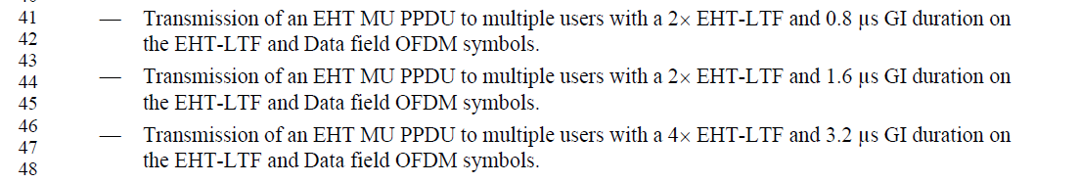
In A non-AP EHT STA shall support section:
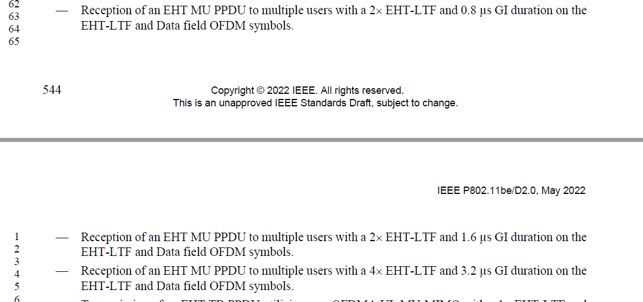
In terms of SU transmission and MU PPDU reception support, we have these two following bullets:
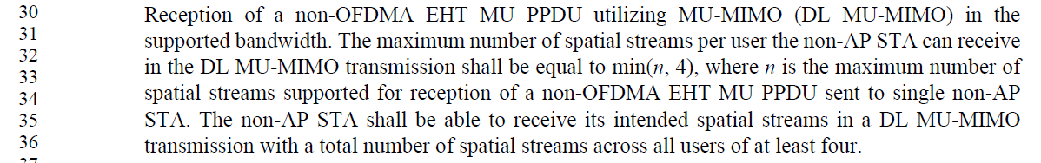
Discussion:
The current requirements under “EHT STA shall support” section are only for single user use case. The requirements under “EHT AP shall support” and “EHT non-AP STA shall support” are requirements for multiple users.
However, there are currently separate requirements in the spec specifying the single user and multiple user support uses cases under all 3 sections. If we ignore the specific use cases, the EHT-LTF+GI support requirement is the same for all 3 sections. And should be combined into one as the commenter suggested.
Instructions to the editor:
In D2.0 P542L42, please make the following indicated changes:
—EHT MU PPDU with a 2xEHT-LTF and 0.8 μs GI duration on the EHT-LTF and Data field OFDM symbols (transmit and receive).
—EHT MU PPDU with a 2xEHT-LTF and 1.6 μs GI duration on the EHT-LTF and Data field OFDM symbols (transmit and receive).
—EHT MU PPDU with a 4xEHT-LTF and 3.2 μs GI duration on the EHT-LTF and Data field OFDM symbols (transmit and receive).
In D2.0 P543L41, delete the following bullets:

In D2.0 P544L63, delete the following bullets:

Note: the requirements under “EHT AP shall support” and “non-AP EHT STA shall support” section regarding EHT-LTF+GI support for EHT TB PPDU remain unchanged.

CID 12476

CID | Clause | Page.Line | Comment | Proposed Change | Resolution
12476 | 36.1.1 | 541.41 | One of the major, practical methods to increase the total AP throughput (not necessarily per-STA) is increase the number of streams, specifically for MU-MIMO. This was one of the original aims of EHT. | Define more than 8 streams. | REJECTED  According to previous agreement in the group. We agreed to not define 16ss in 11be and there will not be changes to the existing signalling. See also CID 12214 in DCN 22/1104r3.  The SP is shown here: " Do you agree that 802.11be shall not define operation with more than 8 spatial streams and that the format of all subfields related to spatial streams shall remain unchanged (i.e. no changing the number of bits)?" and the result in PHY ad-hoc was 22Y, 4N, 5A while the result in Joint was 51Y, 12N, 26A".

CID 10923

CID | Clause | Page.Line | Comment | Proposed Change | Resolution
10923 | 36.1.1 | 543.38 | Mobile AP is defined in MAC. As non-AP STA's mandatory capability for 6GHz is 80MHz, we should relax the mandatory capability for 6GHz of the mobile AP to 80MHz. | As in the comment. | REJECTED  802.11 spec only covers the requirements of general APs. While mobile APs may support a subset of the features of general APs, there is no discussions so far to define mobile AP requirement sets so it will not be listed here.

Background:
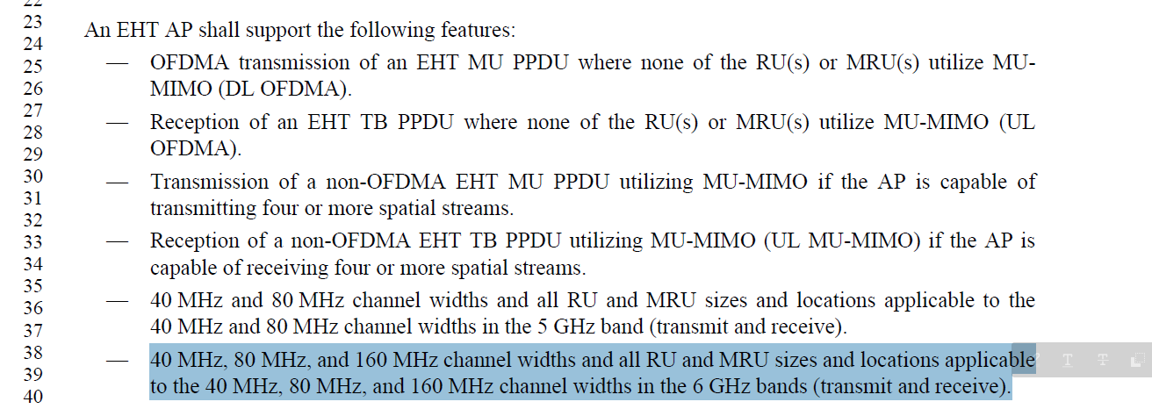

CID 12013

CID | Clause | Page.Line | Comment | Proposed Change | Resolution
12013 | 36.1.1 | 545.20 | Need to add description for SST into the optional feature similar to the 20 MHz operating non-AP EHT STA case. | As in comment. | REJECTED  SST is mainly a MAC feature. The PHY requirements section discuss the 20Mhz operation STA support of SST is mainly to highlight the RU/MRU restrictions for 20 MHz operating devices when it operates in the SST. This RU/MRU restrictions only applies to 20MHz operating STA and hence there’s no need to mention it for general non-AP STAs.  This decision is also consistent with the style used in 11ax standard.

Background:
In “20 MHz operating non-AP EHT STA may support” section, we had the following:
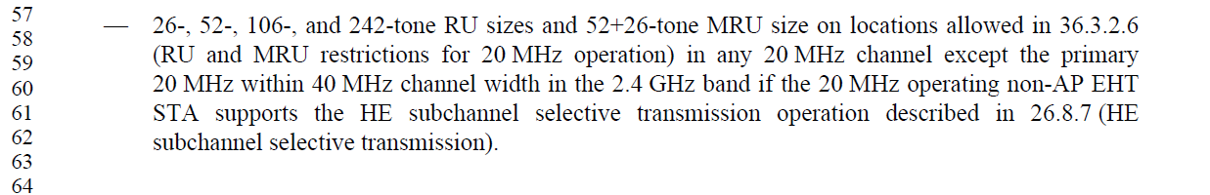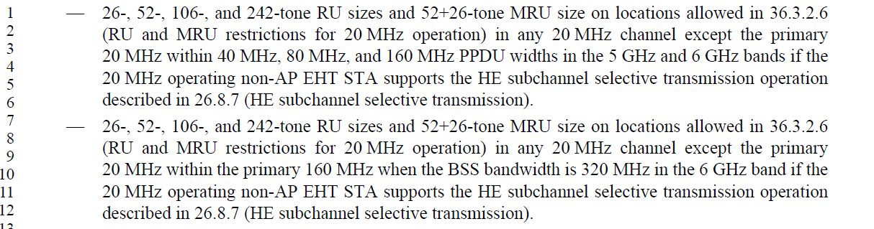

CID 13114

CID | Clause | Page.Line | Comment | Proposed Change | Resolution
13114 | 36.1.1 | 541.01 | There is an error in the PHY | Commenter will provide more details later. | REJECTED  Commenter failed to provide details on this issue.

Background:

CID 11214

CID | Clause | Page.Line | Comment | Proposed Change | Resolution
11214 | 36.1.1 | 543.20 | text: 320 MHz channel width RU and MRU size larger than 996 tones in the 6 GHz band (transmit and  receive).  expected the size is larger than 2x996 tones. | replace 996 by 2x996 | REVISED  Instructions to the editor:  Please make the changes indicated in document DCN: 22/1770r0

Background and discussion:
As Bo Gong has noted in 11/22-1479r1, in the 6 GHz band, AP is mandatory to support 160MHz operating channel width:

802.11be AP is mandatory to support the following:
• 160 MHz operating channel width in 6 GHz band
• 80 MHz operating channel width in 5 GHz band
• 20 MHz operating channel width in 2.4 GHz band
NOTE – “soft AP” is TBD.
[Motion 124, #SP178, [1] and [2]]
A non-AP STA is mandatory to support only up to 80MHz operating channel width:

It is mandatory for a non-AP STA to support 80 MHz operating channel width in 5 and 6 GHz bands.
• Except for 20 MHz only client (if defined in EHT).
[Motion 124, #SP179, [1] and [2]]

The optional support RU size is different in the 6 GHz for EHT AP and non-AP STAs. Based on previous discussions, it is better to separate the optional support description in the 6 GHz band for the AP side and non-AP STA side.
We propose to delete this requirement under “EHT STA may support” section and replace it with separate bullets in the “EHT AP may support” section and “non-AP EHT STA may support” section to reflect the different requirements more accurately.
Instructions to the editor:
Delete the following bullet at P543L20 in D2.0

Insert the following bullet at P544L19 “An EHT AP may support the following:”
—320 MHz channel width and all RU and MRU sizes larger than 2x996 tones in the 6 GHz band (transmit and receive).
Insert the following bullet at P545L40 “A non-AP EHT STA may support the following:”
—320 MHz channel width and all RU and MRU sizes larger than 996 tones in the 6 GHz band (transmit and receive).

