IEEE P802.11  
Wireless LANs

|  |  |  |  |  |
| --- | --- | --- | --- | --- |
| CC40 CR for Topic Threshold – Part 2 | | | | |
| Date: 2022.10.12 | | | | |
| Author(s): | | | | |
| Name | Company | Address | Phone | email |
| Mengshi Hu | Huawei Technologies | H3, Huawei Base, Bantian, Longgang, Shenzhen, Guangdong, China, 518129 |  | humengshi@huawei.com |
| Rui Du |  |  |  |
| Narengerile |  |  |  |
| Stephen McCann |  |  |  |

Abstract

This submission contains the proposed comment resolutions for the following 6 CIDs in the Topic “Threshold” shown in 22/0820 IEEE 802.11bf CC40 comments.

CIDs 128, 283, 284, 286, 435, 559.

Revision Notes

|  |  |
| --- | --- |
| R0 | Initial version |

## CID 128

|  |  |  |  |  |
| --- | --- | --- | --- | --- |
| Page.  Line | Clause Number | Comment | Proposed Change | Resolution |
| 70.50 | 11.21.18.6.5 | "Threshold-based reporting phase" is not shown in any of the examples (Figure 11-41c). | include an example with Threshold-based reporting. | REVISED.  Add sentences saying that the reporting phase can be the basic reporting phase, the threshold-based reporting phase, or both.  ***Instructions to the editor:***  **Please make the changes as shown under CID 128 in 11-22/1758r0.** |

***Instructions to the editor: please add the following paragraph to Line 1, Page 94 in the subclause 11.21.18.6.1 General in 802.11bf D0.3 as shown below:***

Note that the reporting phase in Figure 11-41c (Example of TB sensing measurement instances) can be a basic reporting phase, a threshold-based reporting phase, or both of them. In the case that both the basic reporting phase and the threshold-based reporting phase exist, the basic reporting phase is present as the measurement reporting subphase of the threshold-based reporting phase.

Discussion:

The corresponding figure in 11.21.18.6 TB sensing measurement instance is shown below. As shown in 802.11bf D0.3, the reporting phase of a TB sensing measurement instance has two variants: The basic reporting phase (see 11.21.18.6.5 (Basic reporting phase)), and the threshold-based reporting phase (see 11.21.18.6.6 (Threshold-based reporting phase)). Thus, there is no need to show an example with the threshold-based reporting explicitly. However, to make it clear, I agree that some sentences can be added to show that the reporting phase can be either the basic one, the threshold-based one, and both.

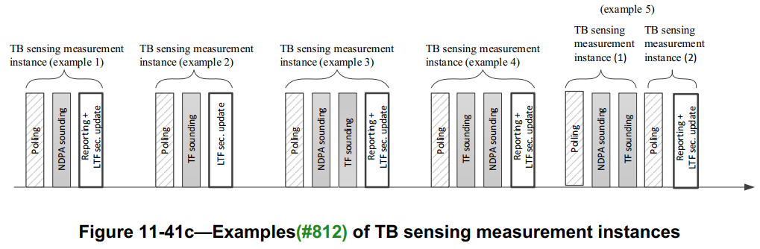

The second added sentence shows what is the basic phase when both the basic reporting phase and the threshold-based reporting phase exist.

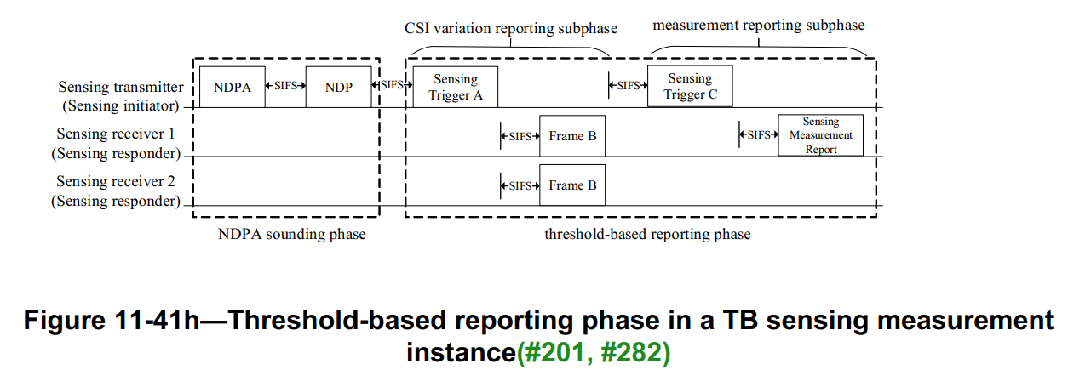

According to some discussions, this figure may be changed into the following format by some CIDs. Since there is still a reporting phase here, the above resolution still applies to the new figure.

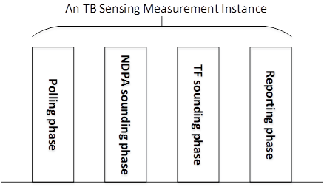

Discussion ends.

## CID 283

|  |  |  |  |  |
| --- | --- | --- | --- | --- |
| Page.  Line | Clause Number | Comment | Proposed Change | Resolution |
| 70.52 | 11.21.18.6.5 | Clarify whether the threshold-based reporting is applicable to other scenarios. | As in the comment. | REJECTED  As shown in 802.11bf D0.3, the threshold-based reporting phase only exists in the TB sensing measurement instance. At present, there is no discussion to extend its applicable scenarios. |

## CID 284

|  |  |  |  |  |
| --- | --- | --- | --- | --- |
| Page.  Line | Clause Number | Comment | Proposed Change | Resolution |
| 70.64 | 11.21.18.6.5 | Need to add details about how to calculate and quantify the CSI variation. | As in the comment. | REVISED.  Add sentences describing how to calculate and quantify the CSI variation.  ***Instructions to the editor:***  **Please make the changes as shown under CID 284 in 11-22/1758r0.** |

***Instructions to the editor: please make the following changes to Line 39, Page 97 in the subclause 11.21.18.6.6 Threshold-based reporting phase in D0.3 as shown below:***

* The CSI variation value determined by a sensing responder indicates the quantified difference between the current measured CSI and the previous measured CSI at the sensing responder. The selection method of the CSI variation value is implementation specific, but it shall follow the following rules:The CSI variation value shall belong to the closed interval [0, 1].
* A larger CSI variation value shall reflect a larger degree of CSI variation.
* The CSI variation value equal to 0 shall indicate the lowest degree of CSI variation.
* The CSI variation value equal to 1 shall indicate the highest degree of CSI variation.
* Note: Which case corresponds to the CSI variation value equal to 0 or 1 is implementation specific.

## CID 286 & 435

|  |  |  |  |  |
| --- | --- | --- | --- | --- |
| Page.  Line | Clause Number | Comment | Proposed Change | Resolution |
| 70.36  **(CID 286)** | 11.21.18.6.5 | The name of Sensing Trigger frame A, Frame B and Sensing Trigger frame C are suggested to be given. | As in the comment. | REVISED.  Agree in principle. Some more accurate names should be given to replace Frames A, B and C.  ***Instructions to the editor:***  **Please make the changes as shown under CID 435 in 11-22/1758r0.** |
| 70.10  **(CID 435)** | 11.21.18.6.5 | "sensing Trigger A" is a confusing name for a frame that acually polls for responses. | consider replacing "Sensing Trigger A" with "Threshold Reporting Poll Trigger" and "Sensing Trigger C" with "Threshold Reporting Measuremnet Poll Trigger" | REVISED.  Agree in principle. Some more accurate names should be given to replace Frames A, B and C.  ***Instructions to the editor:***  **Please make the changes as shown under CID 435 in 11-22/1758r0.** |

***Instructions to the editor: please make the following changes to in the subclause 11.21.18.6.6 Threshold-based reporting phase in D0.3 as shown below:***

Replace all “Sensing Trigger Frame A” with “Sensing Threshold-Based Report Poll Trigger frame”

Replace all “Sensing Trigger Frame B” with “Sensing CSI Variation Feedback frame”

Replace all “Sensing Trigger Frame C” with “Sensing Report Trigger frame”

Discussion:



According to 802.11bf draft 0.3 and other discussions, the Sensing Trigger frame could be: Sensing Poll Trigger frame, Sensing Sounding Trigger frame, Sensing Report Trigger frame. Thus, it is natural to make the following changes:

* Replace “Sensing Trigger Frame A” with “Sensing Threshold-Based Report Poll Trigger frame”
* Replace “Frame B” with “Sensing CSI Variation Feedback frame”
* Replace “Sensing Trigger Frame C” with “Sensing Report Trigger frame”

Note: The detailed designs of these frame will be resolved in some other CIDs.

Discussion ends.

## CID 559

|  |  |  |  |  |
| --- | --- | --- | --- | --- |
| Page.  Line | Clause Number | Comment | Proposed Change | Resolution |
| 71.06 | 11.21.18.6.5 | The threshold information can be exchanged during the sensing measurement setup phase. So this value can be included in the sensing measurement setup request frame. | Modify "a TBD frame" with "a Sensing Measurement Setup Request frame " | REVISED.  Add a CSI Variation Threshold subfield in the Sensing Measurement Parameters field.  ***Instructions to the editor:***  **Please make the changes as shown under CID 559 in 11-22/1758r0.** |

***Instructions to the editor: please make the following changes to Line 49, Page 48 in the subclause 9.4.2.317 Sensing Measurement Parameters element in D0.3 as shown below:***

|  |  |  |  |  |  |  |  |
| --- | --- | --- | --- | --- | --- | --- | --- |
|  | Sensing Transmitter | Sensing Receiver | Sensing Measurement Report Requested | Sensing Measurement Report Type | Measurement Setup Expiry Exponent | CSI Variation Threshold | TBD |
| Bits | 1 | 1 | 1 | 3 | 4 | 4 | TBD |

**Figure 9-1002av— Sensing Measurement Parameters field format**

***Instructions to the editor: please add the following sentence to Line 28, Page 49 in the subclause 9.4.2.317 Sensing Measurement Parameters element in D0.3 as shown below:***

The CSI Variation Threshold subfield indicates the threshold set by the sensing initiator for the threshold-based reporting phase in the corresponding TB sensing measurement instances. The values of the CSI Vairation Threshold subfield are defined in Table x-xx (CSI Variation Threshold subfield Definition).

Table x-xx CSI Variation Threshold subfield Definition

|  |  |
| --- | --- |
| Value | Description |
| 0 | 0 |
| 1 | 0.1 |
| 2 | 0.2 |
| 3 | 0.3 |
| 4 | 0.4 |
| 5 | 0.5 |
| 6 | 0.6 |
| 7 | 0.7 |
| 8 | 0.8 |
| 9 | 0.9 |
| 10 | 1 |
| 11-15 | Reserved |

***Instructions to the editor: please add the following sentence to Line 47, Page 97 in the subclause 11.21.18.6.6 Threshold-based reporting phase in D0.3 as shown below:***

The CSI variation threshold for each sensing responder to be compared with the CSI variation value is determined by the sensing initiator, and is transmitted to each sensing responder within a Sensing Measurement Setup Request frame. Different sensing responders may have different threshold values set by the sensing initiator.

## SP

Do you support the proposed resolutions to the following CIDs and incorporate the text changes into the latest TGbf draft: 128 283 284 286 435 559?

Y/N/A