IEEE P802.11
Wireless LANs

CR for Miscellaneous CIDs
Date: 2022-10-11
Author(s):
Name | Affiliation | Address | Phone | email
Yunbo Li | Huawei |  |  | liyunbo@huawei.com
Ming Gan
Yuchen Guo
Guogang Huang
Yousi Lin
Zhenguo Du
Stephen McCann
Edward Au

Abstract
This submission proposes comment resolution(s) for the following 10 CID(s) received in LB266 on TGbe D2.2

CIDs:
11527, 11837, 11838, 10142, 12045, 12114, 12175, 12570, 13743, 13406

11527, 11837, 10142, 12045, 12114, 12175, 12570, 13743, 13406

Revisions:
- Rev 0: Initial version of the document.
- Rev 1: CID 13406 is added

CID | Commenter | Clause | P.L | Comment | Proposed Change | Resolution
11527 | Xiaofei Wang | 10.2.1 | 279.36 | it is not clear which part of Figure 10-1 is changed | as in comment | Rejected  As per the editing instruction provided by IEEE SA, there is no need to show the change of an updated figure with respect to the previous one.
11837 | Alfred Asterjadhi | 10.2.1 | 279.34 | Incorrect instructon to the editor. Replace "Change" with Replace" | As in comment. | Accepted

Backgroud text:

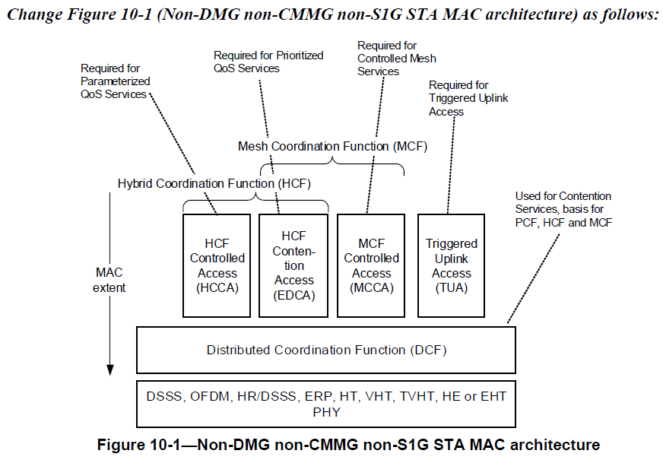

11838 | Alfred Asterjadhi | 10.1 | 279.16 | I think we need to add a couple more refs here (or in EHT channel access itself): EPCS, TXOP sharing, R-TWT. | As in comment. | Rejected  Since it is just a high level description in the introduction subclause. To keep the text simple, it doesn’t need to list all optional features one by one.

TGbe editor: Please make the following changes in subclause 10.1 (Introduction):

10.1 Introduction

The MAC functional description is presented in this clause. The architecture of the MAC sublayer, including the distributed coordination function (DCF), the hybrid coordination function (HCF), the mesh coordination function (MCF), the triggered UL access (TUA), and their coexistence in an IEEE 802.11 LAN are intro-duced in 10.2 (MAC architecture). These functions are expanded on in 10.3 (DCF), 10.23 (HCF), 10.24 (Mesh coordination function (MCF)), 26.2 (HE channel access), 35.2 (EHT channel access), and 35.3.15 (Multi-link group addressed frame delivery and reception). Fragmentation and defragmentation are defined in 10.4 (MSDU and MMPDU fragmentation) and 10.5 (MSDU and MMPDU defragmentation). Multirate sup-port is addressed in 10.6 (Multirate support). A number of additional restrictions to limit the cases in which MSDUs are reordered or discarded are described in 10.7 (MSDU transmission restrictions). Operation across regulatory domains is defined in 10.22 (Operation across regulatory domains). The block ack mechanism is described in 10.25 (Block acknowledgment (block ack)). The No Ack mechanism is described in 10.26 (No Acknowledgment (No Ack)). The protection mechanism is described in 10.27 (Protection mechanisms). Rules for processing MAC frames are described in 10.28 (MAC frame processing).

CID | Commenter | Clause | P.L | Comment | Proposed Change | Resolution
10142 | Ulrich Sinn | 9.2.4 | 119.07 | Superfluent opening bracket in heading "Frame (fields" | Remove superfluent opening bracket and update table of contents | Accepted
12045 | Massinissa Lalam | 9.2.4 | 119.07 | Typo in the subclause 9.2.4 title: remove extra parenthesis ( as it should read "Frame fields" and not "Frame (fields" | As in comment | Revised  Agree with the commenter.  TGbe editor to make changes in 11-22/1744r1 under CID 10142
12114 | JINYOUNG CHUN | 9.2.4 | 119.07 | Delete '(' in the subclause title | As the comment | Revised  Agree with the commenter.  TGbe editor to make changes in 11-22/1744r1 under CID 10142
12175 | Takuhiro Sato | 9.2.4 | 12.07 | typo: Blackets are not closed in the section of 9.2.4. "Frame (fields" should be "9.2.4 Frame (fields)". |  | Revised  Agree with the commenter.  TGbe editor to make changes in 11-22/1744r1 under CID 10142
12570 | Mahmoud Kamel | 9.2.4 | 119.07 | Missing closing parenthesis ")". | Insert the missing right parenthesis ")" | Revised  Agree with the commenter.  TGbe editor to make changes in 11-22/1744r1 under CID 10142
13743 | Yuchen Guo | 9.2.4 | 119.07 | typo on "(" | Delete "(" | Revised  Agree with the commenter.  TGbe editor to make changes in 11-22/1744r1 under CID 10142

TGbe editor: Please make the following changes in subclause title of 9.2.4:

9.2.4 Frame fields (#10142)

CID | Commenter | Clause | P.L | Comment | Proposed Change | Resolution
13406 | Liwen Chu | 35.3.16.8.2 | 460.52 | The MediumSyncDelay timer is started right after its Txed PPDU. This will not happen. | Fix the issues mentioned in the comment | Rejected.  The comment fails to point out what issue it is. It is true the MediumSyncDelay timer starts right after the transmitted PPDU, the detection of channel of aCCAtime happens when the beginning of MediumSyncDelay timer starts. No issue is found here.

Backgroud text:

During the aCCAtime (see 36.3.21.6.3 (CCA sensitivity for the primary 20 MHz channel (#11304))) immediately following the end of the transmission event that caused loss of medium synchronization and subsequent initiation of the MediumSyncDelay timer at the non-AP STA, if the received signal strength exceeds the –62 dBm threshold for the primary 20 MHz channel and no start of a PPDU is detected, the STA should defer for EIFS beginning when the received signal strength falls below the threshold.

