IEEE P802.11
Wireless LANs

CR for Miscellaneous CIDs
Date: 2022-10-11
Author(s):
Name | Affiliation | Address | Phone | email
Yunbo Li | Huawei |  |  | liyunbo@huawei.com
Ming Gan
Yuchen Guo
Guogang Huang
Yousi Lin
Zhenguo Du
Stephen McCann
Edward Au

Abstract
This submission proposes comment resolution(s) for the following 9 CID(s) received in LB266 on TGbe D2.2

CIDs:
11527, 11837, 11838, 10142, 12045, 12114, 12175, 12570, 13743

Revisions:
- Rev 0: Initial version of the document.

CID | Commenter | Clause | P.L | Comment | Proposed Change | Resolution
11527 | Xiaofei Wang | 10.2.1 | 279.36 | it is not clear which part of Figure 10-1 is changed | as in comment | Rejected  As per the editing instruction provided by IEEE SA, there is no need to show the change of an updated figure with respect to the previous one.
11837 | Alfred Asterjadhi | 10.2.1 | 279.34 | Incorrect instructon to the editor. Replace "Change" with Replace" | As in comment. | Accepted

Backgroud text:

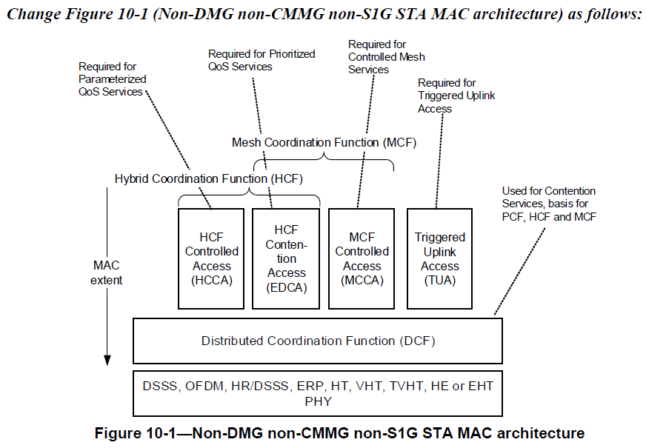

11838 | Alfred Asterjadhi | 10.1 | 279.16 | I think we need to add a couple more refs here (or in EHT channel access itself): EPCS, TXOP sharing, R-TWT. | As in comment. | Revised  Agree with the commenter.  TXOP sharing is already covered in 35.2 (EHT channel access).  The following subclauses are added:  ML channel access: 35.3.16 Multi-link channel access  R-TWT: 35.8 Restricted TWT (r-TWT)  EPCS: 35.16 EPCS priority access  TGbe editor to make changes in 11-22/1744r0 under CID 11838

TGbe editor: Please make the following changes in subclause 10.1 (Introduction):

10.1 Introduction

The MAC functional description is presented in this clause. The architecture of the MAC sublayer, including the distributed coordination function (DCF), the hybrid coordination function (HCF), the mesh coordination function (MCF), the triggered UL access (TUA), and their coexistence in an IEEE 802.11 LAN are intro-duced in 10.2 (MAC architecture). These functions are expanded on in 10.3 (DCF), 10.23 (HCF), 10.24 (Mesh coordination function (MCF)), 26.2 (HE channel access), 35.2 (EHT channel access), 35.3.15 (Multi-link group addressed frame delivery and reception), 35.3.16 (Multi-link channel access), 35.8 (Restricted TWT (R-TWT)), and 35.16 (EPCS priority access) (#11838). Fragmentation and defragmentation are defined in 10.4 (MSDU and MMPDU fragmentation) and 10.5 (MSDU and MMPDU defragmentation). Multirate sup-port is addressed in 10.6 (Multirate support). A number of additional restrictions to limit the cases in which MSDUs are reordered or discarded are described in 10.7 (MSDU transmission restrictions). Operation across regulatory domains is defined in 10.22 (Operation across regulatory domains). The block ack mechanism is described in 10.25 (Block acknowledgment (block ack)). The No Ack mechanism is described in 10.26 (No Acknowledgment (No Ack)). The protection mechanism is described in 10.27 (Protection mechanisms). Rules for processing MAC frames are described in 10.28 (MAC frame processing).

CID | Commenter | Clause | P.L | Comment | Proposed Change | Resolution
10142 | Ulrich Sinn | 9.2.4 | 119.07 | Superfluent opening bracket in heading "Frame (fields" | Remove superfluent opening bracket and update table of contents | Accepted
12045 | Massinissa Lalam | 9.2.4 | 119.07 | Typo in the subclause 9.2.4 title: remove extra parenthesis ( as it should read "Frame fields" and not "Frame (fields" | As in comment | Revised  Agree with the commenter.  TGbe editor to make changes in 11-22/1744r0 under CID 10142
12114 | JINYOUNG CHUN | 9.2.4 | 119.07 | Delete '(' in the subclause title | As the comment | Revised  Agree with the commenter.  TGbe editor to make changes in 11-22/1744r0 under CID 10142
12175 | Takuhiro Sato | 9.2.4 | 12.07 | typo: Blackets are not closed in the section of 9.2.4. "Frame (fields" should be "9.2.4 Frame (fields)". |  | Revised  Agree with the commenter.  TGbe editor to make changes in 11-22/1744r0 under CID 10142
12570 | Mahmoud Kamel | 9.2.4 | 119.07 | Missing closing parenthesis ")". | Insert the missing right parenthesis ")" | Revised  Agree with the commenter.  TGbe editor to make changes in 11-22/1744r0 under CID 10142
13743 | Yuchen Guo | 9.2.4 | 119.07 | typo on "(" | Delete "(" | Revised  Agree with the commenter.  TGbe editor to make changes in 11-22/1744r0 under CID 10142

TGbe editor: Please make the following changes in subclause title of 9.2.4:

9.2.4 Frame fields (#10142)

