IEEE P802.11
Wireless LANs
TGbe LB266 Comment Resolutions on CID 11827 and 12115
Date: 2022-10-14
Author(s):
Name | Affiliation | Address | Phone | Email
Jinyoung Chun | LG Electronics | 19, Yangjae-daero 11gil, Seocho-gu, Seoul 137-130, Korea |  | jiny.chun@lge.com
Dongguk Lim |  |  |  | dongguk.lim@lge.com
Eunsung Park |  |  |  | esung.park@lge.com
Jinsoo Choi |  |  |  | js.choi@lge.com
Insun Jang |  |  |  | insun.jang@lge.com

Abstract
This submission proposes comment resolutions for 2 CIDs: 11827 and 12115
All the changes are based on P802.11be D2.2.

Revisions:
- Rev 0: Initial version of the document.

CID 11827
CID | Commenter | PP.LL | Comment | Proposed Change | Resolution
11827 | 9.2.4.6.1 | 122.04 | This new interpretation is only valid when the RDG/More PPDU bit is included in the CAS Control. Add a note to the table specifying that the Target STA case is present when bit is in CAS control as defined in x.y. | As in comment. | Revised  Agree with the commenter and just add note below.  For your information, other explain about the subfield is described in REVme as below: ‘In a non-HE HT STA, the RDG/More PPDU subfield and the AC Constraint subfield are present in the HTC field. In an HE STA, the RDG/More PPDU subfield and the AC Constraint subfield are present in the CAS Control subfield.’  To TGbe Editor:  Please add the note below the Table 9-17.  ‘NOTE: RDG/More PPDU subfield for the target STA in a MU-RTS TXS Trigger frame is present in the CAS Control subfield (See 9.2.4.6a.7 (CAS Control)).

Background: Table 9-17, CAS Control subfield, and text in subcluase 10.29 Reverse direction protocol

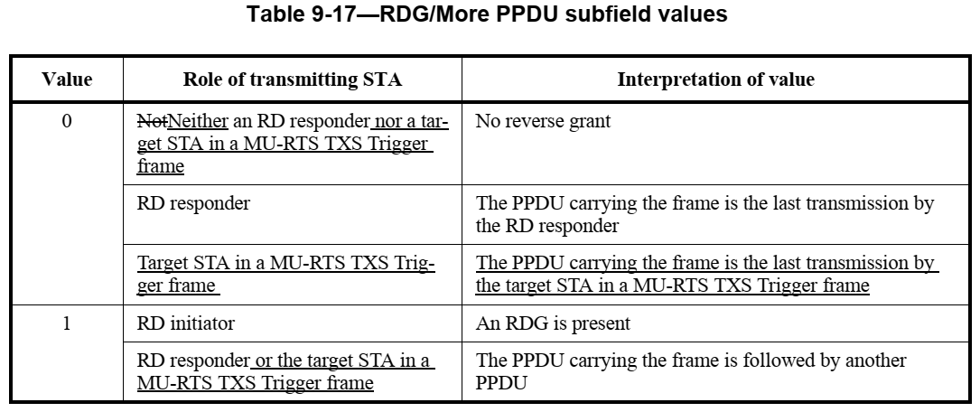

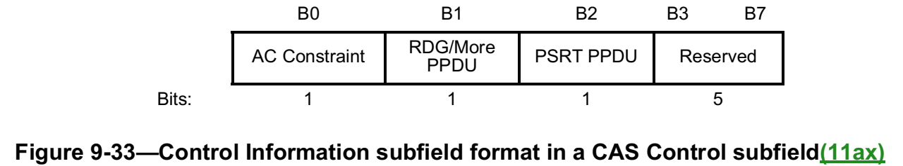

CID 12115
CID | Commenter | PP.LL | Comment | Proposed Change | Resolution
12115 | 9.2.4.6.4 | 122.38 | In 'Content of the Control Information  subfield' of Table 9-25, the subclauses of the reference are wrong. | In 'Content of the Control Information  subfield' of Table 9-25, modify the subclauses of the reference from '9.2.4.6a.1~9.2.4.6a.7' to '9.2.4.7.1' ~ '9.2.4.7.7' | Accepted

