IEEE P802.11
Wireless LANs
LB 266 CR for CID 12538
Date: 2022-09-29
Author(s):
Name | Affiliation | Address | Phone | email
Mahmoud Kamel | InterDigital |  |  | mahmoud.kamel@interdigital.com
Zinan Lin | InterDigital
Hanqing Lou | InterDigital
Rui Yang | InterDigital

Abstract
This submission proposes resolutions for CID 12538 in P802.11be D2.1.1:

NOTE – Set the Track Changes Viewing Option in the MS Word to “All Markup” to clearly see the proposed text edits.

Revision History:

R0: Initial version
R1: Editorial changes

CID 12538

CID | Clause | Page.Line | Comment | Proposed Change | Resolution
12538 | 36.3.12.7.2 | 657.07 | In the current design of EHT-SIG, some allocation scenarios would require a large number of EHT-SIG Symbols which cannot be accommodated in the U-SIG. One example is 144 users each allocated one 26-tone RU in 320 MHz channel. | Several solutions may be devised to allow for allocations with large number of users. I will bring a contribution to fix this issue. | Revised  Such allocation scenarios are allowed by the current specs, however this large number of EHT-SIG symbols cannot be signalled or accommodated. A sentence should be added to the EHT-SIG clause to disallow these allocation scenarios.  TGbe editor: please incorporate the changes shown in 11-22/1676r1 below.

DISCUSSION:
The Number of EHT SIG Symbols field in U-SIG2 of the MU-PPDU is 5 bits, hence the maximum number of EHT-SIG symbols that can be signaled is 32 symbols. Some RU or MRU allocation scenarios are allowed by the 802.11be specs, however the number of required EHT-SIG symbols to signal those scenarios cannot be accommodated by the current design of U-SIG.

Examples: For any small RU or MRU allocation in each 20 MHz of a 320 MHz bandwidth with a low EHT-SIG MCS (0, 1 or 3) and the EHT-SIG content channels are the same in each 80 MHz:
- RU Allocation = 0, EHT-SIG MCS = 0, 1, 3
- RU Allocation = 25, EHT-SIG MCS = 3
- RU Allocation = 55, EHT-SIG MCS = 0, 3
Number of EHT SIG Symbols per content channel | 38
Number of bits of U-SIG Overflow (bits) | 17
Number of bits of 2 RU Allocation-A +CRC + Tail (bits) | 28
Number of bits of 6 RU Allocation-B +CRC + Tail (bits) | 64
Number of Users per content channel (users) | 32
Number of bits of User Specific fields (bits) | 864
Total Number of Bits per content channel (bits) | 973
Number of Data bits per EHT-SIG Symbol (EGT-SIG MCS)  (See Table 36-88 below) | 26

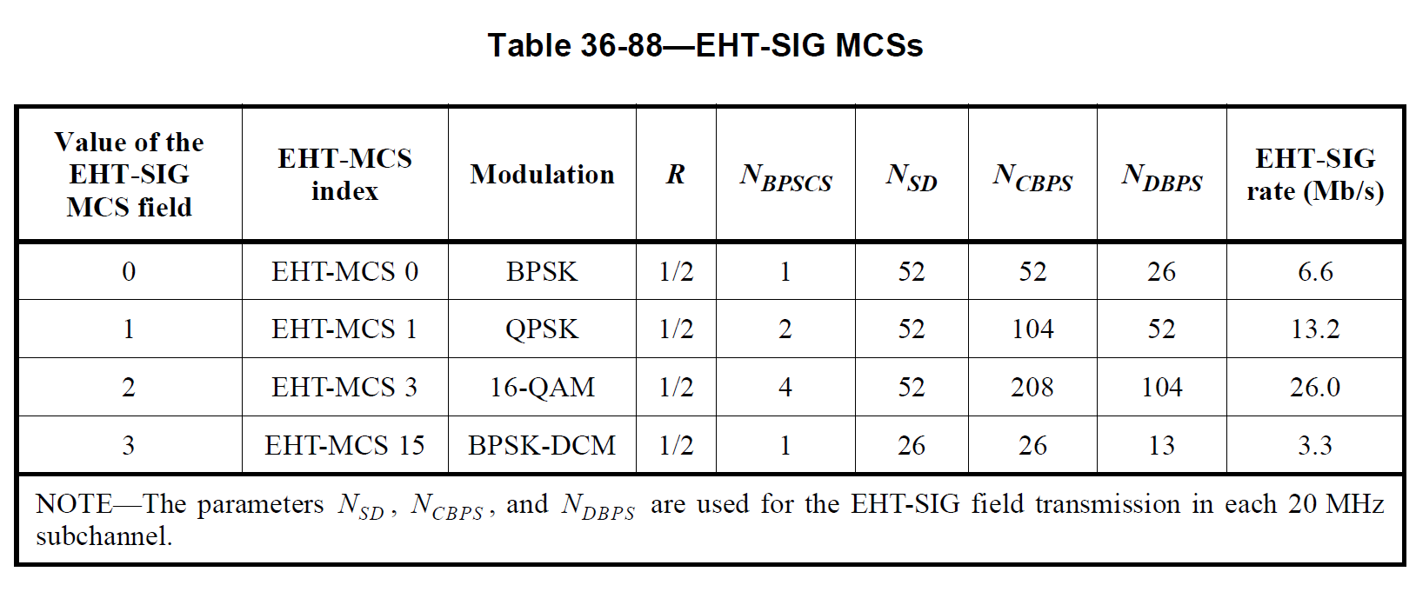
END OF DISCUSSION

TGbe Editor: Please insert the following text in Clause 36.3.12.8.2 EHT-SIG content channels in 11be D2.1.1 P685L1 as follows

NOTE - Any RU or MRU Allocation in combination with EHT-SIG MCS selection which results in a Number of EHT-SIG Symbols that is larger than 32 symbols is not allowed.
“Punctured 242-tone RU (value 26 of RU Allocation field)” shall be used when the preamble portion of corresponding 20 MHz is punctured. In this case, the corresponding 242-tone RU shall not be used for data transmission.

