IEEE P802.11
Wireless LANs
CC40 CR for CIDs on NDP
Date: 2022-09-28
Author(s):
Name | Affiliation | Address | Phone | email
Mahmoud Kamel | InterDigital |  |  | mahmoud.kamel@interdigital.com
Zinan Lin | InterDigital
Rui Yang | InterDigital

Abstract
This submission proposes resolutions for 3 CIDs (172, 545, 563) in subclause 11.21.18 in P802.11bf D0.1:

NOTE – Set the Track Changes Viewing Option in the MS Word to “All Markup” to clearly see the proposed text edits.

Revision History:

R0: Initial version
R1: Added PDT for SI2SR and SR2SI NDP formats
R2: Modified the instructions to Editor to split the PDT text into different parts and insert each in the relevant subclause

CID | Clause | Page.Line | Comment | Proposed Change | Resolution
172 | 11.21.18.7 | 71.57 | The formats of I2R NDP and R2I NDP are not decided yet. | Decide the format of I2R NDP and R2I NDP | Revised  The formats of SI2SR and SR2SI NDPs are decided to follow HE Ranging NDP and HE TB Ranging format when PPDU BW <=160 MHz and EHT Sounding NDP when PPDU BW = 320 MHz as proposed and SPed in DCN 11-22/1380 and motioned in (Motion 141 20/1874r73)  TGbf editor: please incorporate changes shown in 11-22/1673r2 below.
545 | 11.21.18.6 | 68.64 | In TB sensing measurement, R2I NDP and I2R NDP is used for senssing measurement. But, the format of those NDP is not defined. Pleae define the R2I NDP and I2R NDP format. | As in comment. | Revised  The formats of SI2SR and SR2SI NDPs are decided to follow HE Ranging NDP and HE TB Ranging format when PPDU BW <=160 MHz and EHT Sounding NDP when PPDU BW = 320 MHz as proposed and SPed in DCN 11-22/1380 and motioned in (Motion 141 20/1874r73)  TGbf editor: please incorporate changes shown in 11-22/1673r2 below.
563 | 11.21.18.7 | 71.54 | In the Non-TB sensing measurement, I2R NDP and R2I NDP is used, however, I could not find how to configure those type of NDP. Please define each type of NDP in the 11bf spec. | As in comment | Revised  The formats of SI2SR and SR2SI NDPs are decided to follow HE Ranging NDP and HE TB Ranging format when PPDU BW <=160 MHz and EHT Sounding NDP when PPDU BW = 320 MHz as proposed and SPed in DCN 11-22/1380 and motioned in (Motion 141 20/1874r73)  TGbf editor: please incorporate changes shown in 11-22/1673r2 below.

DISCUSSION:
Tables 36-28 and 36-29 from 802.11be D2.2 below indicates that the transmission of EHT sounding NDP is supported in both uplink (addressed to AP STA) and downlink (not addressed to an AP STA).
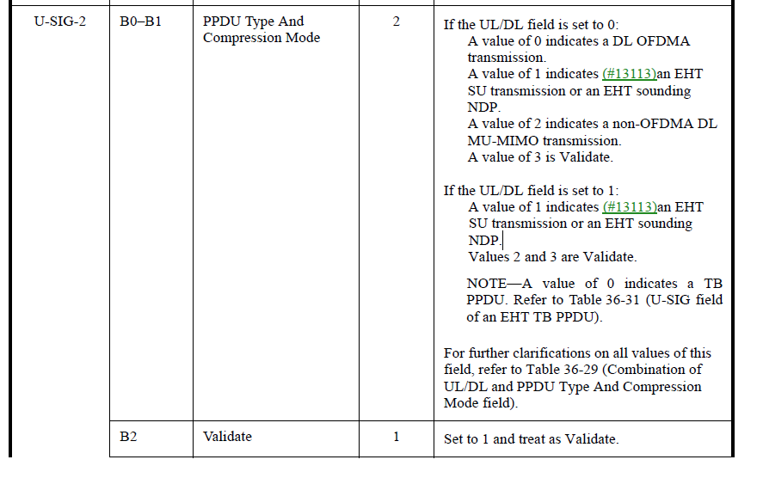
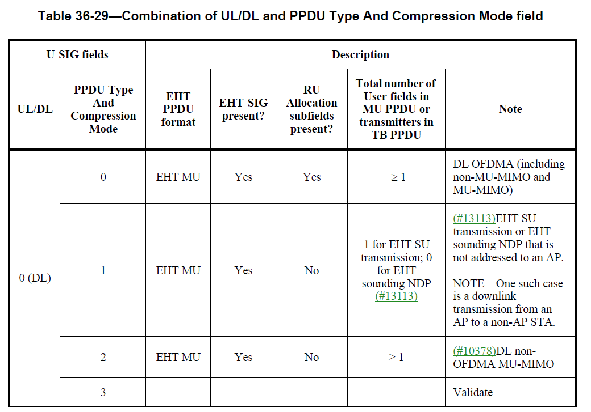
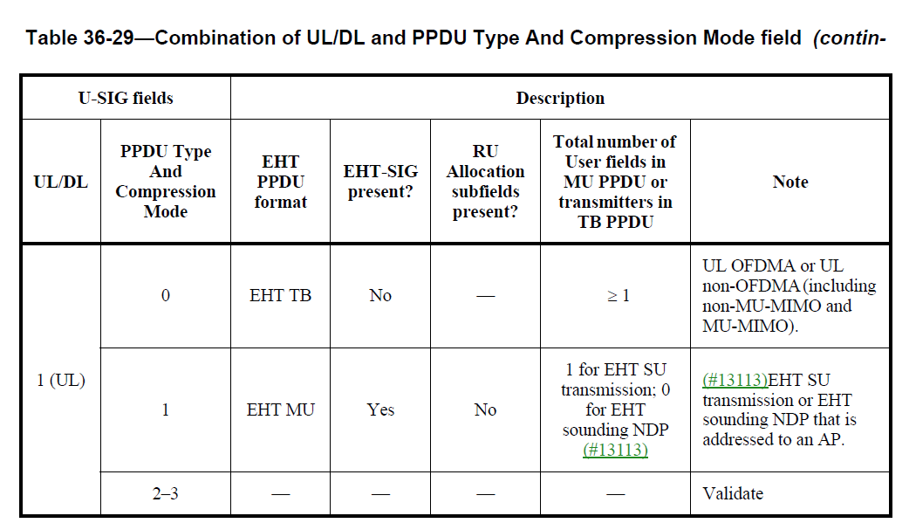
END OF DISCUSSION

Motion to Adopt

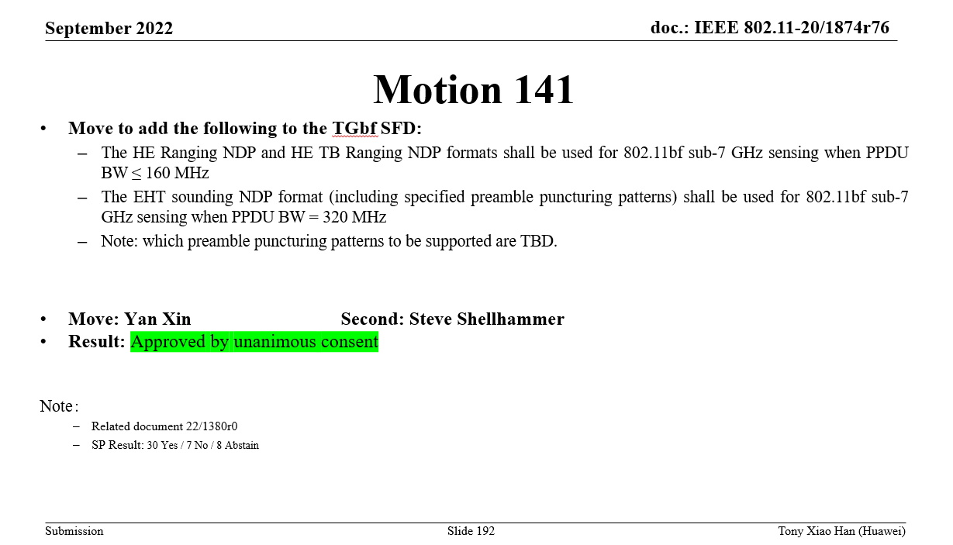

TGbf Editor: Please insert the following text in Clause 11.21.18.6.3 in 11bf D0.3 P96L11

The SI2SR NDP format shall have the format of HE Ranging NDP for below 7 GHz band when the PPDU bandwidth ≤ 160 MHz and shall have the format of EHT sounding NDP including the specified preamble puncturing patterns when the PPDU bandwidth = 320 MHz. The preamble puncturing patterns to be supported for the SI2SR NDP when the PPDU bandwidth = 320 MHz are TBD.

TGbf Editor: Please modify the Editor’s Note in 11bf D0.3 P96L12 as follows

Editor’s Note: The formats of Sensing NDP Announcement frame is TBD.

TGbf Editor: Please insert the following text in Clause 11.21.18.6.4 in 11bf D0.3 P96L53

The SR2SI NDP format shall have the format of HE TB Ranging NDP for below 7 GHz band when the PPDU bandwidth ≤ 160 MHz.

Note: EHT TB sounding NDP is not defined which is out of scope of this amendment.

TGbf Editor: Please modify the Editor’s Note in 11bf D0.3 P96L54 as follows

Editor’s Note: The formats of Sensing Sounding Trigger frame is TBD.

TGbf Editor: Please insert the following text in Clause 11.21.18.7 in 11bf D0.3 P98L44

The SI2SR NDP format and the SR2SI NDP format shall have the same format of HE Ranging NDP for below 7 GHz band when the PPDU bandwidth ≤ 160 MHz and shall have the same format of EHT sounding NDP including the specified preamble puncturing patterns when the PPDU bandwidth = 320 MHz. The preamble puncturing patterns to be supported for the SI2SR NDP and SR2SI NDP when the PPDU bandwidth = 320 MHz are TBD.

TGbf Editor: Please modify the Editor’s Note in 11bf D0.3 P98L45 as follows

Editor’s Note: The formats of the Sensing NDP Announcement frame is
TBD.

